**Installation Prerequisites**

## **Local Administrator Password Solution (LAPS)**

## **Pre-requisites:**

* To download the Local Administrator Password Solution (LAPS) file follow the below steps:
* 1. Download the Local Administrator Password Solution (LAPS) file from the below URL.
* 2.File: LAPS.x64.msi
* 3.URL: https://www.microsoft.com/en-us/download/details.aspx?id=46899
* 4.User should have Administrator right to install software
* Follow the below steps to copy / LAPS.x64.msi setup file into the specific directory. (Eg. C:\Share\LAPS\)
* 1. Log in to the machine where Local Administrator Password Solution (LAPS) will be installed.
* 2. Go to the location where ' LAPS.x64.msi' setup file is downloaded.
* 3. Copy the ' LAPS.x64.msi' setup file.
* 4. Navigate to the specific directory where 'LAPS.x64.msi' will be copied. (C:\Share\LAPS)
* 5. Paste the copied 'LAPS.x64.msi' setup 'file.

## **Installation:**

* Log in to the machine where Local Administrator Password Solution (LAPS) will be installed.
* Navigate to the directory where the 'LAPS.x64.msi' file is copied.
* Double click on 'LAPS.x64.msi'. After that 'Welcome to the Local Administrator Password Solution Setup Wizard' windows will be opened.

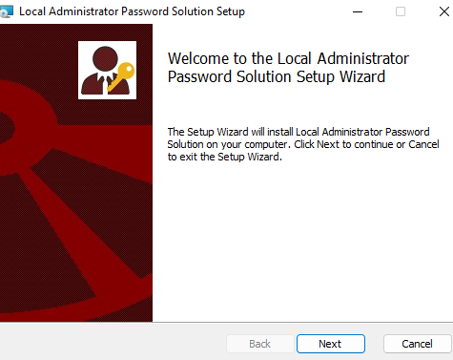

*Fig1: 'Welcome to the Local Administrator Password Solution Setup Wizard'*

* 4. Click on 'Next' Button. After that 'End-User License Agreement' windows will be opened.

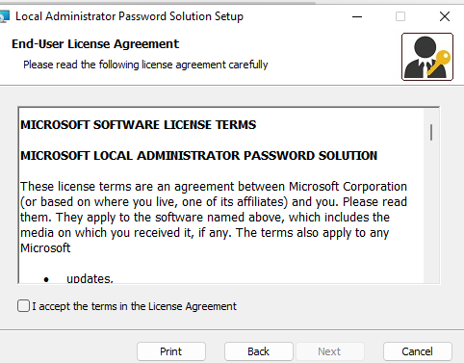

*Fig2: 'End-User License Agreement'*

* 5. Click on 'I accept the terms in the License Agreement' Button. After that Click on 'Next’.

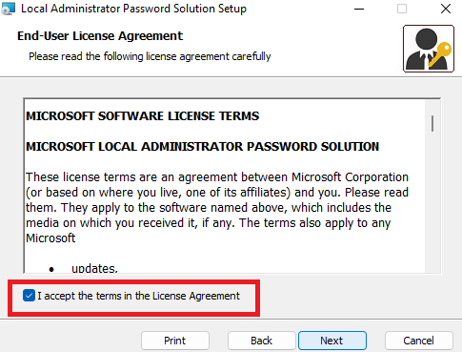

*Fig3: 'I accept the terms in the License Agreement'*

* 6. Click on 'Next' Button. After that 'Custom Setup' windows will be opened.

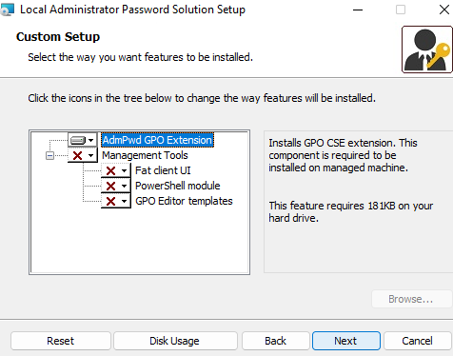

*Fig4: 'Custom Setup'*

* 7.Click on 'Next' Button. After that 'Ready to install Local Administrator Password Solution' windows will be opened.

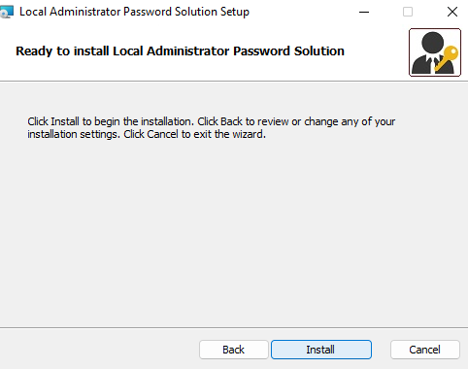

*Fig5: 'Ready to install Local Administrator Password Solution'*

* 8.Click on 'Install' Button. After that installation will be completed.

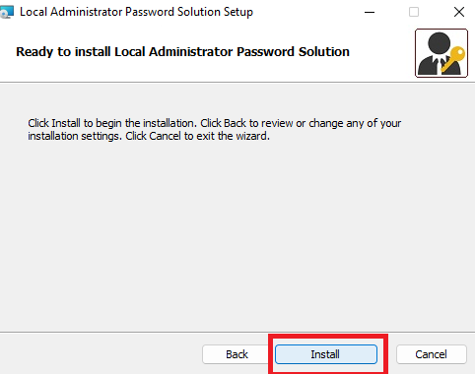

*Fig6: click on Install button*

* Now LAPS has been successfully installed.

## **Verification:**

* Open 'Control Panel'.
* Navigate to 'Programs\Programs and Features'.
* ‘Local Administrator Password Solution’ must be present in the installed software list.

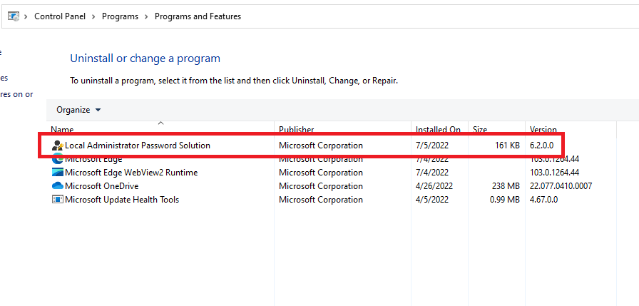

*Fig7: Verification of Installation*