Oracle Database Client Installation Manual Guide

**EMF_necblue**

Version 0.1

19-Feb-2022

NEC Corporation India Pvt. Ltd.

**Revision History**

|  |  |  |  |  |
| --- | --- | --- | --- | --- |
| No | Version | Create Date | Details | Created by |
| 1 | 0.1 | 19-Feb-2022 | Draft version | Sudheer Kumar Sharma |

**Table of Contents**

[Chapter 1 System Requirements 1](#_Chapter_1)

* 1. [Introduction 1](#_Introduction)
  2. [Intended Audience 1](#_Intended_Audience)
  3. [Oracle Client System Requirements 1](#_Target_system_Requirements)

[Chapter 2 Oracle Database Client Installation 2](#_Chapter_1)

* 1. [Oracle Database Client](#_Target_system_Requirements) 2

2.1.1. Pre-requisites 2

2.1.2. Copy Oracle Client Setup File 2

2.1.3. Verification 2

2.1.4. Unzip Oracle Client Setup File 3

2.1.5. Verification 3

2.1.6. Install Oracle Client Setup File 4-6

2.1.7. Verification 7

# Chapter 1

**System Requirements**

This chapter describes the system requirements of Oracle Client installation.

## **Introduction**

This document provides manual steps “Oracle Client Installation & Verification”.

## **Intended Audience**

## NEC Japan

## **System Requirements**

The following table describes the minimum software and hardware (SW/HW) requirements for Oracle Client Installation.

|  |  |
| --- | --- |
| **Details** | **VM1** |
| Purpose | Oracle Client Installation |
| OS | Window11 Version 21H2 |
| RAM | 4 GB |
| CPU Core | 2 |
| Disk Space | 100 GB |

**Table 1.1:** System Requirements

# Chapter 2

**Oracle Database Client Installation**

## **Oracle Database Client**

## **Pre-requisites:**

* To download the ‘WINDOWS.X64\_193000\_client.zip’ file follow the below steps:
* Browse the URL ‘https://www.oracle.com/database/technologies/oracle19c-windows-downloads.html’
* Click on 'WINDOWS.X64\_193000\_client.zip'.
* After that, Login window will be opened. Enter Oracle Login credential and click on 'Login' button.
* After that, 'WINDOWS.X64\_193000\_client.zip' will be downloaded automatically.
* User must have administrator rights to install the Oracle Client setup file.
* Oracle database server must be installed on Linux machine and configure with at least one database. (E.g.: pdb1)

## **Copy Oracle Client Setup File:**

* Log in to the machine where Oracle Client will be copied.
* Go to the location where 'WINDOWS.X64\_193000\_client.zip' setup file is downloaded.
* Copy the 'WINDOWS.X64\_193000\_client.zip' setup file.
* Navigate to the specific directory where 'WINDOWS.X64\_193000\_client.zip' will be copied. (C:\Share\)
* Paste the copied 'WINDOWS.X64\_193000\_client.zip' setup 'file.

## **Verification:**

* Log in to the machine where Oracle Client is copied.
* Navigate to the specific directory where 'Oracle Client' is copied. (C:\Share\).
* 'WINDOWS.X64\_193000\_client.zip' must be present into the directory.

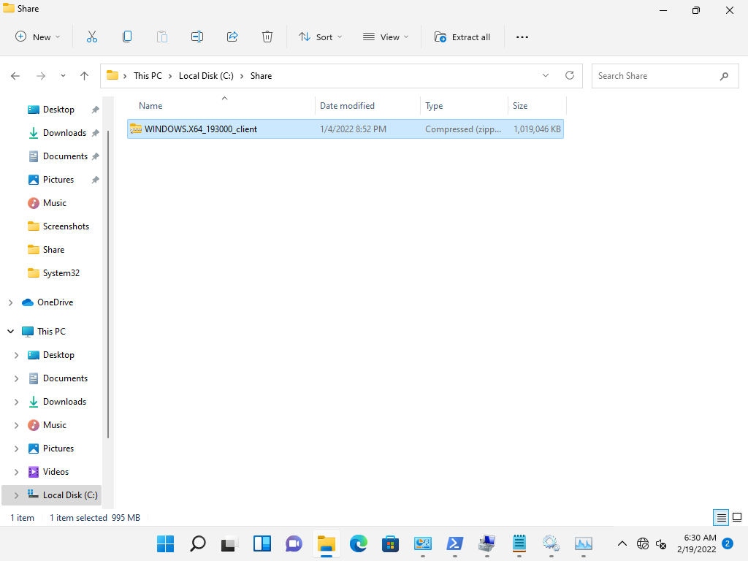

## **Unzip Oracle Client Setup File:**

* Log in to the machine where Oracle Client will is copied.
* Navigate to the location where 'WINDOWS.X64\_193000\_client.zip' is present (Ex. C:\Share\).
* Right click on 'WINDOWS.X64\_193000\_client.zip' and click on ‘Extract All’. After that, ‘Select a Destination and Extract Files’ window will be opened.

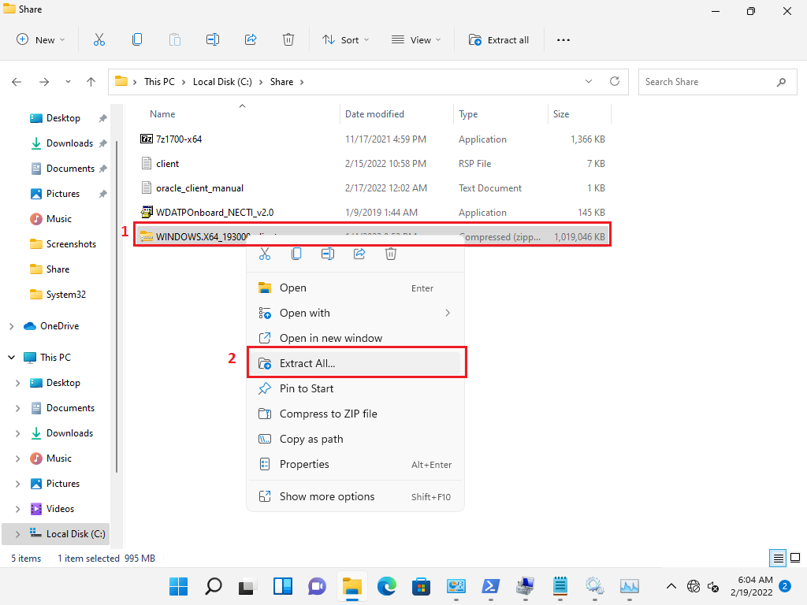

* Click on ‘Extract’ button.

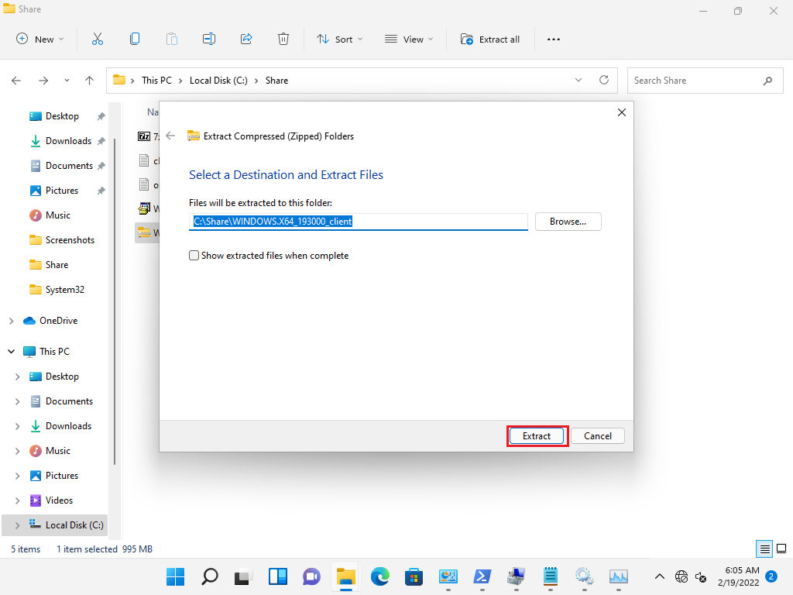

## **Verification:**

* Log in to the machine where Oracle Client is copied.
* Go to the location ‘<extract-dir>\client’ (extract-dir = ‘C:\Share\WINDOWS.X64\_193000\_client’).
* Below content must be present at this location.
  + install (Folder)
  + response (Folder)
  + stage (Folder)
  + setup.exe (File)
  + setup.ini (File)
  + welcome.html (File)

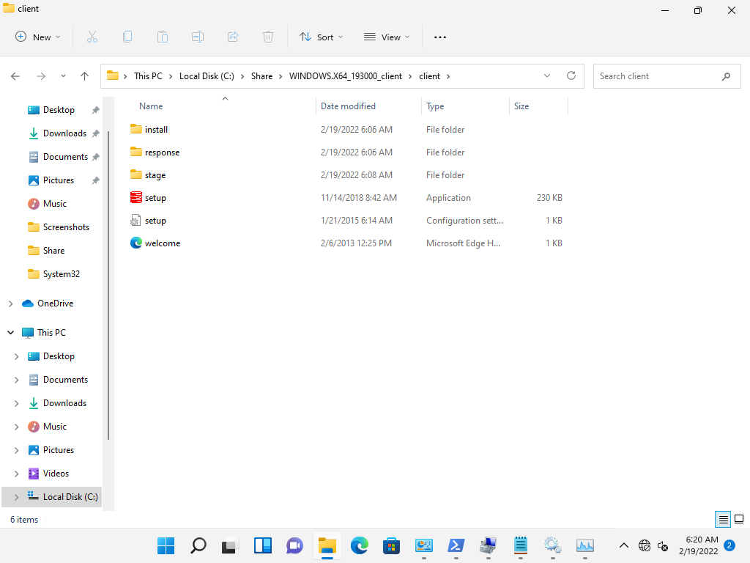

## **Install Oracle Client Setup File:**

* Log in to the machine where Oracle Client will be installed.
* Go to the location ‘C:\Share\WINDOWS.X64\_193000\_client\client’ where the 'setup.exe’ is located.
* Double click on ‘Setup.exe’. After that, Select Installation Type’ window will be opened.

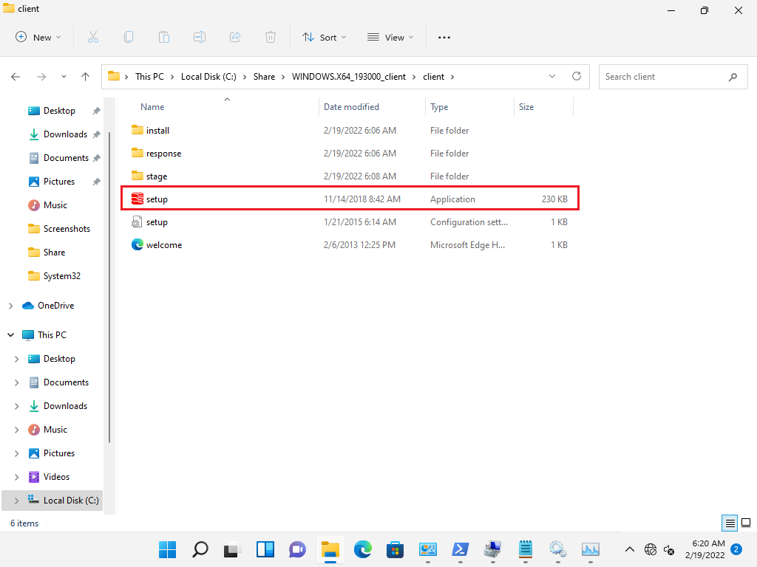

* Select ‘Administrator’ type and click on Next’ button’. After that specify Oracle Home User’ window will be opened.

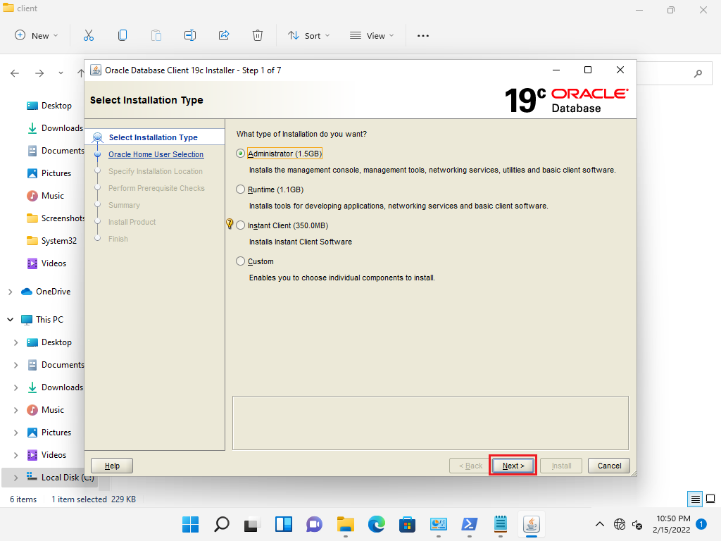

* Select ‘Create New Windows ‘User’, enter User and password, and click on ‘Next’ button.

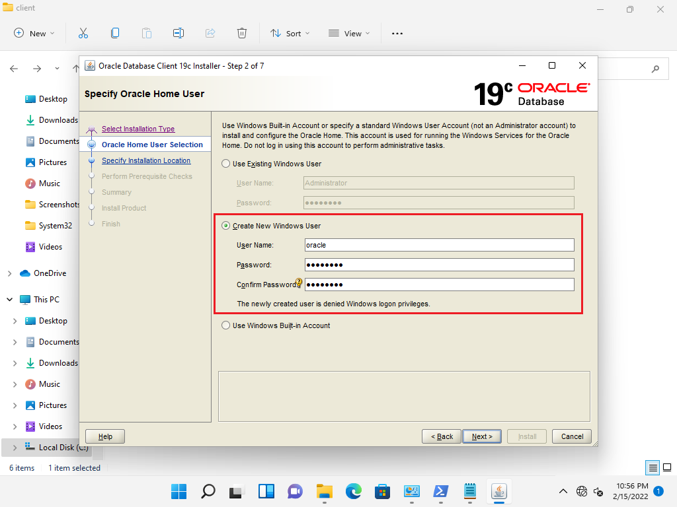

* After that, ‘Specify Installation Location’. Select Oracle base directory and click on ‘Next’ location.

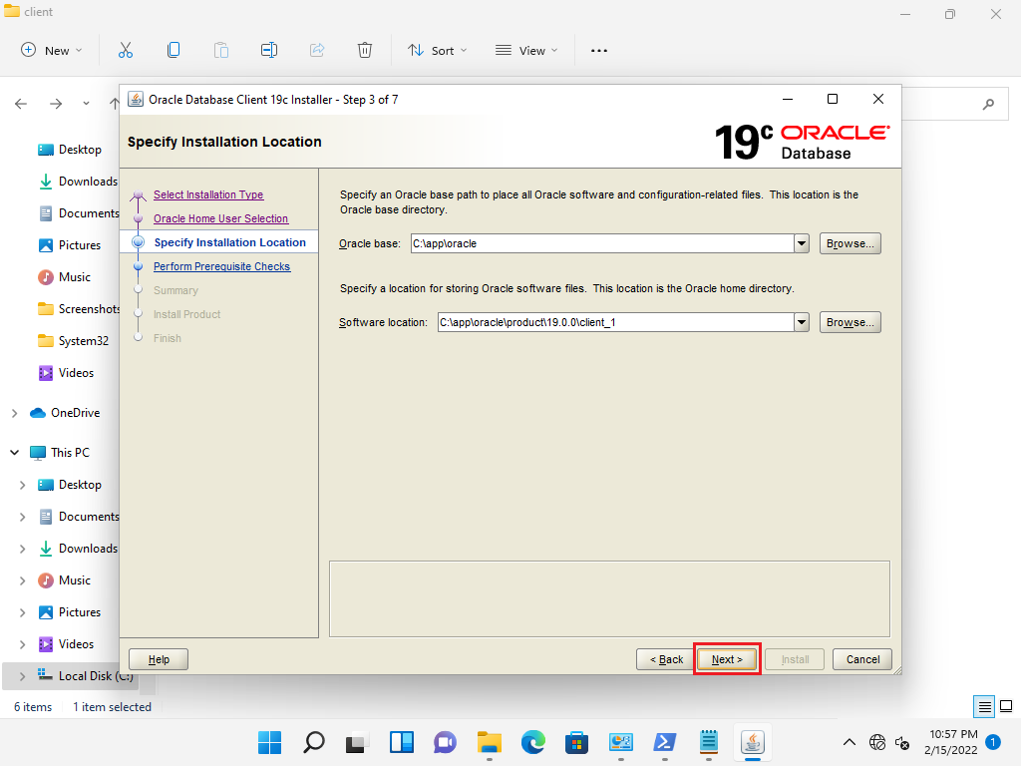

* After that ‘Summary’ window will be opened. Click on ‘Install’ button.

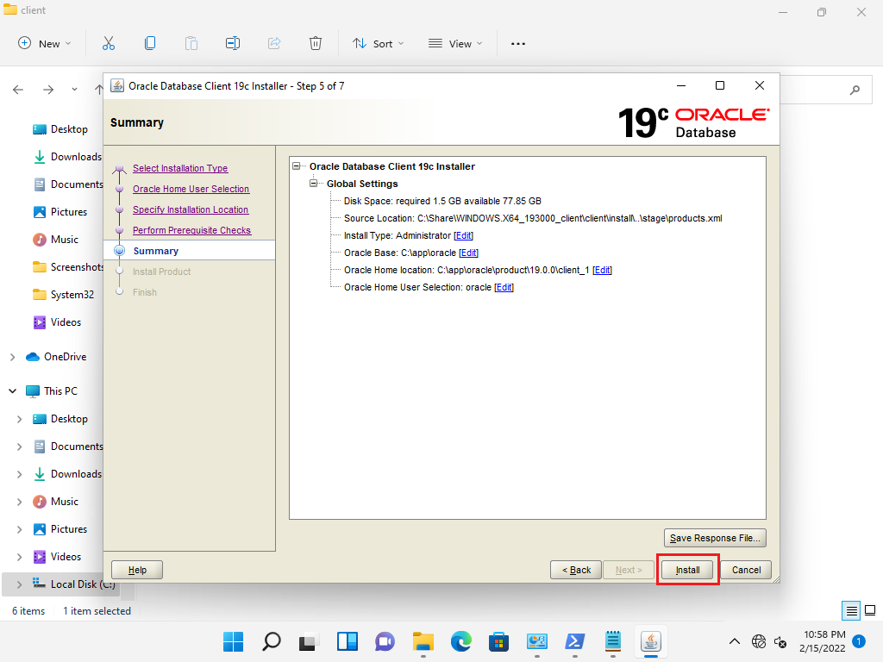

* After successfully installation click on ‘Finish’ button.

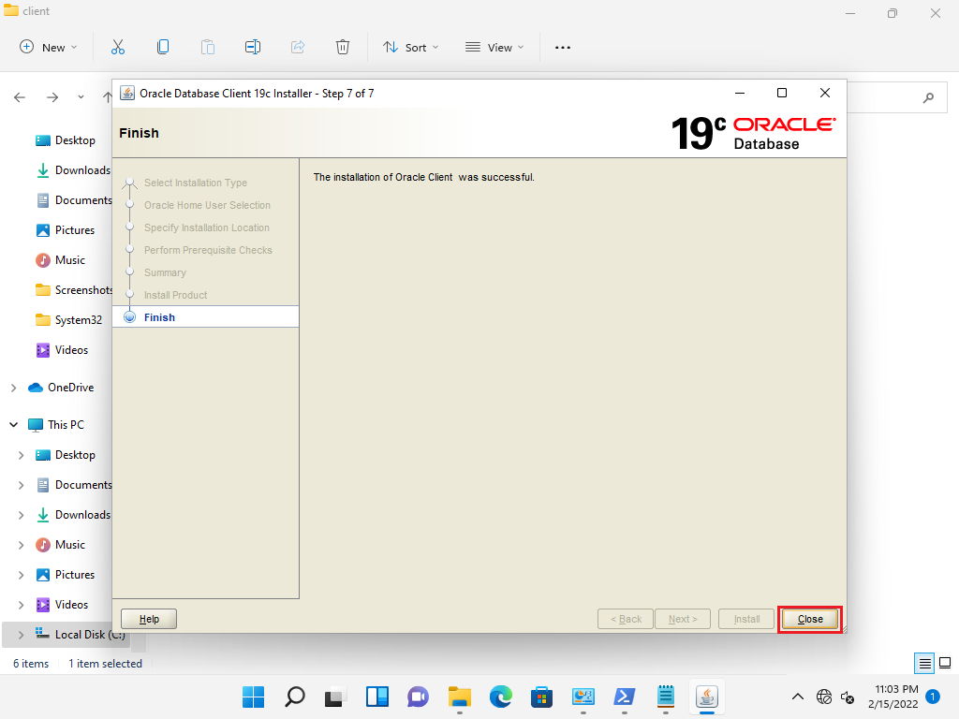

## **Verification:**

* Log in to the machine where Oracle Client is copied.
* Run Command Prompt as Administrator.
* Execute the below command:

sqlplus <oracle\_db\_user>/<password>@//<oracle\_db\_server\_ip>:1521/<db\_name>

Eg: sqlplus [system/SysPassword1@//172.30.67.29:1521/pdb1](mailto:system/SysPassword1@//172.30.67.29:1521/pdb1)

**Note:** Below are the description of parameters used in above command:

**oracle\_db\_user:** This parameter specifies the user by which user can logon to the Oracle database

**password:** This parameter specifies the oracle\_db\_user password.

**oracle\_db\_server\_ip:** This parameter specifies the oracle database server IP.

**db\_name:** This parameter specifies the pluggable database name.

* After that SQL shell will be opened. Execute the below command:

SELECT \* FROM <table\_name>;

**Eg: SQL>** SELECT \* FROM single2;

