**How to install Prometheus**

## **Prometheus:**

## **How to install Prometheus:**

**Steps :**

1. Add a Prometheus user.

**Command:**

useradd --no-create-home --shell /bin/false Prometheus

2.Create needed directories.

**Command:**

mkdir /etc/prometheus

mkdir /var/lib/prometheus

3.Change the owner of the above directories.

**Command:**

chown prometheus:prometheus /etc/prometheus

chown prometheus:prometheus /var/lib/Prometheus

4.Now go to Prometheus downloaded location and extract it.

**Command:**

tar -xvzf prometheus-2.8.1.linux-amd64.tar.gz

5.Rename it as per your preference.

**Command:**

mv prometheus-2.8.1.linux-amd64 prometheuspackage

6.Copy “prometheus” and “promtool” binary from the “prometheuspackage” folder to “/usr/local/bin”.

**Command:**

cp prometheuspackage/prometheus /usr/local/bin/

cp prometheuspackage/promtool /usr/local/bin/

7.Change the ownership to Prometheus user.

**Command:**

chown prometheus:prometheus /usr/local/bin/prometheus

chown prometheus:prometheus /usr/local/bin/promtool

8.Copy “consoles” and “console_libraries” directories from the “prometheuspackage” to “/etc/prometheus folder”

**Command:**

cp -r prometheuspackage/consoles /etc/prometheus

cp -r prometheuspackage/console_libraries /etc/Prometheus

9.Change the ownership to Prometheus user

**Command:**

chown -R prometheus:prometheus /etc/prometheus/consoles

chown -R prometheus:prometheus /etc/prometheus/console_libraries

10. Add and modify Prometheus configuration file.

Configurations should be added to the “/etc/prometheus/prometheus.yml”

Now we will create the prometheus.yml file.

**Command:**

vim /etc/prometheus/prometheus.yml

11.Add the following configuration to the file.

**Command:**

global:

scrape_interval: 10s

scrape_configs:

- job_name: 'prometheus_master'

scrape_interval: 5s

static_configs:

- targets: ['localhost:9090']

save and exit the file

12.Change the ownership of the file.

**Command:**

chown prometheus:prometheus /etc/prometheus/prometheus.yml

13. Configure the Prometheus Service File.

**Command:**

vim /etc/systemd/system/prometheus.service

14.Copy the following content to the file.

**Command:**

[Unit]

Description=Prometheus

Wants=network-online.target

After=network-online.target

[Service]

User=prometheus

Group=prometheus

Type=simple

ExecStart=/usr/local/bin/prometheus \

--config.file /etc/prometheus/prometheus.yml \

--storage.tsdb.path /var/lib/prometheus/ \

--web.console.templates=/etc/prometheus/consoles \

--web.console.libraries=/etc/prometheus/console_libraries

[Install]

WantedBy=multi-user.target

Save and the exit file.

15.Reload the systemd service.

**Command:**

systemctl daemon-reload

16.Start the Prometheus service.

**Command:**

systemctl start Prometheus

17.Check service status.

**Command:**

# systemctl status prometheus

**Node Expoter**

1.Extract the downloaded package.

**Command:**

tar -xvzf node_exporter-0.17.0.linux-amd64.tar.gz

2.Create a user for the node exporter.

**Command:**

useradd -rs /bin/false nodeusr

3.Move binary to “/usr/local/bin” from the downloaded extracted package.

Command:

mv node_exporter-0.17.0.linux-amd64/node_exporter /usr/local/bin/

4. Create a service file for the node exporter.

**Command:**

vim /etc/systemd/system/node_exporter.service

5.Add the following content to the file.

[Unit]

Description=Node Exporter

After=network.target

[Service]

User=nodeusr

Group=nodeusr

Type=simple

ExecStart=/usr/local/bin/node_exporter

[Install]

WantedBy=multi-user.target

6.Save and exit the file.

7.Reload the system daemon.

**Command:**

# systemctl daemon-reload

8. Start node exporter service.

**Command:**

systemctl start node_exporter

9.Add firewall rules.

**Command:**

firewall-cmd --zone=public --add-port=9090/tcp –permanent

2.Reload firewall service.

**Command:**

systemctl reload firewalld

**Alert Manager**

1.Create a user and group for Alertmanager:

**Command:**

sudo useradd -M -r -s /bin/false alertmanager

2.Install the Alertmanager binaries:

**Command:**  https://github.com/prometheus/alertmanager/releases/download/v0.20.0/alertmanager-0.20.0.linux-amd64.tar.gz

tar xvfz alertmanager-0.20.0.linux-amd64.tar.gz

sudo cp alertmanager-0.20.0.linux-amd64/alertmanager /usr/local/bin/

sudo chown alertmanager:alertmanager /usr/local/bin/alertmanager

sudo mkdir -p /etc/alertmanager

sudo cp alertmanager-0.20.0.linux-amd64/alertmanager.yml /etc/alertmanager

sudo chown -R alertmanager:alertmanager /etc/alertmanager

sudo mkdir -p /var/lib/alertmanager

sudo chown alertmanager:alertmanager /var/lib/alertmanager

3.Create a systemd unit for Alertmanager:

**Command:**

sudo vi /etc/systemd/system/alertmanager.service

[Unit]

Description=Prometheus Alertmanager

Wants=network-online.target

After=network-online.target

[Service]

User=alertmanager

Group=alertmanager

Type=simple

ExecStart=/usr/local/bin/alertmanager

--config.file /etc/alertmanager/alertmanager.yml

--storage.path /var/lib/alertmanager/

[Install]

WantedBy=multi-user.target

4.Start and enable the alertmanager service:

**Command:**

sudo systemctl enable alertmanager

sudo systemctl start alertmanager

**Install the Amtool**

1. Copy package

**Command:**

sudo cp alertmanager-0.20.0.linux-amd64/amtool /usr/local/bin/

2.Create a config file for amtool:

**Command:**

sudo mkdir -p /etc/amtool

sudo vi /etc/amtool/config.yml

3.Enter the following content in the config file:

**Command:**

alertmanager.url: <http://localhost:9093>

4.Edit the Prometheus config:

**Command:**

sudo vi /etc/prometheus/prometheus.yml

5.Under alerting, add your Alertmanager as a target:

**Command:**

alerting:

alertmanagers:

- static_configs:

- targets: ["localhost:9093"]

6.Restart Prometheus to reload the configuration:

**Command:**

Sudo systemctl restart prometheus

## **Verification:**

* Open Chrome browser
* Login with Prometheus server IP <Prometheus server IP>:9090/targets

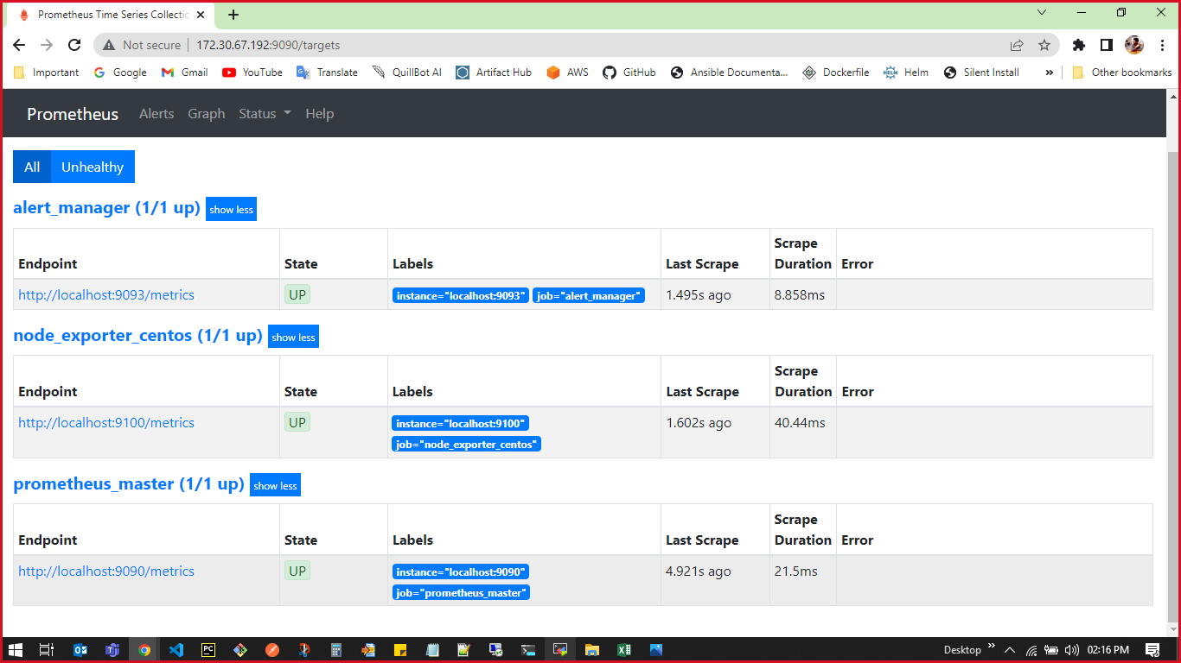

Fig 2.6 Prometheus Server