CLOUD-BASED SMART FILE STORAGE AND SHARING SYSTEM.
1. Introduction
This project is a secure, scalable, cloud-based file storage application built using AWS Lambda, API Gateway, S3, and JWT authentication.
The system enables users to:
- Login using a secure JWT token
- Upload files
- List their files
- Download files
- Delete files
- Generate a shareable link using pre-signed URLs
The application is completely serverless, reducing maintenance costs and enabling pay-as-you-go usage.

2. Problem Statement
Traditional file storage systems depend on servers and manual management, which makes them:
- Costly
- Hard to scale
- Vulnerable to security breaches
This project provides a serverless alternative using AWS.

3. Objectives
To design and deploy a secure, scalable, and efficient cloud-based file storage system where users can upload, access, and share files through a web interface using cloud services.
1. Provide a secure authenticated login system
2. Allow file upload/download using AWS S3
3. Provide a simple UI for users
4. Ensure file security and controlled access
5. Use serverless architecture for scalability

4. Step-by-Step Guide:
Phase 1 – Understanding and Planning
- Research how cloud file storage systems like Google Drive or Dropbox work.
- Create a simple workflow:
  - User signs up/logs in
  - Uploads a file
  - File stored in cloud storage
  - Link generated for sharing or download
- Decide what type of files will be supported (images, PDFs, etc.).
Phase 2 – Setup Cloud Environment
- Create a free AWS or Google Cloud account.
- Create a cloud storage bucket (e.g., Amazon S3 bucket).
- Configure IAM permissions to control access to storage.

Phase 3 – Backend Development
- Use Python (Lambda) or Node.js (Express) to build the backend.
- Implement APIs for:
  - User login (JWT authentication)
  - File upload (store file metadata in database)
  - Generate public/private file URLs
- Store file information in DynamoDB:
  - Table Name: SmartDriveFiles
  - Partition Key: file_id (UUID)
  - Attributes: filename, owner_email, upload_date
Phase 4 – Frontend Development
- Build a simple web interface using HTML, CSS, JavaScript.
- Features include:
  - File upload form
  - Display of uploaded files
  - Download and delete options
  - Share link generation
- Maintain UI using CSS for consistency.
Phase 5 – Integration
- Connect frontend to backend APIs.
- Test uploading and retrieving files from S3.
- Add file deletion and download options.
Phase 6 – Security & Optimization
- Use JWT tokens for secure user authentication.
- Optionally add CloudFront CDN for faster access.
- Enable SSL/HTTPS for data security.
Phase 7 – Deployment
- Deploy backend using AWS Lambda and API Gateway.
- Host frontend on AWS S3 static hosting / Vercel.
- Test the system end-to-end.

5. System Architecture

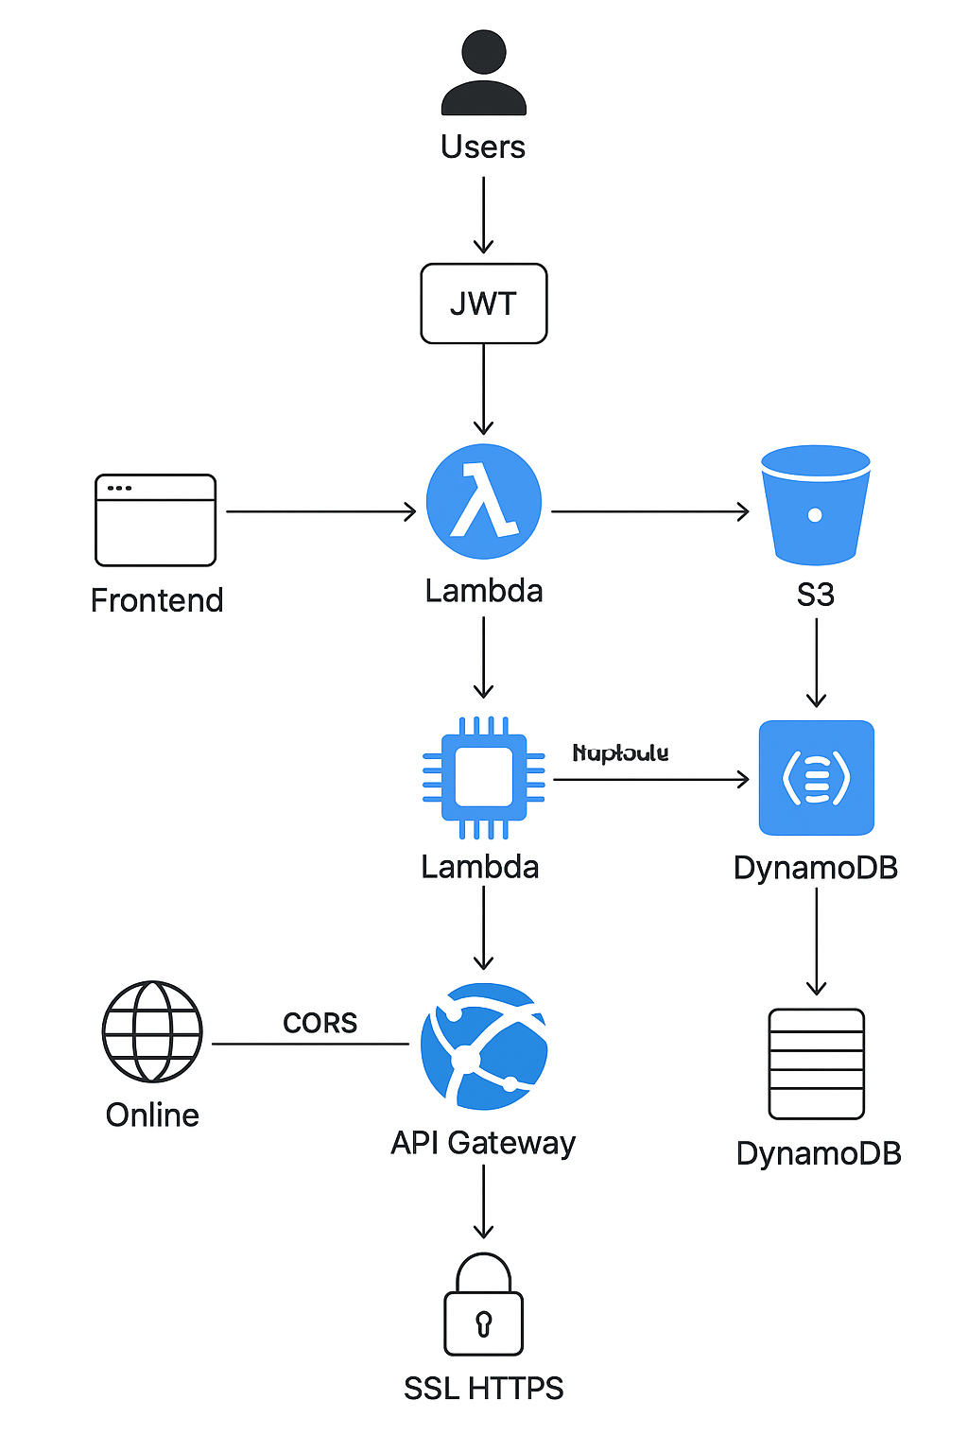

 | Purpose / Role
  Component
AWS S3 | Stores uploaded files securely and provides storage access.
AWS Lambda | Handles backend logic (login, upload, list, delete, download).
API Gateway | Exposes REST API endpoints and routes requests to Lambda.
JWT Tokens | Provides secure user authentication and authorization.
HTML + JavaScript | Implements the front-end user interface for uploads and actions.
CORS | Enables communication between frontend (browser) and backend (API).

6. Workflow Diagram
Detailed System Implementation:
- Users log in using a JWT-secured login system.
- Files uploaded via frontend are converted to Base64 and sent to Lambda.
- Lambda decodes files and stores them in S3.
- Metadata is stored in DynamoDB table 'SmartDriveFiles' including file_id (UUID), filename, owner_email, and upload_date.
- Users can list their files, download, delete, and generate shareable pre-signed URLs.
- Frontend interacts with Lambda via API Gateway, passing JWT for authentication.
- CORS is configured to allow frontend-backend communication.
- The system is completely serverless, scalable, and secure.
- Optional: CloudFront CDN is used for faster access.
- SSL/HTTPS is enabled for secure data transmission.

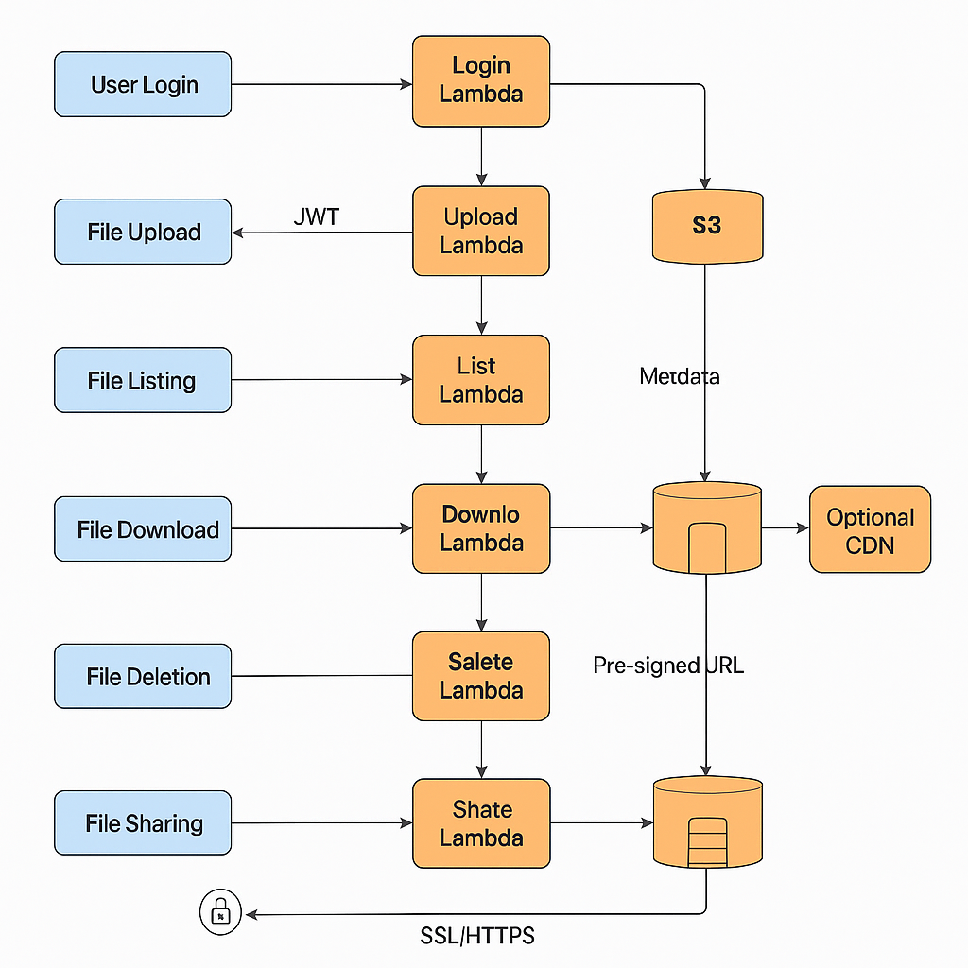

7. Features Implemented

✔ Authentication
- JWT is generated on successful login
- Token expires in 1 hour
- Frontend stores token in localStorage

✔ File Upload
- Converts file to Base64
- Lambda decodes and stores in S3

✔ File Listing
- Lists all S3 objects

✔ File Download
- Returns Base64 content
- Browser converts it into a downloadable file

✔ File Delete
- Deletes selected file from S3

✔ Share File
- Generates 1-hour pre-signed URL

8. Tools & Technologies Used
- Frontend: HTML, CSS, JavaScript
- Backend: Python (AWS Lambda)
- Cloud Platform: AWS
- Storage: Amazon S3
- Database: DynamoDB
- Authentication: JWT
- Deployment: AWS S3, CloudFront

9. API Endpoints

Endpoint | Method | Description
/login | POST | Generate token
/upload | POST | Upload file
/files | GET | List files
/delete | DELETE | Delete file
/download | GET | Download file
/share | POST | Share using pre-signed URL

10. Screenshots to Include
- Login screen
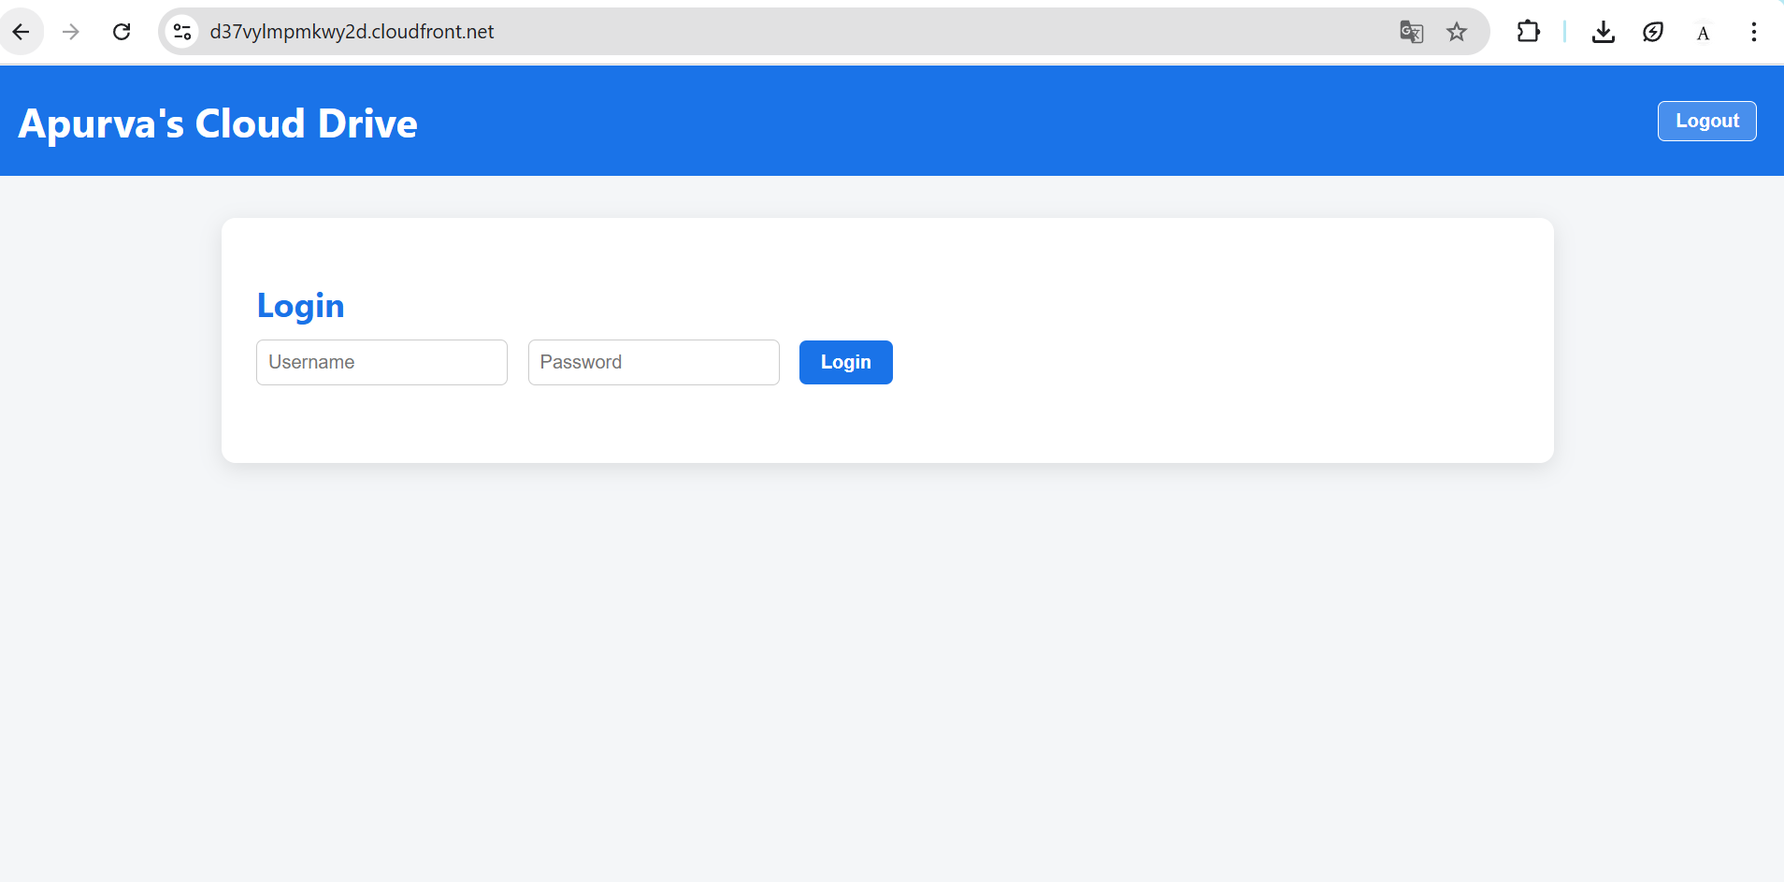
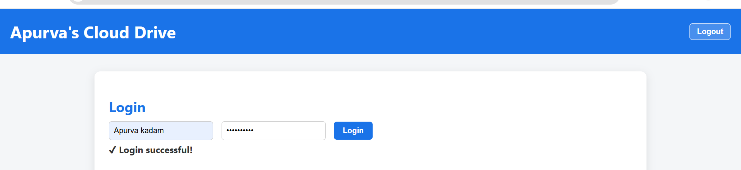

- Upload file

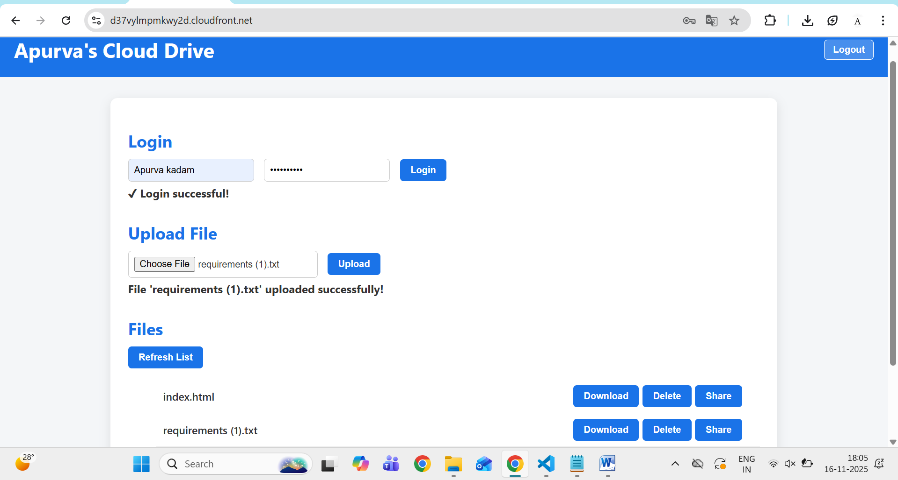

- List files
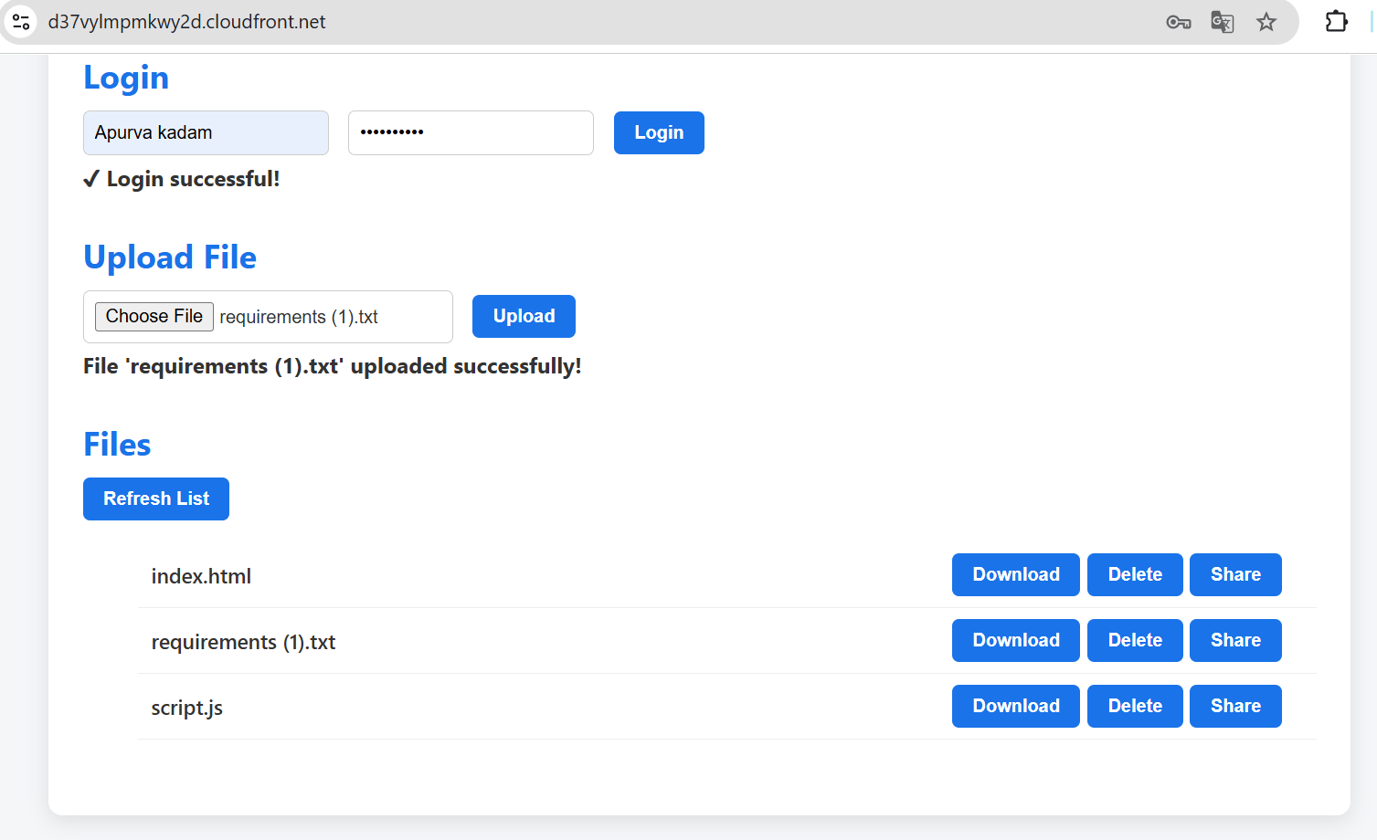

- DynamoDB Table
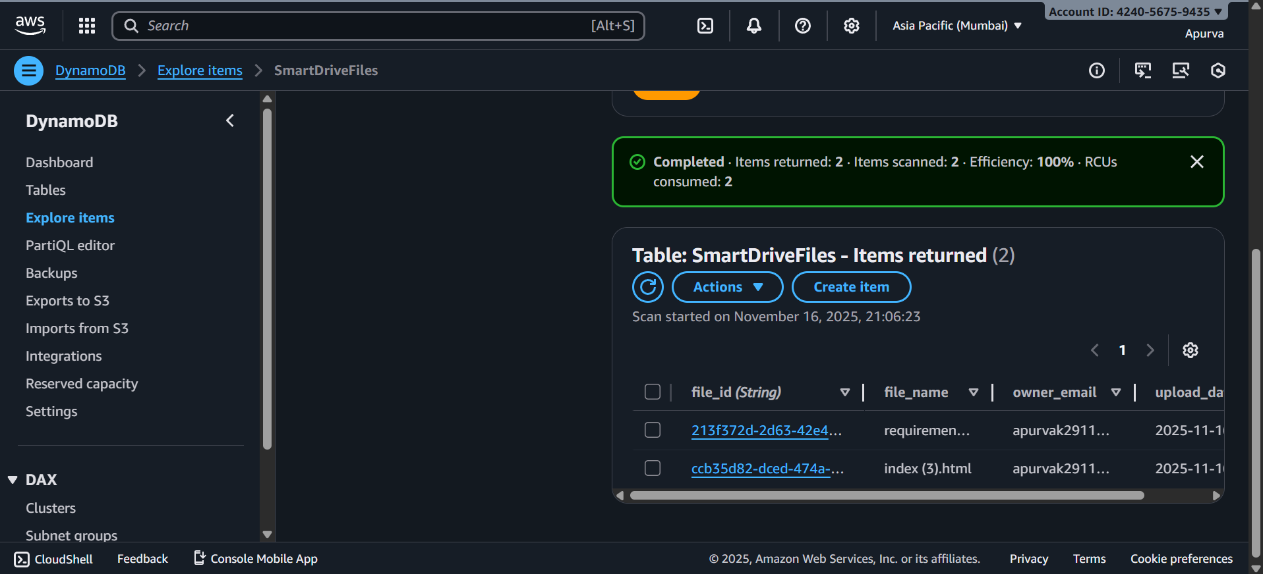
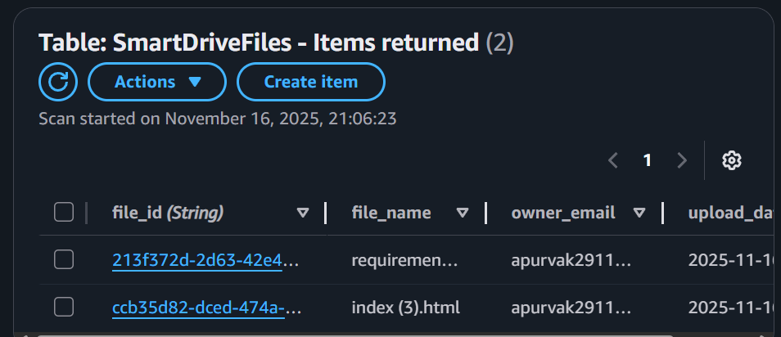

- Download

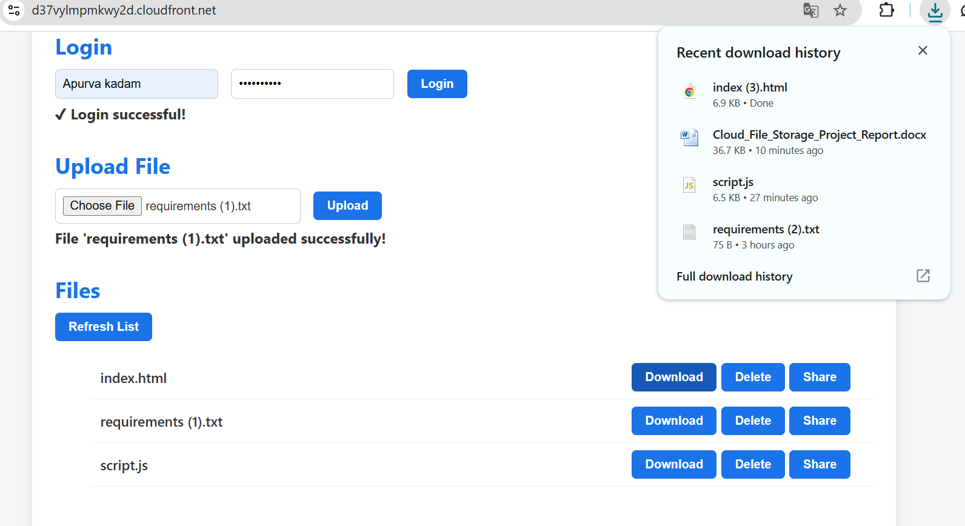

- Delete
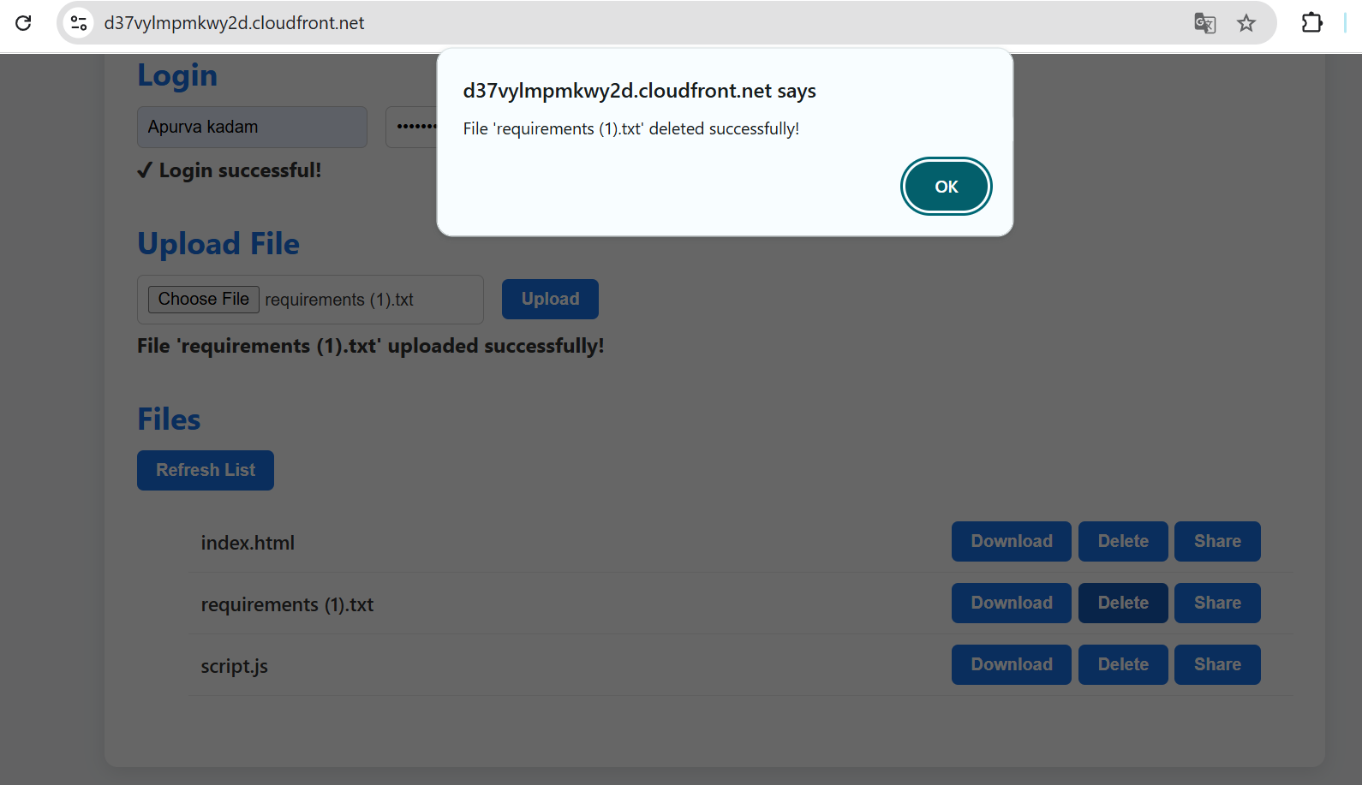
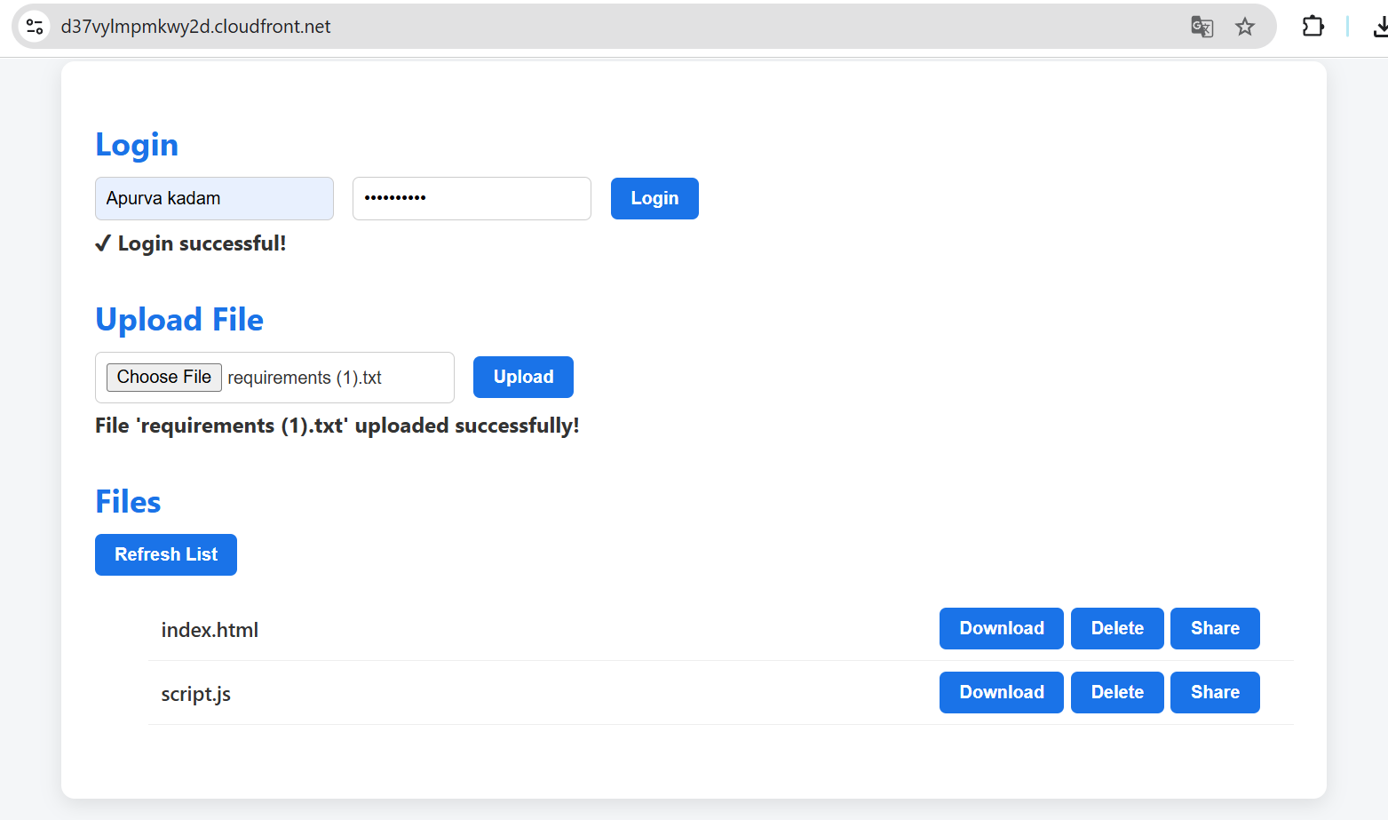

- Share link popup
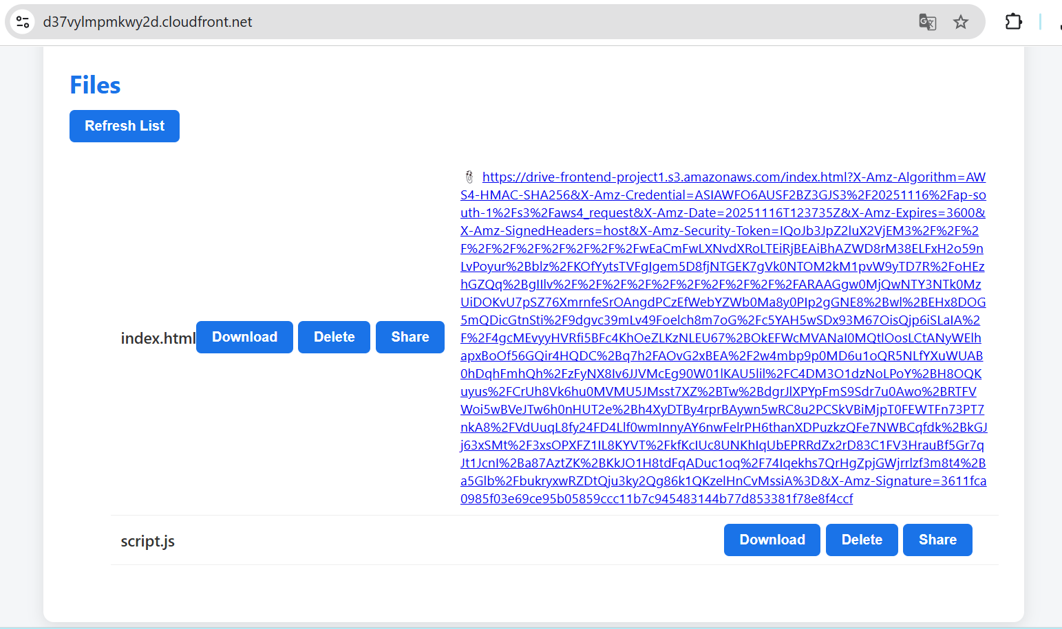

- CloudFront or S3 URL hosting
https://d37vylmpmkwy2d.cloudfront.net/
- Logout

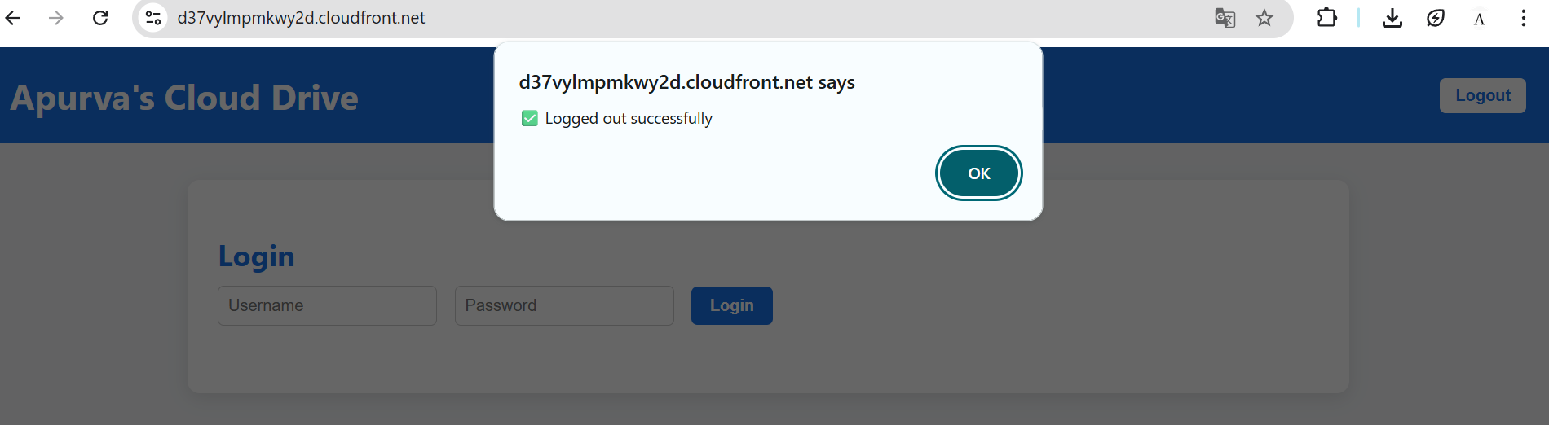

11. Conclusion
This serverless file storage system demonstrates how cloud-native solutions can be:
- Highly scalable
- Secure
- Low cost
- Fully automated
The project is ideal for portfolios, demonstrating real production-level architecture.

