SQL Assignment 1,2,3,4,5,6

Assignment 1

1
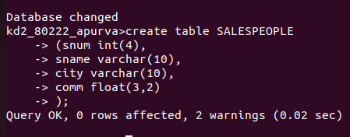

2
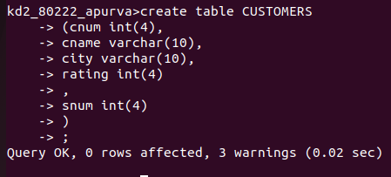

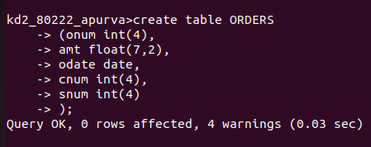
3

4
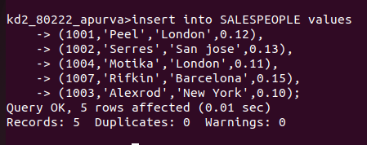

5
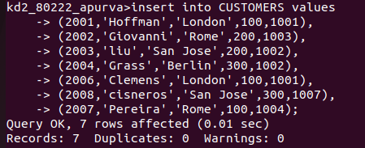

6
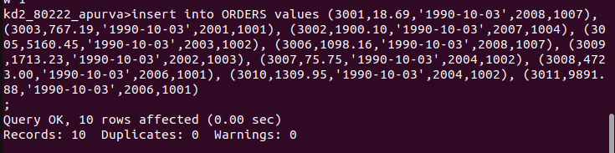

Assignment 2

1. Which field of the customers table is the primary key?
---> Primary key should have the unique values in the table so cnum is the primary key.
2. What is the fourth column of the customers table?
---> Rating
3. What is the another word for row? For column?
--->Another word for row is tupil and for column is attributes.
4. Why is not possible to see the first five rows of a table?
--->The storing structure in the RDBMs is not continuous like that is in file.
Here every row is considered as the file and stored at the discontinuous
memory locations,. Hence it is not possible to see first five rows of the table.

Assignment 3

1. Does ANSI recognise the data type Date?
----> No, the ANSI does not recognise the data type date.
2. Which sub division of SQL is used to insert values in the tables?
---->insert into table_name values
(-----,------,-----,-----),
(-----,------,-----,-----);

Assignment 4

1.

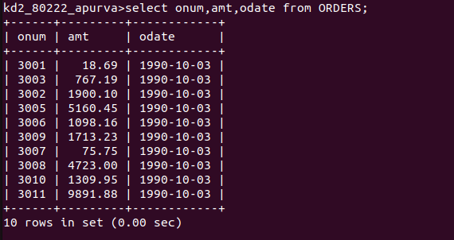

2
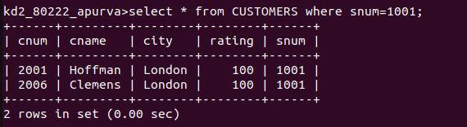

3
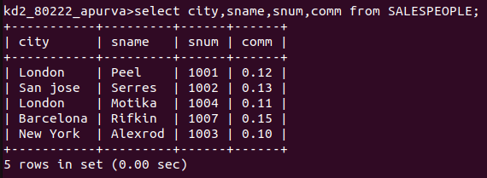

4
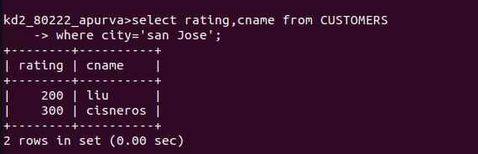

Assignment 5

1
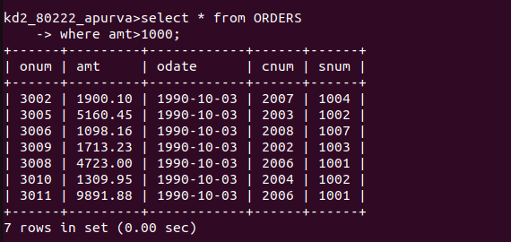

2

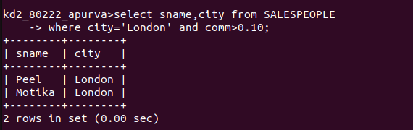

3

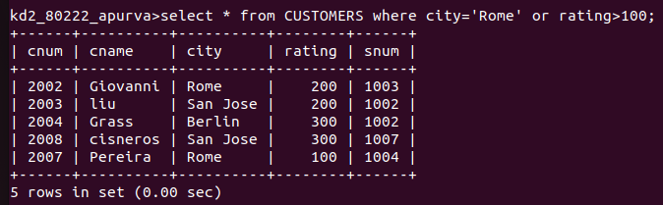

4

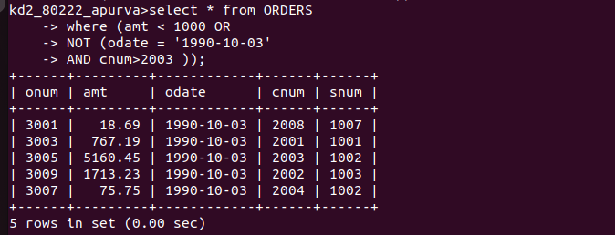

5
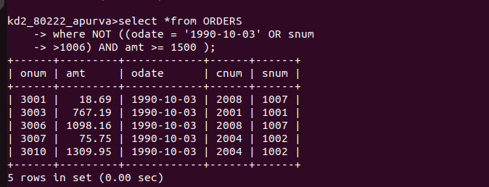

6

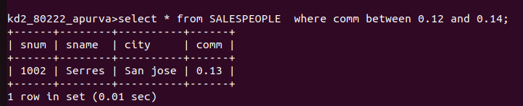

Assignment 6

1
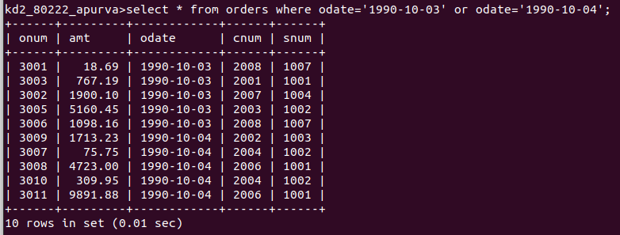
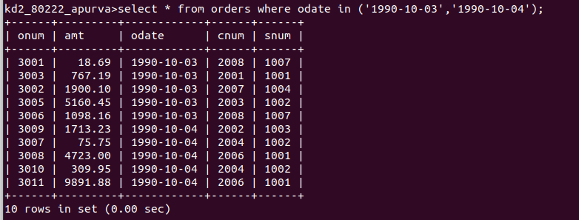

2

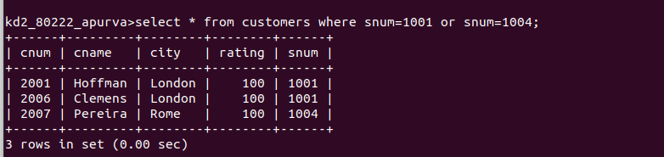

3

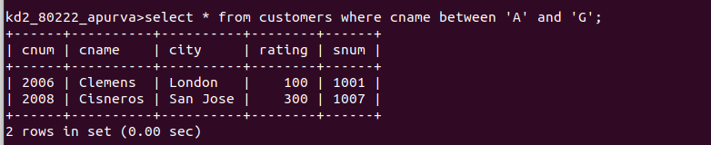

4


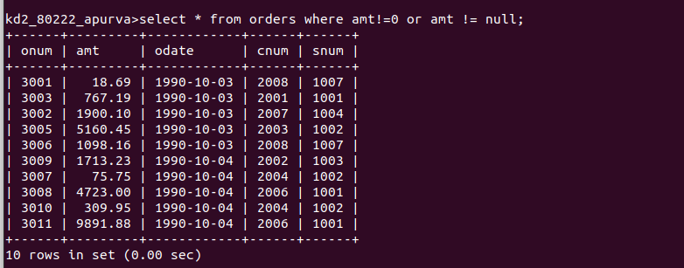
5

