Assignment 12

1. Write a query that selects all customers whose ratings are equal to or greater Serres.
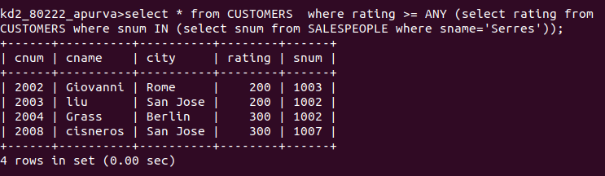

2. Write a query using ANY or ALL that will find all salespeople who have no customers located in their city.
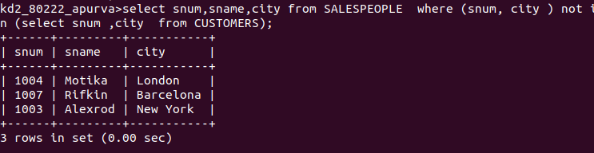

3. write a query that selects all orders for amounts greater than any for the customers in London.

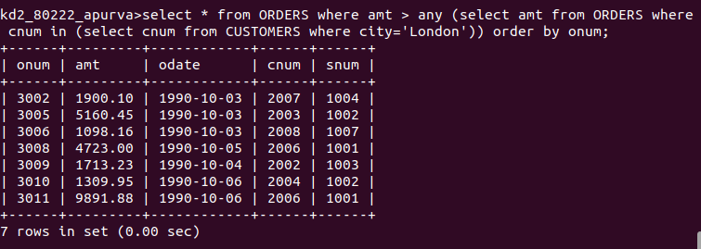

4. Write above query using min and max.

