Assignment 8

1. Assume each salesperson has a 12% commisiion. Write a query on the orders table taht will produce the order number , the salespersons number and the amount of the salesperson’s commisiion fro that order.
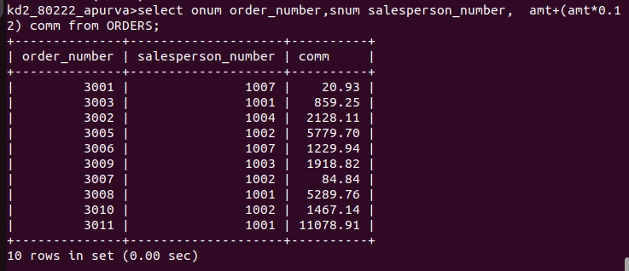

2. Write a query on the customers table taht will find the highest rating in the each city. Put the output in this form:
for the city (city), the highest rating is : (rating).

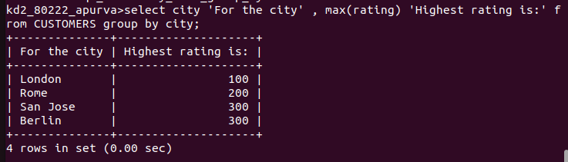

3. Write a query that lists customers in descending order of the rating. Output the rating field first, followed by the customer’s name and the number.

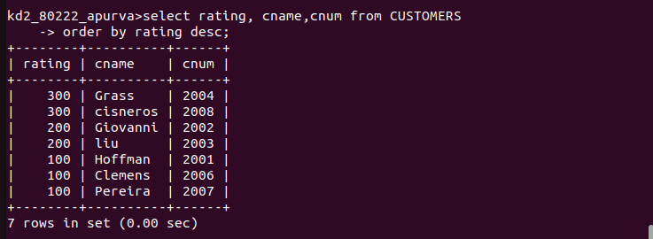

4. Write a query that totals the orders for each day and places the results in descending order
