Assignment 1

1. Create the following tables with the given structures and insert sample data as specified:-

A) SALESPEOPLE
SUM int(4)
SNAME varchar(10)
CITY varchar(10)
COMM float(3,2)

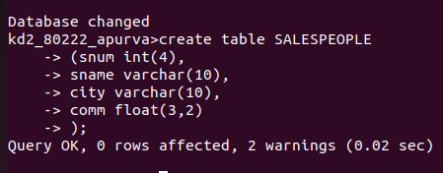

B) CUSTOMERS
Cnum int(4)
Cname varchhar(4)
Rating int(4)
Snum int(4)

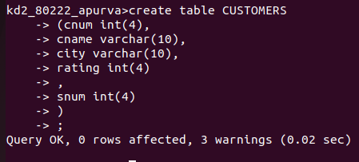

C) ORDERS
Onum int(4)
Amt float(3,2)
Odate date
Cnum int(4)
Snum int(4)

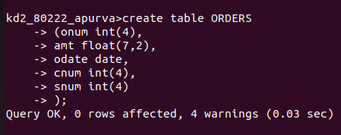

DATA

SALES PEOPLE

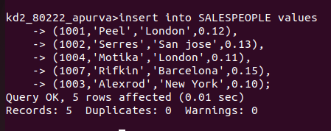

CUSTOMERS

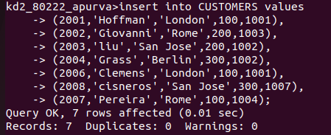

ORDERS

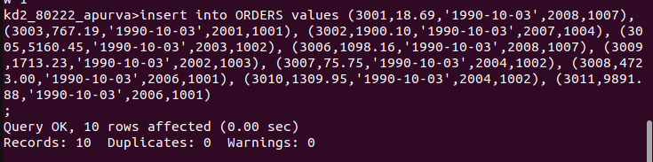
by mistake I inserted similar valuse for date but later i updated it as below

