Assignment 4

1. Write a select command that produces the order number,amountand date for all rows in the orders table.
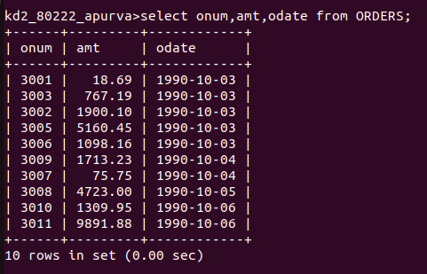

2. Write a query that produces all rows from the customers table for which the salesperson’s number is 1001.

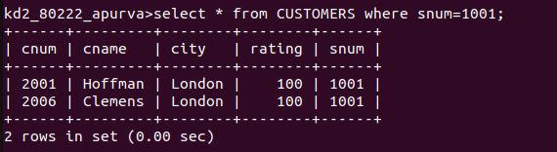
3. Write a query that displays the salespeople table with the colums in the following order: city,sname,snum,comm.

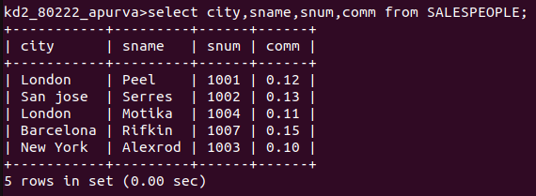

4. Write a select command that produces the rating followed by the name of each customer in San Jose.

