Assignment 14

1. Writing a command that puts the following values, in their given order into the salespeople table: city-san jose
name-Blanco
comm-null
cnum-1100.

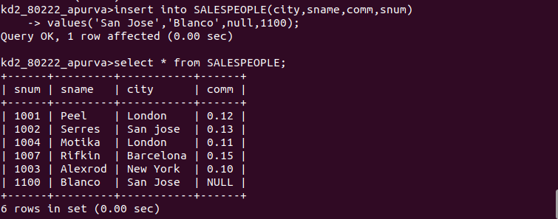

2. Write a command that removes all orders from customer clemens from the orders table.

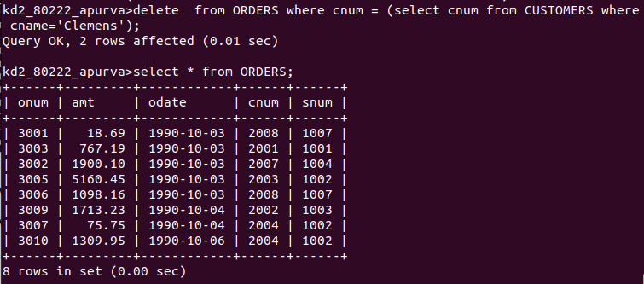

3. Write a command that increases the rating of all customers in rome by 100.

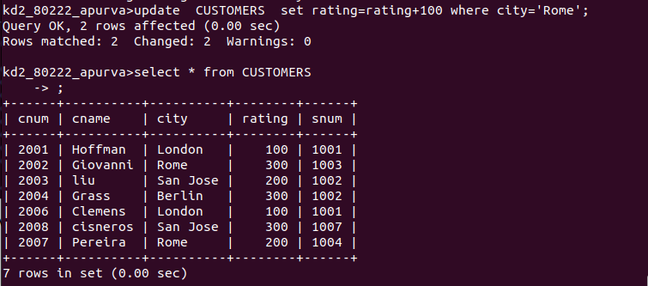

4. Salesperson serres has left the company. Assign her customer to motiks.

