Assignment 15

1. Assume there is a table called Multicust, with all of the same column defination as salespeople. Write a command that inserts all salespeople with more than one customer into this table.
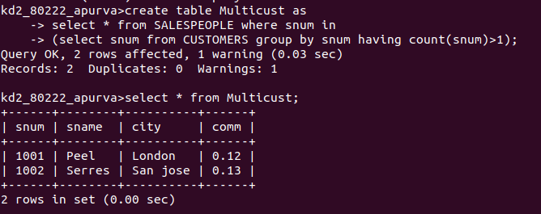
2. Write a command that deletes all the customers with no current orders.
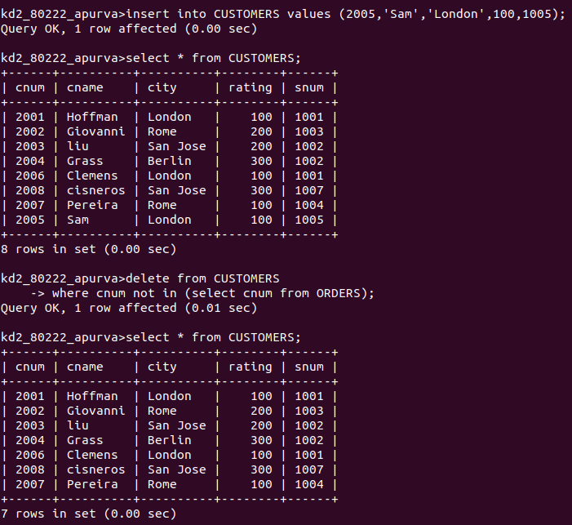

3. Write a command that increases by twenty percent the commission of all salespeople with total orders above rs. 3,000.

