Assignment 13

Using union clause

1. Create a union of two queries that shows the names, cities and ratings of all customers. Those with rating of 200 or grater will also have the words “ High Rating” while others will have the words “Low Rating”.
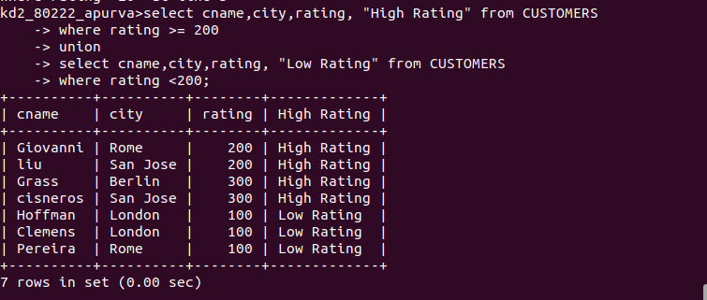

2. Write a command that produces the name and number of each salesperson and each customer with more than one current order. Put the results in alphabetical order.

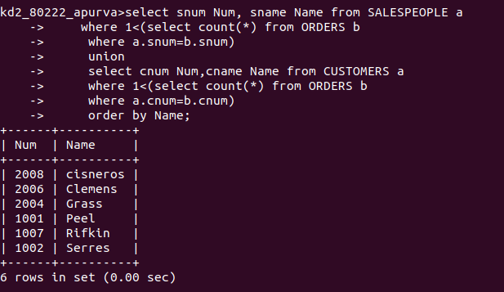

3.Form a union of three queries.Have the first select the sums of all salespeople in san jose;
the second ,the cnums of all customers in san jose ;
and third the onums of all orders on october 3. Retain duplicates between the lsat two queries but eliminate any redundancies between either of them and the first.

