Assignment 7

1. write a query thet counts all the orders for october 3.

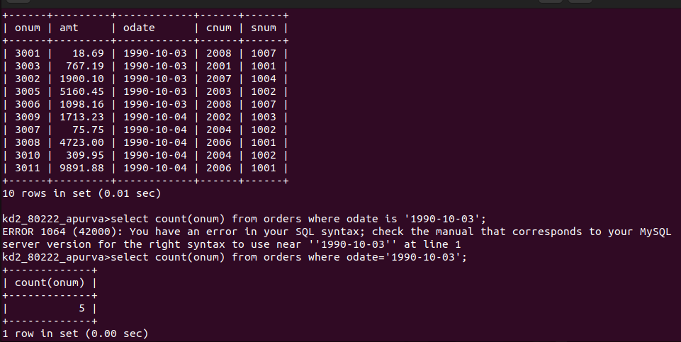

2. Writhe the query that counts the number of the different non null city values in the customers table.

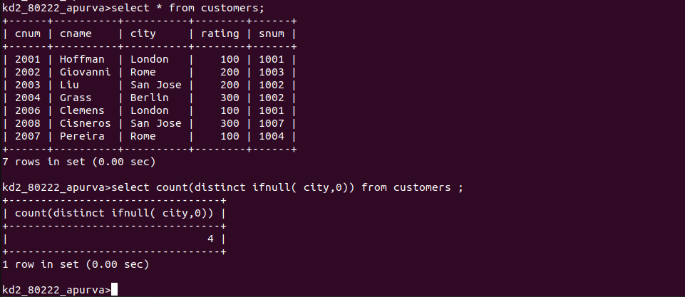

3.Write a query to select the each customers smallest order.

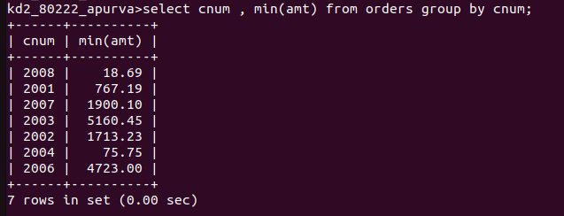

4. write a query that selects the first customer, in alphabetical order, whose name begins with G.


5. write a query that selects the highest rating in esch city.

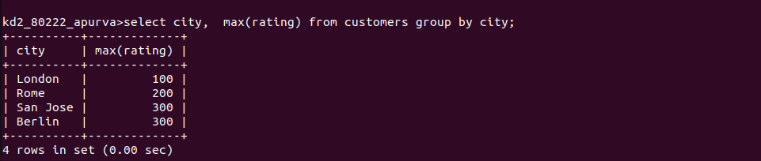

6. write a query that counts the number of salespeople registering orders for each day.(If a sales person has more than one order on a geivenday, he or she should counted only once.)

