Assignment 5

1.Write a query that will give you all the orders for more than rs. 1,000.

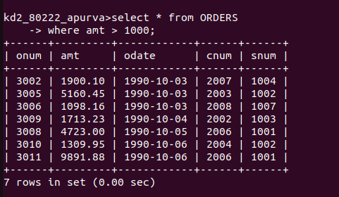

2. Write a query that will give you names and the cities of all salespeople in london with a commission above 0.10.

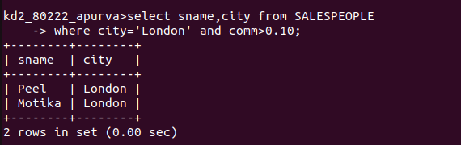

3. Write a query on the customers table whose output will exclude all the customers with rating <= 100, unless they are located in rome.

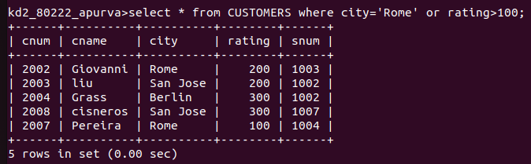

4. What will be the output of the following query?
Select * from Orders
Where (amt < 1000 or
NOT (odate =’1990-10-03’
AND Cname > 2003 ));

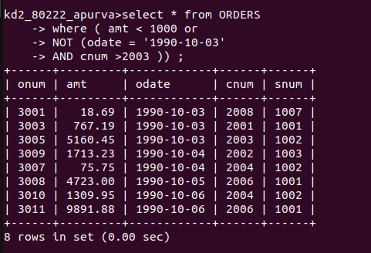

5.What will be the output of the following query?
Select * from Orders
Where NOT (( odate =’1990-10-03’ OR snum
>1006) AND amt>= 1500);

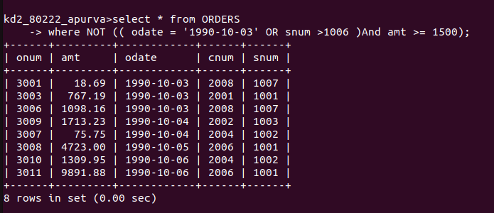

6. What is a simpler way to write this query?
Select snum,sname,city,comm from Salespeople where

( comm > 0.12 OR comm < 0.14 )

