Assignment 11
1. Write a query that uses a subquery to obtain all orders for the customer named cisneros
(Assume that you do not know his customer number cnum)

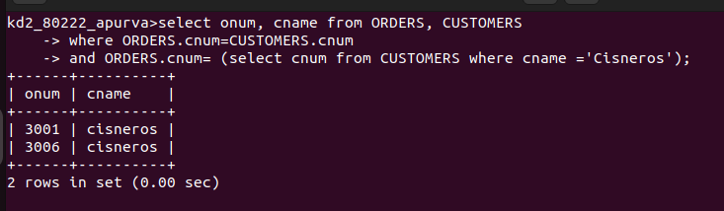

2. Write a query that produces names and ratings of all the customers who have above avarage customers.
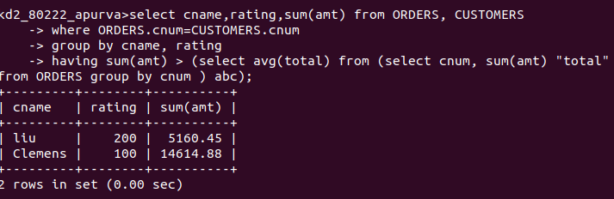

3 Write a query that selects the total amount in orders for each salesperson for whom this total is greater than the amount of the largest order in the table.

