Assignment 6

1. Write two different queries that would produce all orders taken on october 3rd 0r 4th ,1990.

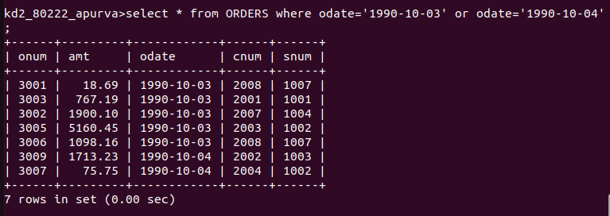

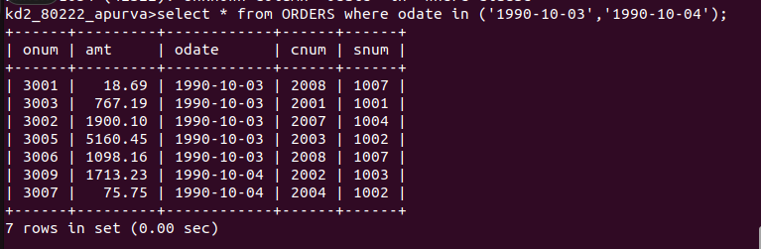

2. Write the query that selects all of the customers serviced by peel or motika.(hint: the sum field relates the two tables to one another).

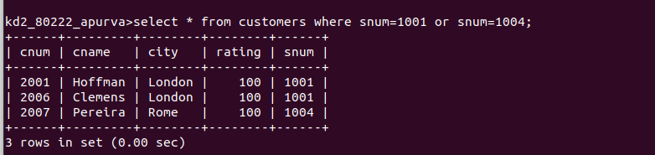

3. Write a query that will produce all the customers whose name begins with a letter from ‘A’ to ‘G’.
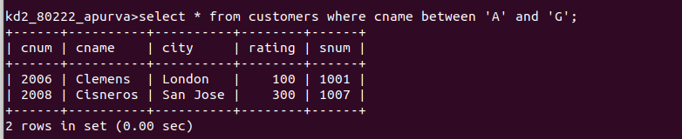

4. Write a query that selects all the customers whose names begin with letter ‘C’.

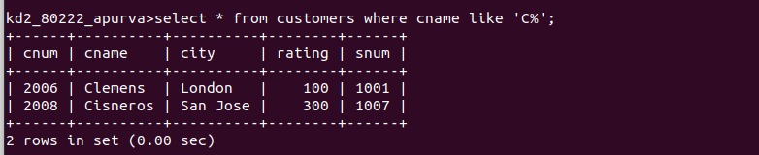

5. Write a query that selects all the orders except those with zeros or null in the amt field.

