1. Introduction to neural network & Deep Learning

* Neural network
* Perceptron
* Backpropagation
* Basic neural network architecture

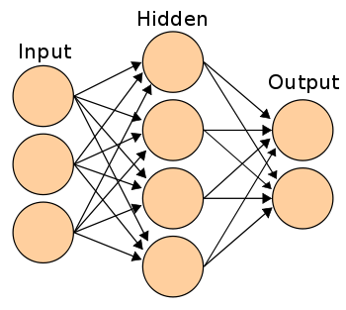

First layer of neural network is input layer. Input layer will have nodes which will have features. Hidden layer can have any number of neurons. As the information goes through all the neurons pre-processing happens in the hidden layer & we get the output.

The above resembles artificial neural network (ANN)

e.g. Distinguish a dog and a cat.

1. How the neural network works?

As discussed earlier the neural network works in a forward manner. As given in the following figure we can understand it better on the basis of weights and activation function.

Suppose we have an input layer of three features x1, x2, x3 which passes through the neuron present in hidden layer, while passing through the hidden layer weight are added (multiplied) for each x1, x2 and x3 respectively and then passed through the neuron.

In this neuron some pre-processing happens.

Y= x1w1+x2w2+x3w3

Z=act(y)