**Deep Learning with Python**

## Part 1 : Fundamentals of Deep Learning

* A machine learning system is trained rather than explicitly programmed. Its presented with many examples relevant to a task, and it finds statistical structure in these examples that eventually allows the system to come up with rules for automating the task.
* Machine learning discovers rules to execute a data-processing task.
* For machine learning we need three things:
* Input data points
* Examples of the expected output
* A way to measure whether the algorithm is doing a good job or not
* Machine learning is , technically searching for useful representations of some input data, within a predefined space of possibilities, using guidance from feedback signal.
* Deep learning is a multistage way to learn data representations.
* 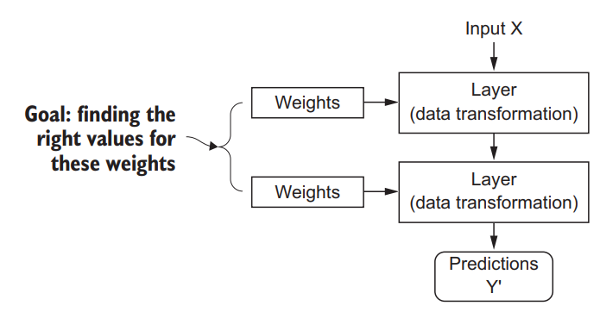
* In deep neural networks input to target mapping is done via a deep sequence of simple data transformations and that these data transformations are learned by exposure to examples.
* The specification of what a layer does to its input data is stored in the layers weight, which is essence are a bunch of numbers. (Transformations implemented by a layer is parameterized by its weights.)
* Finding set of values for the weights of all layers in a network, such that the network will correctly map example inputs to their associated targets.
* The loss function measures the quality of the network output.
* 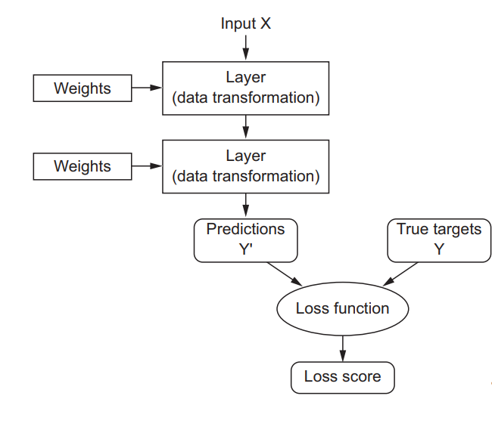
* The fundamental trick in deep learning is to use this score as feedback signal to adjust the values of the weights a little, in a direction that will lower the loss score. This is done by “optimizer”. (main aim is to minimize the loss function)
* Kernel methods are a group of classification algorithms, the best known of which is the support vector machine. It aims at solving classification problems with good decision boundaries between two sets of points belonging to two different categories.
* A kernel function is a computationally tractable operation that maps any two points in your initial space to the distance between these points in your target representation space, completely bypassing the explicit computation of the new representation.