Machine Learning

**22/05/2023**

1. **Support vector machine**

* It is a supervised machine learning algorithm which is used for classification or regression problems. However, it is primarily used for classification.
* The goal here is to find out the best decision boundary also known as hyperplane that can segregate n dimensional space into classes.
* SVM chooses the extreme points/vectors that can help in creating a hyperplane these extreme cases are called as support vectors.

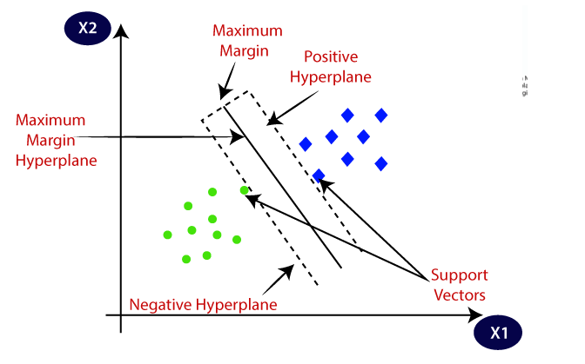

* The dimension of the hyperplane depends on the features present in the dataset.
* We always create a hyperplane that has a maximum margin, which means the maximum distance between the data points.
* Parameters are :

1. C: regularization parameter, the strength of regularization is inversely proportional to C
2. kernel: “linear”, “poly”, “rbf”, “sigmoid”,”precomputed”
3. Degree: 3 (must be non-negative)
4. gamma: “scale”, “auto”

* if gamma='scale' (default) is passed then it uses 1 / (n_features * X.var()) as value of gamma,
* if ‘auto’, uses 1 / n_features
* if float, must be non-negative.

Note: we can calculate coefficients only if we use linear kernel in python code, otherwise it is not possible to calculate the feature importance of the features.