# **Python Problems:**

14/08/2024

## **49. Group Anagrams**

Given an array of strings strs, group **the anagrams** together. You can return the answer in **any order**.

An **Anagram** is a word or phrase formed by rearranging the letters of a different word or phrase, typically using all the original letters exactly once.

**Example 1:**

**Input:** strs = ["eat","tea","tan","ate","nat","bat"]

**Output:** [["bat"],["nat","tan"],["ate","eat","tea"]]

Answer:

* Take an empty dictionary
* Loop through the given array
* Sort every word in the array while looping and check if the sorted word is in the dictionary
* If not add it to the dictionary taking sorted word as the key and the word as the value, if yes append the word to value of sorted word
* Loop through the dictionary and paint all the values in the dictionary

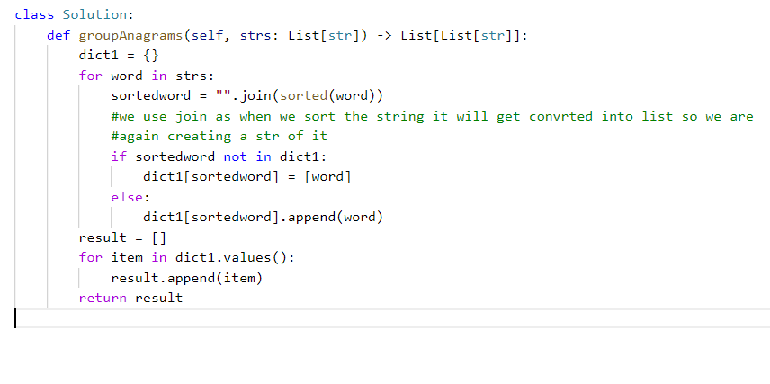

**class Solution:**

**def groupAnagrams(self, strs: List[str]) -> List[List[str]]:**

**dict1 = {}**

**for word in strs:**

**sortedword = "".join(sorted(word))**

**#we use join as when we sort the string it will get convrted into list so we are**

**#again creating a str of it**

**if sortedword not in dict1:**

**dict1[sortedword] = [word]**

**else:**

**dict1[sortedword].append(word)**

**result = []**

**for item in dict1.values():**

**result.append(item)**

**return result**