**Tic Tac Toe Game**

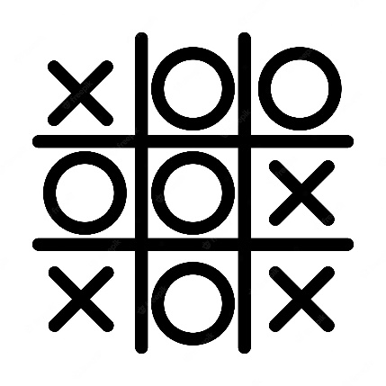

############### tic tac toe game ################

def sum(a, b, c ):

    return a + b + c

#we will create few methods

def printBoard(xState, zState):

    zero = 'X' if xState[0] else ('O' if zState[0] else 0)

    one = 'X' if xState[1] else ('O' if zState[1] else 1)

    two = 'X' if xState[2] else ('O' if zState[2] else 2)

    three = 'X' if xState[3] else ('O' if zState[3] else 3)

    four = 'X' if xState[4] else ('O' if zState[4] else 4)

    five = 'X' if xState[5] else ('O' if zState[5] else 5)

    six = 'X' if xState[6] else ('O' if zState[6] else 6)

    seven = 'X' if xState[7] else ('O' if zState[7] else 7)

    eight = 'X' if xState[8] else ('O' if zState[8] else 8)

    print(f"{zero} | {one} | {two} ")

    print(f"--|---|---")

    print(f"{three} | {four} | {five} ")

    print(f"--|---|---")

    print(f"{six} | {seven} | {eight} ")

def checkWin(xState, zState):

    wins = [[0, 1, 2], [3, 4, 5], [6, 7, 8], [0, 3, 6], [1, 4, 7], [2, 5, 8], [0, 4, 8], [2, 4, 6]]

#above are possible places from where X or O can win the game

    for win in wins:

        if(sum(xState[win[0]], xState[win[1]], xState[win[2]]) == 3):

            print("X Won the match")

            return 1

        if(sum(zState[win[0]], zState[win[1]], zState[win[2]]) == 3):

            print("O Won the match")

            return 0

    return -1

if __name__ == "__main__":

    xState = [0, 0, 0, 0, 0, 0, 0, 0, 0]

    zState = [0, 0, 0, 0, 0, 0, 0, 0, 0]

    turn = 1 # 1 for X and 0 for O

    print("Welcome to Tic Tac Toe")

    while(True):

        printBoard(xState, zState)

        if(turn == 1):

            print("X's Chance")

            value = int(input("Please enter a value: "))

            xState[value] = 1

        else:

            print("O's Chance")

            value = int(input("Please enter a value: "))

            zState[value] = 1

        cwin = checkWin(xState, zState)

        if(cwin != -1):

            print("Match over")

            break

        turn = 1 - turn