Assignment- II

Working and Implementation of Infrastructure as a service Launch EC2 Instance (Linux)- AWS Platform. Prepare Screenshots file Write down the steps to launch the EC2 instance(Linux). Make a single word or PDF file

Step 1: Log in to AWS Management Console and Navigate to EC2 Dashboard

1. Log in to the AWS Management Console at https://aws.amazon.com/.

2. In the search bar at the top, type EC2 and select it from the dropdown.

3. This will take you to the EC2 Dashboard.

Step 2: Launch Instance

1. On the EC2 Dashboard, click on Launch instance.

2. Under the "Name and tags" section, enter a name for your instance (optional), for example: MyLinuxInstance.

Step 3: Choose an Amazon Machine Image (AMI)

1. In the "Application and OS Images (Amazon Machine Image)" section, choose the Amazon Linux AMI , SSD Volume Type.

Step 4: Choose an Instance Type

1. Select an instance type like t2.micro(free tier eligible).

2. Click Next: Configure Instance Details.

Step 5: Configure Instance Details

1. You can leave the default settings or adjust them as needed.

2. Click Next: Add Storage.

Step 6: Add Key Pair

1. When prompted to create or select a key pair, choose Create a new key pair.

2. Name your key pair Kanha(or another name if preferred) and Download the private key file (.pem).

3. Store this file securely on your computer as you’ll need it to connect via SSH.

Step 7: Add Storage

1. The default 8 GB storage is sufficient for basic use. Adjust the size if necessary.

2. Click Next: Add Tags.

Step 8: Add Tags (Optional)

1. Optionally, add tags to easily identify your instance. For example:

- Key: `Name`, Value: `MyLinuxInstance`.

2. Click Next: Configure Security Group.

Step 9: Configure Security Group

1. Create a new security group or choose an existing one.

2. Ensure SSH access is enabled by allowing inbound traffic on port 22.

3. Click Review and Launch.

Step 10: Review and Launch

1. Review your instance details.

2. Click Launch and confirm by clicking Launch Instances.

Step 11: View Instance

1. Click View Instances to see the status of your instance.

2. Wait for the instance's status to change to Running.

Step 12: Convert PEM File to PPK Using PuTTYgen

1.Open PuTTYgen.

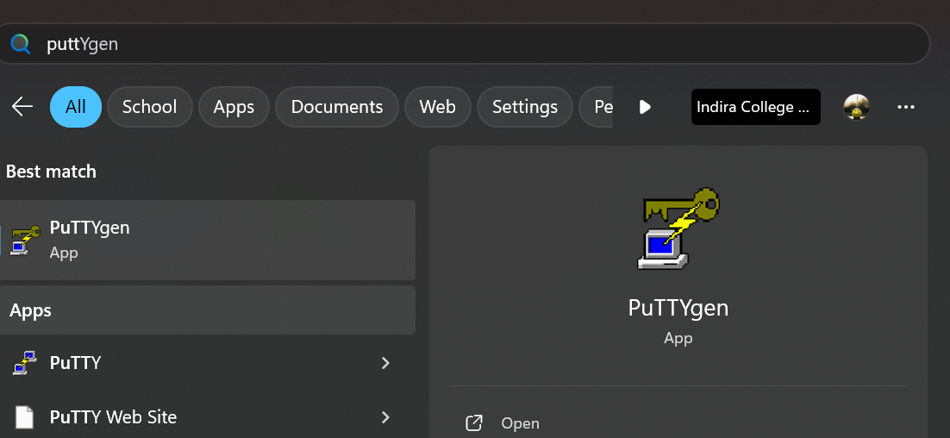

2.Click on Load and navigate to the downloaded `.pem` file (e.g., `Kanha.pem`).

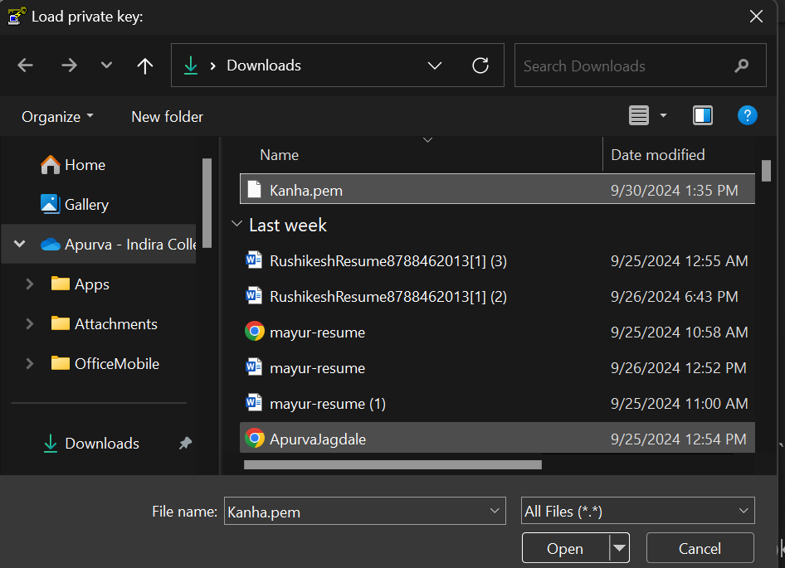

3. Click Save private key to save it as a `.ppk` file (e.g., `Kanha.ppk`).

Step 13: Connect to Your EC2 Instance Using PuTTY

1.Open PuTTY.

2. In the "Host Name" field, enter your EC2 instance’s Public DNS (IPv4), which can be found on the EC2 dashboard under Instances.

1. On the left side of PuTTY, go to Connection > SSH > Auth and browse to select the .ppk file you generated earlier.

1. Click Open to initiate the connection.

Step 14: SSH into the EC2 Instance

1. Upon connection, a command line window will open, prompting you for a username. Enter `ec2-user` to log in.

2. You are now connected to your EC2 instance.

