*Apurva Mithal*

*axm174531*

**READ ME**

* System Requirements:
  + Operating System – Windows 10
* JAVA Version: 1.7.0_80
* Software: Eclipse

**NOTE:**

* Implemented **optional bonus features**
  + Delete from table
  + Creating Index

**HOW TO RUN**

* Download the zip from eLearning and extract the files in your local drive. (say D:\DB_PAS2 \)
* Open the command prompt.
* Change the directory to the path where java files are extracted –( D:\DB_PAS2 \)
* Main file is DavisBasePrompt.java

***Compile and Run:***

* Compile the code by the following command ->
  + *javac DavisBasePrompt.java*
* Run the file by command ->
  + *java DavisBasePrompt*
* 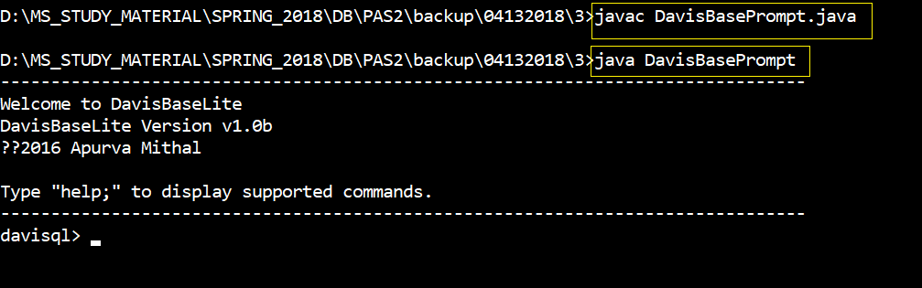

**GET STARTED:**

***CREATE TABLE:***

***Syntax***

*CREATE TABLE <table_name> (rowid int primary key, <column2 datatype2 not null>,....<columnk datatypek>*

***Example***

create table department (rowid int primary key, Dnumber text not null, Dname text);



**INSERT INTO**

***Syntax***

INSERT INTO <table_name> (column_list) VALUES (value1,value2,value3, ...);

INSERT INTO <table_name> VALUES (value1,value2,value3, ...);

***Example***

insert into department (rowid, Dnumber, Dname) values (1, CS01, ComputerScience);

insert into department values (1, CS01, ComputerScience);

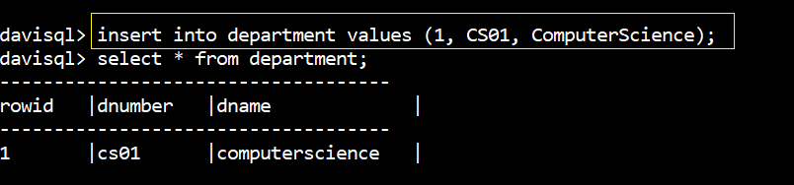

**Unique Constraint**:



**Null Value Constraint**

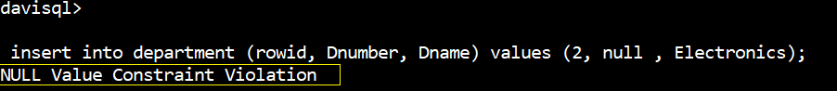

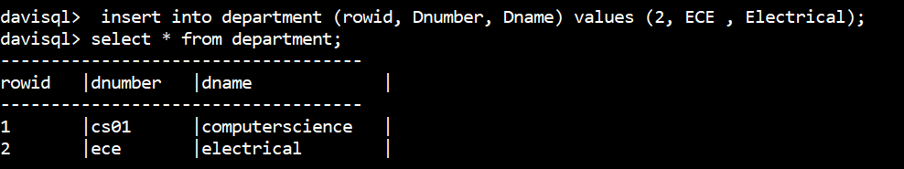

**UPDATE TABLE**

***Syntax***

*UPDATE <table_name> SET <column_name> = <value> [WHERE <condition>]*

***Example***

update department set Dname = Electronics where rowid = 2;

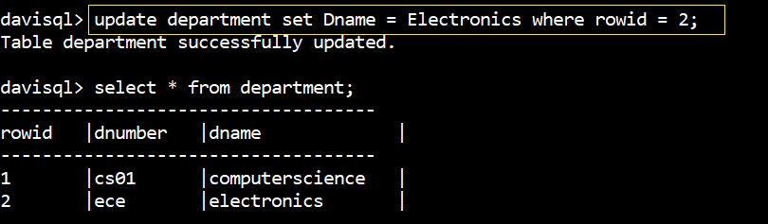

**SELECT**

***Syntax***

SELECT <column_list> FROM <table_name> ;

***Example***

select * from department;

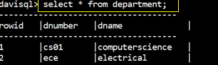

**SELECT <Where>**

***Syntax***

SELECT <column_list> FROM <table_name> [WHERE <condition>];

***Example***

select * from department where rowid = 1;

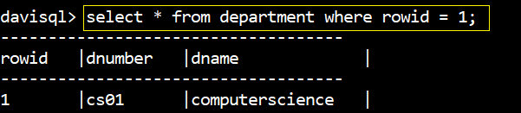

**DELETE (BONUS FEATURE)**

***Syntax***

DELETE FROM <table_name> where <condition>;

***Example***

delete * from department where rowid = 2;

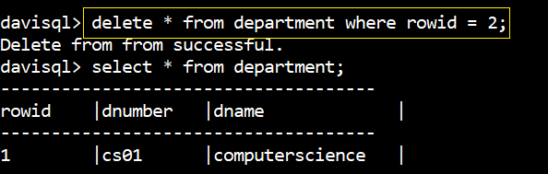

**QUERYING FRON METADATA TABLES**

* **DAVISBASE_TABLES**

**SHOW TABLES;**

***Syntax***

SHOW TABLES;

***Example***

show tables;

select table_name from davisbase_tables;

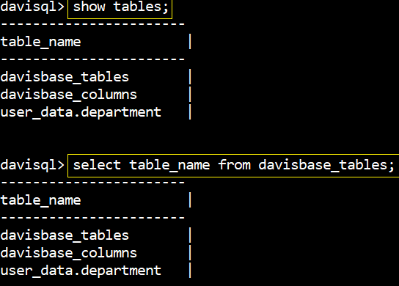

* **DAVISBASE_COLUMNS**

***Example***

select * from davisbase_columns;

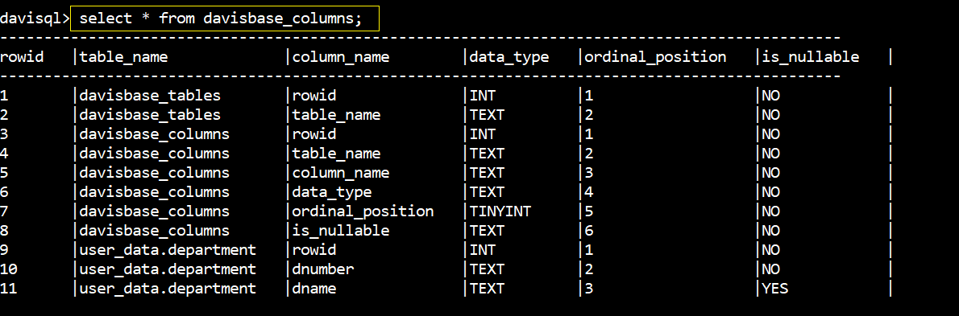

**DROP TABLE**

***Syntax***

DROP TABLE <table_name>;

***Example***

drop table department;

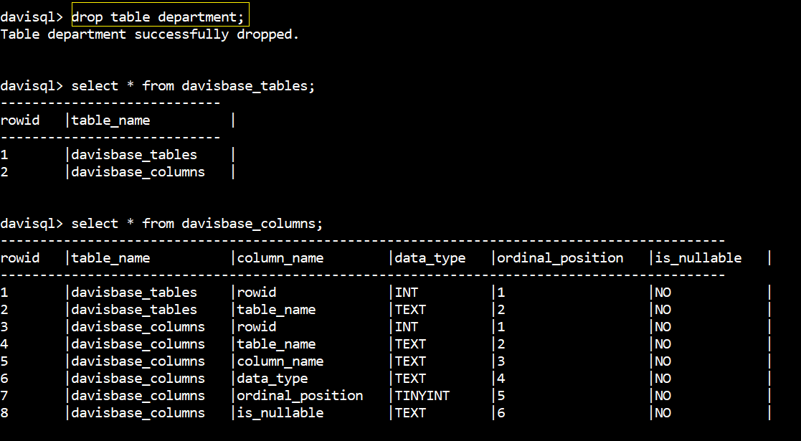

***BONUS FEATURES:***

**DELETE (BONUS FEATURE)**

***Syntax***

DELETE FROM <table_name> where <condition>;

***Example***

delete * from department where rowid = 2;



**INDEXING (BONUS FEATURE)**

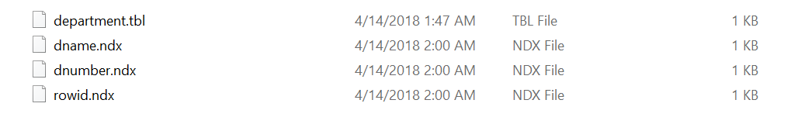

***Directory Structure formed***

