a

Project based learning

ON

“Emptrack: Employee Database management system”
FOR PARTIAL FULFILLMENT
OF THE REQUIREMENTS FOR THE
DATABASE MANAGEMENT
oF T.E. E&TC – 2019 Course, SPPU, Pune

By
Apurwa Kanitkar 32305
Kunal Singh 32240

GUIDE
Prof. L.P. Patil

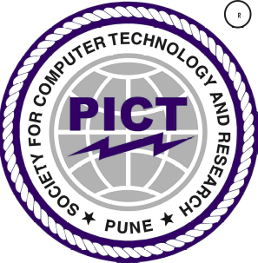

Department Of
Electronics and TELECommunication ENGINEERING
PUNE INSTITUTE OF COMPUTER TECHNOLOGY
PUNE – 43

ACADEMIC YEAR: 2024 - 2025

Department of Electronics and Telecommunication Engineering
Pune Institute of Computer Technology, Pune – 43

CERTIFICATE

This is to certify that the Database Management Project Report entitled
“EmpTrack: Employee Database Management System”
has been successfully completed by

Apurwa Kanitkar 32305
Kunal Singh 32240

Is a bona fide work carried out by them under the supervision of Prof. L.P. Patil and it is approved for the partial fulfillment of the requirements for the Database Management Lab of T.E. E&TC – 2019 Course of the Savitribai Phule Pune University, Pune.

Prof. L.P. Patil
Project Guide

Place: Pune
Date :

ACKNOWLEDGEMENT

We extend our heartfelt gratitude to the SPPU for giving us this opportunity to explore beyond the theoretical ambit of our curriculum.

We would like to thank the director of PICT, Dr. P. T. Kulkarni, the principal Dr. S.T. Gandhe Head of Electronics and Telecommunication department Dr. Mousami Munot, for providing us with lab facilities and premises for successful completion of my project work and our mentor, Prof. L.P. Patil for his constant advice and guidance.

Last but not the least, our sincere thanks to all the faculty members, classmates and our friends who helped us and inspired us to complete the project.

Apurwa Kanitkar: 32305
Kunal Singh: 32240

