# Overview

We are looking for an application that displays a dialog with several options for user actions.

Each action will launch a different file that will be distributed with the application – such as:

* Installation executable
* User guide in pdf format
* Tutorial video in wmv / mov / mp4 format
* Website link
* Etc.

# Assumptions

1. The application must run on PCs running the following operating systems: Windows XP, Windows 7, Windows 8
2. The application must run on PCs that **do not** have .NET framework or MFC installed
3. All external applications required to use the content (i.e. Acrobat Reader for manuals, Windows Media Player for videos) are pre-installed on the PC
4. All graphics will be provided by the customer. **Contractor must raise graphics requirements as part of the proposal submittal**

# Required Solution Description

The application will be a C++ MFC or Win API dialog-based client. The background of the dialog will be an image provided by us (contractor must raise graphics requirements as part of the proposal submittal).

The dialog will be composed of two header lines, each configured separately (see sample below) as well as the following:

1. Button controls with text next to them (i.e. 'Review Release Notes', 'Watch Installation Video', 'Run installation' etc.) and icon on button
2. Red **X** at the menu bar for closing the application

The application will be configured via XML file which will hold:

* Header text + font + font size + font weight (regular / bold / italic)
* Second line header text + font + font size + font weight (regular / bold / italic)
* Background image path (relative to application executable)
* Buttons’ icon file path (relative to application executable)
* Minimum window size (width / height in pixels)
* Whether to resize the window or add scroll bars when the number of items calls for the window to be larger than the minimum size specified above
* List of items – for each one:
  + Meaningful text (i.e. 'Review Release Notes')
  + File to launch with path relative to the installer executable (i.e. '\Docs\ReleaseNotesV1.2.3.pdf')
  + Flag indicating whether to close the application after launching the file (i.e. we will want to keep the application open when opening the release notes, but close it when running the installer)

The application will automatically load all items and will let the user select the desired option.

Invalid items (items for which the launch file exists on the media relative to the installation executable) – button control will be disabled (greyed-out).

If the XML file is not present / empty / does not contain any valid options, the application will display a meaningful error message and will not launch.

The dialog will be of fixed-size (no resize button). Its size is to be determined by the number of items and length of the text lines, at runtime. The background image must stretch (if required) to fit the dialog.

The application must be generic so as to launch the files to run automatically instead of searching for their matching application manually.

The application will remain open until one of the following occurs:

1. The application is closed via the red **X**, or
2. The user selects an option for which the flag indicates to terminate upon launch

The application must be distributed as a standalone executable without additional dlls required.

The application will be developed using Microsoft Visual Studio 2010.

# Application Prototype Sample

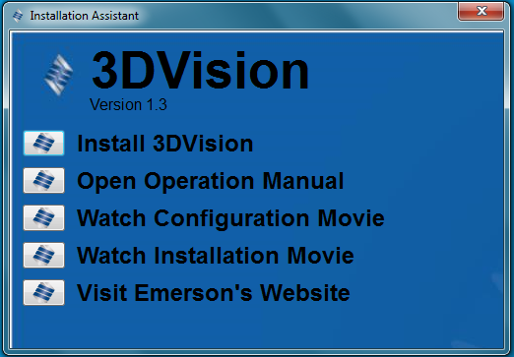

In the sample below, all items marked in a red circle will be configurable via XML:



# Configuration XML

The application receives its inputs and definitions from an XML file which is distributed along with it.

The XML file will have a format resembling the below:

