LNUK-IRLl02125070
PROVISIONING OF CCTV, IIS, ACS AND FTTH SYSTEM SOLUTION
FOR
CANAL SIDE MANCHESTER

PRELIMINARY TECHNICAL PROPOSAL

Prepared for:

Prepared by:
LEAP NETWORKS Global Ltd.


CONFIDENTIALITY NOTICE: The ideas, data, and information contained in this proposal are the proprietary information of Leap Networks Global Ltd. The recipient of this proposal agrees to treat it as confidential and shall NOT disclose any part of it to third parties without the appropriate authorisation.
Document Status: Preliminary – For Review
Confidential.© Leap Networks ® All rights reserved.

Table of Contents

1. INTRODUCTION: 4
2. Summary 4
3. OBJECTIVE 4
a) Executive (clean and client-friendly) 4
b) KPI-rich (with targets) 4
c) Concise one-liner (outcomes-focused) 5
4. LNG Proposed Solutions: 5
5. SOLUTION OVERVIEW 5
6. Engineering DOCUMENTATIONS: 6
7. ARCHITECTURE & TOPOLOGY: 7
7.1 High-level topology showing subsystems, 7
7.2 Network Core Segmentation: 7
8. SYSTEMS SPECIFICATIONS: 9
8.1 Access Control System (ACS) 9
8.2 CCTV System 10
8.3 Integrated Intercom System 11
8.4 FTTH - Fibre to The Home: 11
9. INTEGRATION POINTS BETWEEN SUBSYSTEMS: 12
9.1 Integration Narrative 12
10. Standards & Compliance 13
11. Network, Power & Cabling Design 13
12. Scalability & High Availability 14
13. Implementation Methodology 14
14. ANNEXE A (Bill of Materials) 16
14.1 Assumptions 19
14.2 DATA SHEETS & SPECIFICATIONS (Annexe A) 19
15. Quality, HSE and Information Security 19
16. Programme & Deliverables 19
17. Acceptance & Handover 19
18. Confidentiality 19
19. Next Steps 19
20. ANNEXE B (REFERENCE DRAWINGS) 20
20.1 Ground floor CCTV System: 21
20.2 First Floor CCTV System: 21
20.3 Second Floor CCTV System: 22
20.4 Third Floor CCTV System: 22
20.5 Fourth Floor CCTV System: 23
20.6 Fifth Floor CCTV System: 23
20.7 Ground Floor ACS & IIS Systems: 24
20.8 First Floor ACS & IIS Systems: 24
20.9 Second Floor ACS & IIS Systems: 25
20.10 Third Floor ACS & IIS Systems: 25
20.11 Fourth Floor ACS & IIS Systems: 26
20.12 Fifth Floor ACS & IIS Systems: 26
21. lNG CERTIFICATES 27

Covering letter

Executive summary:

company overview & credentials:

Organisational Overview:
Leap Networks Global Ltd (LNG) is a well-established IT, telecom systems engineering and integration company based in the United Kingdom, with a presence in Saudi Arabia, Abu Dhabi, and Indonesia.
Our expertise in a nutshell:
- Design, integrate, and maintain mission-critical telecoms & security systems (PAGA, CCTV, access control, TETRA/radio, LAN/WAN, Wi-Fi, UPS, structured cabling).
- End-to-end delivery in operationally demanding environments, from studies and FEED through installation, testing, and lifecycle support.
- ISO-certified (9001, 14001, 45001, 27001) with a global project footprint across refineries, gas plants, mining and offshore platforms.
- Pioneers in AI-powered Smart Safety solutions, Real-Time tracking systems, advanced Road Safety and Traffic Management technologies, delivering industry-first innovations to enhance workplace safety.

This proposal presents LNG’s integrated solution for the Canal Side Manchester scheme, comprising Access Control, Integrated Intercom, CCTV and Fibre-to-the-Home (FTTH), with full LAN design, configuration and commissioning. Scope covers main entrances, communal areas, emergency exits, and 138+ apartments (G+5), with design, installation and testing performed by LNG.

Relevant Experience:
lfebldsjbgljsbgljbdsljg

Certifications & Accreditations:
- Achilles
- Ecovadis
- ISO
- GDPR

Key Personnel & Capabilities:

Understanding of requirements:
Customer scope of work.

Proposed technical solution:

Solution Overview:

System Architecture:

Technical Design & Component:

Integration & Interoperability:

Security & Compliance Alignments:

Innovation & Future Scalability:

Engineering Documents:

Bill of Materials (BOM):

delivery and implementation approach:

Prince2 / agile / scrum/ hybrid/ waterfall

Delivery Methodology:

Project Phasing:

Project governance & Reporting:

Implementation Timeline:

Risk Management & Mitigation:

service management & Support model:

Support Structure:

Service Level:

Escalation Process:

Data Protection, Security & Compliance:

Assumptions, Constraints & Dependencies:

Appendix 1:
(Data Sheet)

Summary
LNG proposes a centrally managed, standards-compliant platform that unifies Access Control, Intercom, CCTV and redundant FTTH over a resilient, segmented IP network. Delivery targets include ≥99.95% availability for core security and access, ≥30% faster incident response through event-driven workflows, and 30-day evidential retention on the video platform. The solution is scalable, maintainable and designed to meet British and international standards. The design supports 138 apartments (G+5) plus all communal and egress areas.

OBJECTIVE
Design and deliver an integrated, standards-aligned security and connectivity estate for Canal Side Manchester, uniting Access Control, CCTV, Integrated Intercom and FTTH on a centrally orchestrated, segmented IP core. The platform will be secure-by-design (VLAN isolation, role-based access, audited change control), highly available, and operationally efficient, providing unified monitoring, event correlation and evidential retention across apartments, communal areas, main entrances and emergency egress routes.
- Executive (clean and client-friendly)
Implement a secure, scalable and centrally managed platform that brings together Access Control, CCTV, Intercom system and FTTH across the Canal Side residence to enhance safety, assure compliance and streamline day-to-day operations, all visible through a single pane of glass.
- KPI-rich (with targets)
Deliver a secure, standards-compliant, centrally managed solution unifying Access Control, CCTV, Intercom and redundant FTTH, achieving:
- ≥99.95% availability for core security.
- ≥30% faster incident response via event-driven workflows and cross-system automation,
- 30-day minimum evidential retention on video, aligned to GDPR, and
- ≥99.9% FTTH service uptime to each dwelling—
Within a 10 to 12-week programme, with zero P1 defects at handover.
- Concise one-liner (outcomes-focused)
Deploy a unified physical security and fibre connectivity platform delivering ≥99.95% availability, ≥30% faster incident response, GDPR-compliant 30-day retention and ≥99.9% FTTH uptime within 12 weeks, with zero P1 defects at handover.

LNG Proposed Solutions:
The proposal has been developed based on the site layout drawings and information provided by MERIDIAM Construction, ensuring a tailored solution that aligns with the project's specific requirements and objectives.
The proposed solution is based on limited information provided to LNG and may therefore require updates or revisions to reflect the actual site conditions and final project requirements.
- CCTV System
- Access Control System
- Integrated Intercom System
- FTTH (Fibre to the home) (with redundancy)

SOLUTION OVERVIEW
The proposed architecture consolidates four subsystems on a resilient IP network core with segregated security and operations VLANs. Subsystems integrate via open standards (ONVIF, SIP, REST), enabling event-driven automations and centralised monitoring. A tiered design (edge - aggregation - core) ensures deterministic performance and simplified operations.
Subsystems
- Access Control System (ACS) – centralised identity, door controllers, readers, credentials and I/O to manage apartment and communal access, including emergency egress integration.
- CCTV – fixed and panoramic IP cameras with central recording (ENVR), analytics and secure retention.
- Integrated Intercom – SIP-based door stations integrated with ACS with built-in camera for voice and video verification and remote release to reception and apartments.
- FTTH – point-to-point OS2 redundant fibre to each apartment via MDF/ODF with single-fibre connectivity on the ground floor for ISP handoff.
A tiered LAN (edge → aggregation → core) underpins all subsystems, with VLAN segmentation (security, operations, management) and open integration (ONVIF, SIP, REST) for event correlation and automation under a central Operations & Security management plane. Compute and storage are consolidated at the core for simplified operations and lifecycle management.

Engineering DOCUMENTATIONS:
LNG will produce the following complete engineering and project documentation set, including:
Document Type | Document/ Drawing  Numbers | Document Title
PROJECT GENERAL DOCUMENT
Engineering Document | LN-P02484-OSA-001 | Overall Systems Architecture Diagram
Project Document | LN-P02484-FDS-001 | Functional Design Specification
Project Document | LN-P02484-PWC-001 | Power Consumption
Project Document | LN-P02484-PEP-001 | Project Execution Plan (PEP)
Project Document | LN-P02484-PIS-001 | Project Installation Schedule
Project Document | LN-P02484-PIP-001 | Project Installation Plan
Project Document | LN-P02484-PHP-001 | Project Handover Plan
CCTV SYSTEM ENGINEERING DOCUMENTS
Engineering Document | LN-P02125070-CCTV-BD-0001 | Overall Architecture Block Diagram
Engineering Document | LN-P02125070-CCTV-WTD-0002 | Wiring and Termination Details
Engineering Document | LN-P02125070-CCTV-DMD-0003 | Dimensional and Mounting Details
Engineering Document | LN-P02125070-CCTV-GA-0004 | General Arrangement Details for Cabinets
Engineering Document | LN-P02125070-CCTV-BOM-0005 | Bill of Materials
Engineering Document | LN-P02125070-CCTV-EDS-0006 | Equipment Data Sheet
INTEGRATED INTERCOM SYSTEM ENGINEERING DOCUMENTS
Engineering Document | LN-P02125070-IIS-BD-0001 | Overall Architecture Block Diagram
Engineering Document | LN-P02125070-IIS-WTD-0002 | Wiring and Termination Details
Engineering Document | LN-P02125070-IIS-DMD-0003 | Dimensional and Mounting Details
Engineering Document | LN-P02125070-IIS-BOM-0004 | Bill of Materials
Engineering Document | LN-P02125070-IIS-EDS-0005 | Equipment Data Sheet
ACCESS CONTROL SYSTEM ENGINEERING DOCUMENT
Engineering Document | LN-P02125070-ACS-BD-0001 | Overall Architecture Block Diagram
Engineering Document | LN-P02125070-ACS-WTD-0002 | Wiring and Termination Details
Engineering Document | LN-P02125070-ACS-DMD-0003 | Dimensional and Mounting Details
Engineering Document | LN-P02125070-ACS-BOM-0004 | Bill of Materials
Engineering Document | LN-P02125070-ACS-EDS-0005 | Equipment Data Sheet
FTTH - FIBER TO THE HOME SYSTEM ENGINEERING DOCUMENTS
Engineering Document | LN-P02125070-FTTH-BD-0001 | Overall Architecture Block Diagram
Engineering Document | LN-P02125070-FTTH-WTD-0002 | Wiring and Termination Details
Engineering Document | LN-P02125070-FTTH-DMD-0003 | Dimensional and Mounting Details
Engineering Document | LN-P02125070-FTTH-BOM-0004 | Bill of Materials
Engineering Document | LN-P02125070-FTTH-EDS-0005 | Equipment Data Sheet
LAN SYSTEM ENGINEERING DOCUMENTS
Engineering Document | LN-P02125070-LAN-BD-0001 | Overall Architecture Block Diagram
Engineering Document | LN-P02125070-LAN-WTD-0002 | Wiring and Termination Details
PROJECT TESTING, COMMISSIONING & MAINTENANCE DOCUMENT
Engineering Document | LN-P02848-ISAT-001 | Acceptance Test
Project Document | LN-P02484-ONM-001 | Operation and Maintenance Manual
Project Document | LN-P02484-MAINT-001 | Maintenance Plan and Checklist

ARCHITECTURE & TOPOLOGY:

High-level topology showing subsystems,
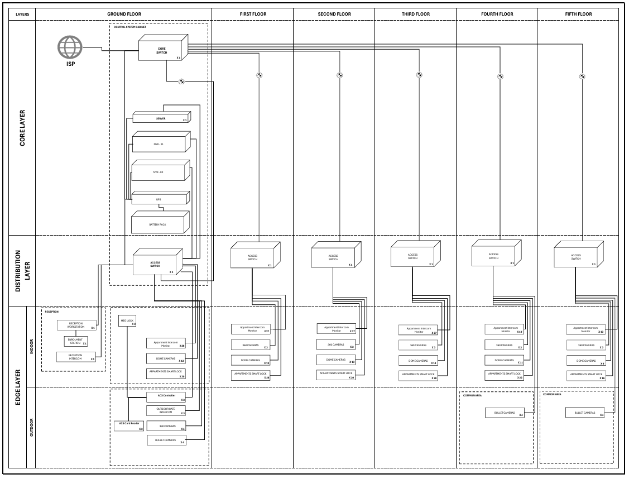
A high-level block diagram (issued as a separate sheet) depicts ACS, CCTV, Intercom, and FTTH interconnected over the segmented LAN with central management, compute and storage at the core.

Figure 1 - System Architecture Block Diagram

Network Core Segmentation:
- Core Switching
A core switching fabric will be deployed using enterprise 24/48-port aggregation switches located in the ground-floor main telecommunications room and per-floor 6U cabinets. This fabric forms the central aggregation hub for all mission-critical subsystems and provides deterministic, high-throughput connectivity across the estate. Interswitch connectivity will utilise P2P fibre optical uplinks for longer runs, ensuring fault-tolerant performance, fast convergence and a clear upgrade path to higher-speed optics as demand grows. Fabric operations (VLAN segmentation, QoS and telemetry) are centrally orchestrated to maintain predictable latency, assured bandwidth and operational transparency for all connected services.
- Floor Distribution — Fast, Clean, and Scalable
Each floor will house a dedicated telecommunications cabinet with a 24- or 48-port PoE/PoE+ access switch (per the final BoM). This access layer powers and connects all edge endpoints, CCTV cameras, card readers, access hubs, intercom viewers and door stations, and applies port-level policies and segmentation. Uplinks from each floor switch to the ground-floor aggregation tier will be a 10/25 Gbps fibre (i.e., no link aggregation and no secondary path). Consequently, service availability on each floor is contingent on the integrity of this single fibre and its associated optics/patching; fault detection and diagnosis will be monitored using central software monitoring, additionally on local switch indicators and on-site inspection.
Fibre interfaces will use LC single-mode transceivers and conform to ISO/IEC 11801 and TIA-568.
The structured cabling will be delivered with clear labelling and managed patching to aid rapid, manual fault isolation.
VLAN-based logical segmentation is maintained per subsystem (ACS, CCTV, Intercom, operations/management) to ensure traffic isolation, security hardening and predictable QoS within the constraints of the single-path design.

Note: UPS backup power connectivity to the distribution network is not proposed and will be provided upon request.
- BACKBONE Uplinks to Aggregation/Distribution (10G/25G)
Each access switch will be uplinked via a single OS2 single-mode fibre link operating at 10 Gbps or 25 Gbps to the distribution/core layer. This design provides a deterministic, high-capacity path for video, voice and WLAN traffic, ensuring stable throughput across all subsystems. All fibre cabling is installed in accordance with ISO/IEC 11801 and TIA-568 standards, with LC terminations, labelled trays, and managed patching practices adopted to support lifecycle clarity and maintainability. Change control procedures and as-built documentation will be provided to guarantee traceability and compliance throughout the project.
- FTTH Fibre to the Home (Redundancy)
A home-run (point-to-point) FTTH architecture will be deployed, providing a redundant and dedicated fibre connection from the ground-floor MDF/ODF cabinet (externally accessible for service providers) to every apartment within the development. Each apartment will terminate on an SC/APC dual-port fibre wall outlet, enabling the tenant to directly connect their ISP-supplied ONT/router via a simplex patch cord. The ground-floor MDF/ODF will host the fibre patch panels, allowing Internet Service Providers to establish service by directly patching into the allocated apartment fibres. This design ensures carrier neutrality, service flexibility, and a future-proofed optical backbone capable of supporting current and next-generation broadband standards.

- Compute & Storage
Centralised compute and management functions will be provided through integrated appliances that act as both secure gateways and controller platforms, capable of running the required network, video, and access management applications natively.

The design allows for future scalability: should additional surveillance or access control capacity be required, the core platforms can host these applications directly, thereby avoiding the need for separate servers or external recording units. Built-in storage bays with support for RAID configurations are available to provide resilience and data protection where required.

Configuration management, firmware updates, topology mapping, and device monitoring are all orchestrated via a unified operating environment, delivering a single control plane across the entire network and security ecosystem. Standard features include retention policy enforcement, role-based access controls, and comprehensive audit logging, ensuring operational efficiency, compliance, and security.

Note: UPS to floor cabinets is by request; core systems include UPS autonomy per Section Annexe A.

SYSTEMS SPECIFICATIONS:

Access Control System (ACS)
The Access Control System will deliver secure, centrally managed access for all apartments, communal areas, main entrances and emergency exits.
- Controllers: Intelligent door controllers managing up to four access points, supporting secure communications and local failover.
- Readers: Modern NFC-enabled access readers with visual indicators, supporting encrypted smart credentials.
- Credentials: Secure RFID key fobs/cards, designed for durability and short-range encrypted authentication.
- Door Hardware: Fail-secure electric strike locks, door position sensors, push-to-exit switches and emergency break-glass units as required.
- Software Functions: Central platform supporting user roles, access schedules, real-time event monitoring, reporting, and audit trails.
- Integration: Fully integrated with the intercom system, allowing remote unlocking following live video verification.
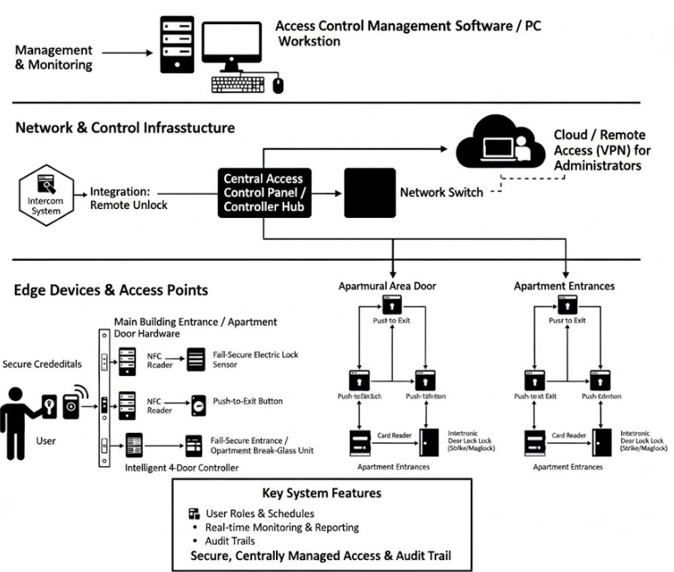

Design notes: Door allocation per controller is based on the current scope. Fire escape integration, I/O mapping and PSU sizing will follow fire zoning requirements. Emergency release devices are included in line with building compliance.

CCTV System
The CCTV system provides continuous surveillance, deterrence and evidential recording across the development.
- Camera Types:
  - Panoramic 360° cameras for wide-area coverage.
  - Dome cameras for indoor and outdoor communal areas, vandal-resistant and low-profile.
  - Bullet cameras for perimeter monitoring and extended field-of-view requirements.
- Video Management: Centralised video management platform (ENVR) with real-time monitoring, playback, search and role-based access.
- Recording Infrastructure: Enterprise-grade recording units with scalable storage capacity, designed for ≥30-day evidential retention.
- Analytics: Built-in video analytics to detect motion, objects and events, enabling faster incident response.
- Compliance: Cameras conform to BS EN 62676 and ONVIF standards, ensuring interoperability and evidence admissibility.

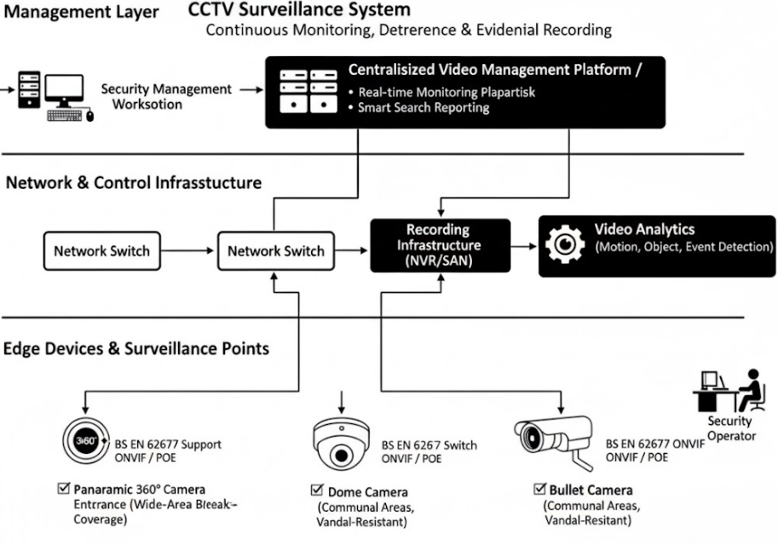

Integrated Intercom System
- Door Stations: Intercom devices will be installed at key building entry points, outdoor stations equipped with high-resolution video, two-way audio and remote door release functions, and SIP compatibility. Each unit includes PoE support and is supplied with flush-mount and sun-shield accessories (IP-rated steel housing).
- Indoor Monitors: Apartment video monitors allowing residents to video preview and release access requests.
- Control Desk: A master station at the security/concierge desk, acting as the master intercom station for call handling, monitoring and managing visitors.
- Call Flows: Visitor presses call on Intercom → routed to security desk station and/or tenant display (Viewer). The operator can view the live feed and unlock the door via integrated ACS.
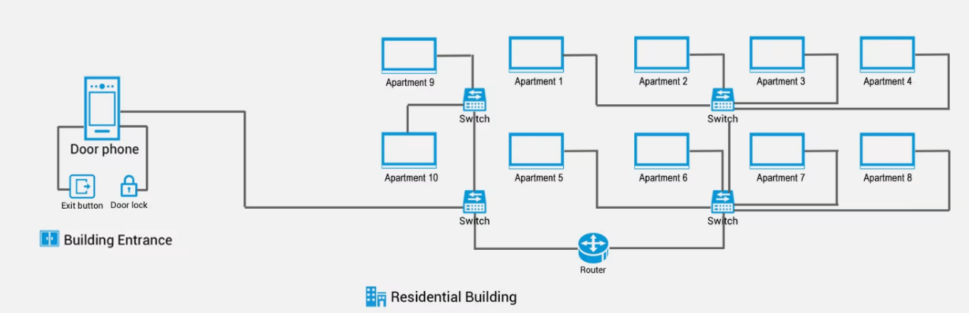
- Features: Live video preview, encrypted audio & video, remote unlock, mobile app integration, event

FTTH - Fibre to The Home:
The FTTH network delivers high-speed, carrier-neutral and redundant connectivity to every apartment.
- Architecture: Home-run (point-to-point) optical design with dual connectivity from a ground-floor MDF/ODF cabinet to each apartment.
- Fibre Drops: Each apartment receives 2 dedicated fibre terminated at a dual-port SC/APC wall outlet.
- Connectivity: ISP service is established by patching at the ground-floor distribution cabinet, ensuring flexibility of provider choice.
- Scalability: Designed for gigabit and multi-gigabit broadband, with capacity to support next-generation optical standards.
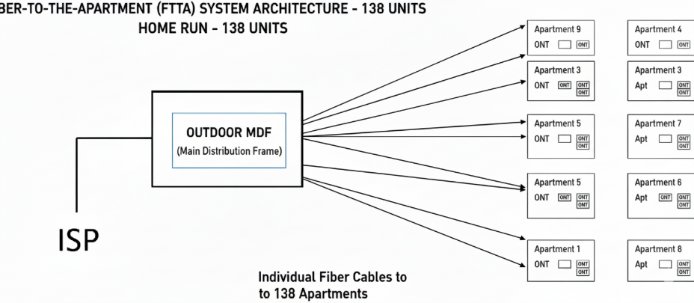
- Resilience: The System is expanded to dual fibre risers for redundancy.

INTEGRATION POINTS BETWEEN SUBSYSTEMS:
Intercom ⇄ Access Control: Incoming visitor calls from the intercom stations trigger live video display on the resident or concierge terminals. Operators or residents can verify the visitor visually and remotely unlock doors via the integrated access control system. All call and entry events are logged within the central access control management platform for audit and compliance purposes.
CCTV ⇄ Core Network: All cameras are connected via PoE to floor-level access switches, which uplink to the aggregation/core layer for centralised recording and monitoring. The video management platform provides real-time viewing, playback, search functions and secure evidential retention, ensuring full integration with the wider network infrastructure.
FTTH ⇄ Core Network: A home-run fibre-to-the-home design, dual links each apartment to a ground-floor MDF/ODF cabinet. Dual-port fibre outlets within apartments allow residents to connect their ISP-supplied router/ONT. The MDF/ODF provides patch access for ISPs to deliver services directly, maintaining flexibility and scalability for residents.

Integration Narrative
The subsystems are designed to operate cohesively under a unified management environment. For example:
- A visitor presses the intercom call button at the building entrance. The call is routed simultaneously to the concierge desk and the resident’s apartment terminal, accompanied by live video from the intercom camera.
- The concierge or resident can verify the visitor’s identity visually and, if appropriate, initiate a remote door unlock command through the integrated access control system.
- The access event is automatically timestamped and logged in the central access control platform, ensuring traceability and compliance.
- Simultaneously, the CCTV system records the entrance area, capturing both the visitor's approach and the door release event, with footage retained for evidential use.
- If required, security staff can correlate intercom call logs with CCTV footage to conduct rapid investigations or confirm compliance during audits.
- The FTTH infrastructure ensures residents maintain reliable and redundant fibre for high-speed connectivity, supporting intercom applications, mobile notifications and remote management of access events, even when off-site.
This integration ensures that access control, video surveillance, intercom communication and fibre connectivity work in tandem, delivering a secure, efficient, and future-proof digital environment for the Canal Side development.

Standards & Compliance
Physical Security & Video: BS EN 62676 CCTV; ONVIF Profiles S/G/T; IEC 62676-4 (application guidelines).
Access Control: OSDP Secure Channel; EN 60839-11-1; BS EN 50133 (legacy sites).
Networking & Cabling: ISO/IEC 11801-1; BS EN 50173; TIA-568; BS 7671 (IET Wiring Regulations).
FTTH/PON: ITU-T G.984 (GPON), G.9807.1 (XGS-PON), G.988 (OMCI), IEC 61754 (connectors).
Data Protection: Access logs & CCTV retention aligned to GDPR; privacy impact assessments (DPIA) where required.

Network, Power & Cabling Design
Switching:
The access and aggregation layers are built on PoE-enabled switches delivering PoE+ and PoE++ where required, with centralised management via the network controller. The switching fabric supports port isolation, LLDP, port mirroring, and cable diagnostics. Logical segmentation is applied using VLANs, configured in line with ISO/IEC 11801, with appropriate trunk and access port assignments for Access Control, CCTV and Intercom subsystems.
PoE Budgeting:
Power budgets have been provisioned to account for all connected devices, with ≥20% design headroom per switch.
- Panoramic cameras: up to 8.64 W
- Dome Camera: 9.25W
- Bullet cameras: 9.9 W
- Intercom stations and resident displays: 10–15 W
- Door Hubs: 19 W
- Door Access:
- Non-PoE edge devices are supported by dedicated 12–24 VDC power supplies as required.
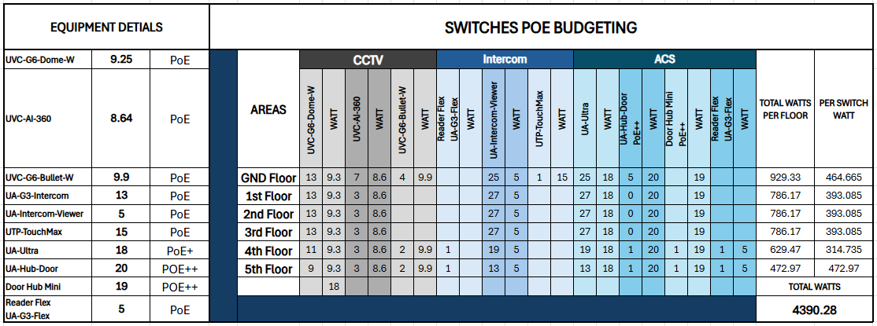

Cabling:
All edge devices are connected via a Cat6A F/UTP structured cabling system, with UV-rated outdoor cable used where exposure is expected. OS2 single-mode fibre backbones provide uplinks from floor access switches to core aggregation switches, using LC-terminated connections. Routing is designed to support structured management, compliance with TIA-568, and provision for future scalability.
Power:
Core networking and security infrastructure is supported by centralised UPS systems, providing ≥30–60 minutes of runtime. Dual PSU capability is employed on critical aggregation switches and recording infrastructure, with generator interface provisions included where continuous availability is essential.
Time/Sync:
A central Network Time Protocol (NTP) service is configured across all platforms to ensure timestamp consistency for audit logs, video recordings, and access control events, supporting evidential integrity and compliance.

Scalability & High Availability
Modular Expansion:
The system architecture has been designed with modular scalability, enabling the seamless addition of doors, cameras, intercom stations, wireless access points, and other endpoints without the need for core infrastructure redesign.
Fibre Backbone:
A centralised fibre backbone underpins the entire estate, allowing rapid integration of additional floors, subsystems, or future services while maintaining consistent performance and security.
Standardised Provisioning & Recovery:
Automated device provisioning ensures all new hardware is deployed with standardised configurations, reducing installation time and minimising human error. The system also supports configuration backups, snapshot recovery, and golden image deployment, providing fast restoration in the event of a failure and ensuring high service availability.
Note: ENVRs (for CCTV) and Access Hubs (for ACS) include built-in storage and management options. Multi-site or database replication solutions can be discussed for advanced redundancy, additionally, upon request.

Implementation Methodology
The implementation approach follows a structured, phased methodology to ensure technical integrity, compliance, and seamless project delivery.
Phase 1 – Survey & Requirements:
Conduct detailed site walks, RF and fibre audits, stakeholder workshops, and risk assessments to validate requirements and capture all design dependencies.
Phase 2 – Design (HLD & LLD):
Develop high-level and low-level designs, including network topologies, IP addressing schemes, VLAN structures, PoE and fibre budgets, storage sizing, and the acceptance testing framework.
Phase 3 – Procurement and Delivery at the site:
Procure all BOM-approved materials from vetted vendors, manage lead times and QA, stage/pre-configure where applicable, schedule logistics, deliver with GRN/inspection, and secure site storage aligned to the build plan.
Phase 4- Build & Installation:
Execute cabling works, rack installations, device mounting, terminations, and labelling in accordance with TIA/ISO standards, ensuring quality and consistency across the build.
Phase 5 – Configuration:
Apply system hardening measures, load security certificates, configure access control roles, video management policies, and intercom workflows, ensuring adherence to best practices and compliance requirements.
Phase 6 – Testing & Commissioning:
Perform Factory Acceptance Tests (FAT) and Site Acceptance Tests (SAT), including failover validation, alarm response checks, and PON light-level tests. Compile full test documentation for client approval.
Phase 7 – Handover:
Deliver complete as-built documentation packs, provide training to client staff, issue spare equipment where agreed, and activate the agreed Service Level Agreement (SLA) for ongoing support.

ANNEXE A
(Bill of Materials)

Assumptions
This technical proposal has been prepared based on the information currently available from the client. As some documentation and details remain incomplete or unavailable, the scope, specifications, and pricing presented herein are based on certain assumptions.

DATA SHEETS & SPECIFICATIONS (Annexe A)
Data sheets for all models listed in the Material List will be appended in the final issue, including at minimum: model overview, electrical/PoE class, interfaces, environmental ratings (IP/IK), operating temperature, dimensions/mounting, compliance and warranty/UI Care details. Where manufacturer data sheets define installation constraints, these shall take precedence over generic project notes. Cross-reference mapping between BoM line items and annexed data sheets will be provided for ease of review.

Quality, HSE and Information Security
All works shall be delivered under LNG’s ISO-aligned QMS, with method statements and risk assessments per CDM and site requirements. GDPR considerations apply to CCTV/ACS logging; LNG will support DPIA activities as requested.

Programme & Deliverables
Target delivery within 12 weeks from notice to proceed, subject to site readiness and approvals, comprising design sign-off, installation, SAT/FAT, training and handover. Detailed Gantt and acceptance plan to be issued with the LLD package.

Acceptance & Handover
Acceptance is based on witnessed SAT/FAT, documentation pack (as-builts, test results, credentials, backups), training completion, and activation of the agreed SLA. Maintenance plan and checklists are provided at handover.

Confidentiality
This document contains confidential, proprietary information of LNG and may not be disclosed without written consent.

Next Steps
- Confirm approval to proceed with LLD and final BoM by floor and area.
- Provide any outstanding architectural drawings and fire zoning inputs.
- LNG will append manufacturer data sheets from the Material List as Annexe A and resubmit the Issue for Review version.

ANNEXE B
(REFERENCE DRAWINGS)

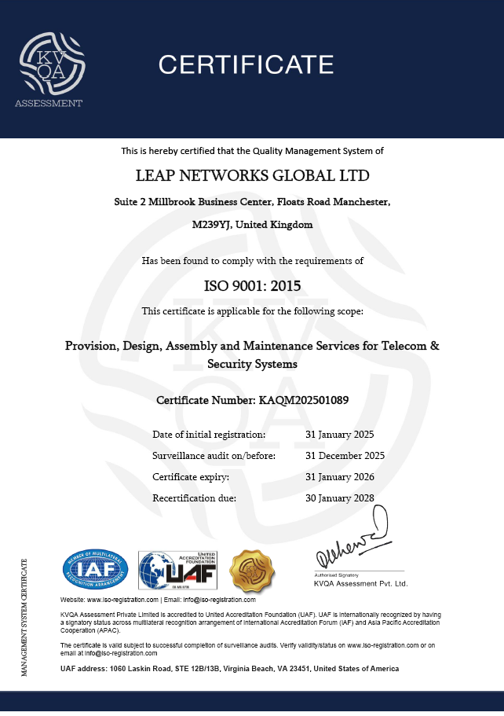

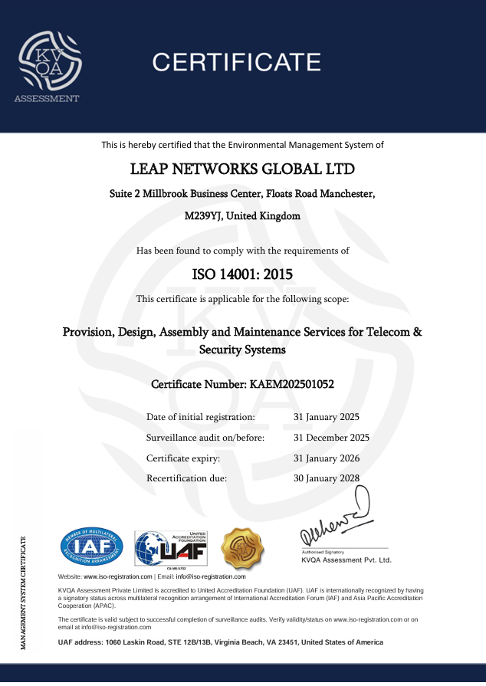

lNG CERTIFICATES

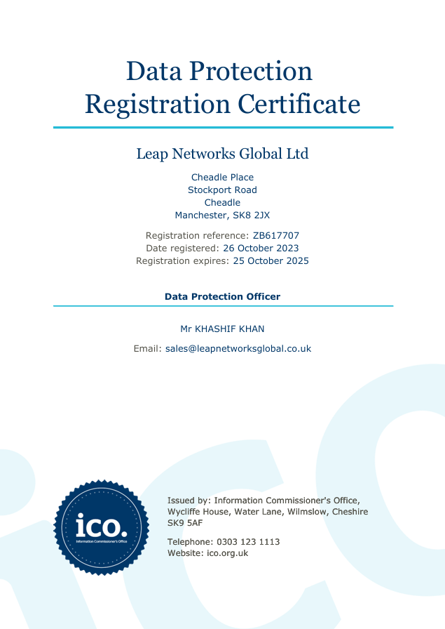

CONFIDENTIALITY NOTICE: The ideas, data and information provided in this proposal are proprietary information of Leap Networks Global Ltd. The receiver of this proposal shall guarantee to deal with it as a commercial secret and shall NOT, in any case disclose such information to any other party without correct authorisations.
Document Status: Preliminary – For Review
Confidential.© Leap Networks. All rights reserved.

