*Github Link:*

https://github.com/AqeedatZameer789/Coursera_Clone/tree/master

*Project Profile:*

This project demonstrate on latest React components and it's integration with NodeJS.In this current time,React is getting more attention of users in the market of web development.It is the new framework introduced by facebook and then it was placed as free of source on github.This project will introduce number of basic and mostly used features of React as well as Node.

*Installation:*

1. Visual Studio Code:

It is used as a development tool.It has number of plugins which make development less complex

1. NodeJS:

It is used for server.NodeJS console will be utilized in doing jobs for a server.

*NodeJS Component:*

1. Express is the popular component of NodeJS that helps you in authorization.Express is used in this project for SignUp purpose.
2. MongoDB is also the popular and widely used NodeJS component.It is used for database purpose.In this project ,array of courses and array of users is stored via MongoDB

*Compilation:*

In this project,different port numbers are given to the front-end and back-end server for their compilation purpose .Therefore both folders are run in an independent console.

1. Firstly,open the terminal for server side folder named as “server” and write the command

***“node App.js”***

1. Secondly ,split the console and write another command

***“node Index.js”***

1. Lastly, slit the console and now direct your cursor to the front-end folder named as “demo1-project” and write the command

***“Npm start”***

After running these commands,the browser will display the front-end while the server will display the user's credential you add and an array of courses.

*Plus of the Project:*

Plenty of work is done over the filtration and pagination which is commonly utilized in 80% of websites.

*Edge of the Project:*

It allows user to have all the basic information of react framework which includes react component ,JS within react component ,dynamic array ,card property,styling in react,integration of multiple react components ,react function based component ,react class based component ,functional rendering ,calling function from another component in class based component ,global react render ,import and export (default and multiple) and many more things.

Screenshots of Front-end of Project

***Landing Page:***

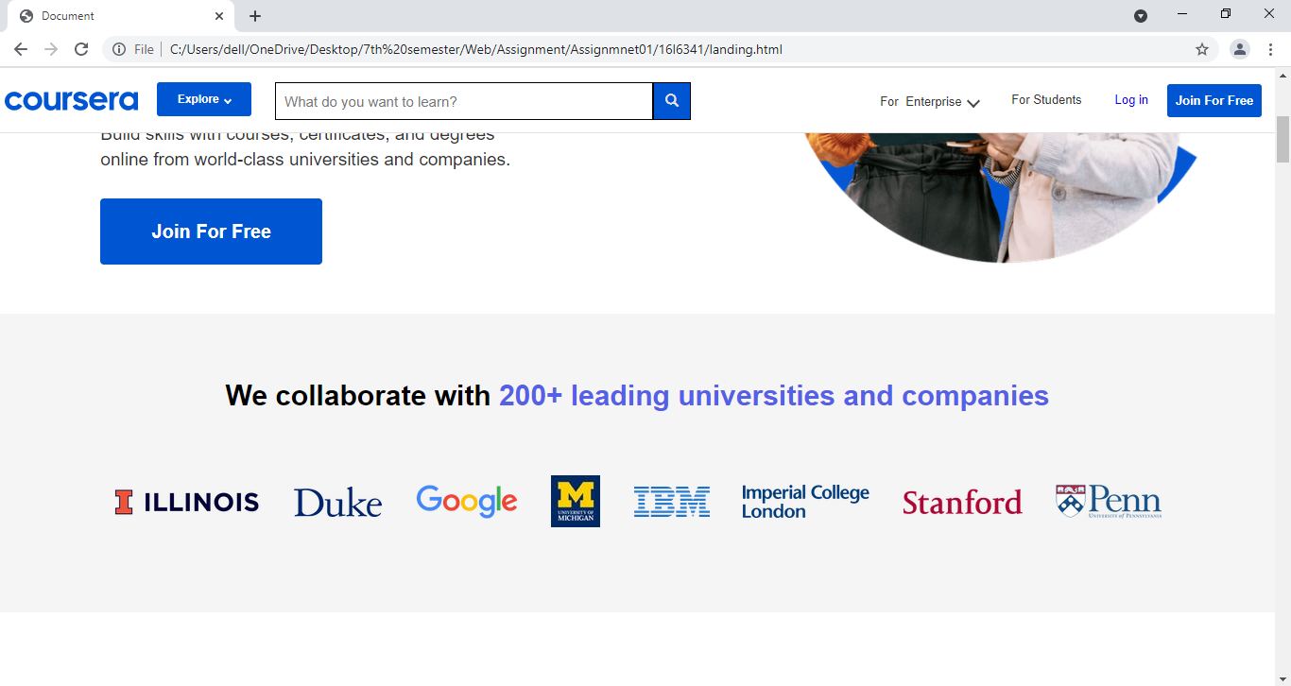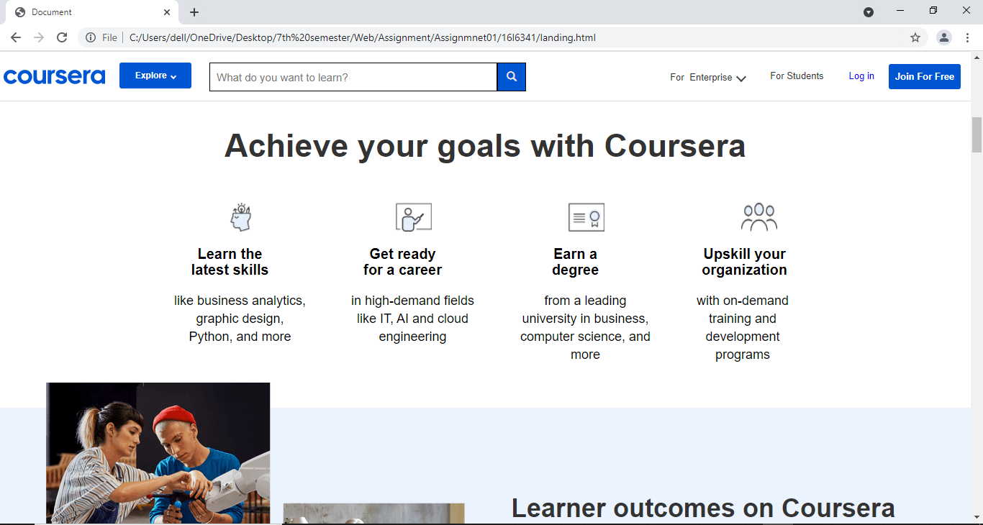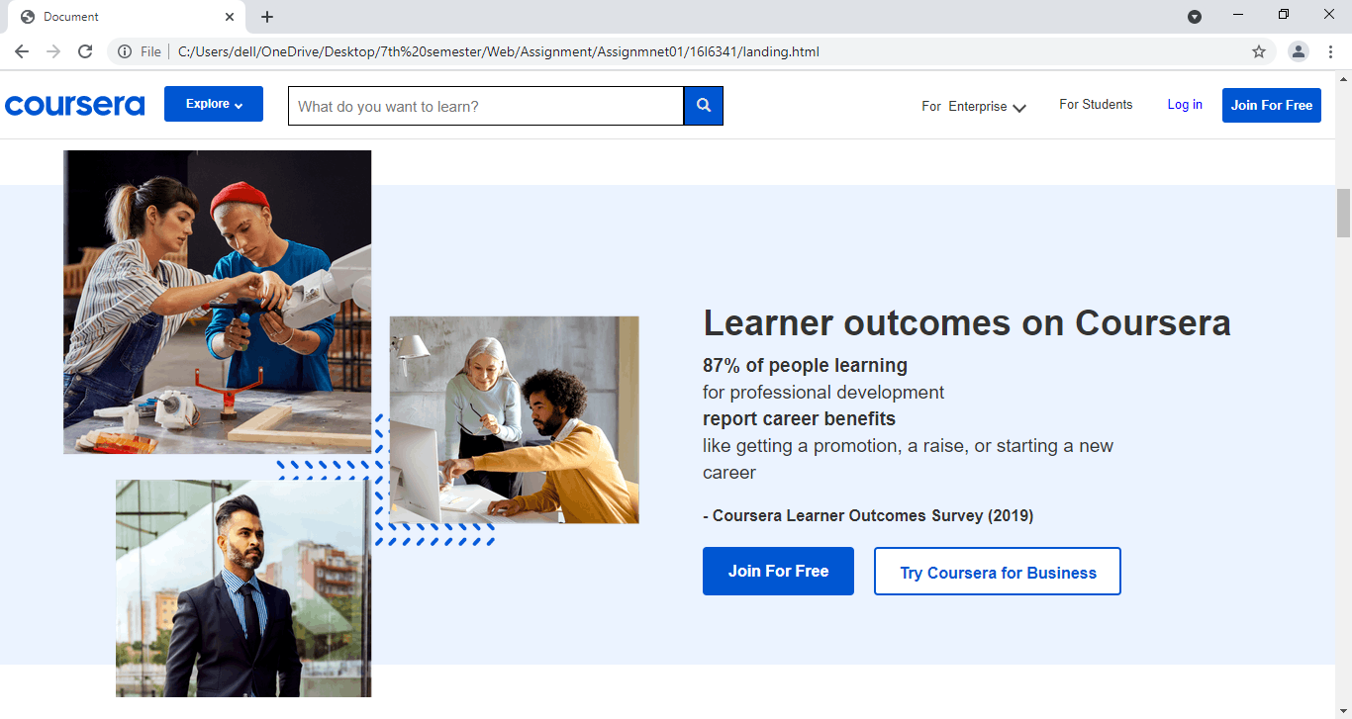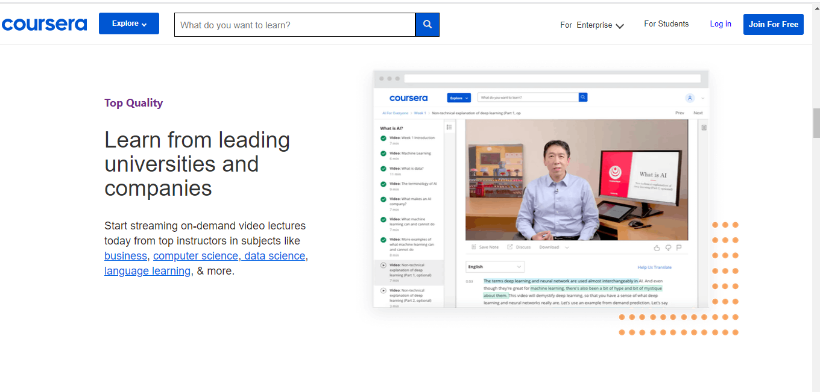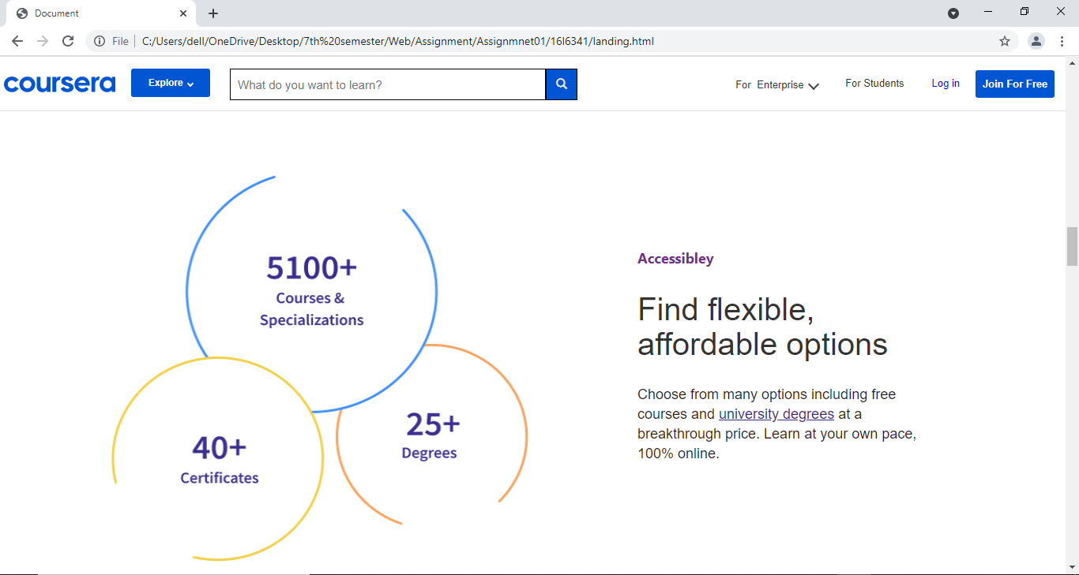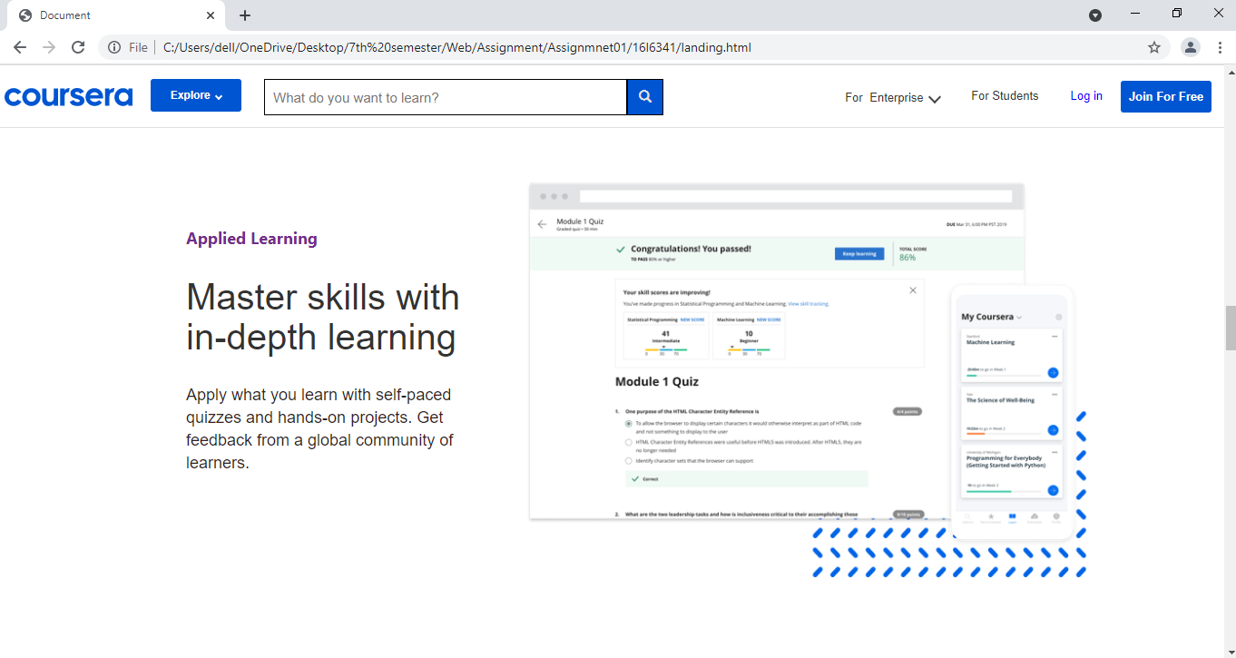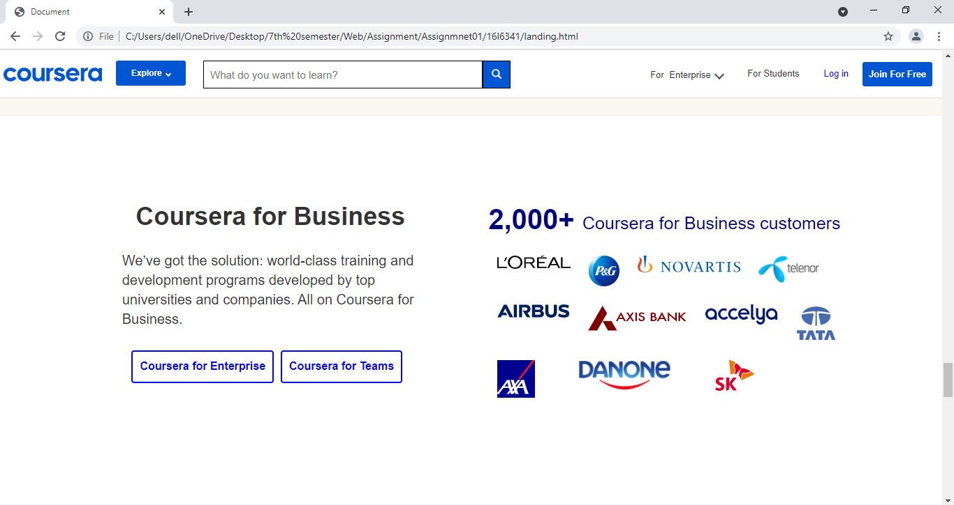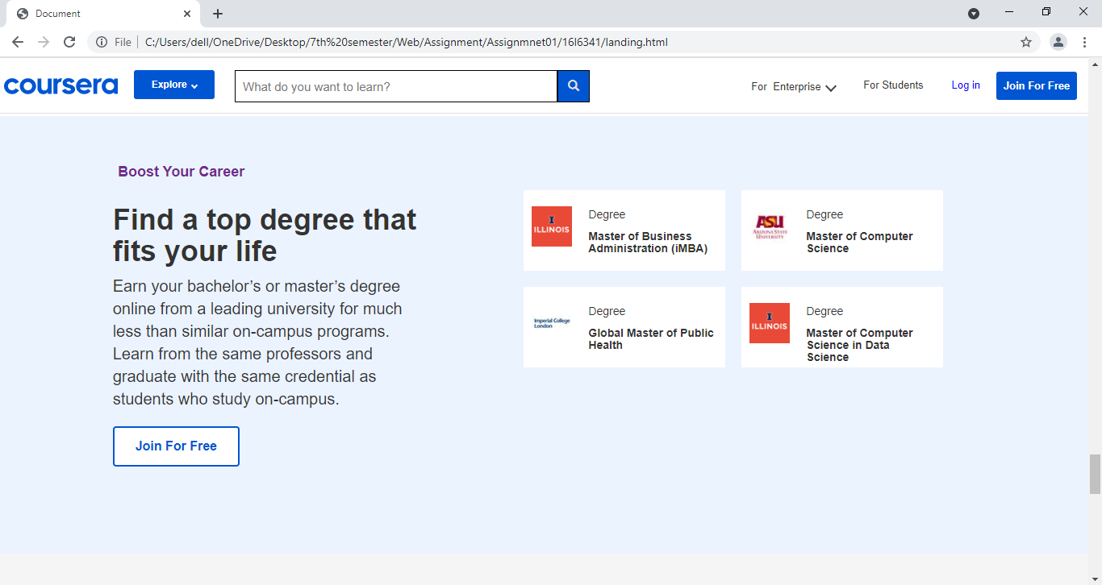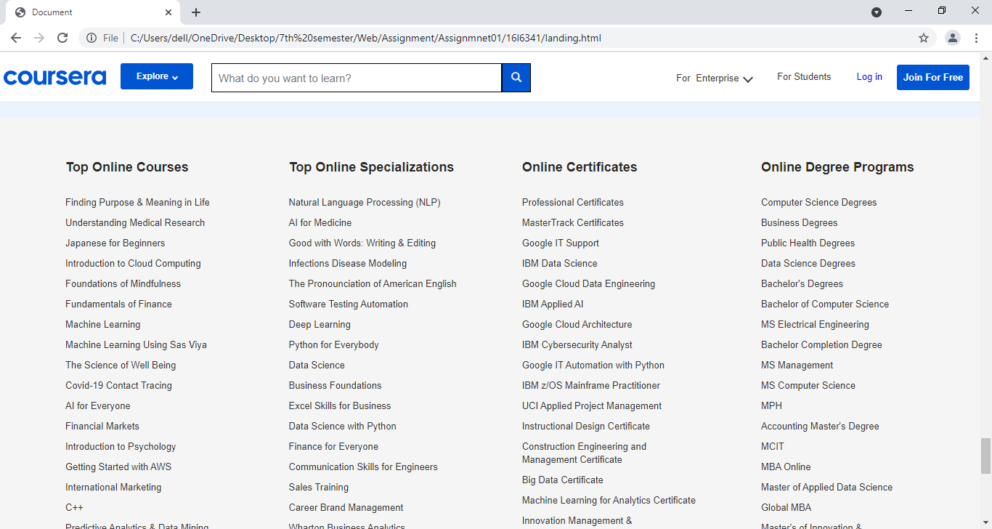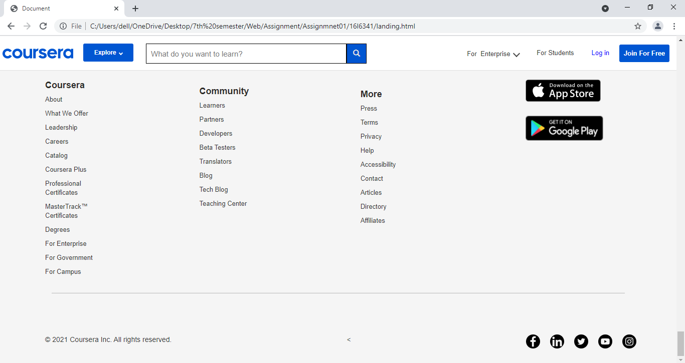

***Courses Display Page:***

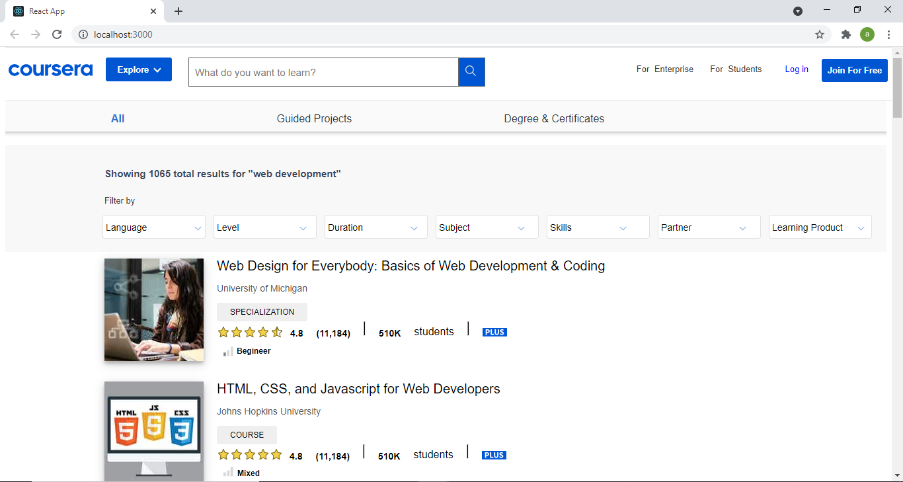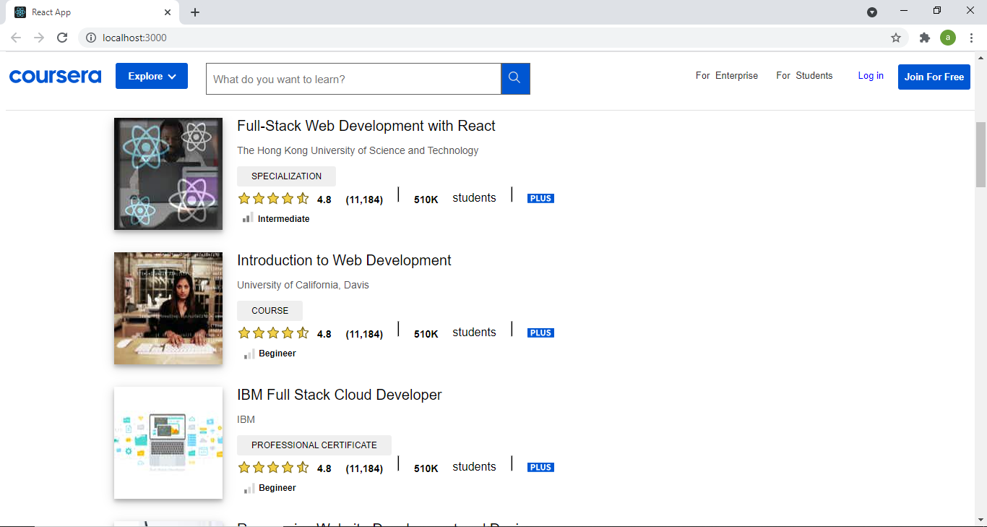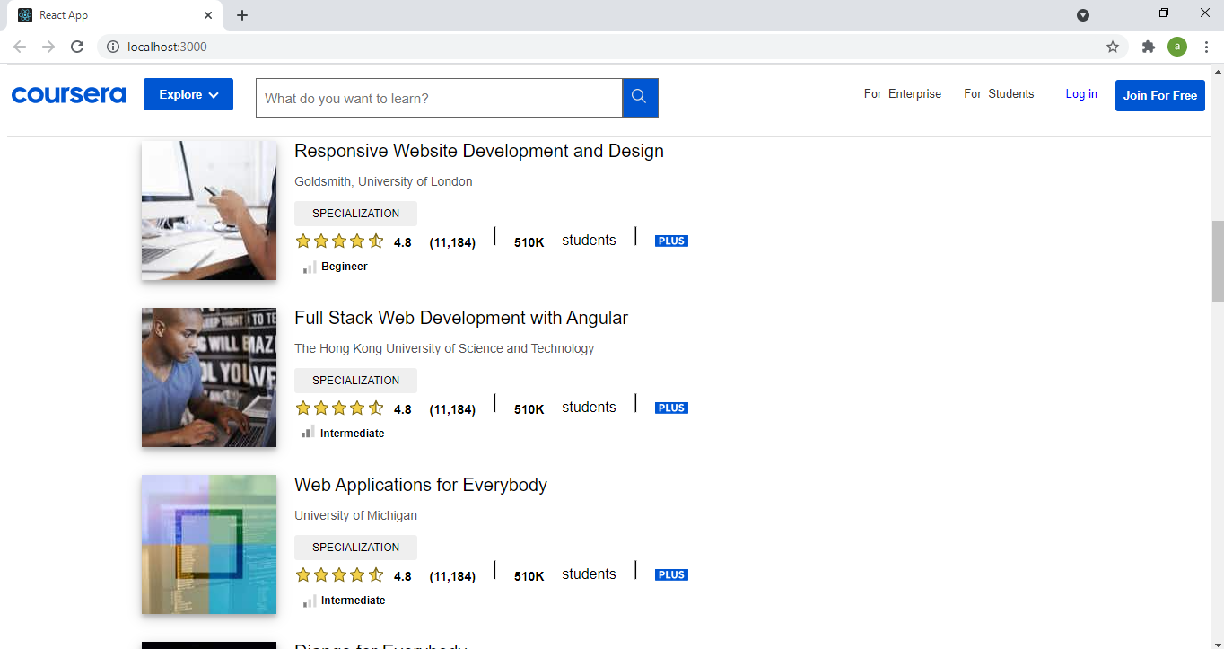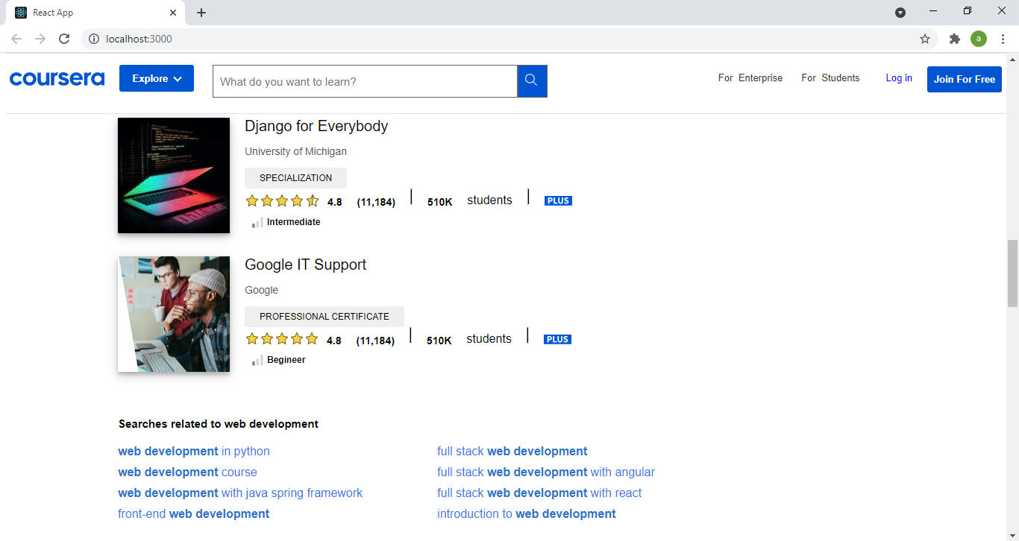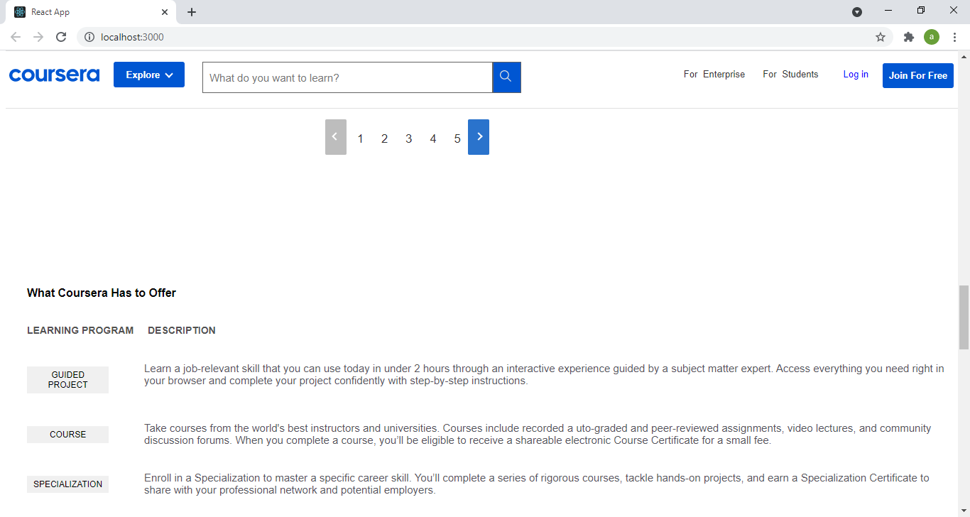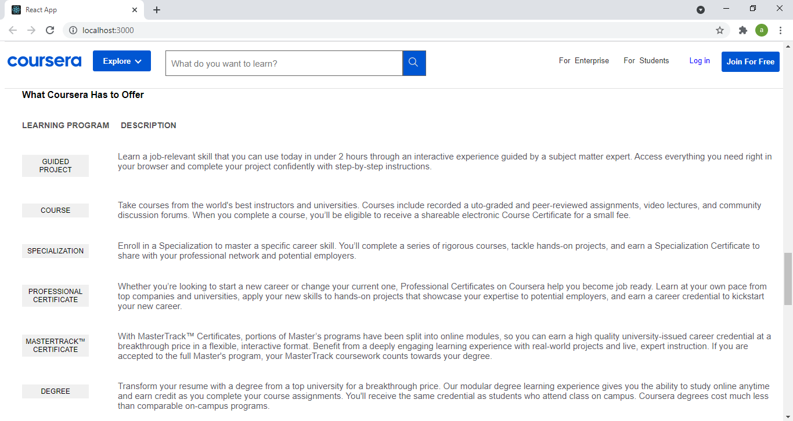

*Filters*

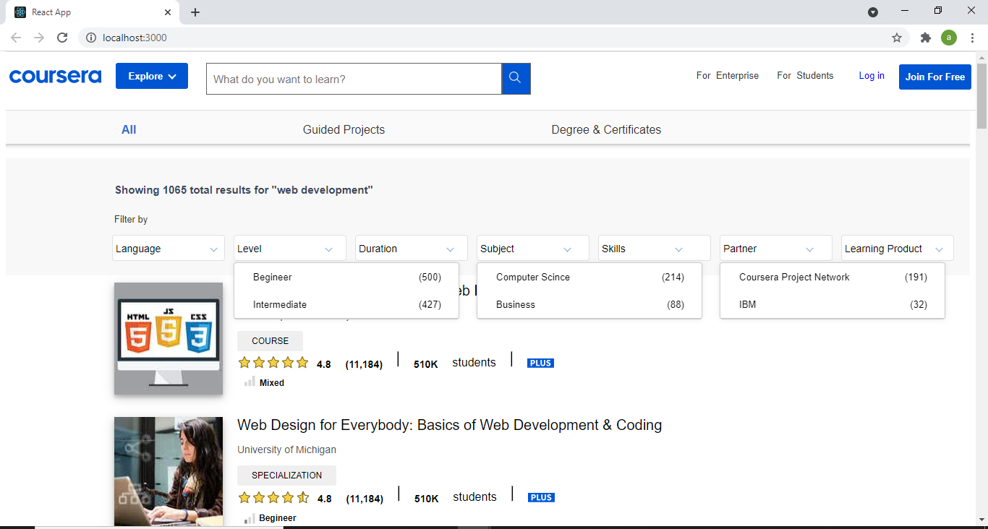

***Sign Up Display :***

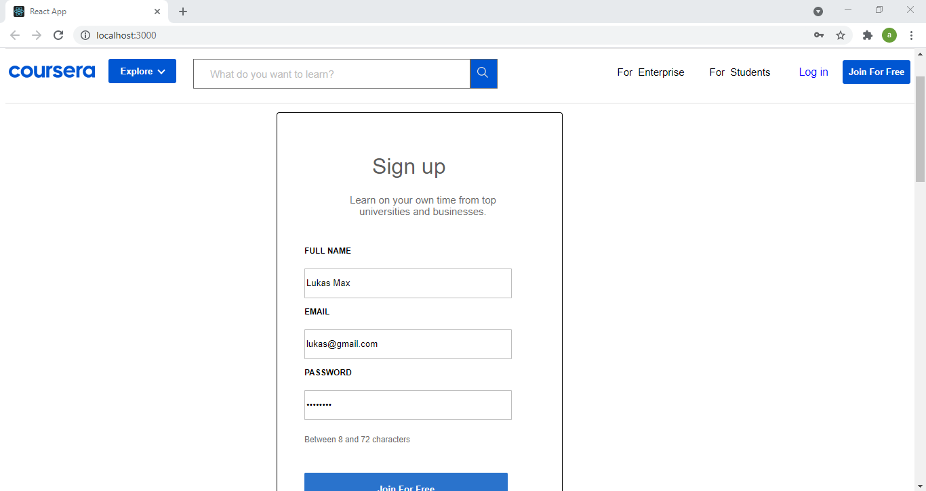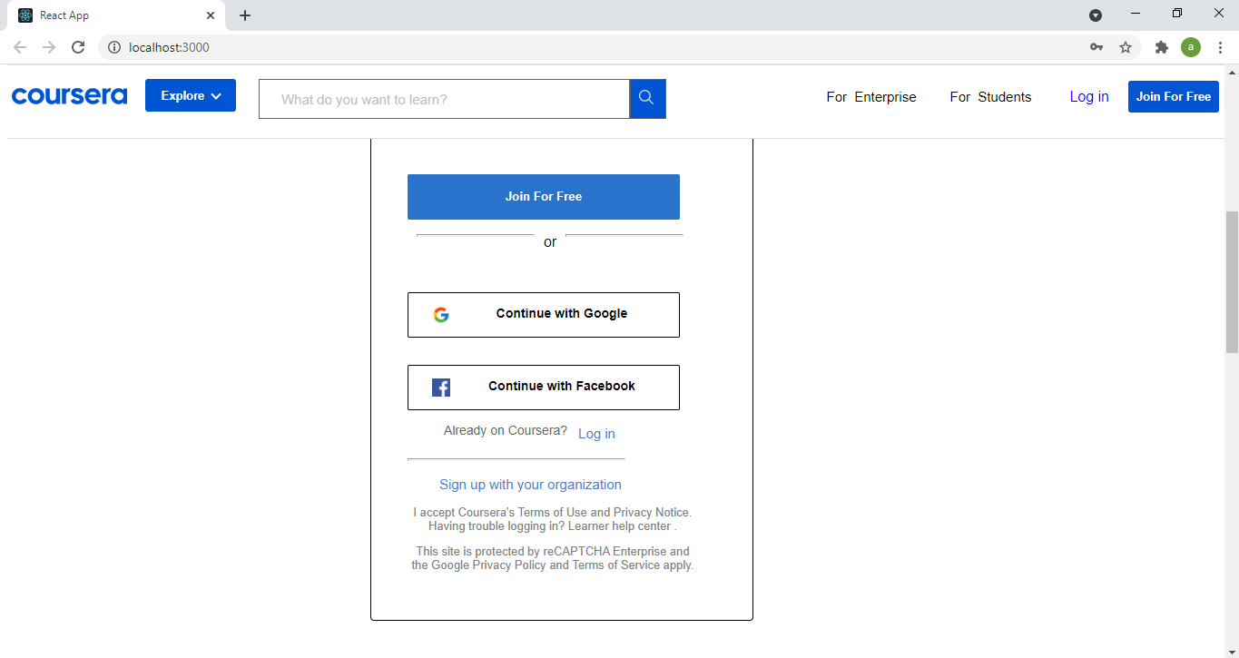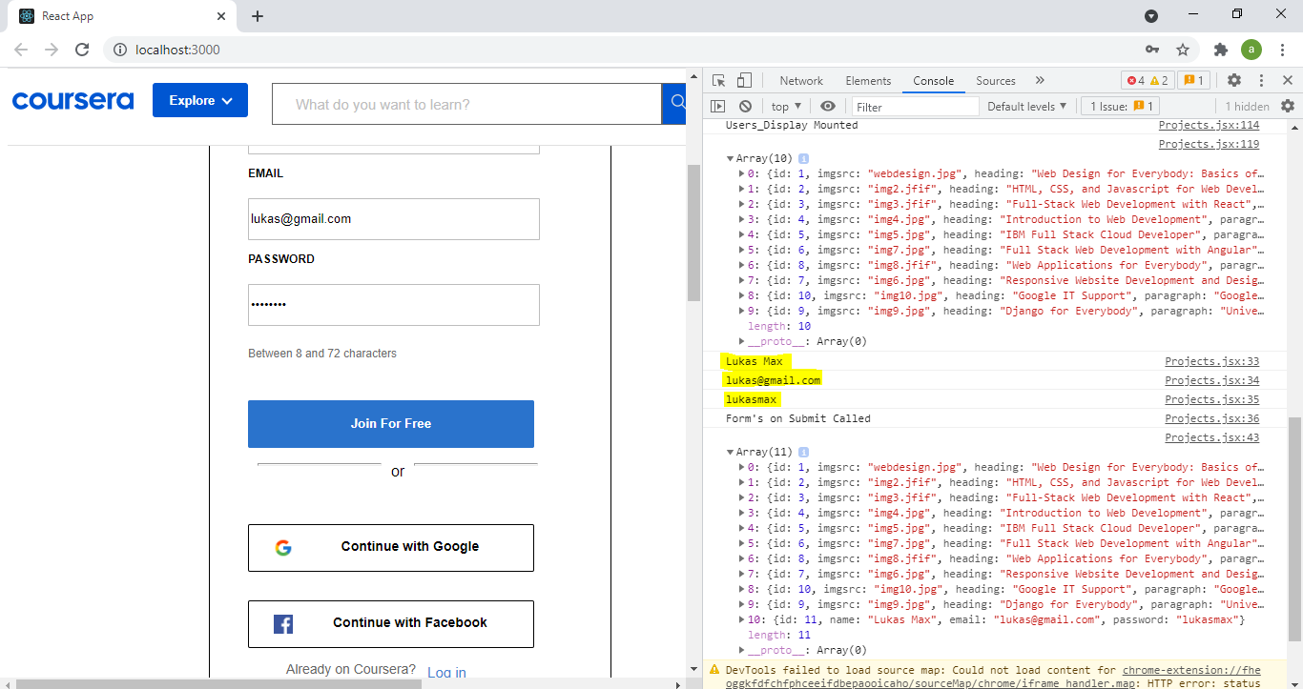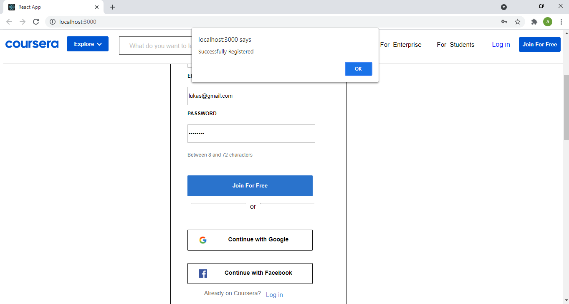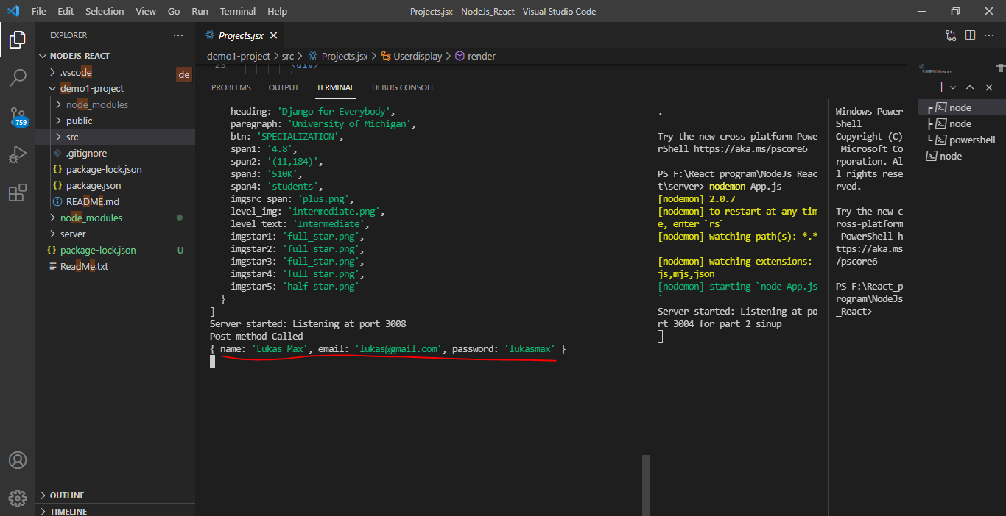***Server:*** *Display array* 