Online Blood Bank Management

Software Requirements Specification

Version 1.0



Student Name: Aqeel Abbas
Supervisor Name: Ghulam Abbas

Revision History

Date (dd/mm/yyyy) | Version | Description | Author
14/05/2025 | 1.0 | Online Blood Bank Management System aims to bridge the gap between blood donors, recipients, and blood banks through an integrated web-based platform. The system will cater to different types of users, including administrator, hospital representatives, donors, and recipients, providing them with the necessary tools to handle all aspects of blood donation and transfusion management efficiently. | BC220200652

Table of Contents

- Scope (of the project) 4
- Functional Requirements Non Functional requirements 4
- Use Case Diagram 5
- Usage Scenarios 7
- Adopted Methodology 12
- Work Plan (Use MS Project to create Schedule/Work Plan) 17

SRS Document

1. Scope of Project:
The Online Blood Bank Management System will serve as a user-friendly web platform that connects blood donors, recipients, hospitals, and blood banks. The main goal of the system is to make the process of donating and receiving blood easier, faster, and more organized.
The platform will allow administrators to manage blood stock, donor records, and blood requests. Hospitals will be able to search for specific blood types, place urgent requests, and track their status. Donors can register, check their donation history, and know when they can donate next. Recipients can also create profiles, request blood, and stay updated on their request status.
By bringing all the users together in one system, this project aims to reduce delays in finding blood and ensure timely help in emergencies. It will improve communication between users and help maintain a proper blood inventory for better healthcare services.

2.Functional and non-Functional Requirements:

Functional Requirements:
Functional Requirements are the requirements that the end user specifically demands as basic facilities that the system should offer. The Functional Requirements of our project are:

1. Administrator:

i) Manage Donor Registrations
The system shall allow the administrator to add, update, approve, or reject donor registrations and manage donor profiles.

ii) Manage Blood Inventory
The administrator shall be able to maintain and update the blood stock, including adding new units, removing used/expired units, and updating quantities.

iii) Manage Blood Requests
The system shall allow the administrator to approve or reject blood requests submitted by hospital representatives or recipients.

iv) Generate Reports
The administrator shall generate reports on blood stock levels, donation history, and blood usage trends for analysis and decision-making.

2. Hospital Representatives:

i) Search Available Blood Units
Hospital representatives shall be able to search for blood units based on blood type and location.

ii) Request Blood
The system shall allow hospital representatives to request blood units for emergency or scheduled cases.

iii) Track Request Status
Hospital representatives shall be able to track the status of submitted blood requests.

3. Donors:

i) Register / Create Profile
Donors shall be able to register and create a personal profile containing their details and blood type.

ii) View Donation History
Donors shall be able to view their past blood donation records.

iii) View Next Eligible Donation Date
The system shall display the next eligible date on which the donor can safely donate blood again.

4. Recipients:

i) Register / Create Profile
Recipients shall be able to register and create a profile for requesting blood.
ii) Search Blood Availability
Recipients shall be able to search for available blood based on type and location.

iii) Request Blood
The system shall allow recipients to submit blood requests.

iv) Track Request Status
Recipients shall be able to view and track the approval status of their blood request.

Non-Functional Requirements:
Non-Functional Requirements are the quality constraints that the system must satisfy according to the project contract. The Non-Functional Requirements of our project are:
- Usability
- The system should be easy to use for all users, including donors, hospital staff, and administrators.
- Performance:
- The system should load pages and respond to user actions quickly, even with many users.
- Security:
- User data and blood request information must be protected from unauthorized access.
- Availability:
- The system should be available 24/7, especially in emergencies.
- Scalability:
- It should support increasing numbers of users and data without affecting performance.
- Reliability:
- The system should work smoothly without frequent errors or crashes.
- Maintainability:
- The code and structure should allow easy updates and bug fixes.

3.Use Case Diagram(s):

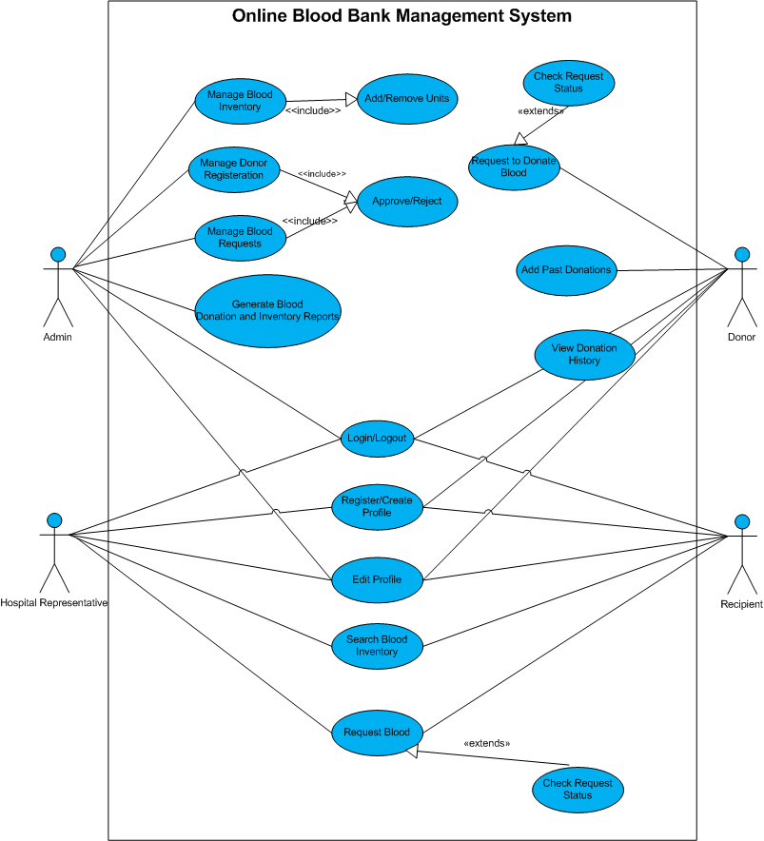

4.Usage Scenarios:

Use Case #01: Administrator – Login

Use Case Title | Administrator – Login
Use Case Id | #01
Actions | Admin enters credentials and logs in.
Description | Enables administrator access to the system.
Alternative Paths | Forgot password recovery.
Pre-Conditions | Valid admin account must exist.
Post-Conditions | Admin is redirected to the dashboard.
Author | BC220200652
Exceptions | Invalid credentials, system error.

Use Case #02: Administrator – Manage Donor Profile

Use Case Title | Administrator – Manage Donor Profile
Use Case Id | #02
Actions | View, edit, delete donor information.
Description | Admin can manage donor records.
Alternative Paths | Filter/search donors by type or name.
Pre-Conditions | Admin must be logged in.
Post-Conditions | Donor data is updated in the database.
Author | BC220200652
Exceptions | Data not found, DB error.

Use Case #03: Administrator – Manage Recipient Profile

Use Case Title | Administrator – Manage Recipient Profile
Use Case Id | #03
Actions | View, edit, delete recipient records.
Description | Admin manages all recipient profiles.
Alternative Paths | Search recipient by name/location.
Pre-Conditions | Admin must be logged in.
Post-Conditions | Updated recipient info saved.
Author | BC220200652
Exceptions | Data not found, DB error.

Use Case #04: Administrator – Update and Maintain Blood Inventory

Use Case Title | Administrator – Update and Maintain Blood Inventory
Use Case Id | #04
Actions | Add, edit, delete blood stock entries.
Description | Keeps blood inventory up to date.
Alternative Paths | Auto-adjust on donations.
Pre-Conditions | Admin login required.
Post-Conditions | Blood stock data is updated.
Author | BC220200652
Exceptions | Entry conflicts, system failure.

Use Case #05: Administrator – Approve and Reject Blood Requests

Use Case Title | Administrator – Approve and Reject Blood Requests
Use Case Id | #05
Actions | View request list and choose to approve/reject.
Description | Handles all blood request decisions.
Alternative Paths | Move to pending/waitlist.
Pre-Conditions | Valid blood request exists.
Post-Conditions | Request status updated.
Author | BC220200652
Exceptions | Blood type not in stock.

Use Case #06: Administrator – Generate Reports on Blood Stock and Donations

Use Case Title | Administrator – Generate Reports on Blood Stock and Donations
Use Case Id | #06
Actions | Select report type, date range, and generate/export.
Description | Provides reports on inventory and donation records.
Alternative Paths | Download as PDF/Excel.
Pre-Conditions | Admin must be authenticated.
Post-Conditions | Report is displayed or downloaded.
Author | BC220200652
Exceptions | No data available, system crash.

Use Case #07: Hospital Representative – Search Blood Inventory

Use Case Title | Hospital Representative – Search Blood Inventory
Use Case Id | #07
Actions | Select type and location to view available stock.
Description | Helps find required blood in system inventory.
Alternative Paths | Refine search or switch filters.
Pre-Conditions | Must search for valid type and location.
Post-Conditions | Stock list is shown.
Author | BC220200652
Exceptions | No stock found, server error.

Use Case #08: Hospital Representative – Request Blood

Use Case Title | Hospital Representative – Request Blood
Use Case Id | #08
Actions | Fill request form based on stock/type.
Description | Places a formal request for blood units.
Alternative Paths | Schedule future collection.
Pre-Conditions | Stock must exist in system.
Post-Conditions | Request submitted to admin.
Author | BC220200652
Exceptions | Invalid request, out-of-stock.

Use Case #09: Hospital Representative – Search Blood Request Status

Use Case Title | Hospital Representative – Search Blood Request Status
Use Case Id | #09
Actions | Enter request ID or view request history.
Description | Tracks the progress of requested blood.
Alternative Paths | Request again if rejected or delayed.
Pre-Conditions | Valid request must exist.
Post-Conditions | Status is shown (approved, pending, rejected).
Author | BC220200652
Exceptions | Request not found, permission denied.

Use Case #10: Donor – Register / Create Profile

Use Case Title | Donor – Register / Create Profile
Use Case Id | #10
Actions | Donor fills out form and submits.
Description | Creates a new donor profile in the system.
Alternative Paths | Already registered → login.
Pre-Conditions | Required details must be filled.
Post-Conditions | Donor account created.
Author | BC220200652
Exceptions | Form validation failed.

Use Case #11: Donor – Login

Use Case Title | Donor – Login
Use Case Id | #11
Actions | Enter credentials and access dashboard.
Description | Authenticates donor access to features.
Alternative Paths | Reset password.
Pre-Conditions | Donor account must exist.
Post-Conditions | Redirected to donor dashboard.
Author | BC220200652
Exceptions | Wrong credentials, server error.

Use Case #12: Donor – View Donation History

Use Case Title | Donor – View Donation History
Use Case Id | #12
Actions | Donor selects history option to view past donations.
Description | Displays all donation events and details.
Alternative Paths | Show "No history available".
Pre-Conditions | Donor must be logged in.
Post-Conditions | History list is visible.
Author | BC220200652
Exceptions | Data fetch error.

Use Case #13: Donor – View Next Eligible Donation Date

Use Case Title | Donor – View Next Eligible Donation Date
Use Case Id | #13
Actions | System calculates based on last donation.
Description | Shows next allowed donation date.
Alternative Paths | Show notice if no prior donation.
Pre-Conditions | Donation history must exist.
Post-Conditions | Date is shown.
Author | BC220200652
Exceptions | Calculation error or no history found.

Use Case #14: Recipient – Register / Create Profile

Use Case Title | Recipient – Register / Create Profile
Use Case Id | #14
Actions | Fills form and submits personal info.
Description | Registers the recipient into the system.
Alternative Paths | Already registered → login.
Pre-Conditions | Required details must be filled.
Post-Conditions | Profile is saved.
Author | BC220200652
Exceptions | Submission fails or input errors.

Use Case #15: Recipient – Login

Use Case Title | Recipient – Login
Use Case Id | #15
Actions | Enters login credentials.
Description | Authenticates recipient access.
Alternative Paths | Reset password.
Pre-Conditions | Account must exist.
Post-Conditions | Access to recipient panel granted.
Author | BC220200652
Exceptions | Incorrect info, locked account.

Use Case #16: Recipient – Search Blood by Type and Location

Use Case Title | Recipient – Search Blood by Type and Location
Use Case Id | #16
Actions | Inputs type & location → results displayed.
Description | Helps recipient find blood availability.
Alternative Paths | No results → reattempt or change location.
Pre-Conditions | User must be logged in.
Post-Conditions | Blood availability list shown.
Author | BC220200652
Exceptions | Stock not available.

Use Case #17: Recipient – Request Blood

Use Case Title | Recipient – Request Blood
Use Case Id | #17
Actions | Fill out blood request form and submit.
Description | Places blood request for a specific type.
Alternative Paths | Contact with the Blood Bank.
Pre-Conditions | Must be logged in.
Post-Conditions | Request is submitted.
Author | BC220200652
Exceptions | Request rejected, system error.

Use Case #18: Recipient – Search Blood Request Status

Use Case Title | Recipient – Search Blood Request Status
Use Case Id | #18
Actions | Check status using request ID or profile.
Description | Shows progress of submitted request.
Alternative Paths | Refresh after delay.
Pre-Conditions | Valid request exists.
Post-Conditions | Status is displayed.
Author | BC220200652
Exceptions | Request not found, expired session.

5.Adopted Methodology

A software development methodology is a structured set of processes used to plan, manage, and control the development of an information system. It defines how tasks are organized, how resources are used, and how the work is broken into phases or iterations.

For this project we have adopted the VU Process Model, which combines the strengths of both the Waterfall and Spiral models to provide a balanced and efficient approach to development.

Waterfall Model:
Waterfall Model suggests a systematic, linear and sequential approach to software development that begins at the system level and progresses through the analysis, design, coding, testing, and maintenance. There are five to eight major stages from which some are:
- Requirements Gathering and Analysis: Understanding what the system should do.
- System Design: Planning the architecture and data structures.
- Development (Coding): Writing the actual code.
- Testing: Checking the system for errors and bugs.
- Deployment – Releasing the system to users.
- Maintenance – Ongoing updates and corrections.

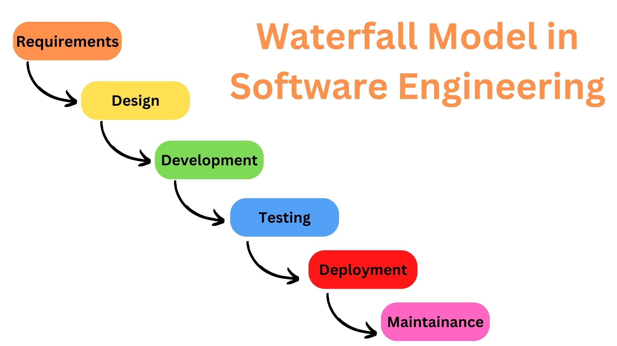

Spiral Model:
The Spiral Model is an iterative and risk-driven development process that combines elements of both design and prototyping. The main idea of this model is to avert risk as there is always an element of risk in development of software. The development process is represented as a spiral with many loops, where each loop or phase includes:
- Planning: Identifying objectives, constraints, and alternatives.
- Risk Analysis: Assessing potential problems and planning solutions.
- Engineering: Designing and developing part of the system.
- Evaluation: Reviewing the progress and getting feedback from users.
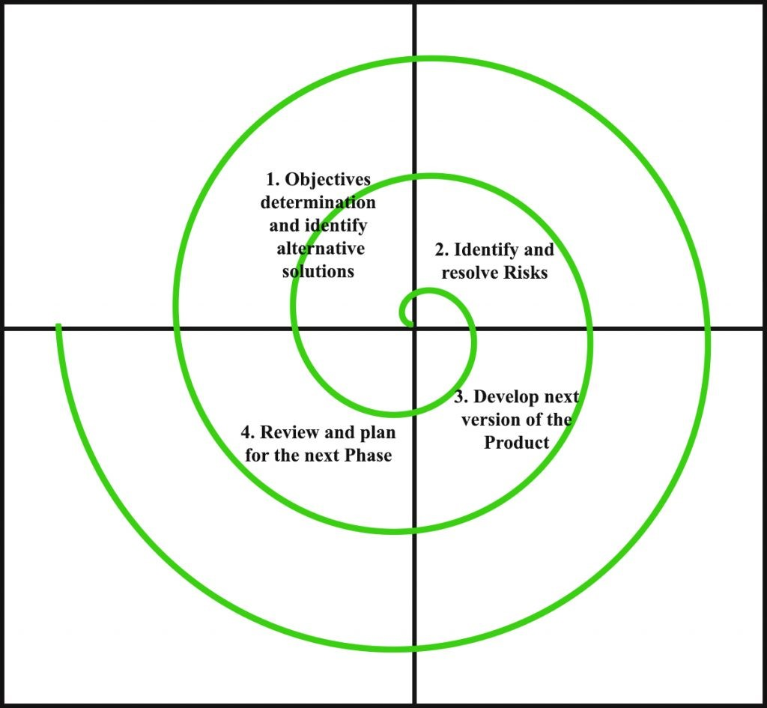

VU Process Model:
Our adopted methodology for this project is VU process Model. It combines the disciplined structure of the Waterfall Model with the flexibility and iterative nature of the Spiral Model. This combination allows developers to follow a structured approach for planning and documentation, while still having the flexibility to revisit previous stages, handle changing requirements, and mitigate risks early. Some of the aspects of this model are:
- Structured Requirement Gathering:
It begins with complete and well-organized requirement collection, similar to the Waterfall model, ensuring clarity from the start.
- Defined Phases with Clear Deliverables:
The model follows distinct stages like design, development, and testing, making it easier to plan, track progress, and manage time.
- Iterative Development Cycles:
Inspired by the Spiral model, the project is developed in repeated cycles, allowing continuous improvement and refinement.
- Effective Risk Management:
Risks are identified and addressed early in each development cycle, reducing the chances of failure or rework.
- Flexibility to Handle Changes:
Unlike the rigid Waterfall model, this process allows revisiting and updating earlier phases if requirements change.
- Early Error Detection:
By testing in each cycle, issues are identified and resolved early, improving system quality.
- Incorporation of User Feedback:
Regular feedback from users or stakeholders helps in aligning the system with actual needs and expectations.
- Balanced Approach for Real-World Projects:
It combines the discipline of Waterfall with the adaptability of Spiral, making it suitable for projects where both structure and flexibility are needed.
Reason for Choosing VU Process Model:
The workflow of our project align with the aspects given above. We can see it in the following points, why VU process model is our choice of selection for this project:
- Our project is divided into different phases, and each phase needs to be completed and submitted to our supervisor in a specific order.
- If any mistakes are found, our supervisor guides us to correct them and improve that part of the project. This flexible and review-based improvement comes from the spiral aspect of the VU Process Model.
- Once a phase is properly completed and approved by the supervisor, we move on to the next phase. This step-by-step progression reflects the waterfall side of the model.
- In this way, both the Waterfall and Spiral models are combined into a single development approach — the VU Process Model. It helps ensure a smoother and more accurate outcome, as each stage is handled carefully and in the right sequence.
A visual representation of the VU Process is model is given below:

6.Work Plan (Use MS Project to create Schedule/Work Plan)



