Name: Aqeel Ahmad

Reg no: SP22-BSE-012

Section: B

GitHub repo link:

<https://github.com/Aqeel012/NodeJS-Authentication.git>

Registration:

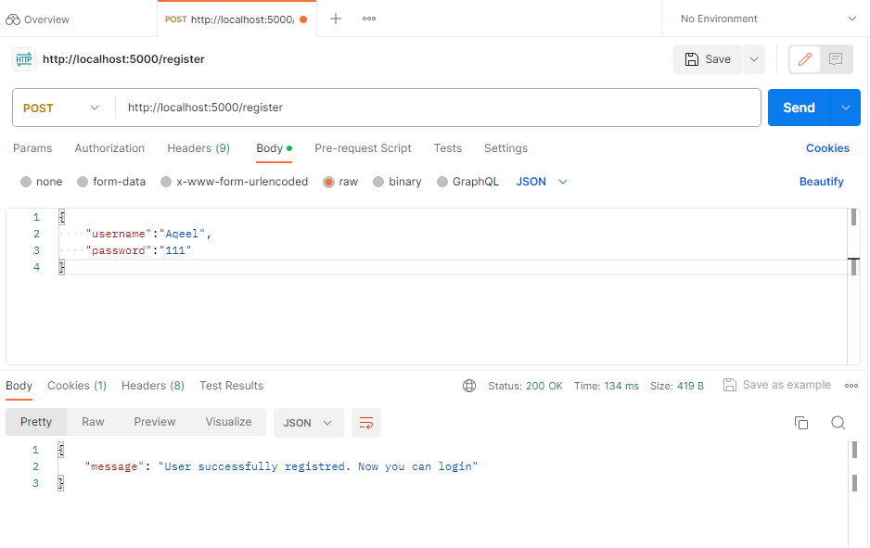

Login:

GET Request:

GET by Email:

POST:

PUT:

Delete:

After 60 Seconds Timeout:

