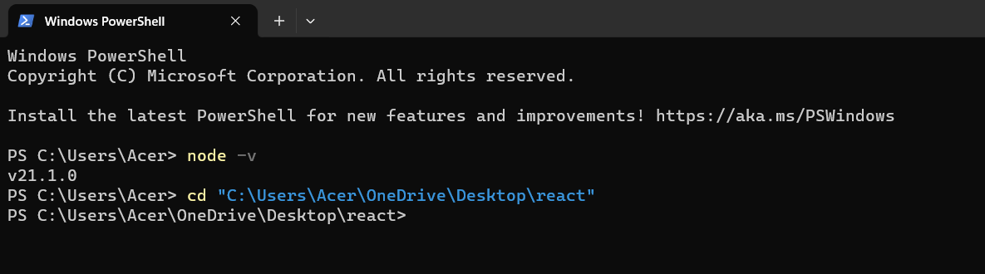

Implementing full-fledged two-factor authentication (2FA) in a web application is a complex task that involves both frontend and backend components. Below, I'll provide an example of how to set up a simple email-based 2FA system using HTML, JavaScript, and a hypothetical backend server for email sending and verification. Keep in mind that a production-ready 2FA system would typically involve more robust security measures and use dedicated authentication services.

**HTML and JavaScript (login.html):**

<!DOCTYPE html>

<html>

<head>

<!-- Add your head content here -->

</head>

<body>

<div class="container">

<h2>Login</h2>

<form>

<label for="email">Email:</label>

<input type="text" id="email" name="email" required><br><br>

<label for="password">Password:</label>

<input type="password" id="password" name="password" required><br><br>

<!-- Add 2FA code input field -->

<label for="code">2FA Code:</label>

<input type="text" id="code" name="code" required><br><br>

<button type="submit" id="login">Login</button>

</form>

</div>

<script>

document.getElementById("login").addEventListener("click", function (e) {

e.preventDefault();

var email = document.getElementById("email").value;

var password = document.getElementById("password").value;

var code = document.getElementById("code").value;

// Send a request to your server to authenticate the user

// Your server should validate the email and password first

// If valid, send an email with the 2FA code to the user's registered email

// On successful email verification, compare the entered code with the one sent to the user

if (code === received2FACode) {

// 2FA code is correct, and the user is authenticated

window.location.href = "homepage.html"; // Redirect to the home page

} else {

alert("Invalid 2FA code. Please try again.");

}

});

</script>

</body>

</html>

**Hypothetical Backend Server (server.js, using Node.js and Nodemailer for email sending):**

const express = require('express');

const bodyParser = require('body-parser');

const nodemailer = require('nodemailer');

const app = express();

app.use(bodyParser.urlencoded({ extended: false }));

// Replace with your own email configuration

const transporter = nodemailer.createTransport({

service: 'your_email_service', // e.g., 'Gmail'

auth: {

user: 'your_email@gmail.com', // Your email address

pass: 'your_password', // Your email password

},

});

// This endpoint simulates user authentication and sends a 2FA code via email

app.post('/login', (req, res) => {

const email = req.body.email;

const password = req.body.password;

// Validate email and password (implement your own validation logic)

// If email and password are valid, generate a 2FA code

const twoFactorCode = generate2FACode();

// Send the 2FA code to the user's email

transporter.sendMail({

from: 'your_email@gmail.com',

to: email,

subject: 'Your 2FA Code',

text: `Your 2FA code is: ${twoFactorCode}`,

});

// Return a response to the client (you can implement your own response format)

res.send('2FA code sent to your email.');

});

// Replace with your own code for generating 2FA codes

function generate2FACode() {

// Implement your own code generation logic here

// It typically involves generating a random code

return '123456'; // For demonstration purposes

}

app.listen(3000, () => {

console.log('Server is running on port 3000');

});

This example demonstrates a simplified 2FA system. In a real-world scenario, you should implement additional security measures, rate limiting, user management, and better code generation methods. The email and password validation should also be more robust and may involve a database for user management. Additionally, consider using a third-party authentication service or library for a more secure and feature-rich 2FA implementation.