**Exercise 3: Stored Procedures**

**Scenario 1:** The bank needs to process monthly interest for all savings accounts.

* + **Question:** Write a stored procedure **ProcessMonthlyInterest** that calculates and updates the balance of all savings accounts by applying an interest rate of 1% to the current balance.

**CODE:**

create or replace procedure ProcessMonthlyInterest as

begin

    for rec in (select AccountType,BALANCE,ACCOUNTID from ACCOUNTS) LOOP

        IF rec.AccountType = 'Savings' THEN

            update ACCOUNTS

            set balance = rec.balance*(1 + 1/100)

            where ACCOUNTID = rec.AccountID;

        end if;

    end loop;

end;

**OUTPUT:**

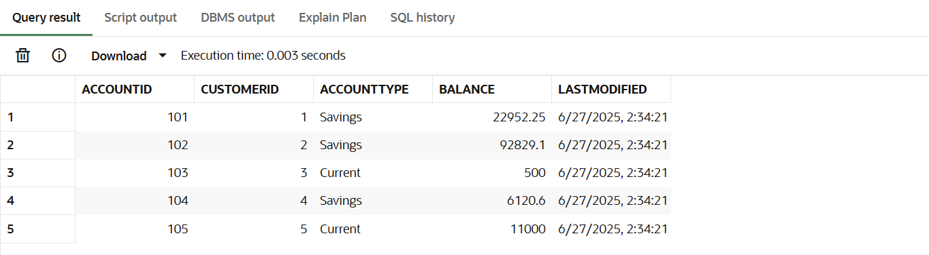

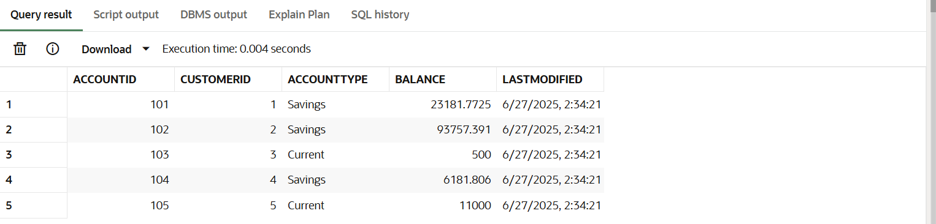

**Scenario 2:** The bank wants to implement a bonus scheme for employees based on their performance.

* + **Question:** Write a stored procedure **UpdateEmployeeBonus** that updates the salary of employees in a given department by adding a bonus percentage passed as a parameter.

**CODE:**

create or replace procedure UpdateEmployeeBonus(x in NUMBER) as

BEGIN

    for rec in (select EmployeeId,Salary from EMPLOYEES) loop

        update EMPLOYEES

        set SALARY = rec.Salary*(1+x/100)

        where EMPLOYEEID = rec.EmployeeID;

    end loop;

end;

**OUTPUT:**

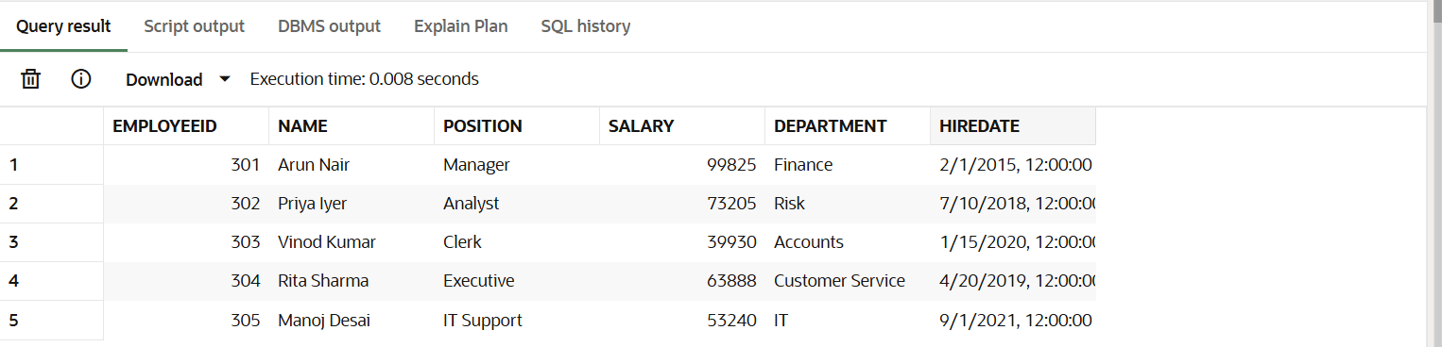

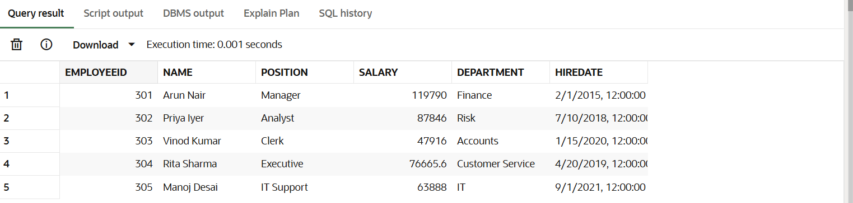

**Scenario 3: Customers should be able to transfer funds between their accounts.**

* + **Question: Write a stored procedure TransferFunds that transfers a specified amount from one account to another, checking that the source account has sufficient balance before making the transfer.**

**CODE:**

create or replace procedure TransferFunds(s in NUMBER,r in number,amt in NUMBER) as

sender number;

BEGIN

    select BALANCE into sender from ACCOUNTS where ACCOUNTID = s;

    if sender < amt then

        RAISE_APPLICATION_ERROR(-20001, 'Insufficient balance for transfer');

    end if;

    update ACCOUNTS

    set Balance = Balance - amt

    where AccountID = s;

    update ACCOUNTS

    set Balance = Balance + amt

    where AccountID = r;

end;

**OUTPUT:**

