**API Integration Report – Avion_Ecommerce**

**API**

<https://hackathon-apis.vercel.app/api/products>

**Sanity Schema**

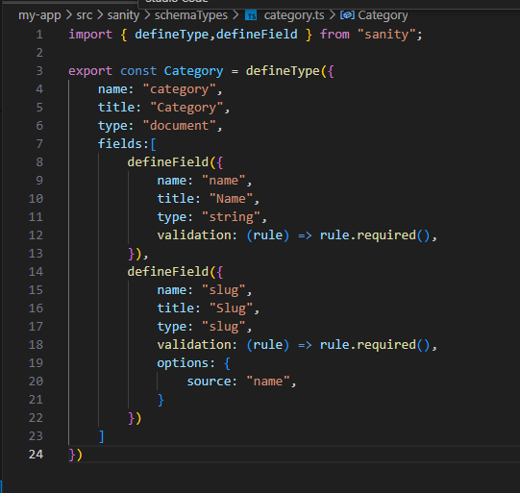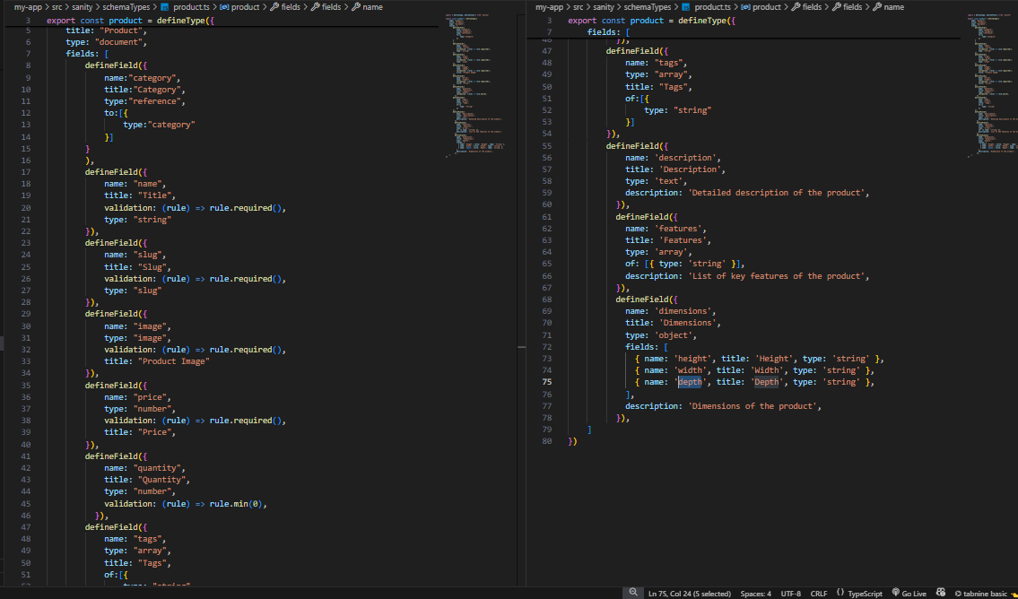

Product.ts

Category.ts

**Data Migration Script**

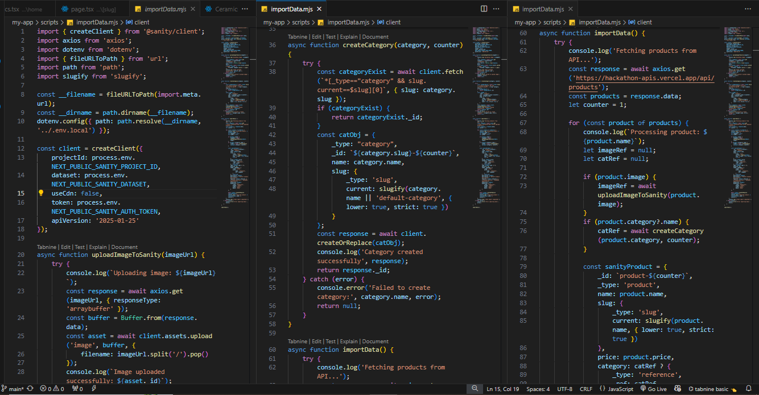

1. **API Requirements**