**Software Design Specification (SDS)**

**Introduction:** This is the document where we build our software design architecture for every perspective view. How the database work, how user and system interact and the pre design class and functionalities that developer has to visualize everything what actually this software act.

Software design specification has some major diagram –

1. Database schema
2. E-R Diagram
3. Use case diagram
4. UML class diagram
5. UML sequence diagram
6. Database Schema: Database architectural design is here –

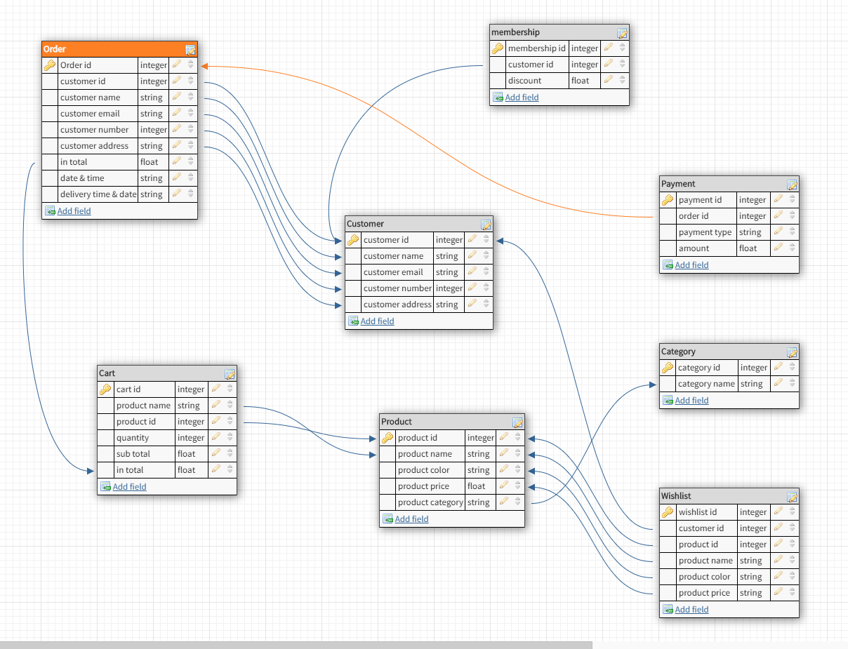

Fig 1: Database Schema diagram (using software)

1. E-R diagram: Here is our entity relationship diagram –

Login

c.email

cate.ID

Hass

ll

c.email

c.number

Total price

Date &time

c.address

c.ID

c.name

In total

**Cart**

**Order**

p.color

p.name

Quantity

Sub total

w.id

c.ID

p.id

**Wishlist**

p.category

p.name

Payment type

Discount

m.ID

cate.name

Amount

Payment.id

**Payment**

**Membership**

c.ID

**Products**

**Category**

Online

Shopping

does

c.address

c.number

c.ID

c.name

**Customer**

View

Has

p.ID

p.price

Added to

Discount

Confirm order

done

p.name

Cart.id

Order.id

Expected delivery time & date

1. Use case diagram: here is our use case diagram –

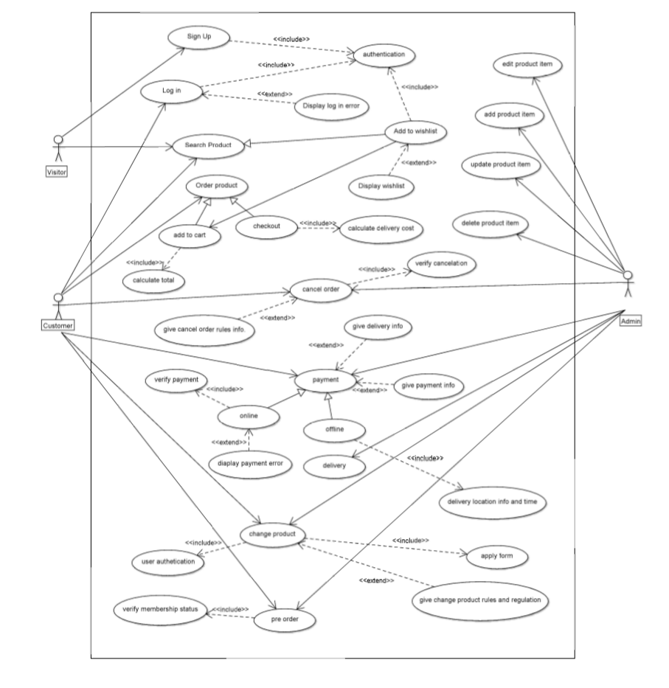

Fig 2: Use case diagram

1. UML class diagram: UML class diagram is here –

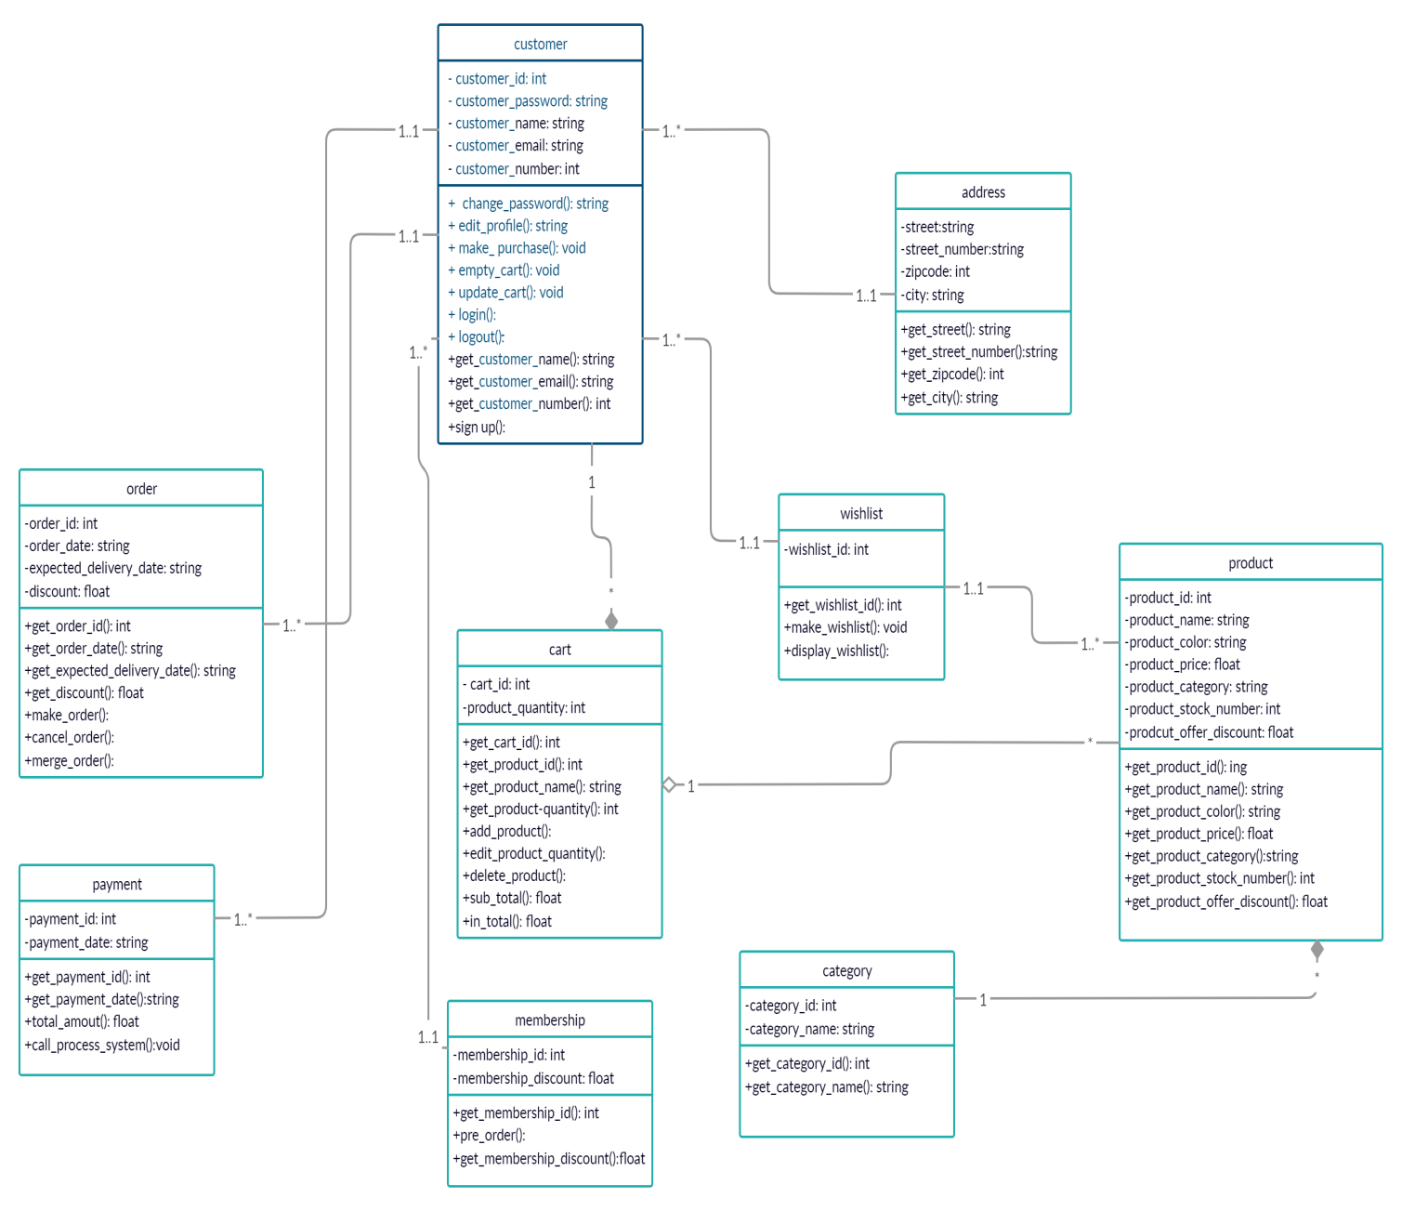

Fig 3: UML class diagram