https://openflexure.org/projects/microscope/build
https://build.openflexure.org/openflexure-microscope/v7.0.0-beta5/interactive_3d_view_rms.html
https://build.openflexure.org/
https://build.openflexure.org/openflexure-microscope/v7.0.0 beta5/high_res_microscope/prepare_stand.html

Common fastening hardware. Bulk total (using unit prices) 3.80 GBP. One-off total (using pack prices) 19.20 GBP
Name | Qty | Supplier | Code | Pack size | Unit price | Pack price
Common hardware
M3x25mm hexagon head screws | 3 | Westfield Fasteners | WF10920 | 30 | 0.104 GBP | 3.12 GBP
M3 brass nut | 4 | Westfield Fasteners | WF20152 | 50 | 0.049 GBP | 2.45 GBP
M3 stainless steel washer | 8 | Westfield Fasteners | WF10888 | 200 | 0.009 GBP | 1.8 GBP
M3x8mm cap head screw | 14 | Westfield Fasteners | WF2344 | 80 | 0.035 GBP | 2.8 GBP
M2x6mm cap head screws | 4 | Westfield Fasteners | WF14259 | 30 | 0.11 GBP | 3.3 GBP
mm Viton Rubber O-Rings | 3 | Simply Bearings |  | 5 | 0.56 GBP | 2.8 GBP
Common electronics
5mm white LED | 1 | Farnell | 2419079 | 1 | 0.23 GBP | 0.23 GBP
60 Ohm resistor | 1 | Farnell | 2401722 | 10 | 0.0298 GBP | 0.298 GBP
Motorised version
M4x6mm button head screws | 6 | Westfield Fasteners | WF2233 | 40 | 0.06 GBP | 2.4 GBP

Materials
Tools
- 1 #1 pozidrive screwdriver
- 1 2.5mm Ball-end Allen key
- 1 extra M3 nut - For mounting the hex bolt in the large gear
- 1 extra M3x10 cap screw - For mounting trapped nuts - For mounting trapped nuts
- 1 Fused Filament 3D printer
- 1 Pi Camera lens tool - This should come with the Raspberry Pi Camera Module v2. If it is missing, you can 3D print a workaround lens removal tool.
- 1 precision wire cutters - Can use a utility knife if these are unavailable.
- 1 utility knife - Not a scalpel!
Materials
- 4 cm^2 of 0.5mm polypropylene
- 20 g of Black PLA filament
- 380 g of PLA filament - Of any colour you want. Two contrasting colours may look best.
Consumables
- 3 drops of light oil - Don't skip this or you will damage the screws
Optical Components
- 1 12.7 mm achromatic lens
- 1 condenser lens
- 1 microscope objective - This page provides more information on choosing an objective.
Electronic Components
- 2 2 pin Du Pont connector female housing
- 1 200mm Pi Camera ribbon cable - Make sure that the cable is Type B, as identified in the part page
- 3 28BYJ-48 micro geared stepper motors
- 1 illumination PCB - A 5mm LED can be used instead, if you follow the LED workaround.
- 1 micro SD card - you may also need a compatible SD card reader
- 1 Pre-crimped Female-Female jumper cable (30 cm), Black
- 1 Pre-crimped Female-Female jumper cable (30 cm), Red
- 1 Raspberry Pi Camera Module v2
- 1 Raspberry Pi Power Supply
- 1 Raspberry Pi v4
- 1 Sangaboard v0.5 - If you cannot get a Sangaboard, you can put together workaround motor electronics instead.
Mechanical Components
- 3 M3 brass nut
- 21 M3 nut
- 8 M3 stainless steel washers
- 17 M3x10 cap head screws
- 4 M3x25mm stainless steel hex bolt
- 18 No 2 6.5mm self tapping screws
- 3 Viton O-ring (30mmx2mm) - "Viton band"

Configure and test your printer
For this section you will need:
Tools
- 1 2.5mm Ball-end Allen key
- 1 extra M3x10 cap screw - For mounting trapped nuts
- 1 Fused Filament 3D printer
Materials
- 5 g of PLA filament
Mechanical Components
- 1 M3 nut
Step 1: Set your printer settings
- All microscope parts can be printed out of PLA filament on most Fused Filament 3D printers.
- Set your slicer to the following printer settings:
Setting | Value
Material | PLA
Layer height | 0.2mm
Nozzle diameter | 0.4mm
Supports | None
Infill | Printer default
Brim | Recommended for all parts without built in brim
Slice gap closing radius | 0.001mm Slicer dependent - see note

The microscope body has a custom brim included in the STL, and the condenser lens and optics module also contain small gaps. This may require you to set the slice gap closing radius.
As a general rule, strength is more important than surface finish, so very thin layers (less than 0.15mm or so) are unlikely to result in a microscope that performs any better, though it may improve the appearance.

Step 2: Test your print settings
Download ../models/leg_test.stl
Download ../models/nut_trap_test.stl
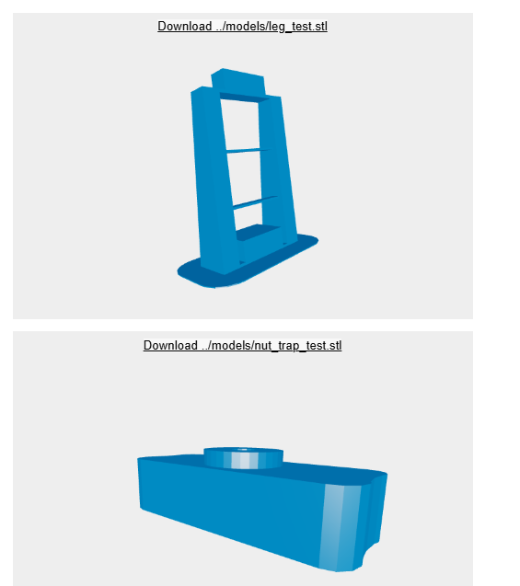
- Now test whether your printer can print the bridges in the microscope and the custom brim on the main body, and test the assembly of nut traps
- Download the leg test and nut trap files
- Slice and print the files. Do not add brim in your slicer. This will only use about 5 grams of PLA
Step 3: Check your leg test print
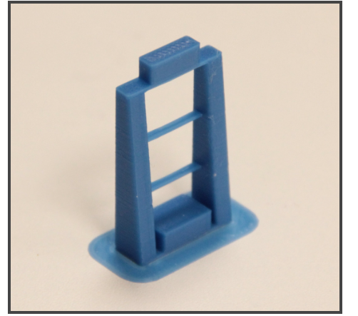
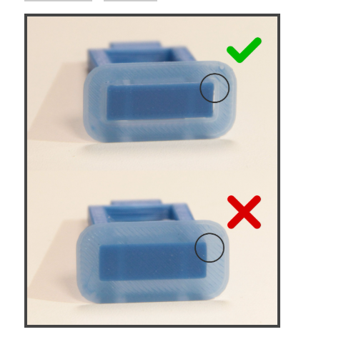

- Check that the bridge at the top of the leg test has crossed the gap cleanly
- The thinner support bridges in the middle of the legs do not need to be complete, but problems there can be an indicator of more hidden printing issues
- Check that the brim has printed as a separate object around the leg
- Check that the brim is easy to remove. If it is difficult to remove, check that it has not been joined to the leg when sliced
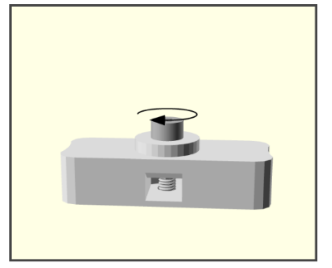
Step 4: Test assembly of the nut trap
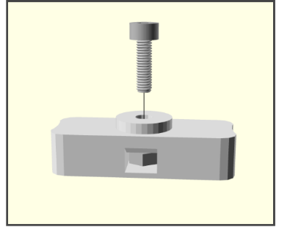
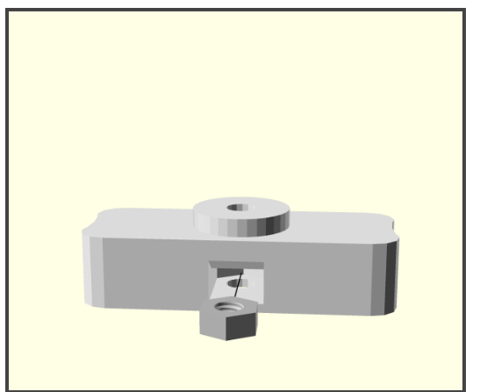

- Check that the nut hole entrance is clear and free from dangling filament. If there are obstructions this indicates that there are printing issues
- Place an M3 nut into the slot in the nut trap test object
- Put an M3x10 cap head screw into the hole above the nut
- Tighten with a 2.5mm Ball-end Allen key until you feel reasonable resistance.
- Unscrew and remove the screw. The nut should stay mounted.
- Check that you have not crushed the surface of the test object with the screw. If you have, reprint the test object and try using less force to embed the nut.

Print the plastic parts
For this section you will need:
Tools
- 1 Fused Filament 3D printer
- 1 precision wire cutters
- 1 utility knife - Not a scalpel!
Materials
- 20 g of Black PLA filament
- 375 g of PLA filament - Of any colour you want. Two contrasting colours may look best.
Step 1: Check your printer settings
Check your printer is configured as suggested in the Configure and test your printer page.
The recommended printer settings are given in the Configure and test your printer page. It's also a good idea to try the test print if you have not printed the microscope before.
Step 2: Printing
The microscope body has a custom brim included in the STL. This may require custom print settings.
Now you have tested your printer and PLA filament you can print the following parts:
- Actuator assembly tools (nut tool, band tool, and band tool cover): actuator_assembly_tools.stl
- Gear tools (gear holder and nut spinner): gear_tools.stl
- Lens tool: lens_tool.stl
- Sample clips: sample_clips.stl
- Main body: main_body.stl - The smart brim may require custom print settings.
- 3 cable tidy caps: cable_tidies.stl
- Microscope stand: microscope_stand.stl
- Electronics drawer: electronics_drawer-pi4_sanga_stack_11mm.stl - This electronics drawer is for a Pi 4 and HAT-style Sangaboard with 11mm tall headers. For all other combinations of electronics, refer to the customisation page
- 3 small gears: small_gears.stl
- Illumination dovetail: illumination_dovetail.stl
- Condenser arm: condenser.stl - This should be printed in dark, opaque filament.
- Condenser board spacer: condenser_board_spacer.stl
- Condenser lid: condenser_lid.stl
- Illumination thumbscrew: illumination_thumbscrew.stl
- 3 large gears: large_gears.stl
- 3 feet: feet.stl
- Optics module: optics_picamera_2_rms_f50d13.stl - This must be printed in black! 
- pi camera cover: picamera_2_cover.stl
You can download all of the STLs as a single zipfile
Step 3: Clean-up of printed parts
Be careful when removing brim
To avoid injury first remove the bulk of the brim without a knife. Remove the remaining brim with a peeling action as described below.
Carefully remove the printing brim from all parts (except the main body).
To remove brim:
- Use precision wire cutters to remove most of the brim from the part.
- Clean up remaining brim with a utility knife:
  - Hold the knife in your dominant hand with 4 fingers curled around the handle, leaving thumb free.
  - Hold the part in your other hand, as far away from the surface to be cut as possible.
  - Support the part with the thumb of your dominant hand.
  - Place blade on surface to be cut, and carefully close your dominant hand moving the blade, under control, towards your thumb.

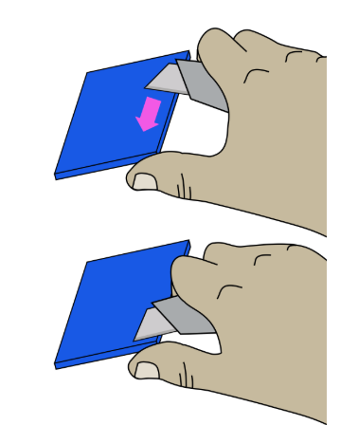
Prepare the main body
For this section you will need:
Tools
- 1 2.5mm Ball-end Allen key
- 1 extra M3x10 cap screw - For mounting trapped nuts
- 1 precision wire cutters - Can use a utility knife if these are unavailable.
- 1 utility knife
Printed Parts
- 1 main body
Mechanical Components
- 12 M3 nut

Step 1: Remove brim and supports
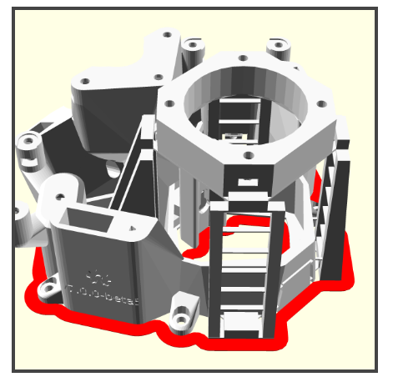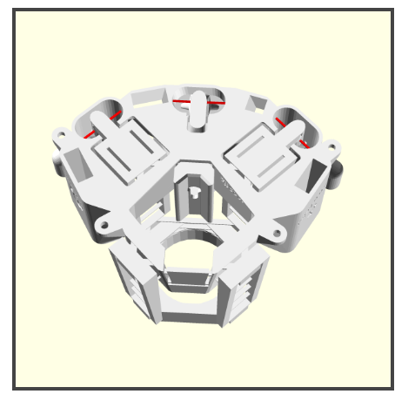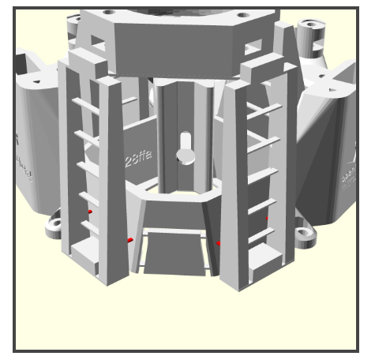
The main body has some custom supports and a custom brim to remove. These are highlighted in red in the images.
- Remove the brim with a utility knife and precision wire cutters
- Cut out the ties inside the actuator columns (6 total) with the precision wire cutters
- Cut out the ties for the rear legs (4 total) with the precision wire cutters and trim the stubs flush, so that they do not obstruct the stage movement
Step 2: Embed mounting nuts in the stage
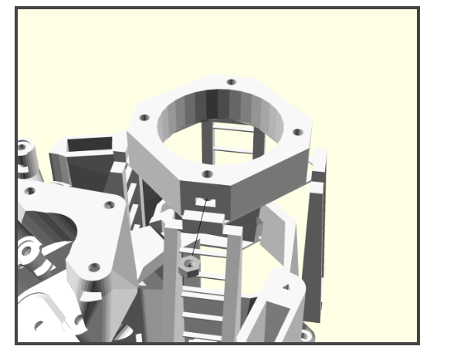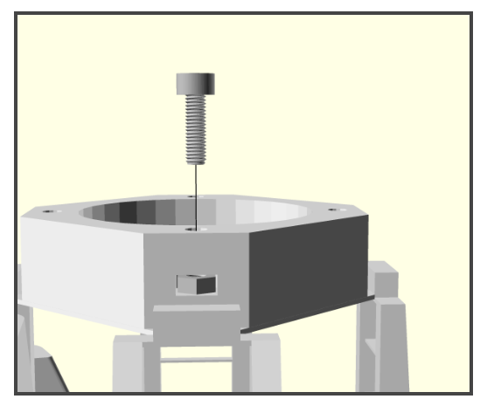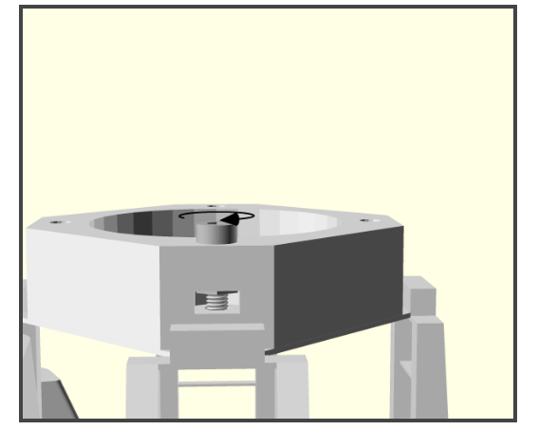
- Place an M3 nut into one of the slots at the side of the stage
- Put an M3x10 cap head screw into the hole above the nut
- Tighten with a 2.5mm Ball-end Allen key until you feel reasonable resistance.
- Remove the screw. The nut should stay mounted.
- Repeat for the other three holes in the stage.
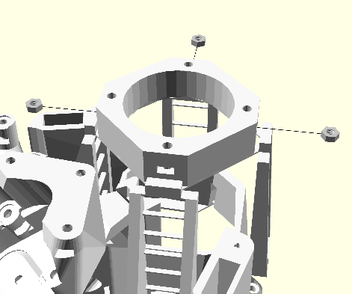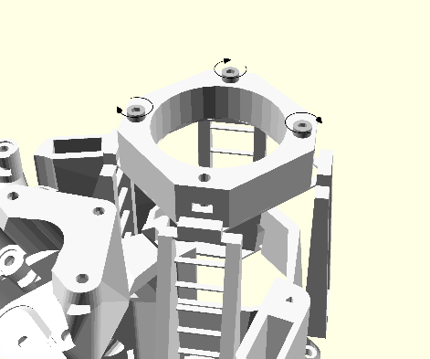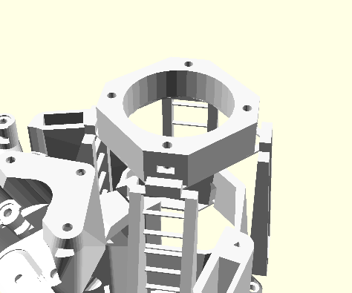
Step 3: Embed mounting nuts in the illumination platform
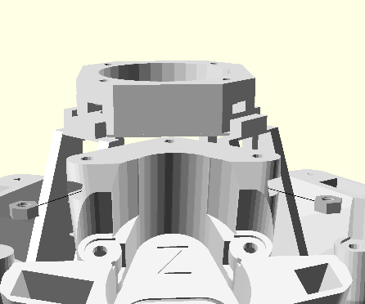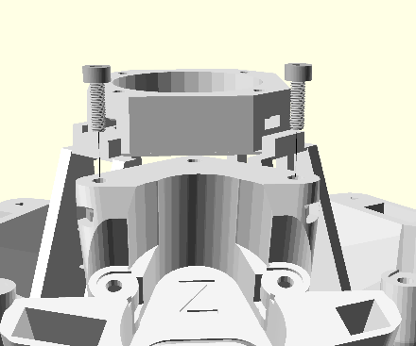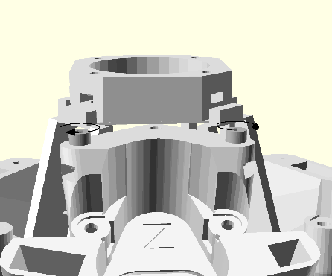
- Repeat the steps used above to add two M3 nuts into the platform above the z-axis. You do not need to insert a nut in the third hole on the illumination platform
Step 4: Embed mounting nuts for the X and Y motors
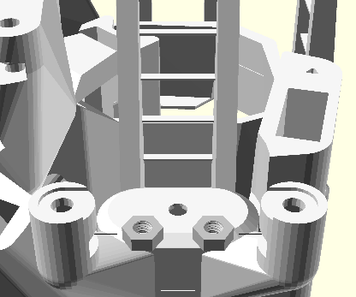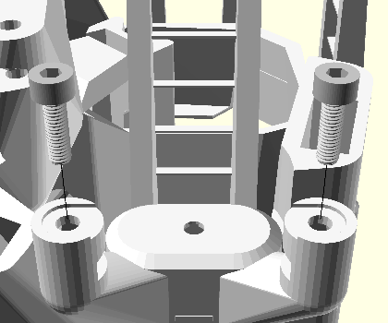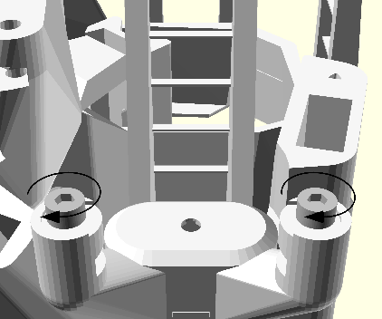
- Repeat the steps used above to add two M3 nuts each to the X and Y motor mounts (Only Y axis side shown in the images)
Step 5: Embed mounting nuts for the Z motor
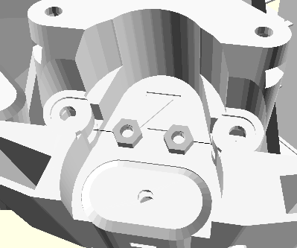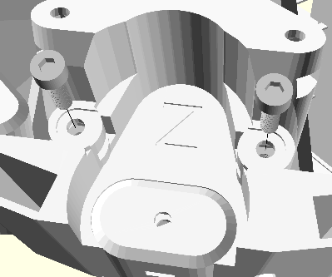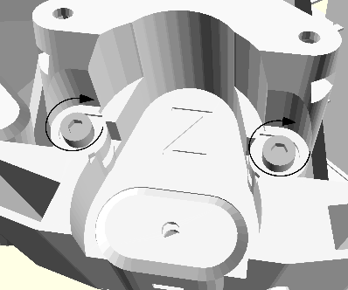
- Repeat the steps used above to add two M3 nuts to the Z motor mount
The prepared main body is now ready for assembly.
Prepare the microscope stand

