Experiment No 3:

Combinational Circuits : Structural Modeling Simulation

Submitted To:

Ubaid Ullah Fayyaz

Submitted By :

Muhammad Aqib Wazir

2022-EE-172

Section D

Digital System

University Of Engineering And Technology, Lahore

Truth Table:

|  |  |  |  |  |  |  |  |  |  |
| --- | --- | --- | --- | --- | --- | --- | --- | --- | --- |
| **a** | **b** | **c** | **c1** | **ab1** | **ab2** | **ab3** | **ab23** | **x** | **y** |
| 0 | 0 | 0 | 1 | 0 | 1 | 0 | 1 | 1 | 0 |
| 0 | 0 | 1 | 0 | 0 | 1 | 0 | 1 | 0 | 0 |
| 0 | 1 | 0 | 1 | 1 | 1 | 1 | 0 | 0 | 0 |
| 0 | 1 | 1 | 0 | 1 | 1 | 1 | 0 | 1 | 0 |
| 1 | 0 | 0 | 1 | 1 | 1 | 1 | 0 | 0 | 0 |
| 1 | 0 | 1 | 0 | 1 | 1 | 1 | 0 | 1 | 0 |
| 1 | 1 | 0 | 1 | 1 | 0 | 1 | 1 | 0 | 1 |
| 1 | 1 | 1 | 0 | 1 | 0 | 1 | 1 | 1 | 1 |

Circuit Diagram:

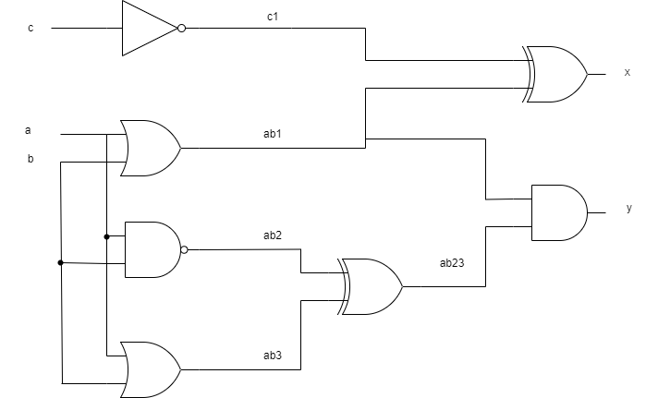

Maximum combinational delay in Synthesis:

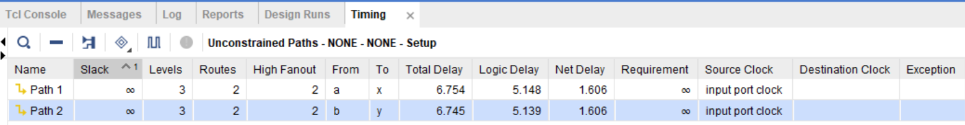

Resource Utilization:

