Name: Aqib Shakeel | Reg no. : 2022104
Feculty: Cyber security | Cs-205L Final

Question : 1
part(a)
{I}

Making a file with the name “permission.txt” with random data:

Changing permission with the command “chmod”:

Checking the permission before and after:

{ii}

Creating a file with the name “wordlist.txt” and added some data.

Part(b)

Question 2:

cloning:
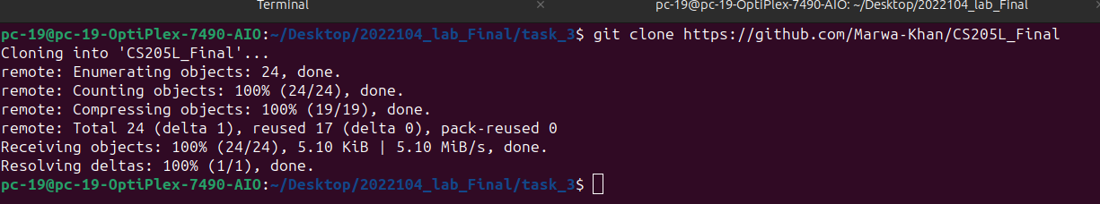

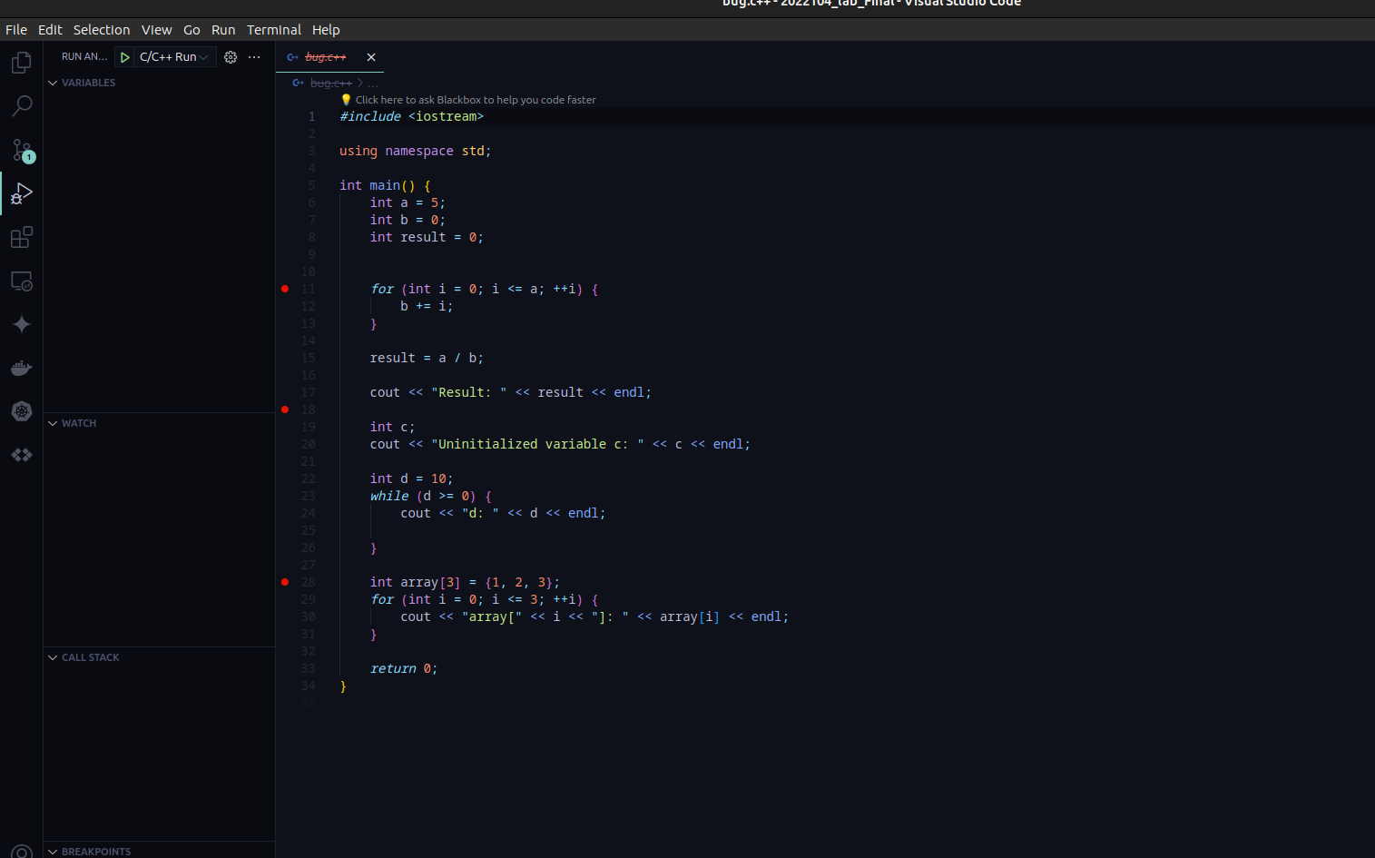

Question 3:

Modifying the existing index.html

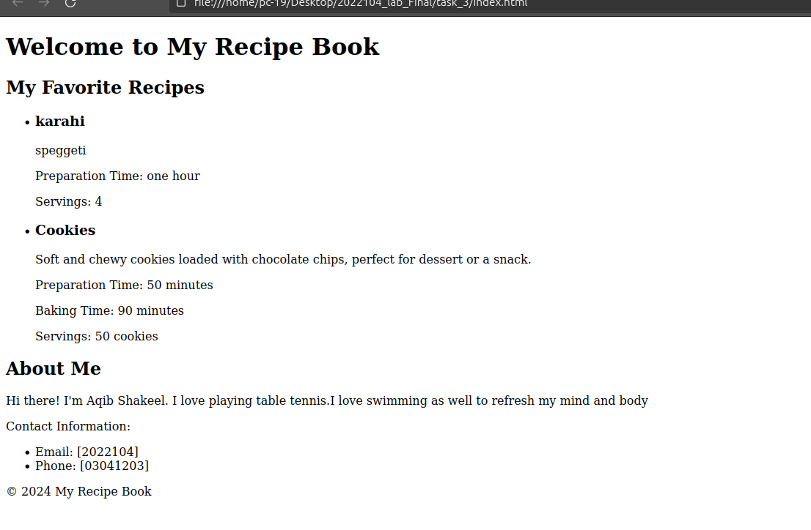

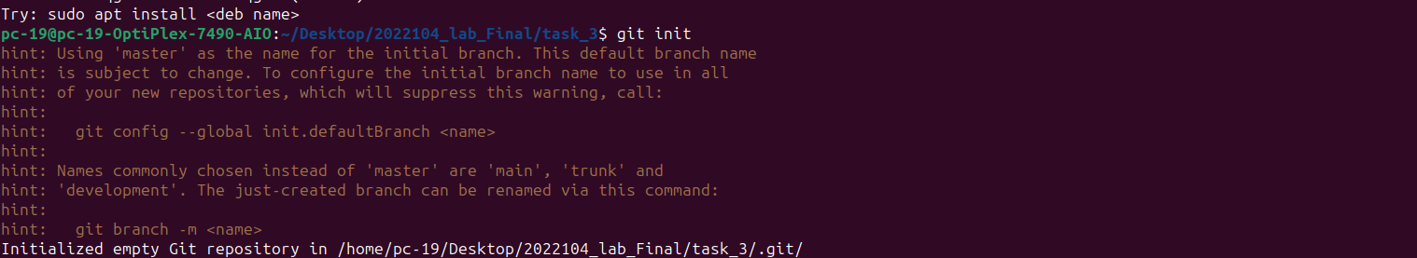
Add remote repository:

checking git status:

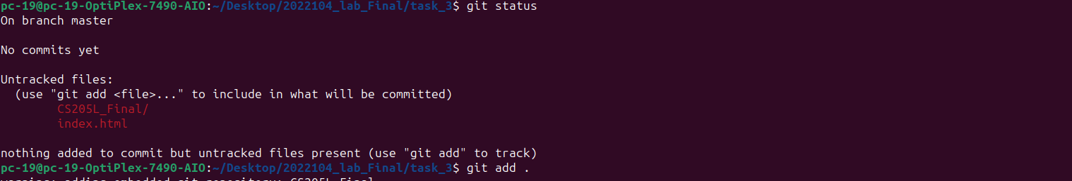

Committing changes.

built image
docker built -t image name
docker login
docker push

