1. **Task : User Registration**

API : <http://localhost/rest-auth/registration>

Location : srms/urls.py

API Type : List Create API

Details : This API is used for the registration of new user.

Fields :

* + Username : The username of user, this field will be unique.
  + Email : The email id of user. Not already registered.
  + Password1 : The Password of user. It should be 8 characters long with 1 capital letter, 1 symbol and 1 digit.
  + Password2 : The field will be same as Password1.
  + Is customer : This field set user is customer or not.
  + Is admin : This field set user is Admin or not.
  + Notification token : Generate notification token.
  + Password changed : Set user have changed password permission or not.

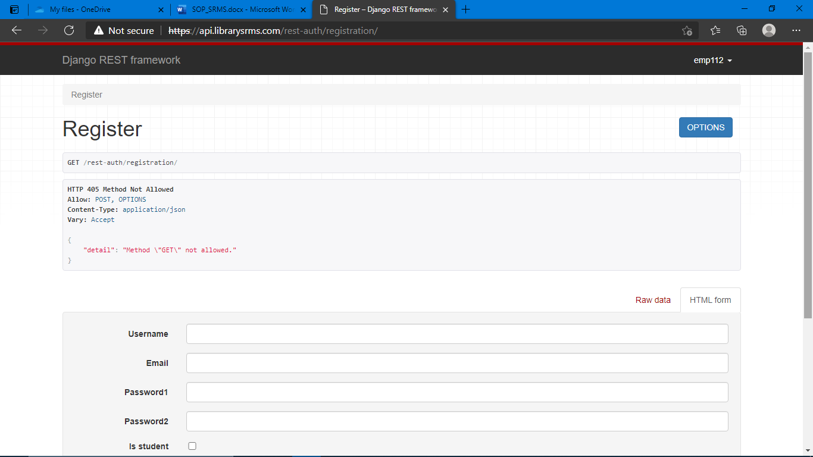

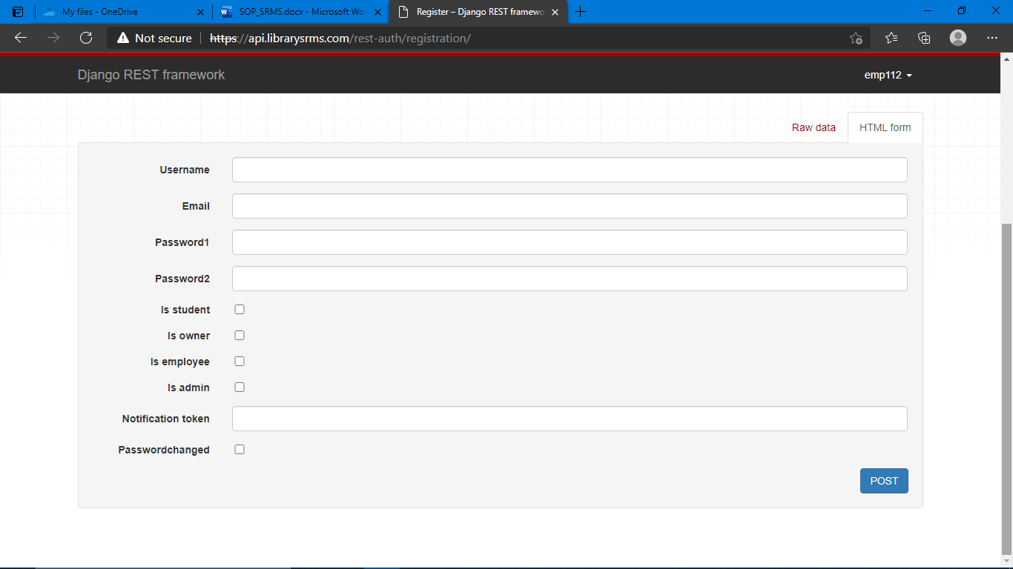

1. **Task : User Login**

API : <http://localhost/rest-auth/login>

Location : srms/urls.py

API Type : List Create API

Details : This API is used for the login in the site.

Fields :

* + Username : The username of user.
  + Email : The email id of user.
  + Password : The password of user.

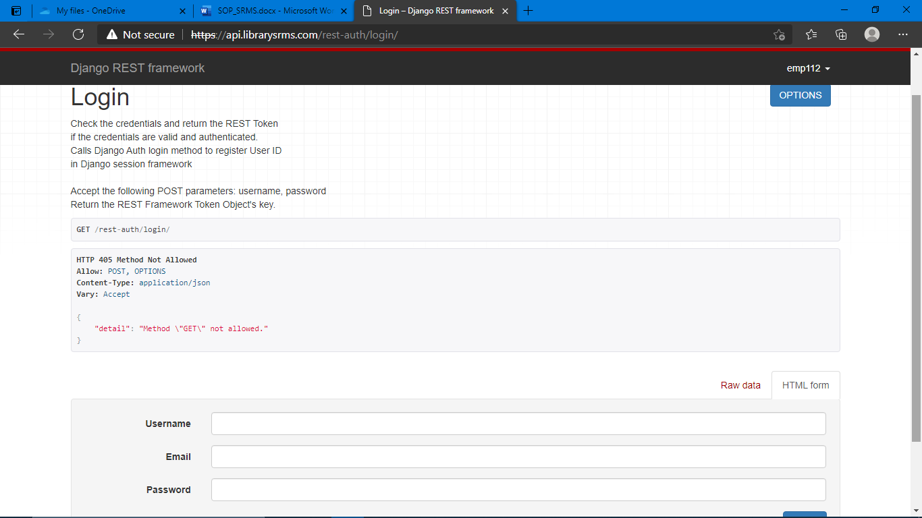

1. **Task : Django Admin Sie Login**

API : [http://localhost/](http://localhost/rest-auth/login)admin

Location : srms/urls.py

API Type : List Create API

Details : This API is used for the super user login.

Fields :

* + Username : The username of superuser.
  + Password : The password of superuser.

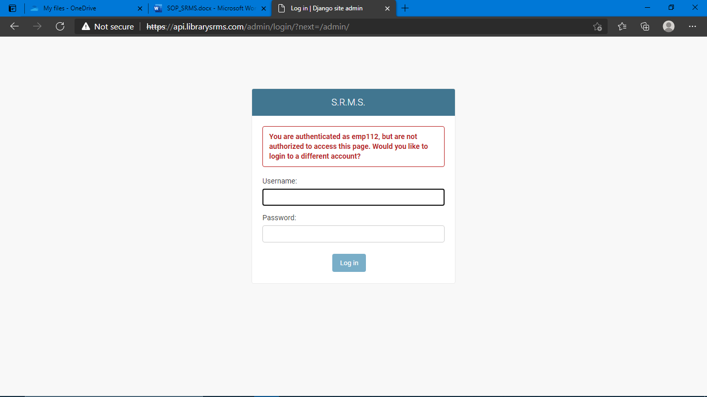

1. **Task : Library Registration**

API : [http://localhost/](http://localhost/rest-auth/login)api/library

Location : srms/routers.py

API Type : List Create API

Details : This API is used for the register library.

Fields :

* + Name : The name of library
  + Active : The active status of library.
  + Date : The registration date of library, this field is auto added.
  + History : This field auto save the history of library model.

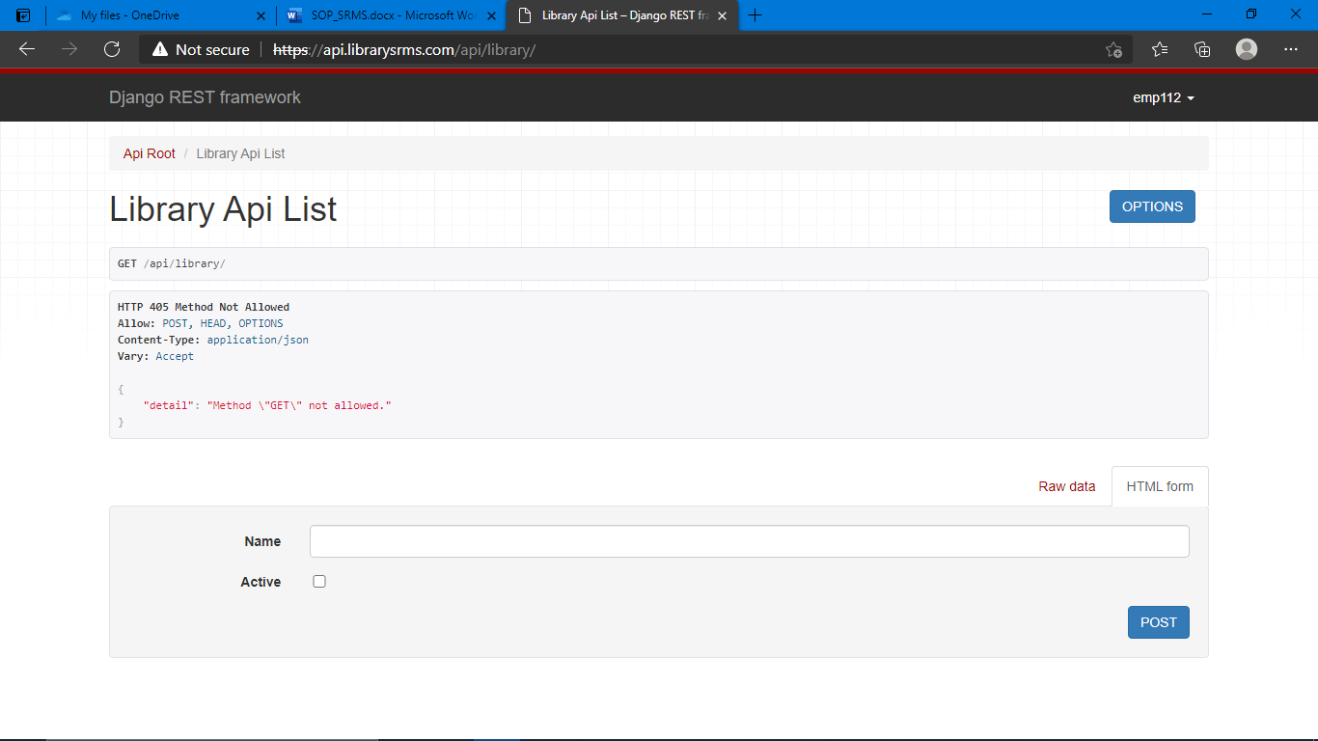

1. **Task : Library Branch Registration**

API : [http://localhost/](http://localhost/rest-auth/login)api/library-branch

Location : srms/routers.py

API Type : List Create API

Details : This API is used for the register library branch.

Fields :

* + Library : The id of registered library.
  + Name : The branch name.
  + Logo : The image of branch logo.
  + Seat capacity : The number of seating capacity of branch.
  + No. of booking per slot : How much users book per slot.
  + No. of lockers : The number of lockers in library branch.
  + Opening days : The opening days of library branch.
  + Opening time : The opening time of library branch.
  + Closing time : The closing time of library branch.
  + Night shift from : The starting time of night shift.
  + Night shift to : The ending time of night shift.
  + Description : The details and description of library branch.
  + Beginning of summer season : The starting month of summer season.
  + Beginning of winter season : The starting month of winter season.
  + Address : The address of library branch.
  + City : The city of library branch.
  + State : The state of library branch.
  + Pincode : The pincode of city.
  + Location : The location of library branch.
  + Admission fees : The admission fees of library branch.
  + Locker fees : The locker fees of library branch.
  + Gst : The gst for addmission.
  + Ammenities : The facilities provided by library.
  + Image : The image of library.
  + Date : The registration date of library, this field is auto added.
  + Active : The active status of library.
  + Active sub : The active status of library.
  + Report : Upload the file of library.
  + History : This field auto save the history of library branch model.

