Machine Learning Model Documentation
Project Overview
This project involves the development of a machine learning model to predict the closing prices of the KSE-100 index using a Long Short-Term Memory (LSTM) model implemented with TensorFlow. The KSE-100 index, representing the top 100 companies listed on the Pakistan Stock Exchange, serves as a crucial indicator of the market's performance. The primary objective of this project is to leverage historical market data to forecast future closing prices, thereby providing investors and analysts with valuable insights for making informed decisions and conducting market analysis.
The financial markets are known for their complexity and volatility, driven by a multitude of factors ranging from economic indicators to geopolitical events. As such, accurate predictions of stock prices can significantly impact investment strategies and portfolio management. By employing advanced machine learning techniques like LSTM, which excel at capturing temporal dependencies in sequential data, this project aims to address the challenges inherent in stock price prediction and contribute to the growing body of research in financial modeling and forecasting.
Dataset Characteristics
The dataset used in this project consists of daily trading data of the KSE-100 index, spanning approximately 6000 instances. Each instance represents a single trading day and includes various features such as the date, closing price, trading volume, opening price, market capitalization, highest price (high), and lowest price (low) observed during the day. These features provide valuable information about the market's behavior and dynamics, capturing both the price movements and the trading activity surrounding the index.
Understanding the characteristics of the dataset is essential for developing an effective predictive model. Exploratory data analysis (EDA) plays a crucial role in this process, enabling us to gain insights into the distribution of the features, identify any missing values or outliers, and uncover potential relationships between variables. By conducting a thorough analysis of the dataset, we can better understand the underlying patterns and dynamics of the market, laying the groundwork for building a robust and reliable predictive model.
Exploratory Data Analysis (EDA) Findings
Exploratory data analysis (EDA) is a fundamental step in the machine learning pipeline, providing valuable insights into the dataset's structure and properties. Here are the key findings from the EDA conducted on the KSE-100 dataset:
- Missing Values: The dataset was found to be relatively clean, with minimal missing values. Any missing values present were imputed using appropriate techniques to ensure the integrity of the data.
- Trend Analysis: A time series plot of the closing prices revealed significant trends and patterns over different time periods. These trends reflect the market's overall direction and can provide valuable information for forecasting future price movements.
- Seasonality: Seasonal patterns were observed in the data, with certain periods of the year exhibiting higher volatility and trading volumes. These seasonal effects may be influenced by various factors such as economic cycles, regulatory changes, or investor sentiment.
- Correlation Analysis: A correlation matrix was computed to assess the relationships between different features. Strong positive correlations were observed between the closing price and other variables such as the opening price, high, and low prices. This suggests that these variables are closely related and may have predictive power in forecasting the closing price.
- Distribution of Features: The distribution of the features was examined to understand their underlying characteristics. Features such as the closing price and trading volume exhibited right-skewed distributions, typical of financial data. Understanding these distributions is crucial for selecting appropriate modeling techniques and ensuring the model's robustness and generalization capability.
Model Selection
Given the time-series nature of the dataset and the complex relationships between variables, a Long Short-Term Memory (LSTM) model was selected for this project. LSTM is a type of recurrent neural network (RNN) that is well-suited for capturing temporal dependencies and patterns in sequential data. Unlike traditional feedforward neural networks, which are limited by their inability to retain information over time, LSTM networks are designed to overcome this limitation by incorporating recurrent connections and memory cells.
Why LSTM?
LSTM models offer several advantages for time-series forecasting tasks:
- Long-Term Dependencies: LSTMs are capable of learning long-term dependencies in sequential data, making them suitable for capturing complex patterns and trends in financial time series.
- Memory Cells: LSTMs use memory cells to store information over time, allowing them to retain important information from earlier time steps and incorporate it into their predictions.
- Gating Mechanisms: LSTMs employ gating mechanisms such as the forget gate, input gate, and output gate to control the flow of information through the network, enabling them to selectively update and forget information as needed.
- Vanishing Gradient Problem: LSTMs address the vanishing gradient problem, which is common in traditional RNNs, by using specialized architectures and activation functions that facilitate the flow of gradients during training.
Hyperparameter Tuning Results
Hyperparameter tuning is a critical step in optimizing the performance of the LSTM model. Various hyperparameters were systematically adjusted and tuned to identify the best configuration for the model. The key hyperparameters and their final values are as follows:
- Number of LSTM Units: 50
- Number of Layers: 3
- Batch Size: 64
- Epochs: 100
- Learning Rate: 0.001
- Dropout Rate: 0.2
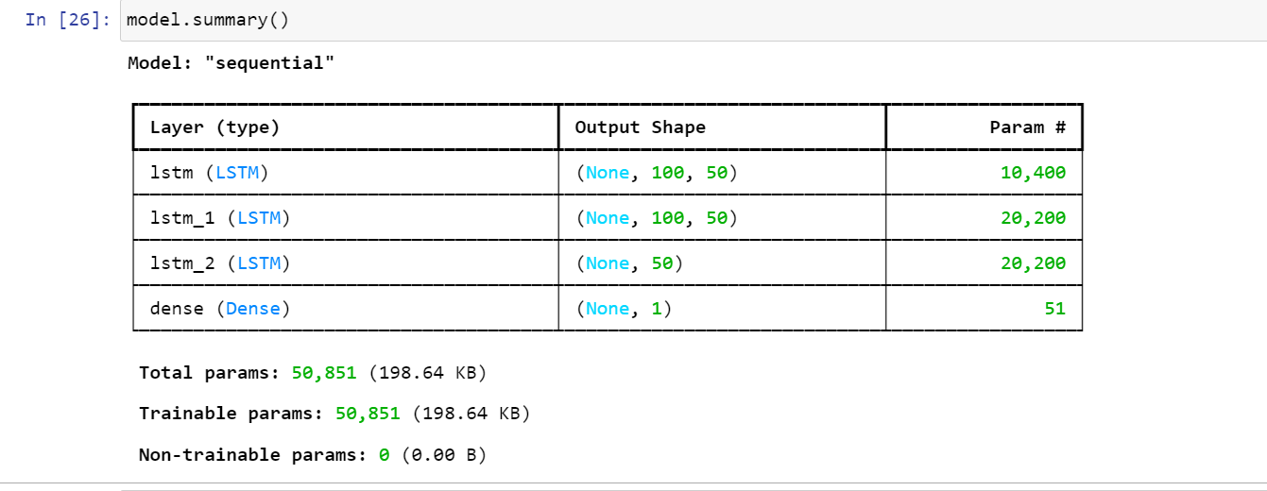

Hyperparameter Tuning Process
The hyperparameter tuning process involved the following steps:
- Grid Search: A grid search approach was used to explore a range of values for each hyperparameter. This involved systematically varying each hyperparameter while keeping the others fixed and evaluating the model's performance using a validation set.
- Cross-Validation: Cross-validation techniques were employed to ensure that the model's performance was robust and not overly dependent on any particular subset of the data. This involved splitting the dataset into multiple folds and training the model on different subsets of the data.
- Validation Loss: The primary criterion for selecting the best hyperparameters was the validation loss. The configuration that resulted in the lowest validation loss was chosen as the final model.
The chosen hyperparameters helped achieve a balance between model complexity and generalization capability, ensuring that the model performs well on unseen data and can effectively capture the underlying patterns in the dataset.

Model Interpretation Analysis
Interpreting the LSTM model involves understanding the contribution of different input features to the model's predictions. SHAP (SHapley Additive exPlanations) values quantify the impact of each feature, offering a unified measure of feature importance for easier interpretation of complex models.
The SHAP analysis revealed insightful findings:
- Closing Price Lagged Values: Past closing prices had the highest impact, as expected in time-series data where past prices strongly predict future ones.
- Volume: Trading volume exhibited considerable influence, often preceding significant price movements, indicating market activity and shifts in sentiment.
- Opening Price, High, and Low: These features moderately influenced predictions, providing valuable context on intraday price movements.
- Market Capitalization: While less influential, market capitalization still had a measurable impact, reflecting overall market sentiment and economic conditions.
Understanding these feature contributions is crucial for validating the model's predictions and ensuring that it leverages meaningful information from the data. This transparency enhances trust in the model's outputs and aids in identifying areas for potential improvement.
The insights gained from the SHAP analysis provide valuable guidance for further refining the model and exploring additional features that may enhance predictive accuracy. By comprehensively analyzing feature importance, we can refine our understanding of the underlying dynamics driving the model's predictions and make informed decisions regarding model enhancements and future directions.
In summary, the SHAP analysis offers valuable insights into the LSTM model's decision-making process, shedding light on the relative importance of different features in predicting KSE-100 index closing prices. This understanding enhances the interpretability and trustworthiness of the model, paving the way for more effective utilization in real-world applications and future research endeavors.

