**Web-based Interface Design**

**(CSF3133)**

**LAB REPORT**

**LECTURE**: Assoc. Prof. Ts. Dr. Wan Nural Jawahir Hj Wan Yussof

**DEMONSTRATOR**: Madam Wan Fatin Fatihah Yahya

**NAME** : AQIL MIZWAR BIN MOHD ROSLAN

**MATRIC**: S72471

**3.1 BLOCK**

Code

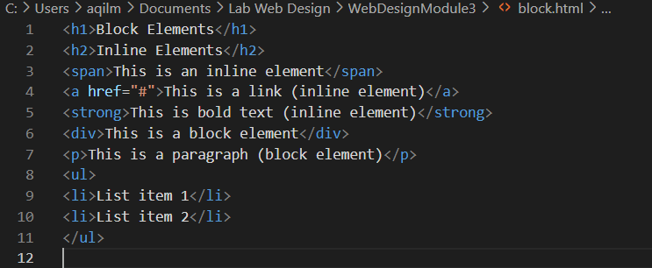

Output

**3.2 DIV**

Code

Output



**3.3 ENTITY**

Code

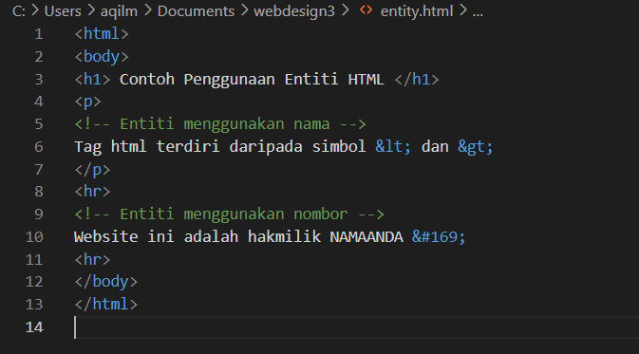

Output

**3.4 INTRO5**

Code

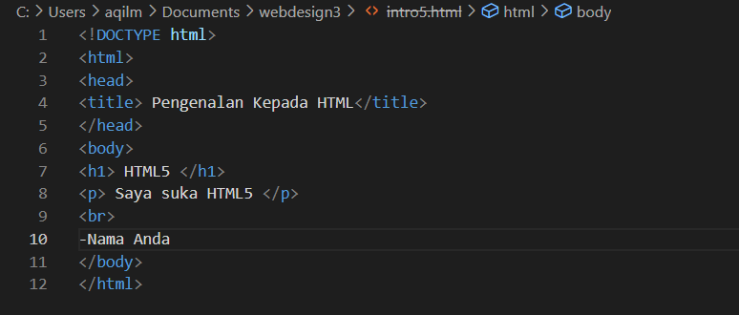

Output

**3.5.1 INPUT5**

Code

Output

**3.5.2 INATTRIBUTE5**

Code

Output

**3.5.3 OUTPUT5**

Code

Output

**LAB 3 EXERCISE**

Code

Output

**QUESTION**

1. What display did you find? Does your HTML5 file comply with the requirements? If not, what are the mistakes made?

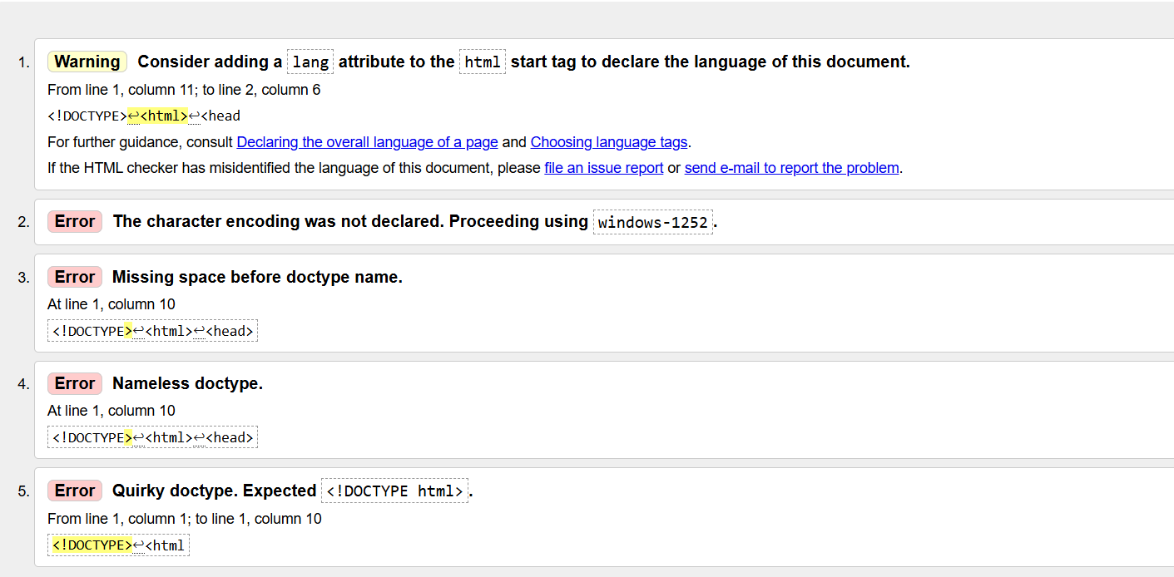

The most important thing to remember is that the use of <!DOCTYPE html> is mandatory in every document that uses HTML5

1. Fill in the ‘Amen’ value in the ‘Student Name’ box and leave it blank in the ‘Father Name’ column. Then, click on the ’Save’ button. What happened?

* It can’t be submit since the ‘Father Name’ is required which is user need to fill the field

1. Refresh your web files and make sure both spaces are empty. Then, enter the letter ‘A’ into the ‘Student Name’ box. What did you find? Does autocomplete work?

* No