Lab1

*Student: Ahmad Alkabeer*

*422112150*

Part 1:

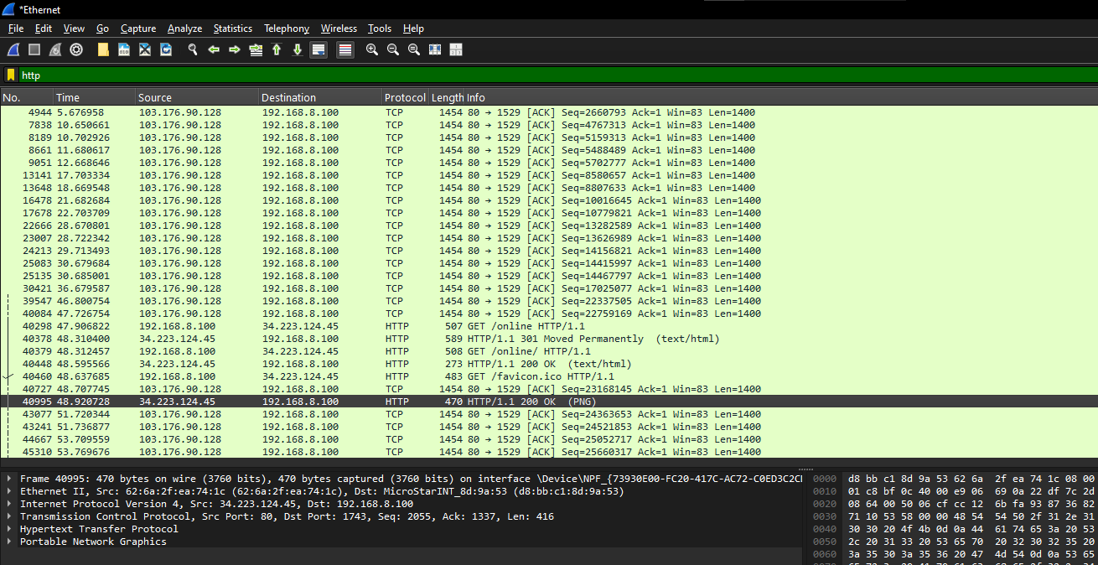

Part2:

Task 1:

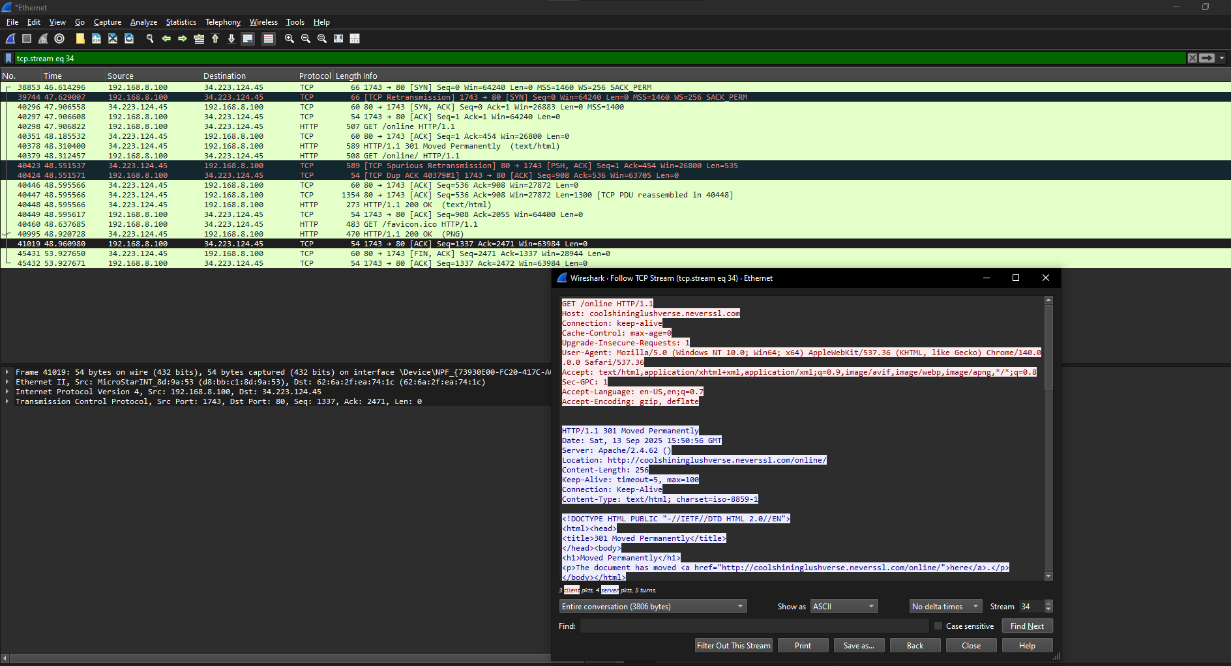

Task 2\ step1:



Task2\ step 4: 

Part3:

Task1:

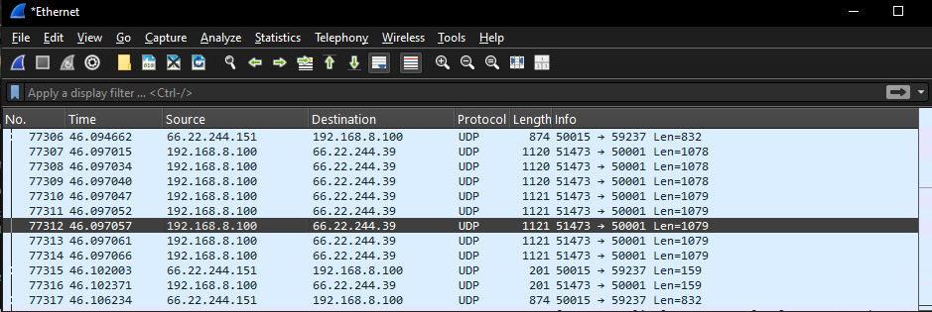

Task2:

Part4:

Task1:

|  |  |  |
| --- | --- | --- |
|  | TCP or UDP | Reasons |
| Reliability and Connection Establishment | TCP | TCP provides reliable communication through 3-way handshakes, acknowledgments, retransmissions, and error checking. In the Wireshark capture, you can see the **SYN, SYN-ACK, and ACK** steps (connection establishment) as well as retransmissions, which prove reliability. |
| Data Integrity and Ordering | TCP | |  | | --- | |  |   TCP ensures ordered delivery of packets and checks for data corruption using sequence numbers and acknowledgments. From the capture, you can see **sequence numbers and ACK numbers** being exchanged, which guarantees correct order and integrity. UDP does not provide ordering. |

Task2:

|  |  |  |
| --- | --- | --- |
|  | TCP | UDP |
| Use cases | - Web browsing (HTTP/HTTPS)  - File transfers (FTP, SFTP)  - Email (SMTP, IMAP, POP3)  - Remote access (SSH, Telnet) | - Streaming (YouTube, Netflix, Spotify)  - Voice over IP (VoIP, Skype, Zoom)  - Online gaming (low-latency required)  - DNS lookups |
| Performance | |  | | --- | |  |  |  | | --- | | - Slower due to overhead from connection establishment, reliability, and ordering mechanisms.  - Higher latency compared to UDP. | | - Faster, lightweight, low latency since there’s **no connection setup, no acknowledgments, no retransmissions**.  - But less reliable (packets may be lost or arrive out of order). |