LAB 2 CS471

*Student Ahmad Alkabeer*

*422112150*

PART1:

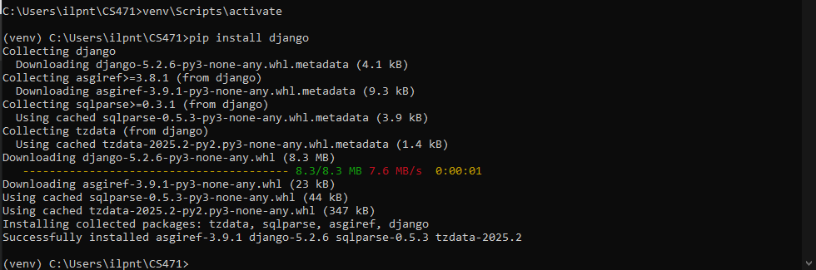Task1:

Task2:

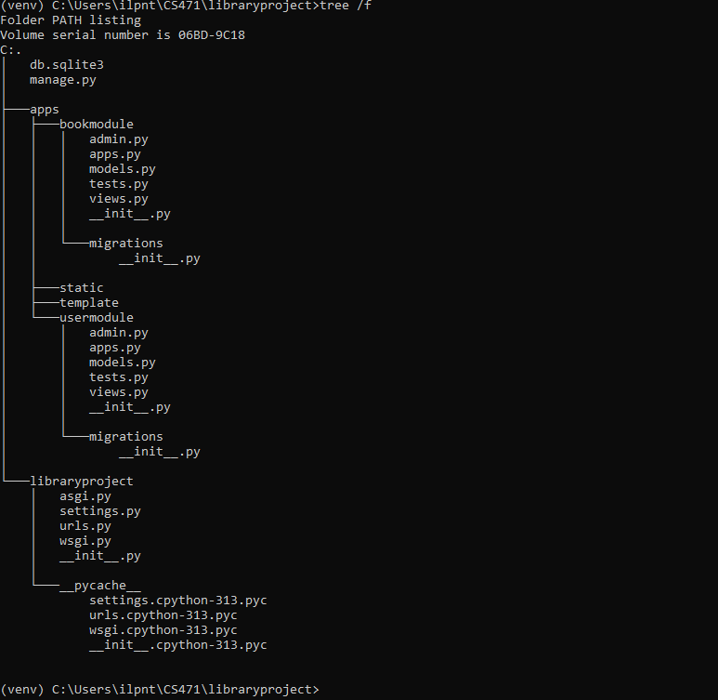Task3: Step 1 & 2:

Changed names to app. (as tasked in step 3)

Step4:

Step 5:

Everything works!

Part 2:

Task 1:

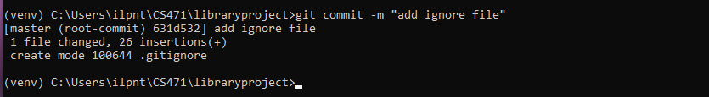

Task2:

