Lab3 CS471

*Student Ahmad Alkabeer*

*422112150*

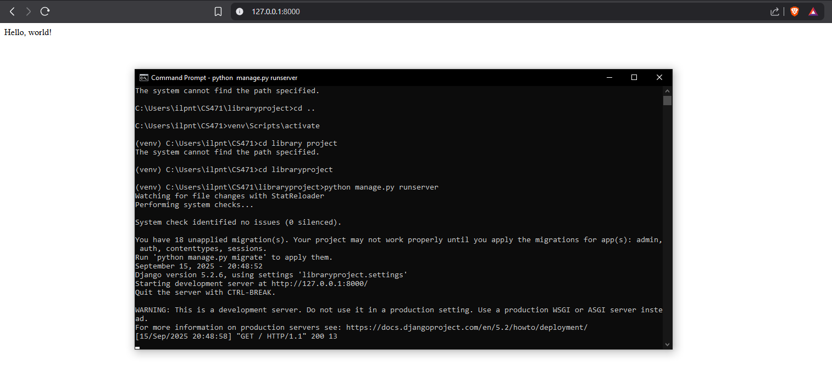PART1:

Task 1 :

Task2:

Task 3:

Task 4,5,6:

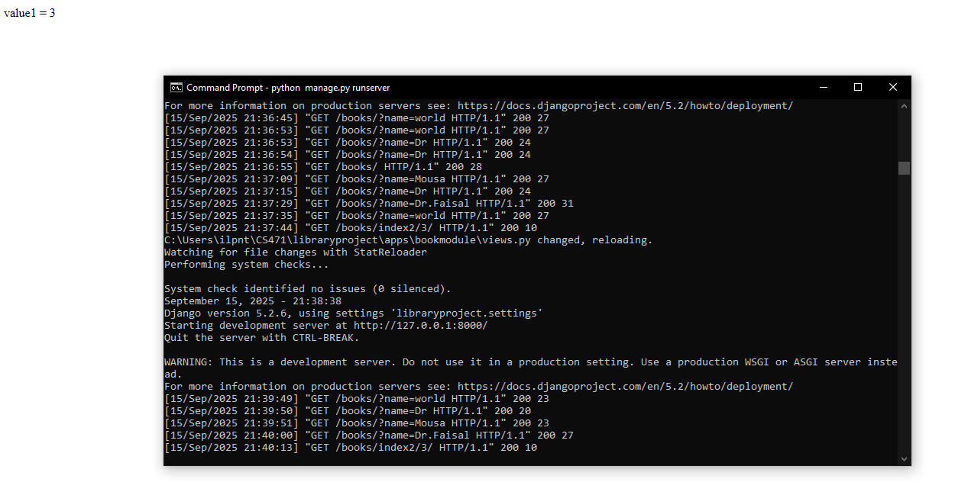

Task 7:

