A SMARTER OPERATING SYSTEM FOR RESIDENCY SCHEDULING
Clarity Schedule
From resident requests to a fair, editable, publish-ready schedule
A program-wide platform that replaces disconnected forms, spreadsheets, PDFs, and manual cross-checking with one coordinated workflow for residents, chiefs, and departments.
2  connected portals | 13 or 26  configurable blocks | 1  source of scheduling truth
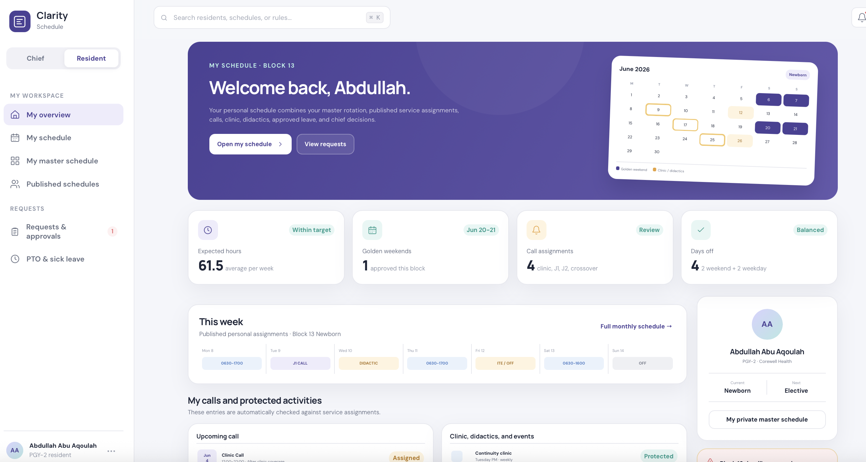
Resident experience: personal assignments, calls, protected time, requests, and schedule statistics in one place.
Designed for the complexity of graduate medical education - flexible enough for Pediatrics, Internal Medicine, Emergency Medicine, and other training programs.

THE OPERATIONAL PROBLEM

Scheduling is not one spreadsheet
Every block combines annual rotations, monthly service schedules, protected educational time, individual preferences, leave, coverage requirements, work-hour limits, and last-minute changes. Today, these inputs often live in separate places and must be reconciled manually.
Fragmented inputs  Google Forms, emails, PDFs, institutional clinic rules, and annual master schedules are reviewed separately. | Repeated manual work  Chiefs rebuild the same logic each block and repeatedly check who is eligible, available, or over-assigned.
Hidden conflicts  Clinic, didactics, post-call needs, adjacent calls, leave, and next-block assignments are easy to miss. | Limited visibility  Residents struggle to understand assignments and fairness; leadership lacks a real-time readiness view.

One connected workflow
1  Collect  Residents submit preferences, leave, weekends, and master-schedule rankings. | 2  Configure  Chiefs define institution patterns, services, coverage roles, and working hours. | 3  Generate  The system pulls eligible residents from the master schedule and builds editable drafts. | 4  Validate  Coverage gaps, clinic conflicts, hours, nights, and fairness are flagged before publishing.
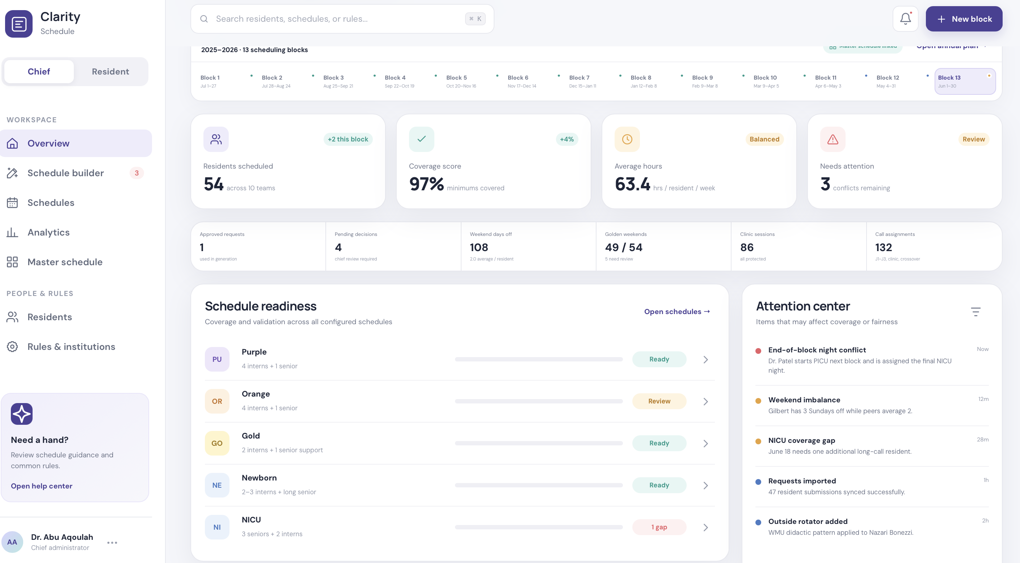
Chief overview: each block shows configured services, readiness, coverage status, and items requiring attention.

BUILT FOR CHIEFS

Generate faster. Edit freely. Publish with confidence.
Clarity does not lock chiefs into a rigid algorithm. It prepares a rules-aware draft, explains conflicts, and preserves human judgment through an Excel-like editing experience.
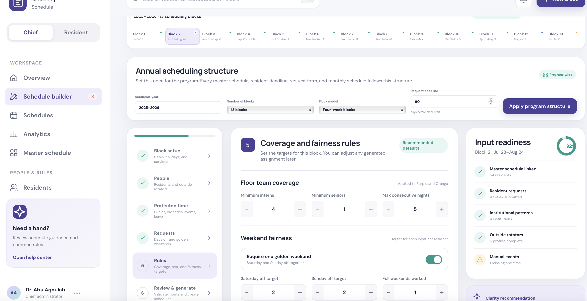
Configurable service builder: add any service, define teams or units, staffing roles, eligible PGY levels, and working-hour templates.
Program configuration  Choose the academic year, number of blocks, block model, request deadlines, holidays, and protected events. | Service-level rules  Create NICU, PICU, floor teams, consult services, jeopardy, night coverage, or any custom service.
Master-linked rosters  Automatically pull residents assigned to a service in that block, while allowing call-pool or manual additions. | Editable schedule workspace  Drag, move, copy, and revise assignments while coverage, hours, nights, and fairness recalculate.
Conflict intelligence  Flag clinic overlap, didactics, leave, back-to-back calls, staffing gaps, and end-of-block night conflicts. | Readiness and analytics  Track schedules as pending, draft, ready, or published and compare calls, weekends, nights, and work hours.

BUILT FOR RESIDENTS

A clear schedule and a simpler way to request changes
Residents see only their private annual master schedule, while published service rosters remain visible program-wide. Requests become structured data instead of messages that must be interpreted later.

One resident dashboard combines the monthly schedule, calls, golden weekends, clinics, didactics, leave, and expected hours.
Submit requests  Vacation, PTO, sick leave, weekends, days off, special needs, fellowship timing, and master-schedule preferences. | Understand assignments  See daily work hours, service coverage, call type, post-call time, clinic, didactics, conferences, and exams.
Call-switch marketplace  Offer an assigned call, list acceptable alternatives, and volunteer for calls offered by peers. | Instant eligibility checks  The system checks same-day clinic, next-day clinic, duplicate assignments, and back-to-back calls before submission.

Three people, one decision trail
Offerer -> receiving resident -> chief approval. The chief receives the proposed switch together with the eligibility evidence, so all three parties no longer need to search separate schedules.
The original assignment remains unchanged until final approval, protecting schedule integrity and creating a documented review process.

WHY PROGRAMS CHOOSE THIS APPROACH

Benefits beyond making the calendar
Stakeholder | Immediate benefit | Program-level impact
Chiefs | Less manual reconciliation; faster drafting; clear conflicts and fairness summaries. | More time for education, resident support, and higher-value leadership work.
Residents | Transparent assignments, easier requests, private master schedules, and safer call switches. | Improved trust, predictability, communication, and perceived fairness.
Department | Consistent rules, documented approvals, readiness tracking, and exportable schedules. | Better operational resilience, auditability, coverage awareness, and continuity.

What makes Clarity different
- Flexible by institution, specialty, service, unit, PGY level, shift type, and block structure.
- Human-in-the-loop: the system recommends and validates; chiefs retain final control.
- Rules are entered once and reused, while block-specific exceptions remain editable.
- Master schedule, monthly service schedules, resident requests, analytics, and approvals stay linked.
- Designed around real residency workflows rather than generic employee shift scheduling.

A practical pilot
Phase 1 | Configure  Load one academic year, resident profiles, institution patterns, and two representative services. | Phase 2 | Parallel test  Generate one block beside the current process and compare coverage, conflicts, fairness, and editing time. | Phase 3 | Evaluate  Collect chief and resident feedback, refine rules, then decide whether to expand program-wide.
The goal is simple: transform residency scheduling from a recurring manual project into a transparent, reusable, and safer program workflow.
Concept developed by Abdullah Abu Aqoulah | Clarity Schedule

