PARSER OUTPUT COMPARISON REPORT
Structured Parser Output vs. Marker Output
Document evaluated | et al.pdf (9 pages)
Purpose | Compare extraction quality and identify datasets and experimental parameters reported in the paper

1. Executive Summary
Both parser outputs captured most of the source document’s text, but they serve different purposes. The structured output is better suited to data pipelines because it separates content into typed elements and preserves page-level metadata. Marker produces a more readable Markdown reconstruction, with clearer section hierarchy and useful figure descriptions. Neither output should be treated as fully reliable for numerical tables, equations, or generated figure interpretations without checking the original PDF. Runtime measurements from the supplied screenshots were 13.05 seconds for Marker and 13.95 seconds for Unstructured.io; Marker was 0.90 seconds faster in these observed runs.
Recommendation: Use the structured output as the primary source for extraction and traceability, and Marker as a readability/reconstruction reference. Validate important table values, equations, and figure interpretations against the source PDF.

2. Quantitative Overview
Coverage figures below are approximate token-overlap estimates against text extracted from the source PDF. They measure text representation, not correctness of tables, equations, layout, or meaning.
Measure | Structured output | Marker output
Pages represented | 9 | 9
Approximate text coverage | 99.9% | 98.4%
Output structure | 142 typed elements | Markdown document
Notable content types | 78 narrative text, 18 titles, 9 tables, 6 formulas, 9 images, 9 footers | Headings, paragraphs, Markdown tables, image references/descriptions

Parsing Time: Screenshot Evidence
Both screenshots show the same input file, et al.pdf. Marker reports an end-to-end parsing time of 13.05 seconds, while Unstructured.io reports 13.95 seconds. The difference is 0.90 seconds (approximately 6.5% less than the Unstructured.io time). This is an observed-run comparison, not a controlled benchmark.
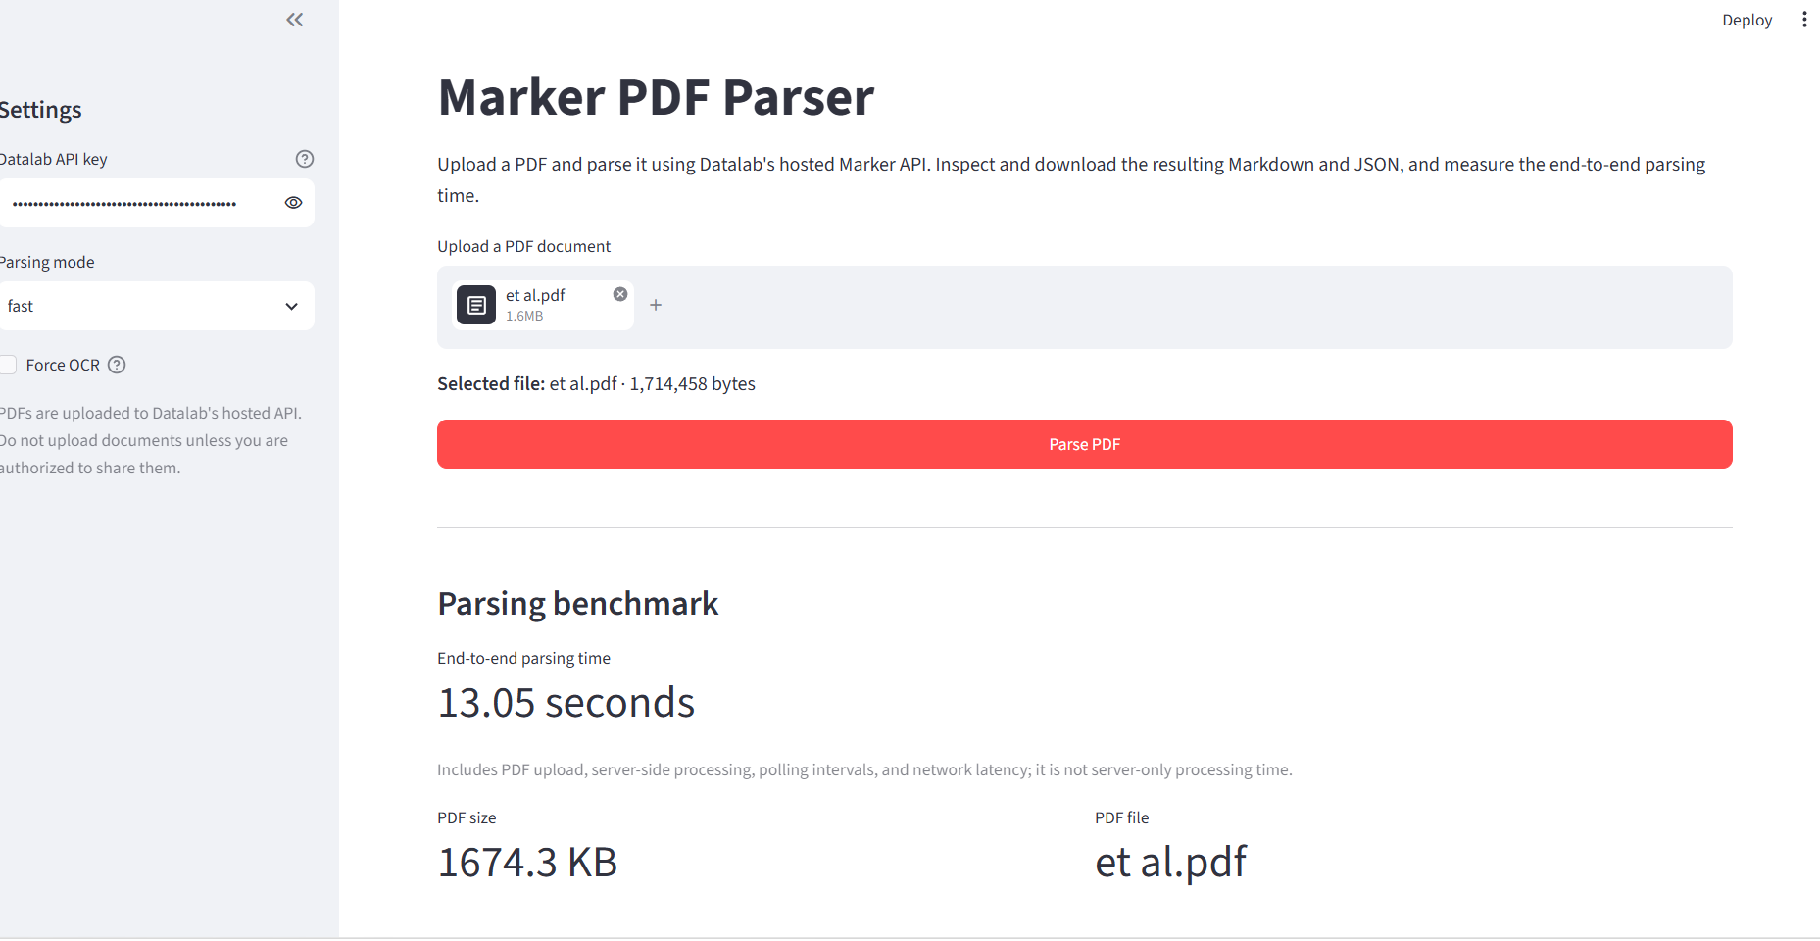
Figure 1. Marker PDF Parser — end-to-end parsing time: 13.05 seconds.
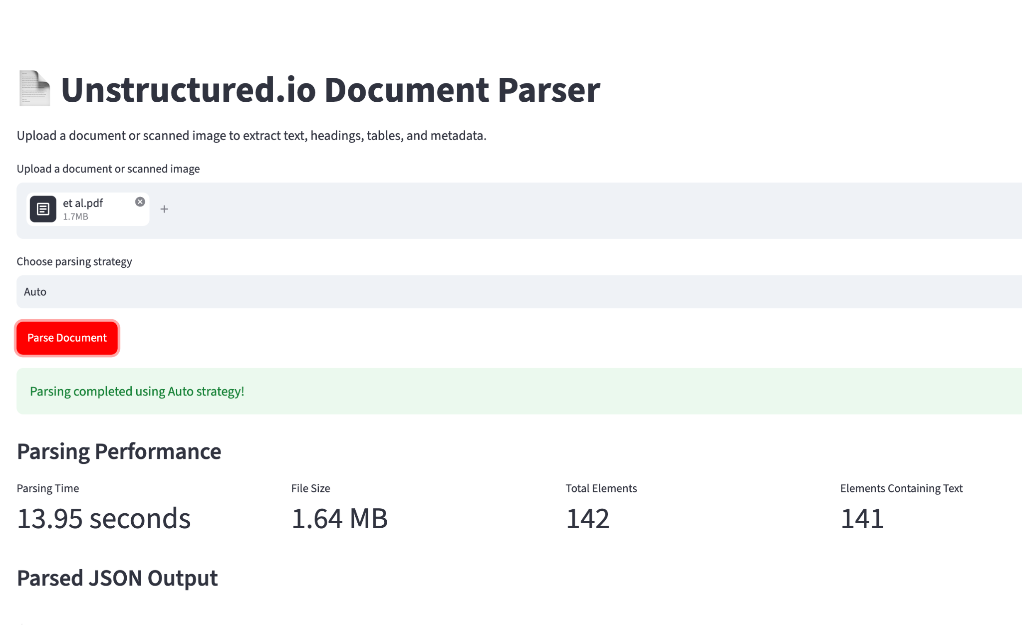
Figure 2. Unstructured.io Document Parser — parsing time: 13.95 seconds; 142 total elements, 141 containing text.

3. Detailed Parser Comparison
Area | Structured output | Marker output | Assessment
Text extraction | Very high approximate coverage; text split into typed elements. | High coverage with readable continuous text. | Structured output has a slight measured coverage advantage.
Section hierarchy | Titles and narrative elements are separate; reading order may require reconstruction. | Headings and subheadings form a clearer Markdown outline. | Marker is easier to read and review.
Tables | Separate table elements include HTML data; plain-text table strings can be scrambled. | Generally readable Markdown tables; some literal HTML tags remain. | Use both views and verify values.
Equations | Separate Formula elements, but some formula strings are visibly distorted. | Less explicit formula typing and may be harder to isolate. | Neither should be used for unverified mathematical reuse.
Figures and captions | Image and FigureCaption elements support separation of figure content. | Image references and generated descriptions aid interpretation. | Marker descriptions are helpful hints, not ground truth.
Metadata / traceability | Element types and page numbers support audit and pipeline logic. | Less explicit element-level metadata. | Structured output is preferable for programmatic processing.
Human readability | Requires more processing to recreate a polished document view. | More natural for quick review and reconstruction. | Marker is preferable for human-facing review.

4. Observed Issues and Risks
- Formula fidelity: Some extracted formula strings are visibly garbled, including notation on pages 5–6. Verify equations visually against the PDF.
- Table fidelity: Structured table plain text can lose row/column relationships. The HTML table representation is more useful, but values still require validation.
- Generated figure-description risk: Marker includes a description that expands PSM as “Pooled Spatial Module,” while the paper uses “Pyramid Scale Module.” This illustrates possible semantic drift in generated descriptions.
- Coverage is not correctness: The approximate coverage percentages do not measure table-cell correctness, equation accuracy, layout fidelity, or semantic correctness.

5. Suitability by Use Case
Use case | Preferred output | Reason
Automated extraction / data processing | Structured output | Typed elements and page-level traceability are easier to process.
Human review / Markdown reconstruction | Marker | Clearer reading flow, tables and figure descriptions.
Scientific or numerical reuse | Neither without validation | Tables, equations and descriptions may contain errors.
Quality assurance | Both, checked against PDF | Cross-checking helps identify suspicious values and omissions.

6. Recommended Next Steps
- Keep the structured output as the canonical extraction artifact and retain page numbers and element types.
- Use the structured output’s HTML table payload instead of relying only on plain-text table fields.
- Use Marker’s Markdown for rapid review and for identifying sections, tables and figures requiring inspection.
- Manually validate scientific equations, dataset-specific λ values, and key table entries against the original PDF before using them in analysis or reporting.
Basis: Comparison of the two supplied parser outputs and the source PDF, et al.pdf. Dataset and parameter details are reported from the paper’s implementation and experiments sections.

