Project Name – Flipkart

1. **HOME PAGE:**

# Logo

# Options

# Icons - (wishlist, Add to Cart)

# Search bar

# Sliders with Arrows - (Images)

# Deals - (Images)

# Feature - (Images)

# Treanding - (Images)

# Footer – ( Contact us , Helplines , Breif Description

About the Company, Link to Mobile app )

-Search bar

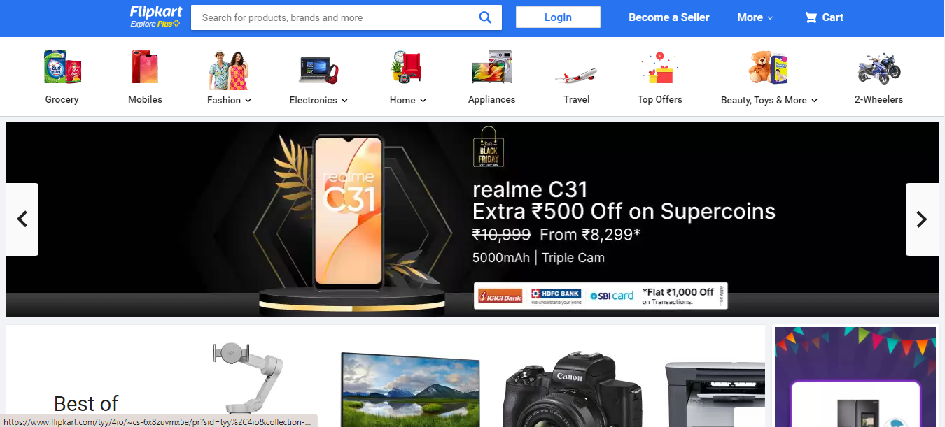

-Deals,Treading,Features

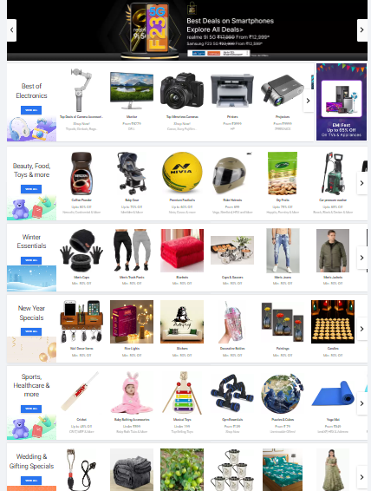

-Options

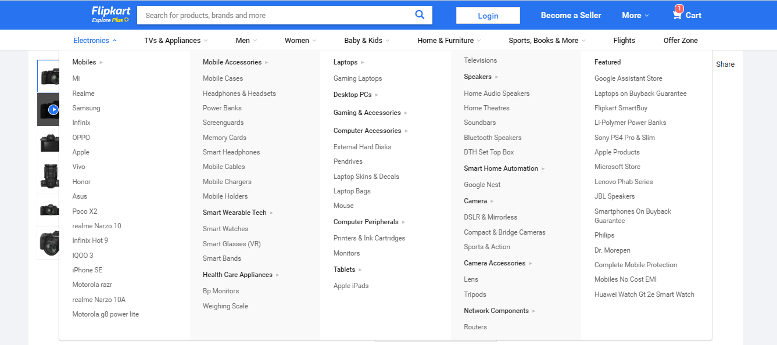

1. **LOGIN** PAGE

# Login

# Create an Account

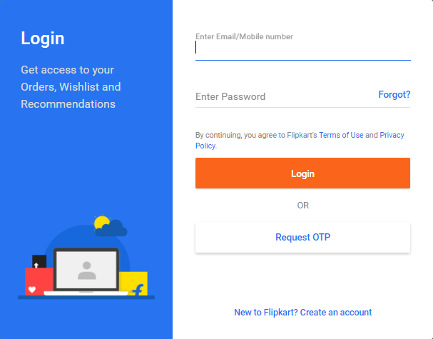

1. **Main Page (Product Details)**

**# Product Details**

**# Product Photos**

**# Filter Option**

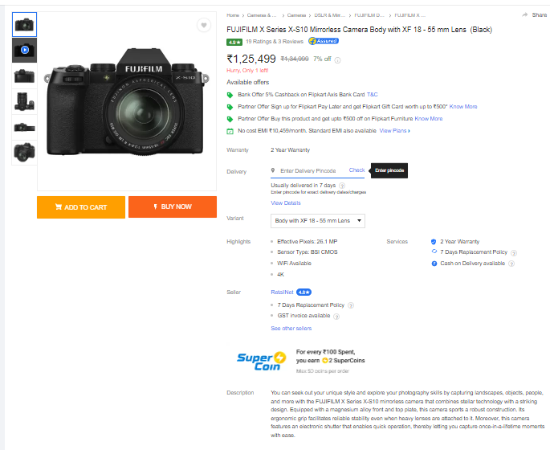

**4.Payment Page**

**#Payment Option**

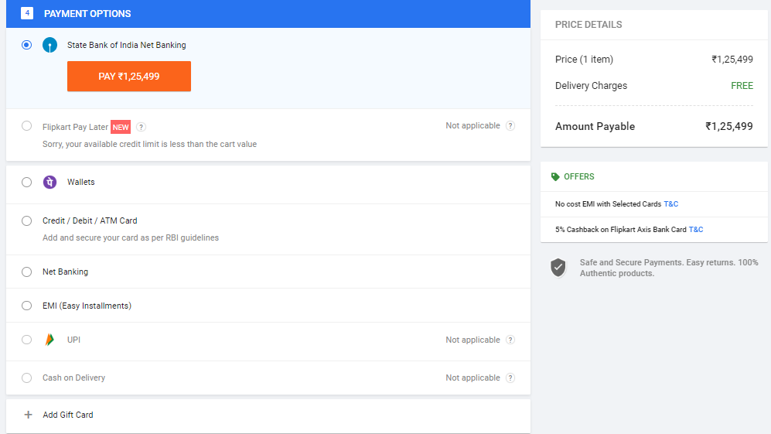

**5.Footer**

**#Details about Company,Helplines**

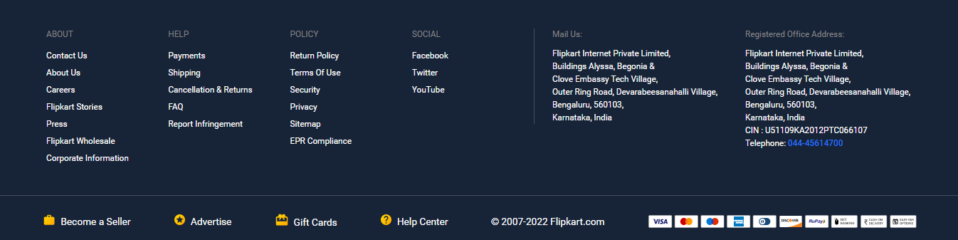

**Thank you**