Report of Final Project
AI-Powered Study Assistant Telegram Bot
Full name: Kusman Aktanbi
Topic: AI-Powered Study Assistant Telegram Bot
Programming language: Python
Used technologies: Telegram Bot API, Groq API, JSON, CSV, unittest
1. Introduction
In modern learning, students often need quick help: an explanation of the topic, examples, self-test questions, and a place to save notes. Therefore, the Telegram bot AI-Powered Study Assistant was developed, which helps the student study directly in Telegram.
The user can ask questions, create short quiz tasks, save notes and view statistics of their activity. The Groq API is used to generate responses, and local JSON and CSV files are used to store data.
2. Project goal
The goal of the project is to create a practical Python application that demonstrates the main topics of the course and solves a real educational problem.
Main objectives of the project:
• create a Telegram bot;
• connect Groq API for AI responses;
• implement commands for educational assistance;
• save user notes;
• save the history of actions;
• show the use of Python course topics;
• add unit tests.
3. Functionality
The bot supports the following commands:
• `/start` - user greeting;
• `/help` - list of available commands;
• `/ask question` - ask a question to the AI ​​assistant;
• `/quiz topic` - create a short quiz on a topic;
• `/note text` - save a note;
• `/notes` - show saved notes;
• `/stats` - show training statistics.
4. Project architecture
The project is divided into several modules to make the code easier to read, explain, and maintain.
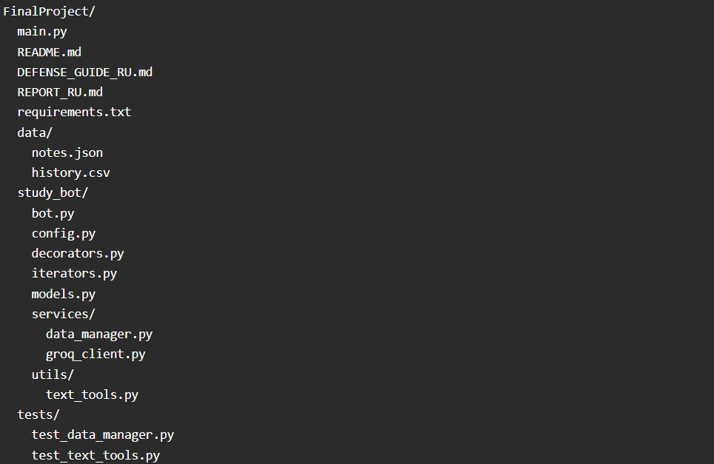
Description of main files
main.py is the application launch point. Loads settings and launches the bot.
study_bot/bot.py - the main class of the Telegram bot. Command handlers are located here.
study_bot/config.py - loading settings from .env.
study_bot/services/groq_client.py - class for working with Groq API.
study_bot/services/data_manager.py - class for saving notes and history to files.
study_bot/models.py - user and training session classes.
study_bot/utils/text_tools.py - functions for text processing.
tests/ - unit tests for testing functions and working with data.
5. Python themes used
Introduction to Python and Basic Programming Concepts
The project uses the basic elements of Python: variables, strings, numbers, data types, input and output. The input is the user's Telegram messages, and the output is the bot's responses.
Example:
message = "Hello, student!"
await update.message.reply_text(message)
Control Flow and Looping
Conditional statements are used to check the correctness of commands. Loops are used when reading history, calculating statistics, and displaying notes.
Example:
if not is_valid_study_text(question):
await update.message.reply_text("Please write a question after /ask.")
return
Collections
The project uses lists, dictionaries and sets:
• list - list of notes;
• dict - one note or statistics;
• set - unique keywords;
• tuple can be used for immutable sets of commands or settings.
Files and Data Formats
The project works with the following files:
• `notes.json` - stores user notes;
• `history.csv` - stores the history of actions;
• `os.makedirs()` - creates the `data` folder if it does not exist.
Functions
Functions are used to divide logic into small, understandable pieces. For example, clean_text() clears extra spaces, and is_valid_study_text() checks text.
The project also has lambda, map and filter in the summarize_keywords() function.
Object-Oriented Programming
The project uses classes:
• `StudyAssistantBot`;
• `DataManager`;
• `GroqClient`;
• `StudyUser`;
• `StudySession`;
• `QuizSession`.
A class helps to combine data and methods that belong to the same part of the program.
Advanced OOP
The project has inheritance: QuizSession inherits from StudySession.
There is also polymorphism: both classes have a describe() method, but return different text.
Association is shown in the StudyAssistantBot class: it uses DataManager and GroqClient objects.
Modules and Packages
The study_bot folder is a Python package. The code is divided into modules and subpackages:
• `services`;
• `utils`;
• `models`;
• `bot`.
This makes the project more structured.
Decorators
The decorators.py file implements a decorator log_command, which displays information about the start and end of a command to the terminal.
Example:
@log_command("ask")
async def ask(...):
...
Iterator
The iterators.py file implements a custom iterator NoteIterator. It uses the __iter__() and __next__() methods, as well as StopIteration.
Generator
The chunk_text() function uses yield to split long AI responses into chunks. This is necessary because Telegram has restrictions on message length.
Regular Expressions
The text_tools.py file uses the re module:
• `re.sub()` - clearing extra spaces;
• `re.findall()` - search for words and keywords.
Unit Tests
Unit tests are used to test the project:
python -m unittest discover tests
The tests check text processing and data storage.
6. Working with Groq API
Groq API is used as an AI engine. The user posts a question to Telegram, the bot passes the question to the GroqClient class, and then Groq returns the answer.
The main logic is in the file study_bot/services/groq_client.py.
The advantage of this approach: if you need to replace the AI ​​provider in the future, it is enough to change one file, not the entire project.
7. Working with data
Data is saved locally:
• notes are stored in JSON;
• activity history is stored in CSV.
This approach is simple and understandable for an educational project. It shows working with files and data formats without a complex database.
8. Testing
The project contains unit tests in the tests folder.
Checked:
• text cleaning;
• checking the validity of the text;
• keyword search;
• saving and loading notes;
• statistics calculation.
Result of running tests:
Ran 5 tests
OK
9. Startup instructions
1. Install dependencies:
pip install -r requirements.txt
2. Create a .env file:
TELEGRAM_BOT_TOKEN=your_telegram_bot_token
GROQ_API_KEY=your_groq_api_key
GROQ_MODEL=llama-3.1-8b-instant
3. Launch the project:
python main.py
4. Open the Telegram bot and test the commands.
10. Conclusion
As a result, a Telegram bot was created to help with learning. The project shows how Python can be used to create a real application with an AI API, user command processing, data storage, and testing.
The project follows the course topics: basic Python, conditions, loops, collections, files, functions, OOP, inheritance, modules, decorators, iterators, generators, regular expressions and unit tests.

