Date: 31 January 2025

Descriptive title:
A spatially explicit framework to assess the risk of aquatic contaminants to insectivorous birds.

Short title: Contaminant Food Webs

Principal investigators: Johanna M. Kraus¹, Christy Morrissey², Brianna Williams³, Jeff Wesner⁴

¹ U.S. Geological Survey, Columbia Environmental Research Center. 4200 New Haven Rd., Columbia, MO 65201, USA. jkraus@usgs.gov, +1 434-806-8324.
² University of Saskatchewan, Dept of Biology, 112 Science Place, Saskatoon, Saskatchewan, S7N5E2, Canada, christy.morrissey@usask.ca.
³ U.S. Geological Survey, New Jersey Water Science Center, 3450 Princeton Pike #110, Lawrenceville, NJ 08648, USA. bmwilliams@usgs.gov.
⁴University of South Dakota, Department of Biology, 414 E. Clark Street, Vermillion, SD 57069, USA. jeff.wesner@usd.edu

Project summary
Food web connections between predator and prey are one of the major, yet understudied, pathways by which contaminants affect biodiversity. The effects of aquatic contamination on the quantity and quality of nutritionally important aquatic insect prey have been implicated in the declines of insectivorous birds across North America and Europe. Specifically, aquatic contaminants reduce adult aquatic insect emergence and are retained in adult insect tissues, thereby altering the quantity and quality of these prey fluxes from freshwater to insectivorous birds. Here we propose to use resources provided by the USGS Powell Center to predict how contaminant and nutrient fluxes by adult aquatic insects contribute to a landscape of risk for aerial insectivorous birds. To quantify their potential uptake of contaminants and nutrients from aquatic insects, we will combine detailed data on the spatial distribution of insectivorous birds from the United States and Europe (e.g., eBird, EuroBirdPortal), information about their diets (AvoNET, meta-analysis), and recently compiled data on global aquatic insect emergence and contaminant flux (AquaSYNC). We will utilize digital stream networks and statistical models to integrate these databases. This approach will enable us to map areas of elevated risk for aerial insectivorous birds across the U.S. and Europe from contaminant effects on aquatic insect prey. Specifically, we will elucidate the spatial patterns of risk due to prey loss and contaminant exposure through diet. This synthesis will enhance our understanding of the spatial extent of aquatic contaminant fates and the impacts of those contaminants on aerial insectivores. This work will support species and habitat management by equipping decision-makers with the tools to anticipate where and to what extent aquatic-borne contaminants and their (re)distribution across the landscape pose risks to environmental health at local, regional, and continental scales.

Start and end dates: May 2026 to April 2029.

Number and duration of working group meetings: 2 meetings, 5 days each

Proposed data release date: September 2028

Is this a resubmission? No, but builds on a past unfunded Powell Center proposal that subsequently received funding from another synthesis center (AquaSYNC, Denmark, 2023–2024).

Conflicts of interest with reviewers: None known

Keywords: ecosystems, environmental health, energy and minerals, water, climate and land use change

Problem statement
Environmental contaminants threaten biodiversity globally, including through changes in diet quality and quantity (i.e., dietary pathways) ¹⁻⁴. However, we have a poor understanding of the spatial patterns and drivers of these risks. For example, winged adult aquatic insects are nutritionally and globally important prey for declining terrestrial consumers such as aerial insectivorous birds (i.e., birds that prey on flying insects, ⁵⁻⁷). Like fish in the diets of humans, adult aquatic insects provide to insectivores critical long-chain polyunsaturated omega-3 fatty acids (LC-PUFA), which are necessary for animal survival and growth ⁵. However, changes in land-use and land-use derived chemicals over time have altered contaminant run-off into the freshwater ecosystems where aquatic insect larvae develop ^{2,8,9}. Exposure to these contaminants including pesticides, heavy metals, and organic pollutants can lead to reduction in emergence of adult aquatic insects, changes in emergence timing and nutrient quality, and increases in the bioaccumulation and transfer of contaminants from aquatic to terrestrial food webs ^{10,11}. Because, unlike for humans, there are no “aquatic insect consumption advisories” and limited sources of important fatty acids, aquatic contaminants can have cascading effects on terrestrial food webs, particularly impacting specialized insectivores ¹²⁻¹⁴. However, despite the recognized negative effects on insectivores (e.g., prey loss, increased dietary contaminant exposure), our ability to spatially predict these risks is currently very limited to nonexistent ¹⁵⁻¹⁷. There is a critical need for continental-scale predictions of dietary exposure and food loss risk to insectivores. These predictions will be essential for identifying imperiled species and regions where contaminants are likely to be transported to land, potentially driving insectivore declines through impacts on the quality and quantity of their insect prey.
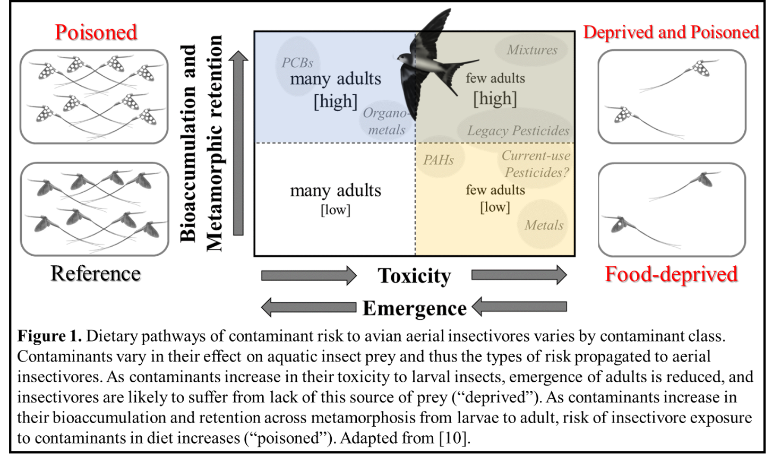
Aerial insectivores are declining at continental scales ^{18,19}, particularly in farmland habitats ²⁰. Across trophic guilds, many aerial insectivores are among the most rapidly declining bird species ^{21,22}. For instance, within Canada, aerial insectivorous birds have declined by 43% since 1970 ²². Changes in the quantity, quality, and phenology of insect prey have been implicated in these declines ²³⁻²⁷. Studies suggest that land use change, especially urbanization, agricultural intensification, and increased pesticide use, is a major driver of these declines ^{20,28,29}. Agricultural pesticides and fertilizers have been detected more frequently in surface waters due to changes in land use and climate-driven events that increase precipitation and runoff ^{30,31}. Contaminants including the controversial neonicotinoids ^{9,32}, as well as other contaminants transported by emergent aquatic insects, such as methyl mercury ^{14,33,34}, can cause a diversity of detrimental problems ranging from bird reproductive failure, shifts in bird behavior, and changes in invertebrate prey communities. However, the exact mechanisms (e.g., reduced prey availability and/or changes in prey quality) through which land use and pesticides impact aerial insectivore populations remain unresolved ^{23,35-38}. Moreover, while aerial insectivores are declining more rapidly in some regions than others ^{39,40}, we still have only a limited understanding of where risks from contaminants are greatest and therefore where management actions would be most beneficial (but see e.g., ^{13,41}).
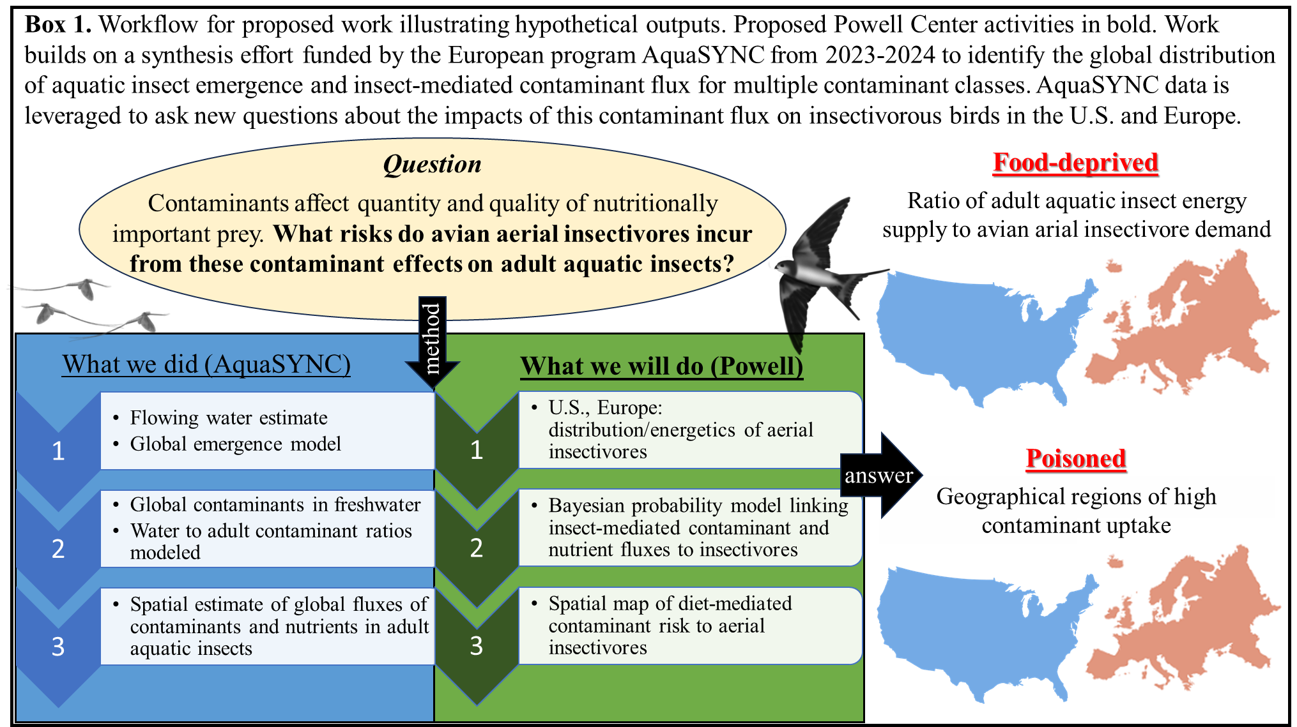
Contaminants differ in their effects on the quantity and quality of aquatic insect prey available to terrestrial insectivores. In general, contaminants like trace metals (e.g., copper, cadmium, zinc, and lead) are highly toxic to aquatic insects but are less likely to be retained across metamorphosis from larval to adult stages and are thus more likely to affect terrestrial insectivores by reducing food availability ^{10,42-45} On the other hand, while unlikely to reduce insect emergence at environmentally relevant concentrations, highly bioaccumulative/biomagifying contaminants such as polychlorinated biphenyls (PCBs) and organometalloids (e.g., mercury, arsenic, selenium) are highly likely to be bioaccumulated from the aquatic environment in the larval stage and retained during insect metamorphosis into adult insect tissues. These properties of highly bioaccumulative contaminants increase the risk of dietary contaminant exposure for terrestrial insectivores ^{10,42,44,45}. Pesticides like neonicotinoid insecticides, herbicides, and fungicides may pose dual threats to terrestrial insectivores by reducing prey emergence and bioaccumulating in the food chain ⁴⁶⁻⁴⁹. By reducing emergence (g insect m⁻² water surface d⁻¹) and/or increasing contaminant concentrations (µg contaminant g⁻¹ insect) in the bodies of adult aquatic insects ^{10,11}, these contaminants alter the diet-mediated nutrient and contaminant fluxes (the product of emergence and tissue concentration; µg m⁻² d⁻¹) available to insectivores (Fig. 1). Patterns of aquatic insect-mediated contaminant flux for multiple classes of contaminants (Table 1) are a key metric for determining where in the United States and Europe aquatic contaminants are mostly likely to increase risk and reduce benefits of adult aquatic insect prey to insectivorous birds ^{10,50,51}.
To address the need for spatially explicit predictions of dietary contaminant effects on insectivores, we propose to convene a team of leading experts to develop statistical models and spatial maps to identify areas of high risk (“hotspots”) to aerial insectivorous birds arising from the impacts of contaminants on adult aquatic insects emerging from streams and rivers within the U.S. and Europe (Box 1). To do this, we will develop a spatial framework for predicting the dietary pathways of contaminant risk to insectivorous birds at local, regional, and continental scales, and a web application that allows researchers and managers to identify these risks down to the level of watershed. Our hypothesis is that risk of diet-related contaminant exposure and loss of prey to aerial insectivores will vary geographically with land use (agriculture, urban, mining etc.), contaminant class (Fig. 1, Table 1), and the distribution and foraging ecology of the insectivore. We will use detailed data on global fluxes of contaminants in adult aquatic insects (AquaSYNC, Table 1), the spatial distribution of insectivorous birds from the United States and Europe (eBird, EuroBirdPortal), and bird diet and field metabolic rates (e.g., Birds of the World, AvoNET) to model potential uptake of contaminants and nutrients from adult aquatic insects by aerial insectivorous birds (Table 2). Then, using digital stream networks and statistical models to integrate land-use, bird, insect, and contaminant databases, we will map hotspots of risk and benefit of aquatic insect prey to aerial insectivores across the U.S. and Europe, highlighting geographic differences in dietary contaminant exposure and adult insect emergence (Box 1).
This synthesis will improve our understanding of the spatially explicit role of dietary effects of contaminants on aerial insectivores. Specifically, we will:
1) create a spatially explicit vulnerability assessment (i.e., risk map) based on i) a recently developed global map of contaminant and nutrient fluxes by adult aquatic insects (AquaSYNC), ii) insectivorous bird range maps, iii) species sensitivity distributions for specific contaminants, and iv) application of known toxicity thresholds appropriate for insectivorous birds (when they exist),
2) write a synthetic and prospective paper outlining findings and data gaps related to assessing the dietary effects of contaminants on declining insectivorous birds, and
3) compile a public database with accessible interactive features (a “geonarrative” with dashboard) to facilitate species and habitat management by providing risk assessors and decision makers with the tools to anticipate where and to what extent aquatic contaminants may affect the quality and quantity of prey available to declining insectivorous birds.

Table 1. List of contaminants by class and compound/element for which global contaminant flux from rivers and streams by adult aquatic insects has been modeled (AquaSYNC). These contaminants will be used to determine aquatic contaminant risk to aerial insectivores through changes in diet quality and quantity. Potential risk/effects on insectivores are hypothesized based on transfer across insect metamorphosis and observed risks to consumers in the field and laboratory. For insectivorous birds, reduced aquatic insect emergence is linked to reduced return rates to breeding areas and increased oxidative stress ⁵², reduced nestling growth rates ⁵³, lost feeding opportunities ⁵⁴, and population declines ^{37,55}. Increased exposure to contaminants through diet can have a range of implications for bird reproduction, survival, and behavior depending on contaminant type and concentration ^{14,32,56}.

Contaminant Class | Compound/Element | Potential Risk/Effects
Trace Metals | Zinc, Copper, Cadmium, Lead | Loss of adult aquatic insect prey, diet shifts, non-toxic exposure ^{43,57,58}
Organic metal(loid)s | Methylmercury, Total Mercury, Selenium | Toxic exposure risk, reduced embryo survival, neurological effects ^{12,59-61}
Herbicides | Propyzamide, Metalochlor, Prosulfocarb, Metamitron, Dimethenamid, Terbuthylazine, Metobromuron, Napropamide, Atrazine, Metolachlor | Some loss of adult aquatic insect prey, diet shifts, some exposure risk ^{46,48,49,59,62}
Insecticides | Thiacloprid, Acetamiprid, Imidacloprid, Clothianidin, Tebufenocide, Primicarb, Dimethoate, Bifenthrin | Loss of adult aquatic insect prey, diet shifts, exposure risk ^{46,48,49,59,62}
Fungicides | Azoxystrobin, Boscalid, Fluopyram, Propyzamide, Tebuconazole, Trifloxystrobin, Metalaxyl (sum of isomers), Fluopicolid, Metrafenone, Pyraclostrobin, Cyflufenamid | Some loss of adult aquatic insect prey, some exposure risk, potential effects on gut microbiome ⁶²⁻⁶⁴
Pharmaceuticals | Azithromycin, Ketoprofen, Tilmicosin, Thiabendazole, Carbamazepine, Salicylic acid | Exposure risk to terrestrial insectivores ^{45,65,66}

Proposed activities
Four primary activities are anticipated as part of our Powell Center working group. These activities should be funded by the Powell Center because they involve interdisciplinary analysis and synthesis that brings together expertise relevant to multiple USGS mission areas. The questions addressed by these activities are both pressing and complex, relating to issues of biodiversity loss, water quality, and land-use at the continental scale.

- Bayesian models of diet-mediated contaminant risk We will use Bayesian modeling to predict how aquatic contaminants pose risk to insectivorous birds through impacts on diet quality and quantity. The core models will be linear or non-linear models that generate spatial predictions of a) nutrient and contaminant flux by adult aquatic insects given inputs of aquatic contaminant concentrations, land use, secondary production, emergence production, metamorphic mortality, and metamorphic contaminant retention (Fig. 1, Fig. 3), and b) potential dietary uptake of nutrients and contaminants by birds given inputs of location, insectivorous bird species identity, population density, proportion of aquatic prey in their diet, field metabolic rate, and other factors identified by the working group.
The first part of this effort will come from an ongoing AquaSYNC synthesis, which produced probabilistic estimates of contaminant flux in aerial insects from earth’s streams and rivers (Fig. 2, Fig. 3). As part of this working group, these estimates will be refined to include emergence patterns of individual insect orders (e.g., Diptera, Plecoptera, Ephemeroptera, etc.) and evaluate how order-level taxa richness is related to contaminant flux (AquaSYNC, Table 2). The second part of this effort will occur solely as Powell Center synthesis work and includes modeling the relationships between contaminant and nutrient flux in adult aquatic insects and their dietary uptake into birds (estimated from field metabolic rates and proportion of aquatic insect prey in diet, see Activity 2) using a similar workflow as for aquatic insect contaminant flux (Fig. 2).
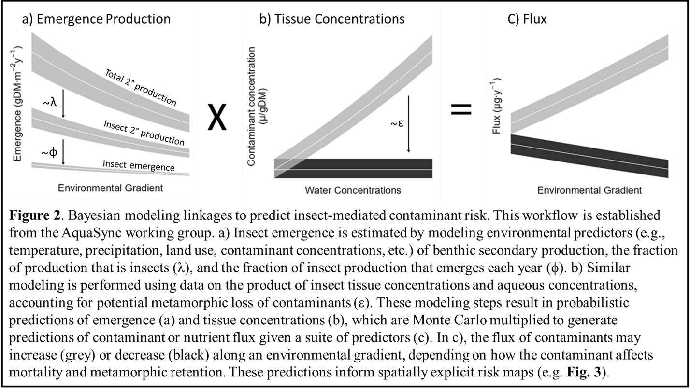
Bayesian models are ideal for these tasks because they naturally incorporate multiple sources of information (Table 2) using prior probability distributions and/or hierarchical model structures. They also generate probabilistic estimates of our quantities of interest (e.g., contaminant flux and dietary uptake) that explicitly quantify both central tendency and uncertainty ⁶⁷. The models are mechanistic in that they predict contaminant and nutrient concentrations, flux, and dietary uptake based on physical, chemical, and ecological properties of the system being modeled ^{44,68-70}. For aquatic insect contaminant flux, we made these predictions spatially explicit by projecting them onto digital flowlines/watersheds to generate contaminant flux maps (Fig. 3) and will do the same here to produce insectivore risk maps (see Activity 2).

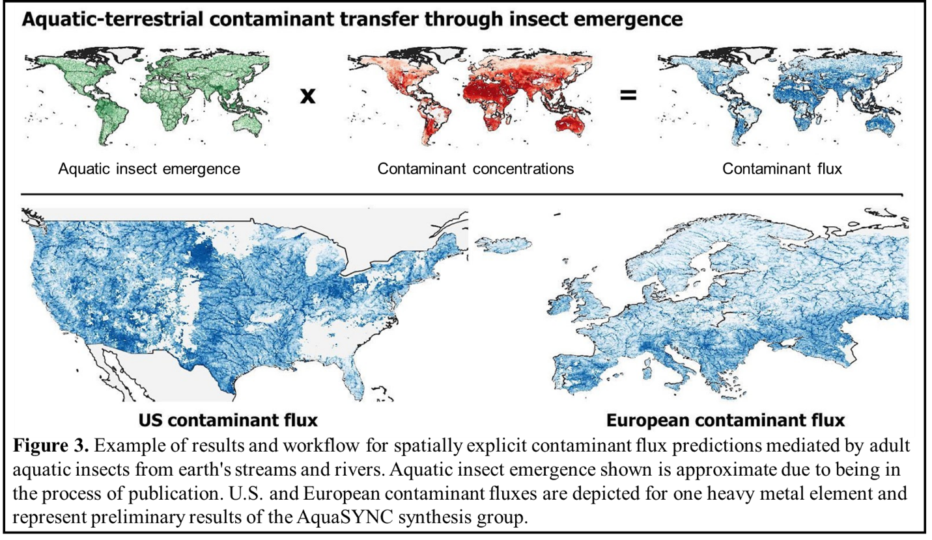
Table 2. Databases for extraction and synthesis that will inform the Bayesian and spatial vulnerability assessment models (i.e., risk maps) of diet-mediated contaminant risk to aerial insectivores across the conterminous U.S. and Europe. Data types represent example variables within each dataset that will be extracted when synthesizing data.

Database Description | Data Types
Stream and Water Quality Databases
AquaSYNC - Geospatial Predictor Variables  24 distinct geospatial predictors of water quality including geological (e.g. bulk density, soil pH), meteorological (e.g. rainfall erosivity, precipitation), hydrological (e.g. Strahler order, catchment size), topological (e.g. terrain slope), land-use (e.g. crop intensity, mining footprint) and others.  These data were extracted from the following data: HydroRivers / HydroBasins / HydroLakes (version 1.0.1);  https://www.hydrosheds.org/  EEA Catchments and Rivers Network System (ECRINS v1.2)  bit.ly/4apVX91  National Hydrography Dataset Version 2 (NHDPlusV2)  https://bit.ly/40gbNyn | Global surface area of flowing water based on sub-basins.
AquaSYNC - Global Aqueous Concentration Modeling Aquatic contaminant concentration modelling ultimately leveraged 24 distinct geospatial predictors to produce spatiotemporally comprehensive contaminant occurrence and concentration estimates in global surface waters. These data were extracted from the following databases and modelled:  US - Water Quality Portal;  https://www.waterqualitydata.us/  EU - Waterbase v2023 (WISE6);  https://bit.ly/42bBVgj  UNEP GEMS - Global Freshwater Quality Archive  https://zenodo.org/records/13881900 | Continental or global dissolved concentrations of contaminants in running freshwater
Aquatic Insect Contaminant Flux Estimates
AquaSYNC - Mapping Biologically-Mediated Movements Of Chemical Contaminants From Freshwaters To Land  Collaborative effort to estimate the spatially explicit fluxes of nutrients and contaminants by adult aquatic insects globally.  These data were extracted from the literature and modelled. | Global annual fluxes of contaminants in adult aquatic insects (kg contaminant/ watershed/yr)  Global annual aquatic insect emergence (kg insect/watershed/yr)  Relationships between adult insect (μg/g) and aquatic contaminant concentrations (μg/L)  N, P, PUFA in adult aquatic insects (mg/g)
Bird Databases
eBird Status and Trends data products  Spatially explicit predictions of weekly abundance for birds across the globe based on public observer data. Selected as the most comprehensive database for similar modeling projects in North America (Ruiz-Gutierrez et al. 2020).  Citation: Finck et al. 2020 https://science.ebird.org/en/status-and-trends/trends-maps | Guild (aerial insectivore)  spatiotemporal distribution  modeled abundance
EuroBirdPortal  Data repository based on aggregated data from online bird recording portals from across Europe.  Citation: https://www.eurobirdportal.org/ | Guild (aerial insectivore)  spatiotemporal distribution  modeled abundance
Birds of the World  Comprehensive life history of birds  Citation: https://birdsoftheworld.org/bow/home | Allometric scaling and body mass used to model field metabolism
AvoNET  Comprehensive functional trait data of all birds  Citations: Tobias et al. 2022 Ecology Letters,  https://opentraits.org/datasets/avonet.html | Morphometry, diet proportion from different trophic levels
Nestwatch  Global monitoring network recording spatially explicit information about when nesting occurs, number of eggs laid, how many eggs hatch, and how many hatchlings survive.  Citation: https://nestwatch.org/ | Reproductive success
Toxicity and Metabolism Databases
Kopp Dissertation, Table S3  Modelled using allometric scaling and estimated bird body mass. Citation: Kopp 2021, Nagy et al. 1999, Dunning 2008 | Field metabolic rate for 53 aerial insectivorous birds in North America
ECOTOX Knowledgebase  https://cfpub.epa.gov/ecotox/  OpenFoodTOX database  https://www.efsa.europa.eu/en/microstrategy/openfoodtox  PPDB - Pesticide Properties Database  https://sitem.herts.ac.uk/aeru/ppdb/  ECHA Chemicals Database  https://echa.europa.eu/information-on-chemicals | Curated ecotoxicological databases

- Spatial vulnerability assessment (i.e. risk maps) for insectivorous birds We will create a spatially explicit vulnerability assessment by overlying Bayesian model predictions of contaminant and nutrient dietary uptake from emergent aquatic insects with spatial distributions of aquatic insect emergence, nutrient and contaminant flux, and insectivorous birds during the breeding season. Aerial insectivorous birds, such as Nightjars and Allies, Swifts, Tyrant Flycatchers, or Swallows, catch insects in flight and often preferentially consume emergent aquatic insects to meet their energetic demands. For the purpose of this proposal, the following species are of particular interest due to availability of extensive datasets on their distributions and variability in the dietary reliance on aquatic insects: In North America, Chimney Swifts (Chaetura pelagica), Tree swallow (Tachycineta bicolor), Barn Swallow (Hirundo rustica), Bank swallow (Riparia riparia), Purple martin (Progne subis), and Common nighthawk (Chordeiles minor); In Europe, Common Swifts (Apus apus), Alpine Swifts (Tachymarptis melba), House Martins (Delichon urbicum), Barn Swallows (Hirundo rustica), Sand martin (Riparia riparia), and European nightjar (Caprimulgus europaeus). Abundance information for these species is available from existing databases such as eBird Status and Trends ^{71,72} (Table 2). To harmonize the bird distribution data with the insect flux data, we will use information from the breeding/growing season when insects are most likely to be emerging and birds are most likely to be reproducing and provisioning young (eBird, Birds of the World, AvoNET, Nestwatch, Table 2).
To estimate the dietary uptake/requirements (i.e., energetic or nutrient demand) for these insectivorous birds, we will extract/calculate field metabolic rates and proportion diet of aquatic insects during the breeding season. Field metabolic rate (FMR) includes the energy expended by an organism in the environment and is strongly correlated with body mass in birds ^{73,74}. Body masses and food intake rates for aerial insectivores are available from ⁷⁵ and ⁷⁶. Total and species-specific annual aerial insectivore energetic or nutrient demand (e.g., kJ y-1) will be calculated at the resolution of the distribution maps as the summed FMR for all species (following ⁷⁰) and adjusted to reflect demand during the breeding season. Because aerial insectivores vary in their consumption of emergent aquatic insects (e.g., ranging from high aquatic prey use by Bank and Tree Swallows to lower aquatic prey use by Barn Swallows), we will also estimate the percentage of energetic demands from aquatic prey based on species-, population- or region-specific dietary data from previous studies via meta-analysis (conducted as part of Powell Center Fellow activities) ^{7,77-81} and the AvoNET database (Table 2). Incongruencies between estimated emergence and energetic demand from aquatic insect prey may indicate risk from prey loss due to aquatic contaminants (e.g., log [energy available in aquatic insect prey/energy needed] < 0). The effects resulting from this risk could include switching to less nutritious/preferred prey sources (i.e., with lower LC-PUFA content), loss of high-quality foraging sites, or a reduction in overall energy consumption.
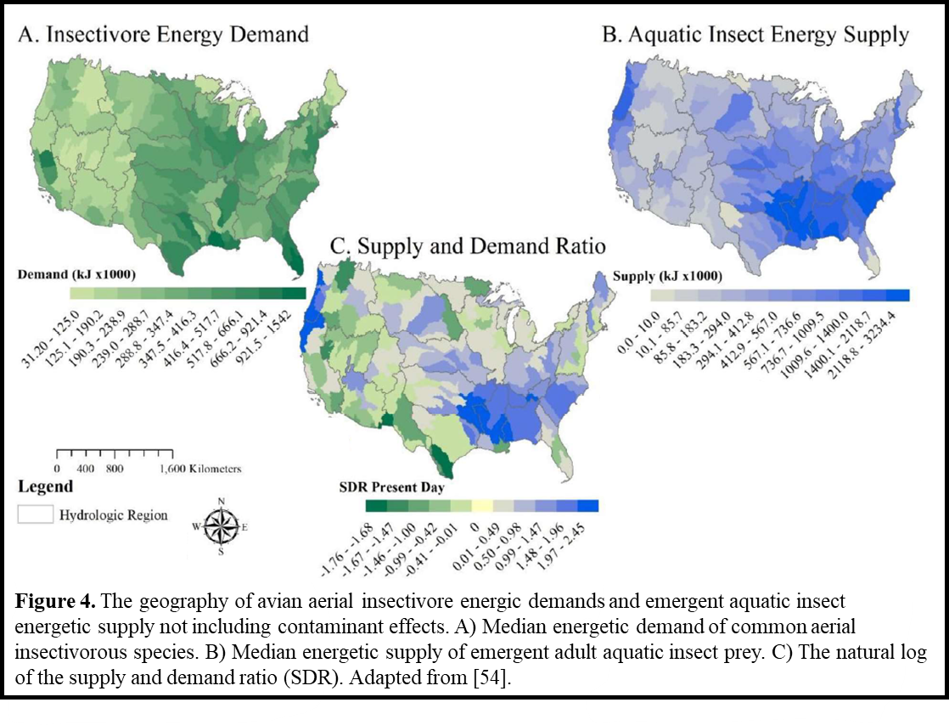
By integrating spatially explicit models of aerial insectivore energy requirements and reliance on aquatic insects with predictions of aquatic insect emergence and contaminant fluxes, this working group will investigate: 1) whether the quantity of emergent aquatic insects, potentially altered by contaminants, adequately fulfills the metabolic needs of insectivorous birds in a specific location (i.e., food deprivation) (Fig. 4) and 2) the extent of contaminant exposure risk experienced by birds through their aquatic insect prey (Fig. 3). Specifically, contaminant exposure risk at a given location will be calculated by dividing species-specific annual aerial insectivore energetic demand or availability (whichever is larger) by the number of birds of that species to give the uptake of specific contaminants per bird during the breeding season. To further assess potential effects derived from the risk of food deprivation and contaminant exposure, the working group will also combine available laboratory-based toxicity thresholds and species sensitivity distributions from field measurements (e.g., toxicity and metabolism databases in Table 2) with estimates of toxicity thresholds for individual compounds and species (e.g., ⁸²) (Table 1).

- Synthetic and prospective paper We will leverage our spatially explicit predictions of diet-mediated contaminant risks to address data gaps and understudied pathways contributing to the decline in aerial insectivorous birds. These predictions will allow us to test hypotheses about the roles of land use and ecological processes in modulating dietary contaminant effects on aerial insectivorous birds (Fig. 1, Box 1). By modeling the overlap of avian population density, metabolism, and aquatic contaminant flux, we will identify hotspots of contaminant exposure (individual and mixtures) that pose the greatest cumulative risk to insectivores. We will also address conceptual gaps including how aquatic insect taxa richness could influence insectivore exposure to contaminants and effects of contaminants on nutrient fluxes. For example, does higher richness reduce contaminant flux and risk by increasing the number taxa with lower tissue concentrations or does greater aquatic insect richness increase the risk because food chains (typically associated with increased diversity) amplify some contaminants via bioaccumulation/magification? Finally, data generated here will help to identify environmentally relevant exposure rates to test dietary toxicity thresholds in laboratory settings (of both single contaminants and mixtures). We will disseminate these findings in a high-impact peer-reviewed publication to advance our understanding of the factors determining risk to insectivores from contaminant effects on diet quality and quantity, and to inform future research directions.

- Interactive data application for a landscape of risk We will construct an interactive geonarrative web application using R Shiny or ESRI online products that will allow researchers, managers and the public to use and explore our results. Geonarrative products are widely used among members of the public, academics, scientists, and decision-makers across all levels of government. These products can provide background information (for example, EDCs in the Chesapeake), detailed information and results aimed at answering stakeholder, risk assessor, and conservation practitioner needs (for example, showing where management actions are best implemented), or showcase select results to inform the general public (for example, showing where there is a higher risk of PFAS in public drinking water sources and tapwater).
As part of this Powell Center Working Group, we will create a geonarrative to allow users to address questions including: where are insectivorous birds abundant? Where are specific aquatic contaminants most prevalent? What is the magnitude of insect emergence and contaminant flux at those locations? And what does the overlapping distribution among those categories (i.e., risk) look like? Previously developed geonarratives will be used as a template for this effort, allowing for more rapid development and publication of results. Our geonarrative will contain a synthesis of the goals and methods in public friendly language, along with an interactive map and dashboard that will allow users to explore individual layers (contaminant sources, insect emergence, insect contaminant flux, bird abundance and modeled bird risk), the intersection among those layers, and view areas of higher and lower relative risk for contaminants and food web impacts to aerial insectivores. Because the models are being developed at the small watershed scale (HUC12 and equivalents), the results will be viewable at a spatial resolution relevant to land managers and government agencies. In addition to these benefits, the geonarrative will provide a single location to gather and link to supporting data, contacts, and other publications related to the working group activities.

Names of participants 72 words
We have assembled a highly qualified team of experts (Table 3) including six early-career scientists, eight international faculty/researchers from five countries, and five government employees. Bridger Creel, the proposed Powell Center Fellow, will be responsible for ensuring the requirements of the Powell Center Data and Information Policy are met, and will serve as the liaison with the Powell Center computing staff. We anticipate everyone will participate fully, co-author manuscripts, and attend meetings.

Table 3. List of participants. Powell Center liaison shown with asterisk. All confirmed participants are bolded.

Name, Title, Affiliation | Scientific Expertise | Role in Working Group | Career Stage
Johanna Kraus,  Research Ecologist  USGS CERC, MO | Contaminants in insect-based food webs, aquatic-terrestrial linkages | Interpretation of contaminant effects on insects and food webs | Mid-career
Christy Morrissey,  Professor  University of Saskatchewan, Saskatoon, Canada | Ecotoxicology and conservation of birds and aquatic insects from pesticides, Hg, and other environmental contaminants | Bird and insect contaminant model input and interpretation of ecological risk | Late career
Brianna Williams,  Geographer  USGS NJWSC, NJ | Spatial modeling, geospatial analysis, Geonarrative/Shiny App | Spatial modeling, create Geonarrative, build risk map | Mid-Career
Jeff Wesner  Professor  University of South Dakota, SD | Bayesian modeling, contaminant fluxes, big data, aquatic-terrestrial linkages | Bayesian modeling, R packages, food web interpretation | Mid-career
Bridger Creel*  Graduate Student,  U of Montana, MT | Diet-based effects of mining on riparian songbirds | Powell Center Fellow | Current PhD student
Darin Kopp,  Aquatic Ecologist  US EPA, OR | Spatial analysis and mapping habitat-based biodiversity metrics, eBird, aquatic insects | Spatial modeling, supply-demand ratio, R packages | Early career
Cornelia Twining,  Assistant Professor  ETH Zürich and Group Leader, Eawag, Kastanienbaum, Switzerland | Nutritional quality aquatic insects, fatty acids, insectivorous birds, phenology | Interpretation of quality vs. quantity of aquatic insect prey to birds | Early career
Stephanie Gordon,  Physical Scientist  USGS EESC, WV | Geospatial analysis, spatial risk and contaminant assessments related to eBird | Spatial modeling, build risk map | Early career
Stefano Larsen,  Researcher  Edmund Mach Foundation, San Michele all’Adige, Italy | Led AquaSYNC grant, global change effects, aquatic-terrestrial linkages | Interpretation of aquatic insect emergence | Mid-career
Jakob Wolfram, Researcher  RPTU  Kaiserslautern Landau, Germany | Contaminant modeling, machine learning, big data, species sensitivity distributions | Contaminant modelling | Early career
Jeffrey Muehlbauer,  Unit Leader  USGS/University of Alaska, Fairbanks | Spatial distribution of aquatic insects, food webs, geomorphology | Interpretation of aquatic insect emergence | Mid-career
Ralf Schulz,  Professor  RPTU  Kaiserslautern Landau, Germany | Large-scale effects of agricultural contaminants on aquatic-terrestrial linkages | Interpretation of contaminant effects on insects and food webs | Late career
Jose M. Álvarez-Martínez,  Professor  University of Oviedo, Principality of Asturias, Spain | Integrating ecosystem and contaminant models to predict the effects of ecosystem fluxes on contaminant dynamics | Ecosystem and contaminant modeling | Mid-career
Mireia Bartrons,  Associate Professor  University of Vic, Barcelona, Spain | Aquatic insect flux modeling, pollutant tracers | Modeling contaminant fluxes in aquatic insects | Mid-career
Sydney Moyo,  Assistant Professor  Louisiana State University, LA | Meta-analysis, aquatic-terrestrial linkages, contaminant fluxes, fatty acids | Interpretation of contaminant fluxes in aquatic insects | Early career

Elevating performance culture and standards of conduct in STEM
In assembling our working group, we have included people with expert knowledge, demonstrated ability, high standards of conduct, and interdisciplinary experience (Table 2). Researchers in this group have complementary abilities in the fields of ecotoxicology, aquatic-terrestrial food web linkages, macroinvertebrate ecology, bird health, spatial modelling, machine learning, big data, and interactive data applications. They are high performers with a demonstrated ability to attract external research funding, work productively together on complex projects, mentor and train students and early career scientists, and disseminate research to the broader scientific, public and stakeholder community.
Our working group postdoctoral fellow will benefit from the team’s wide range of expert knowledge, high performance, and standards of conduct by receiving mentorship at all stages of the project. In turn, the postdoctoral fellow will be encouraged to participate as a mentor themselves through the Society for Freshwater Science (SFS) Instars & Emerge programs. These are long-standing programs that provide mentoring to high performing students during the annual SFS meeting (where the postdoctoral fellow will present our work) and provide year-long programming to fellows across the life cycle of a scientific career; from undergraduates, to graduate students and early career scientists. These types of sustained peer-peer and peer-mentorship programs play a particularly important role in recruiting and retaining the best scientists in STEM.
In developing our interactive data application, we will work with the U.S. Department of the Interior (DOI) Natural Resource Damage Assessment and Restoration Program (NRDAR) to help streamline effective solutions for solving government-related obligations. The DOI NRDAR program works to restore natural resources in cases where contaminant releases have occurred to inland freshwaters. One of the PIs (Kraus) has worked on numerous projects to provide effective tools to aid practitioners in restoring natural resources to the American public. Our work here would also help inform such cases to ensure these results are available to resource practitioners.

Data Management Plan
Data Inputs (list of datasets used to produce the synthesized data product(s))
Title | Format (csv, ascii) | Data Volume Estimate  (MB, GB, TB) | Source/URL | Use Restrictions
AquaSYNC | csv/shp | 5GB | Shared AquaSYNC OneDrive | Privately maintained until publication (by end of FY25)
eBird | csv/shp | 5GB | https://science.ebird.org/en | None
EuroBirdPortal | csv/shp | 5GB | https://www.eurobirdportal.org/ | None
AvoNET | csv | 1GB | Tobias et al. 2022 https://doi.org/10.1111/ele.13898  https://opentraits.org/datasets/avonet.html | None
Ecotox databases (Table 2) | csv | 1GB | Olker et al. 2022 https://setac.onlinelibrary.wiley.com/doi/10.1002/etc.5324  https://cfpub.epa.gov/ecotox/ | None

Data Processing (will occur during the course of Working Group activities)
Access and Sharing | Data will be shared within the Working Group using a combination of USGS OneDrive for data storage and GitHub for code. OneDrive and GitHub allow cloud storage, version control, cloning to individual computers, and options to limit user access.
Data Storage | Acquired data will be stored on the GitHub and USGS OneDrive  servers while the working group is active. Upon project completion, derived data will be stored on USGS ScienceBase.
Transformation and processing workflow | Data transformations include extracting data from published papers into Excel spreadsheets, data harmonization, data cleaning and visual evaluation, outlier removal/assessment, spatial alignment of data, statistical model outputs.  All data processing will be done in Excel and R/RStudio with all transformation steps noted above completed within code when possible, for maximum reproducibility and transparency. R code will be shared with GitHub, which will inherently incorporate version control and tracking of the data processing workflow. A text document with individual data processing methods will also be maintained and shared on OneDrive.
Technology needs | No special technology is required.

Proposed Data Publishing^{[1]} (repeat if there will be multiple derived data products)
Title (Dataset 1) | Calculated bird field metabolic rates and proportion diet from aquatic insects
Description | Proportion diets from aquatic insects during the breeding season for aerial insectivorous birds in North America and Europe, primarily derived from the literature. Bird field metabolic rates calculated using values from the literature and databases listed above following Kopp 2021 for aerial insectivorous birds in North America and Europe.
Format | csv
Data Volume Estimate | <10 MB
Data Storage | USGS ScienceBase
Metadata Point of Contact | Johanna Kraus, jkraus@usgs.gov
Restrictions | None
Title (Dataset 2) | Bayesian models of contaminant risk to birds
Description | Data, model parameters and R code used to generate predictions of potential dietary uptake of nutrients and contaminants by birds given inputs of location, trophic group, proportion of aquatic prey in their diet, and field metabolic rates.
Format | csv, text
Data Volume Estimate | <10 MB
Data Storage | USGS ScienceBase and GitHub with a permanent DOI via Zenodo
Metadata Point of Contact | Jeff Wesner, jeff.wesner@usd.edu
Restrictions | none
Title (Dataset 3) | Spatial vulnerability assessment
Description | Spatially-explicit estimates of risk incurred by aerial insectivorous birds from contaminant flux in adult aquatic insect prey. Interactive data application will provide access and visual interface for users.
Format | shp, csv, interactive data application (geonarrative)
Data Volume Estimate | 3 GB
Data Storage | USGS ScienceBase and GitHub with a permanent DOI via Zenodo
Metadata Point of Contact | Brianna Williams, bmwilliams@usgs.gov
Restrictions | None
^{[1]} USGS has outlined a new, formal data publishing process, applicable to all projects started in FY17+, as part of its Fundamental Science Practices. More details on this can be found here: https://www.usgs.gov/fsp/policies.asp

Timetable
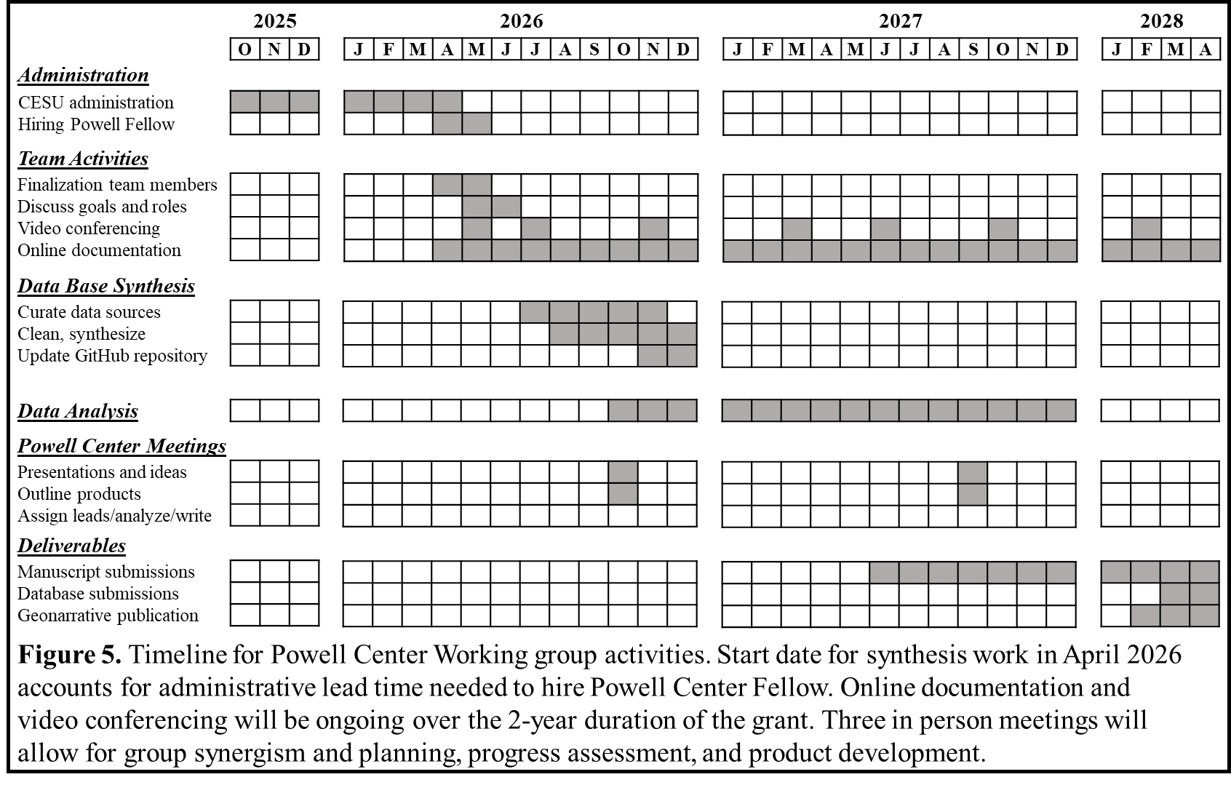

Anticipated Results and Benefits
- Network of insect, bird, nutrient and toxicology researchers Food webs by definition include consumers and resources as well as fluxes of nutrients, fats, energy, and contaminants. One of the biggest benefits of our work is the bringing together of lines of research that are traditionally siloed to define fundamental questions in food web ecology. Our expert team includes ornithologists, entomologists, ecotoxicologists, ecologists, geographers, modellers, and field researchers. As a result, we will integrate approaches that provide a more nuanced understanding of contaminants effects on food webs (i.e., both through bioaccumulation and effects on resource quality and quantity, Carson, 1962) compared to more traditional research.

- Peer-review articles
  - Prospective article identifying hotspots of dietary contaminant risk to insectivorous birds in the U.S. and Europe and data gaps. Targeted to Science or Nature, this article would deliver the high-impact overview of the results from our working group.
  - Article describing interactive data dashboard as a tool for exploring, studying, and managing the dietary pathways of contaminant effects and their potential role in insectivore decline. Targeted to Journal of Applied Ecology.

- Training of Highly Qualified Personnel This project will train one postdoctoral fellow in modelling, spatial statistics, and data interpolation using several large datasets. The postdoctoral fellow will be well supported with mentorship from the multiple PIs, participation and presentation of updates to gather feedback in regular meetings with the full research team, and dissemination of their work through publications and presentations to the scientific and stakeholder communities in different countries. We anticipate that the postdoctoral fellow will also help mentor one or more graduate students and possibly undergraduates. These students will assist with data mining or organization and several smaller side projects related to compiling datasets on aerial insectivore diet and foraging ecology, productivity, and avian toxicity reference values for use in generating species sensitivity distributions. Given the nature of this interdisciplinary team of experts, this will be a rich and excellent training environment.

- Benefits of the modelling approach(es) Our hierarchical Bayesian modeling approach allows inference of contaminant flux and bird exposure risk to be made at multiple spatial scales, from the individual study sites to watersheds to continentals. Most importantly, our approach ensures that uncertainty is propagated through these different levels. This yields probabilistic predictions showing areas with more or less uncertainty in a given risk. That is crucial, as areas of high uncertainty may be the most beneficial areas to target future field studies, providing principled future direction for studies of aquatic-terrestrial contaminant transfer. The posterior distributions we provide can be used as prior distributions in those future studies.

- Benefits of the public-facing web application By using a geonarrative to present our results, we will make them accessible and understandable to a wider audience. Specifically, this effort will benefit the public, researchers, and managers to better understand the link between effects of contaminants on insects and aerial insectivore decline. Geonarratives are high-level syntheses of projects that allow scientists to highlight and communicate the key takeaways to the public and experts.

- Data release and R-packages For any Powell Center funded activities, we would release all data in an accessible, lasting, and public format following USGS guidelines. The data release would allow replication and building on our results. In addition to a data release, the working group will release any code and R packages developed for the work. PI Wesner has experience building packages in R (https://github.com/jswesner/isdbayes) as do several participants.

Literature Cited

1 Stehle, S. & Schulz, R. Agricultural insecticides threaten surface waters at the global scale. Proceedings of the National Academy of Sciences 112, 5750-5755 (2015). https://doi.org/10.1073/pnas.1500232112
2 Bernhardt, E. S., Rosi, E. J. & Gessner, M. O. Synthetic chemicals as agents of global change. Frontiers in Ecology and the Environment 15, 84-90 (2017). https://doi.org/10.1002/fee.1450
3 Gibbons, D., Morrissey, C. & Mineau, P. A review of the direct and indirect effects of neonicotinoids and fipronil on vertebrate wildlife. Environ Sci Pollut Res Int 22, 103-118 (2015). https://doi.org/10.1007/s11356-014-3180-5
4 Richardson, K. et al. Earth beyond six of nine planetary boundaries. Sci Adv 9, eadh2458 (2023). https://doi.org/10.1126/sciadv.adh2458
5 Twining, C. W., Shipley, J. R. & Winkler, D. W. Aquatic insects rich in omega-3 fatty acids drive breeding success in a widespread bird. Ecology Letters 21, 1812-1820 (2018). https://doi.org/10.1111/ele.13156
6 Twining, C. W. et al. Aquatic and terrestrial resources are not nutritionally reciprocal for consumers. Functional Ecology 33, 2042-2052 (2019). https://doi.org/10.1111/1365-2435.13401
7 Génier, C. S. V., Guglielmo, C. G., Mitchell, G. W., Falconer, M. & Hobson, K. A. Nutritional consequences of breeding away from riparian habitats in Bank Swallows: new evidence from multiple endogenous markers. Conserv Physiol 9, coaa140 (2021). https://doi.org/10.1093/conphys/coaa140
8 Schulz, R. et al. A synthesis of anthropogenic stress effects on emergence-mediated aquatic-terrestrial linkages and riparian food webs. Sci Total Environ 908, 168186 (2024). https://doi.org/10.1016/j.scitotenv.2023.168186
9 Morrissey, C. A. et al. Neonicotinoid contamination of global surface waters and associated risk to aquatic invertebrates: a review. Environ Int 74, 291-303 (2015). https://doi.org/10.1016/j.envint.2014.10.024
10 Kraus, J. M. Contaminants in linked aquatic–terrestrial ecosystems: Predicting effects of aquatic pollution on adult aquatic insects and terrestrial insectivores. Freshwater Science 38, 919-927 (2019). https://doi.org/10.1086/705997
11 Kraus, J. M., Walters, D. M. & Mills, M. A. Contaminants and Ecological Subsidies. (Springer Nature, 2020).
12 Ackerman, J. T., Peterson, S. H., Herzog, M. P. & Yee, J. L. Methylmercury effects on birds: A review, meta-analysis, and development of toxicity reference values for injury assessment based on tissue residues and diet. Environmental Toxicology and Chemistry 43, 1195-1241 (2024). https://doi.org/10.1002/etc.5858
13 Evers, D. C. et al. Patterns and interpretation of mercury exposure in freshwater avian communities in northeastern north America. Ecotoxicology 14, 193-221 (2005). https://doi.org/10.1007/s10646-004-6269-7
14 Twining, C. W. et al. Emergent freshwater insects serve as subsidies of methylmercury and beneficial fatty acids for riparian predators across an agricultural gradient. Environmental Science and Technology 55, 5868-5877 (2021). https://doi.org/10.1021/acs.est.0c07683
15 Moyo, S. Preliminary Estimations of Insect Mediated Transfers of Mercury and Physiologically Important Fatty Acids from Water to Land. Biomolecules 10 (2020). https://doi.org/10.3390/biom10010129
16 Manning, D. W. P. & Sullivan, S. M. P. Conservation across aquatic-terrestrial boundaries: Linking continental-scale water quality to emergent aquatic insects and declining aerial insectivorous birds. Frontiers in Ecology and Evolution 9 (2021). https://doi.org/10.3389/fevo.2021.633160
17 Shipley, J. R. et al. Consumer biodiversity increases organic nutrient availability across aquatic and terrestrial ecosystems. Science 386, 335-340 (2024). https://doi.org/10.1126/science.adp6198
18 Bowler, D. E., Heldbjerg, H., Fox, A. D., de Jong, M. & Bohning-Gaese, K. Long-term declines of European insectivorous bird populations and potential causes. Conserv Biol 33, 1120-1130 (2019). https://doi.org/10.1111/cobi.13307
19 Nebel, S. et al. Falling through the policy cracks: implementing a roadmap to conserve aerial insectivores in North America. Avian Conservation and Ecology 15 (2020). https://doi.org/10.5751/ace-01618-150123
20 Rigal, S. et al. Farmland practices are driving bird population decline across Europe. Proc Natl Acad Sci U S A 120, e2216573120 (2023). https://doi.org/10.1073/pnas.2216573120
21 Rosenberg, K. V. et al. Decline of the North American avifauna. Science 366, 120-124 (2019). https://doi.org/10.1126/science.aaw1313
22 Canada, B. & Canada, E. a. C. C. (2024).
23 Garrett, D. R., Pelletier, F., Garant, D. & Bélisle, M. Combined influence of food availability and agricultural intensification on a declining aerial insectivore. Ecological Monographs 92 (2022). https://doi.org/10.1002/ecm.1518
24 Stanton, R. L., Morrissey, C. A. & Clark, R. G. Tree Swallow (Tachycineta bicolor) foraging responses to agricultural land use and abundance of insect prey. Canadian Journal of Zoology 94, 637-642 (2016). https://doi.org/10.1139/cjz-2015-0238
25 Shipley, J. R. et al. Birds advancing lay dates with warming springs face greater risk of chick mortality. Proc Natl Acad Sci U S A 117, 25590-25594 (2020). https://doi.org/10.1073/pnas.2009864117
26 Shipley, J. R. et al. Climate change shifts the timing of nutritional flux from aquatic insects. Curr Biol 32, 1342-1349 e1343 (2022). https://doi.org/10.1016/j.cub.2022.01.057
27 Dunn, P. O. et al. Extensive regional variation in the phenology of insects and their response to temperature across North America. Ecology 104, e4036 (2023). https://doi.org/10.1002/ecy.4036
28 Malaj, E. et al. Organic chemicals jeopardize the health of freshwater ecosystems on the continental scale. Proc Natl Acad Sci U S A 111, 9549-9554 (2014). https://doi.org/10.1073/pnas.1321082111
29 Betini, G. S. et al. Spatial variation in the association between agricultural activities and bird communities in Canada. Sci Total Environ 881, 163413 (2023). https://doi.org/10.1016/j.scitotenv.2023.163413
30 Malaj, E., Liber, K. & Morrissey, C. A. Spatial distribution of agricultural pesticide use and predicted wetland exposure in the Canadian Prairie Pothole Region. Sci Total Environ 718, 134765 (2020). https://doi.org/10.1016/j.scitotenv.2019.134765
31 Wolfram, J., Stehle, S., Bub, S., Petschick, L. L. & Schulz, R. Water quality and ecological risks in European surface waters - Monitoring improves while water quality decreases. Environ Int 152, 106479 (2021). https://doi.org/10.1016/j.envint.2021.106479
32 Molenaar, E., Viechtbauer, W., van de Crommenacker, J. & Kingma, S. A. Neonicotinoids Impact All Aspects of Bird Life: A Meta-Analysis. Ecol Lett 27, e14534 (2024). https://doi.org/10.1111/ele.14534
33 Hallinger, K. K., Cornell, K. L., Brasso, R. L. & Cristol, D. A. Mercury exposure and survival in free-living tree swallows (Tachycineta bicolor). Ecotoxicology 20, 39-46 (2011). https://doi.org/10.1007/s10646-010-0554-4
34 Cristol, D. A. et al. The movement of aquatic mercury through terrestrial food webs. Science 320, 335 (2008). https://doi.org/10.1126/science.1154082
35 Garrett, D. R., Pelletier, F., Garant, D. & Bélisle, M. Negative effects of agricultural intensification on the food provisioning rate of a declining aerial insectivore. Ecosphere 13 (2022). https://doi.org/10.1002/ecs2.4227
36 Poisson, M. C. et al. Assessing pesticides exposure effects on the reproductive performance of a declining aerial insectivore. Ecol Appl 31, e02415 (2021). https://doi.org/10.1002/eap.2415
37 Stanton, R. L., Morrissey, C. A. & Clark, R. G. Analysis of trends and agricultural drivers of farmland bird declines in North America: A review. Agriculture, Ecosystems & Environment 254, 244-254 (2018). https://doi.org/10.1016/j.agee.2017.11.028
38 Michelson, C. I., Clark, R. G. & Morrissey, C. A. Agricultural land cover does not affect the diet of Tree Swallows in wetland-dominated habitats. The Condor 120, 751-764 (2018). https://doi.org/10.1650/condor-18-16.1
39 Cox, A. R., Robertson, R. J., Rendell, W. B. & Bonier, F. Population decline in tree swallows (Tachycineta bicolor) linked to climate change and inclement weather on the breeding ground. Oecologia 192, 713-722 (2020). https://doi.org/10.1007/s00442-020-04618-8
40 Taylor, L. U., Woodworth, B. K., Sandercock, B. K. & Wheelwright, N. T. Demographic drivers of collapse in an island population of Tree Swallows. The Condor 120, 828-841 (2018). https://doi.org/10.1650/condor-18-75.1
41 Evers, D. C. et al. Biological mercury hotspots in the northeastern United States and southeastern Canada. BioScience 57, 29-43 (2007). https://doi.org/10.1641/b570107
42 Kraus, J. M. et al. Ecological harm and economic damages of chemical contamination to linked aquatic-terrestrial food webs: A study-design tool for practitioners. Environ Toxicol Chem (2023). https://doi.org/10.1002/etc.5609
43 Kraus, J. M. et al. Cross-ecosystem impacts of stream pollution reduce resource and contaminant flux to riparian food webs. Ecological Applications 24, 235-243 (2014). https://doi.org/10.1890/13-0252.1
44 Kraus, J. M. et al. Metamorphosis alters contaminants and chemical tracers in insects: implications for food webs. Environmental Science and Technology 48, 10957-10965 (2014). https://doi.org/10.1021/es502970b
45 Bundschuh, M., Pietz, S., Roodt, A. P. & Kraus, J. M. Contaminant fluxes across ecosystems mediated by aquatic insects. Curr Opin Insect Sci 50, 100885 (2022). https://doi.org/10.1016/j.cois.2022.100885
46 Kraus, J. M. et al. Cross-ecosystem fluxes of pesticides from prairie wetlands mediated by aquatic insect emergence: implications for terrestrial insectivores. Environmental Toxicology and Chemistry 40, 2282-2296 (2021). https://doi.org/10.1002/etc.5111
47 Eng, M. L., Stutchbury, B. J. M. & Morrissey, C. A. A neonicotinoid insecticide reduces fueling and delays migration in songbirds. Science 365, 1177-1180 (2019). https://doi.org/10.1126/science.aaw9419
48 Roodt, A. P., Huszarik, M., Entling, M. H. & Schulz, R. Aquatic-terrestrial transfer of neonicotinoid insecticides in riparian food webs. J Hazard Mater 455, 131635 (2023). https://doi.org/10.1016/j.jhazmat.2023.131635
49 Huszarik, M. et al. Increased bat hunting at polluted streams suggests chemical exposure rather than prey shortage. Sci Total Environ 905, 167080 (2023). https://doi.org/10.1016/j.scitotenv.2023.167080
50 Walters, D. M., Mills, M. A., Fritz, K. M. & Raikow, D. F. Spider-mediated flux of PCBs from contaminated sediments to terrestrial ecosystems and potential risks to arachnivorous birds. Environmental Science and Technology 44, 2849-2856 (2010). https://doi.org/10.1021/es9023139
51 Chumchal, M. M. & Drenner, R. W. An environmental problem hidden in plain sight? Small human-made ponds, emergent insects, and mercury contamination of biota in the Great Plains. Environmental Toxicology and Chemistry 34, 1197-1205 (2015). https://doi.org/10.1002/etc.2954
52 Stanton, R., Clark, R. G. & Morrissey, C. A. Intensive agriculture and insect prey availability influence oxidative status and return rates of an aerial insectivore. Ecosphere 8 (2017). https://doi.org/10.1002/ecs2.1746
53 McKinnon, L., Picotin, M., Bolduc, E., Juillet, C. & Bêty, J. Timing of breeding, peak food availability, and effects of mismatch on chick growth in birds nesting in the High Arctic. Canadian Journal of Zoology 90, 961-971 (2012). https://doi.org/10.1139/z2012-064
54 Lewis-Phillips, J. et al. Ponds as insect chimneys: Restoring overgrown farmland ponds benefits birds through elevated productivity of emerging aquatic insects. Biological Conservation 241 (2020). https://doi.org/10.1016/j.biocon.2019.108253
55 Hallmann, C. A., Foppen, R. P., van Turnhout, C. A., de Kroon, H. & Jongejans, E. Declines in insectivorous birds are associated with high neonicotinoid concentrations. Nature 511, 341-343 (2014). https://doi.org/10.1038/nature13531
56 Spiller, K. J. & Dettmers, R. Evidence for multiple drivers of aerial insectivore declines in North America. The Condor 121 (2019). https://doi.org/10.1093/condor/duz010
57 Custer, C. M. et al. Exposure of insects and insectivorous birds to metals and other elements from abandoned mine tailings in three Summit County drainages, Colorado. Environmental Monitoring and Assessment 153, 161-177 (2009). https://doi.org/10.1007/s10661-008-0346-y
58 Lidman, J., Jonsson, M. & Berglund, A. M. M. Availability of specific prey types impact pied flycatcher (Ficedula hypoleuca) nestling health in a moderately lead contaminated environment in northern Sweden. Environmental Pollution 257, 113478 (2020). https://doi.org/10.1016/j.envpol.2019.113478
59 Henry, B. L. & Wesner, J. S. Severing ties: Different responses of larval and adult aquatic insects to atrazine and selenium. Environ Sci Technol 52, 8848-8857 (2018). https://doi.org/10.1021/acs.est.8b01791
60 Chumchal, M. M. & Drenner, R. W. in Contaminants and Ecological Subsidies Ch. Chapter 2, 17-33 (2020).
61 Spallholz, J. E. & Hoffman, D. J. Selenium toxicity: cause and effects in aquatic birds. Aquat Toxicol 57, 27-37 (2002). https://doi.org/10.1016/s0166-445x(01)00268-5
62 Roodt, A. P. et al. Emerging midges transport pesticides from aquatic to terrestrial ecosystems: Importance of compound- and organism-specific parameters. Environ Sci Technol 56, 5478-5488 (2022). https://doi.org/10.1021/acs.est.1c08079
63 Wilson, E. R. et al. Assessing the potential effects of fungicides on nontarget gut fungi (Trichomycetes) and their associated larval black fly hosts. J Am Water Resour Assoc 50, 420-433 (2014). https://doi.org/10.1111/jawr.12166
64 Zubrod, J. P. et al. Fungicides: An Overlooked Pesticide Class? Environ Sci Technol 53, 3347-3365 (2019). https://doi.org/10.1021/acs.est.8b04392
65 Richmond, E. K. et al. A diverse suite of pharmaceuticals contaminates stream and riparian food webs. Nat Commun 9, 4491 (2018). https://doi.org/10.1038/s41467-018-06822-w
66 Previsic, A., Vilenica, M., Vuckovic, N., Petrovic, M. & Rozman, M. Aquatic insects transfer pharmaceuticals and endocrine disruptors from aquatic to terrestrial ecosystems. Environ Sci Technol 55, 3736-3746 (2021). https://doi.org/10.1021/acs.est.0c07609
67 Hobbs, N. T. & Hooten, M. B. Bayesian Models. (2015).
68 Kraus, J. M., Wesner, J. S. & Walters, D. M. Insect-mediated contaminant flux at the land-water interface: are ecological subsidies driving exposure or is exposure driving subsidies? Environmental Toxicology and Chemistry 40, 2953-2958 (2021). https://doi.org/10.1002/etc.5203
69 Wesner, J., Kraus, J. M., Henry, B. & Kerby, J. in Contaminants and Ecological Subsidies Ch. Chapter 6, 111-125 (2020).
70 Kopp, D. Geographical variation in an aquatic-to-terrestrial resource subsidy pathway Ph.D. thesis, University of Oklahoma, (2021).
71 Fink, D. et al. Modeling avian full annual cycle distribution and population trends with citizen science data. Ecol Appl 30, e02056 (2020). https://doi.org/10.1002/eap.2056
72 Johnston, A. et al. Comparing abundance distributions and range maps in spatial conservation planning for migratory species. Ecol Appl 30, e02058 (2020). https://doi.org/10.1002/eap.2058
73 Nagy, K. A. Field metabolic rate and body size. J Exp Biol 208, 1621-1625 (2005). https://doi.org/10.1242/jeb.01553
74 Nagy, K. A., Girard, I. A. & Brown, T. K. Energetics of free-ranging mammals, reptiles, and birds. Annu Rev Nutr 19, 247-277 (1999). https://doi.org/10.1146/annurev.nutr.19.1.247
75 Dunning Jr., J. D. CRC Handbook of Bird Body Masses, 2nd Edition. (CRC Press, 2007).
76 Nagy, K. A. Food requirements of wild animals: predictive equations for free-living mammals, reptiles, and birds. Nutrition Abstracts and Reviews Series B 71, 21R-31R (2001). https://doi.org/https://escholarship.org/uc/item/18s7d943
77 McClenaghan, B., Nol, E. & Kerr, K. C. R. DNA metabarcoding reveals the broad and flexible diet of a declining aerial insectivore. The Auk 136 (2019). https://doi.org/10.1093/auk/uky003
78 Nancekivell, P. R. & Nocera, J. J. DNA metabarcoding reveals dietary divergence among sympatric swallows and flycatchers. Ornithology (2024). https://doi.org/10.1093/ornithology/ukae056
79 Dunoyer, J. N., Lalla, K. M., Fraser, K. C. & Elliott, K. H. Diet is associated with age and habitat, not foraging range, in purple martins: implications for aerial insectivores as indicators. Canadian Journal of Zoology 102, 567-577 (2024). https://doi.org/10.1139/cjz-2023-0164
80 Bumelis, K. H., Cadman, M. D. & Hobson, K. A. Endogenous biomarkers reveal diet partitioning among three sympatric species of swallows. Ornithology 139 (2022). https://doi.org/10.1093/ornithology/ukab078
81 Génier, C. S. V., Guglielmo, C. G. & Hobson, K. A. Combining bulk stable H isotope (δ2H) measurements with fatty acid profiles to examine differential use of aquatic vs. terrestrial prey by three sympatric species of aerial insectivorous birds. Frontiers in Ecology and Evolution 10 (2022). https://doi.org/10.3389/fevo.2022.1006928
82 Mineau, P. et al. Pesticide acute toxicity reference values for birds. Reviews of Environmental Contamination and Toxicology 170, 13-74 (2001).

Curriculum Vitae
Johanna M. Kraus
U.S. Geological Survey
Columbia Environmental Research Center, Columbia, MO, USA
Duty Station: Fort Collins, CO
jkraus@usgs.gov

Education

2006 Ph.D. University of Virginia, Charlottesville, VA; Department of Biology
1998 B.A. with honors, Brown University, Providence, RI; Dept. of Ecology and Evolution
Professional Experience

2019 - present Research Ecologist, US Geological Survey, CERC, Columbia, MO
2015 - 2019 Research Ecologist, US Geological Survey, FORT, Fort Collins, CO
2011 - 2015 Mendenhall Postdoctoral Fellow, US Geological Survey, Fort Collins, CO
2007 - 2010 Postdoctoral Researcher, Biology, Virginia Commonwealth University
2006 - 2007 Visiting Assistant Professor, Biology, Washington and Lee University

Publications and Reports (Select)

Kraus J.M., Skrabis K., Ciparis S. Isanhart J., Kenney A., Hinck J.E. 2023. Ecological harm and economic damages of chemical contamination to linked aquatic-terrestrial food webs: a study-design tool for practitioners. Environmental Toxicology and Chemistry. https://doi.org/10.1002/etc.5609
Walters, D.M., Kraus, J.M., Tillitt D.E., 2023, Bioenergetic pathways of Polychlorinated Biphenyl (PCB) transfer from contaminated waters to birds at the Anniston Polychlorinated Biphenyl Assessment Area. Restricted File Federal Interagency Report to Office of Damage Assessment and Restoration. Non-citable.
Kraus J.M., Holloway J.M., Pribil M.J., McGee B.N., Stricker C.A., Rutherford D.L, Todd A.S. 2022. Increased mercury and reduced insect diversity in linked stream-riparian food webs downstream of an historical mercury mine. Environmental Toxicology and Chemistry. https://doi.org/10.1002/etc.5342. Awarded ET&C’s Top 10 Exceptional Papers of 2022.
Bundschuh M., Pietz S., Roodt A., Kraus J.M. 2022. Contaminant fluxes across ecosystems mediated by aquatic insects. Current Opinions in Insect Science. 50: 100885. https://doi.org/10.1016/j.cois.2022.100885
Kraus J.M., J. Wesner, and D.M. Walters. 2021. Insect-mediated contaminant flux at the land-water interface: Are ecological subsidies driving exposure or is exposure driving subsidies? Environmental Toxicology and Chemistry. 40: 2953-2958. https://doi.org/10.1002/etc.5203. Focus Article.
Kraus J.M., K.M. Kuivila, M.L. Hladik, N. Shook, D.M. Mushet, K. Dowdy, R. Harrington. 2021. Cross-ecosystem fluxes of pesticides from wetlands mediated by adult aquatic insect emergence: Implications for terrestrial insectivores. Environmental Toxicology and Chemistry. 40: 2282-2296. https://doi.org/10.1002/etc.5111
Kraus J.M., D.M. Walters and M.A. Mills, eds. 2020. Contaminants and Subsidies: The Land-Water Interface. Springer Scientific, Cham. https://doi.org/10.1007/978-3-030-49480-3
Kraus J.M. 2019. Contaminants in linked aquatic-terrestrial ecosystems: Predicting effects of aquatic pollution on adult aquatic insects and terrestrial insectivores. BRIDGES Cluster for Freshwater Science. https://doi.org/10.1086/705997.
Muehlbauer J.D., C.A. Lupoli, J.M. Kraus. 2019. Aquatic-terrestrial linkages provide novel opportunities for freshwater ecologists to engage stakeholders and inform riparian management. BRIDGES Cluster for Freshwater Science. https://doi.org/10.1086/706104
Kraus J.M., P.P. Gibson, D.M. Walters, M.A. Mills. 2017. Riparian spiders as sentinels of PCB contamination across heterogeneous aquatic ecosystems. Environmental Toxicology and Chemistry 36: 1278-1286. https://doi.org/10.1002/etc.3658
Kraus J.M., J.F. Pomeranz, A.S. Todd, D.M. Walters, T.S. Schmidt, and R.B. Wanty. 2016. Aquatic pollution increases use of terrestrial prey by stream fish. Journal of Applied Ecology 53: 44-53. https://doi.org/10.1111/1365-2664.12543
Kraus J.M., D.M. Walters, J.S. Wesner, C.A. Stricker, T.S. Schmidt, and R.E. Zuellig. 2014. Metamorphosis alters contaminants and chemical tracers in insects: implications for food webs. Environmental Science and Technology 48: 10957-10965. https://doi.org/10.1021/es502970b. Awarded Editors’ Choice Paper American Chemical Society.
Kraus J.M., T.S. Schmidt, D.M. Walters, R.B. Wanty, R.E. Zuellig, and R.E. Wolf. 2014. Cross-ecosystem impacts of stream pollution reduce resource and contaminant flux to riparian food webs. Ecological Applications. 24: 235-243. https://doi.org/10.1890/13-0252.1

Grants and Funding (Selected)

2025 USGS Ecological Pathways IST, Environmental Health ($632,450 since 2019)
2025 USGS Food Resources IST, Environmental Health ($369,831 since 2019)
2024 Office of Restoration and Damage Assessment ($250,000)
“Dietary pathways of contaminant effects on bats in NRDAR cases”
2019 Office of Restoration and Damage Assessment ($50,000)
“Quantifying injury to develop damages claims in linked aquatic-terrestrial ecosystems in NRDAR cases”
2016 USGS Mineral Resources Program ($64,000)
2014 USGS Contaminant Biology Program ($250,000)
2011 USGS Mendenhall Postdoctoral Research Fellowship ($312,000)
“Biologically mediated fluxes of stream metals to riparian food webs”
2006 National Science Foundation/JSPS EAPSI Fellowship, Japan ($8,500)
2002 National Science Foundation Graduate Research Fellowship ($110,500)
2000 Presidential Fellowship, University of Virginia ($18,000)

Leadership and Service

2024 Dissertation Committee Member, Colorado State University
2022 Lead organizer, “Operationalizing the science: Collaborating across disciplines to put
ecological theory into practice”, Joint Aquatic Sciences Meeting 2022, Portland, OR
2021 Co-organizer, “Impact of chemical pollutants in food webs within and across ecosystem
boundaries”, Society for Environmental Toxicology and Chemistry Europe 2021, virtual.
2021 Society of Freshwater Science Meeting, Invited Mentorship Panelist
2017 Rocky Mountain Society for Environmental Toxicology and Chemistry, President
2016 Rocky Mountain Society for Environmental Toxicology and Chemistry, Vice President
CHRISTY A. MORRISSEY
Department of Biology University of Saskatchewan, Saskatoon, Canada
Phone: 306-966-4433 Email: Christy.morrissey@usask.ca

EDUCATION
2003 | PhD, Avian population ecology and Wildlife ecotoxicology  Department of Biological Sciences  Simon Fraser University, Burnaby, British Columbia, Canada
1997 | BSc, Zoology (minor: English)  University of British Columbia, Vancouver, British Columbia, Canada
PROFESSIONAL AND EMPLOYMENT RECORD
07/2019 – present | Professor, with tenure, Biology
07/2015 – 06/2019 | Associate Professor, with tenure, Biology (primary 70%) and School of Environment and Sustainability (secondary joint 30%)
10/2010 – 06/2015 | Assistant Professor, without tenure, Biology (primary 70%) and School of Environment and Sustainability (secondary joint 30%)
10/2008 – 09/2010 | Leverhulme Trust Early Career Fellow, Cardiff University (Biosciences), Cardiff, Wales, United Kingdom
04/2006 – 09/2008 | Royal Society and NSERC Postdoctoral Fellow, Cardiff University and University of British Columbia
10/2003 – 03/2006 | Post-doctoral Research Associate, Environment Canada (Canadian Wildlife Service)
AWARDS AND GRANTS
· The Royal Society College of New Scholars, Artists and Scientists, November 2020.
· Distinguished Graduate Alumni Award, Dept of Biological Sciences, Simon Fraser University, February 2018
· In past 6 years, PI or co-PI on >$13M (CAD) in external grant funding from NSERC, CFI, Mitacs, Agriculture Agri Food Canada, Environment and Climate Change Canada, Sask Ministry of Agriculture, Molson Foundation, National Geographic.

PUBLICATIONS
Authored Books/Chapters | 1
Papers in Refereed Journals | 91
Reports and Other Outputs | 3
Google Scholar h-index | 37
Total Citations | 10,535

Selected Papers in Refereed Journals
Diaz, A, KA Hobson, CA Morrissey 2025. Tracing aquatic resource contributions to Tree and Barn swallow nestling diets across a cropland and wetland gradient. Avian Conservation and Ecology (in press)
ME Harris, KA Hobson, CA Morrissey 2024. Hirundo rustica (Barn Swallows) and Tachycineta bicolor (Tree Swallows) select wetlands in agriculturally intensive landscapes, as revealed by GPS tracking Ornithological Applications 126 (3), duae012
Betini, GS., E Malaj, C Donkersteeg, AC Smith, S Wilson, GW Mitchell, RG Clark, CA Bishop, LE Burns, R Dakin, CA Morrissey, NA Mahony (2023) Spatial variation in the association between agricultural activities and bird communities in Canada Science of The Total Environment 881, 163413
Berzins, L. L., Morrissey, C. A., Howerter, D. W., & Clark, R. G.* Conserving wetlands in agroecosystems can sustain aerial insectivore productivity and survival. Canadian Journal of Zoology,in press doi:10.1139/cjz-2021-0204
Malaj, E., & Morrissey, C. A.* (2022). Increased reliance on insecticide applications in Canada linked to simplified agricultural landscapes. Ecological Applications, 32(3), e2533. doi:https://doi.org/10.1002/eap.2533
Michel, N. L.*, Hobson, K. A., Morrissey, C. A., & Clark, R. G. (2021). Climate variability has idiosyncratic impacts on North American aerial insectivorous bird population trajectories. Biological Conservation, 263, 109329.
Berzins, L.L., Mazer, A.K., Morrissey, C.A., Clark, R.G*. (2021). Pre-fledging quality and recruitment in an aerial insectivore reflect dynamics of insects, wetlands and climate. Oecologia 196, 89–100.
Elgin, A.S., Clark, R.G., Morrissey, C.A.* (2020). GPS tracking reveals Tree Swallow selection for wetlands in agricultural landscapes predicted by central-place foraging theory. Ornithological Applications 122, Issue 4, duaa039
Nebel, S.*, J. Casey, M.-A. Cyr, K. J. Kardynal, E. A. Krebs, E. F. Purves, M. Bélisle, R. M. Brigham, E. C. Knight, C. Morrissey, and R. G. Clark. (2020). Falling through the policy cracks: implementing a roadmap to conserve aerial insectivores in North America. Avian Conservation and Ecology 15(1): 23
Malaj, E., Liber, K.L., Morrissey, CA*. (2020). Spatial distribution of agricultural pesticide use and predicted wetland exposure in the Canadian Prairie Pothole Region. Science of the Total Environment 718: 134765.
Michelson, CI, Clark, RG, C.A. Morrissey* (2018). Agricultural land cover does not affect diet of Tree Swallows in wetland dominated habitats. Condor 120(4):751-764.
Cavallaro, M., Liber, KL, Headley, JV, Peru, KM, C.A. Morrissey* (2018). Community-level and phenological responses of emerging aquatic insects exposed to three neonicotinoid insecticides: an in situ wetland limnocorral approach. Environ. Tox. Chem. 37(9):2401-2412.
Stanton, R, Clark, RG, C.A. Morrissey* (2018). Trends and drivers of North American farmland bird declines: A review. Agric. Ecosys. Environ. 254:244-254
Eng, ME, Stutchbury, B, C.A. Morrissey* (2017). Imidacloprid and chlorpyrifos insecticides impair migratory ability in a seed-eating songbird. Scientific Reports. DOI: s41598-017-15446-x.
Stanton, R, Clark, RG, C.A. Morrissey* (2017). Intensive agriculture and insect prey availability influence oxidative status and return rates of an aerial insectivore. Ecosphere. DOI 10.1002/(ISSN)2150-8925.
Stanton, R, Morrissey, C.A*, RG. Clark (2016). Tree swallow (Tachycineta bicolor) foraging responses to agricultural land use and insect prey abundance. Canadian Journal of Zoology 94(9):637-642.
Main, A.R., Michel, N.L., Cavallaro, M.C., Headley, J.V., Peru, K.M. and C.A. Morrissey* (2015). Ecological and Landscape Drivers of Neonicotinoid Insecticide Detections and Concentrations in Canada’s Prairie Wetlands. Environ. Sci. Technol. 49(14):8367–8376.
Morrissey, C.A.*, Devries, J., Mineau, P., Sanchez-Bayo, F., Liess, M., Cavallaro, M., K. Liber (2015). Neonicotinoid contamination of surface waters and relative risks to aquatic invertebrates: a review. Environment International 74:291-303.

Brianna Williams
United States Geological Survey, New Jersey Water Science Center, Lawrenceville, NJ
Duty Station: Tucson, AZ | bmwilliams@usgs.gov
Education
M.S. Geography (Coastal Geomorphology), 2015 Texas A&M University, College Station, TX
B.S. Geography (GIS), 2012 The Pennsylvania State University, University Park, PA
Experience
2017– Present Geographer, New Jersey Water Science Center, USGS, Lawrenceville, NJ
2015 – 2017 Geographer, Eastern Geographic Science Center, USGS, Reston, VA
2013 – 2015 Teaching Assistant, Dept. of Geography, Texas A&M University, College Station, TX
2011 – 2015 Physical Science Technician, Eastern Geographic Science Center, USGS, Reston, VA
Publications (Select)
McHugh, A.R., Suro, T.P., Sullivan, S.L., and Williams, B.M., 2024, Streamflow characteristics and trends in New Jersey, water years 1903-2017: U.S. Geological Survey Scientific Investigations Report 2024-5099, https://doi.org/10.3133/sir20245099.
Smalling, K.L., Romanok, K.M., Bradley, P.M, Morriss, M.C., Gray, J.L., Kanagy, L.K., Gordon, S.E., Williams, B.M., Breitmeyer, S.E., Jones, D.K., DeCicco, L.A., Eagles-Smith, C.A., and Wagner, T., 2023, Per- and Polyfluoroalkyl Substances (PFAS) in United States Tapwater: Comparison of Underserved Private-Well and Public-Supply Exposures and Associated Health Implications, Environment International, p. 108033, https://doi.org/10.1016/j.envint.2023.108033.
Williams, B.M., Hopkins, K.G., Metes, M.J., Jones, D.K., Gordon, S. and Hamilton, W., 2022. Tracking geomorphic changes after suburban development with a high density of green stormwater infrastructure practices in Montgomery County, Maryland. Geomorphology, 414, p.108399. https://doi.org/10.1016/j.geomorph.2022.108399.
Hopkins, K.G., Woznicki, S.A., Williams, B.M., Stillwell, C.C., Naibert, E., Metes, M.J., Jones, D.K., Hogan, D.M., Hall, N.C., Fanelli, R.M. and Bhaskar, A.S., 2022. Lessons learned from 20 y of monitoring suburban development with distributed stormwater management in Clarksburg, Maryland, USA. Freshwater Science, 41(3), pp.459-476. https://doi.org/10.1086/719360.
Laughrey, Z.R., Christensen, V.G., Dusek, R.J., Senegal, S., Lankton, J.S., Ziegler, T.A., Jones, L.C., Jones, D.K., Williams, B.M., Gordon, S. and Clyde, G.A., 2022. A review of algal toxin exposures on reserved federal lands and among trust species in the United States. Critical Reviews in Environmental Science and Technology, 52(23), pp.4284-4307. https://doi.org/10.1080/10643389.2021.2010511.
Gordon, S., Jones, D.K., Blazer, V.S., Iwanowicz, L., Williams, B.M. and Smalling, K., 2021. Modeling estrogenic activity in streams throughout the Potomac and Chesapeake Bay watersheds. Environmental Monitoring and Assessment, 193(2), p.105. https://doi.org/10.1007/s10661-021-08899-1.
Smalling, K.L., Bunnell, J.F., Cohl, J., Romanok, K.M., Hazard, L., Monsen, K., Akob, D.M., Hansen, A., Hladik, M.L., Abdallah, N., Ahmed, Q., Assan, A., De Parsia, M., Griggs, A., McWayne-Holmes, M., Patel, N., Sanders, C., Shrestha, Y., Stout, S., and Williams, B.M., 2018, An initial comparison of pesticides and amphibian pathogens between natural and created wetlands in the New Jersey Pinelands, 2014–16: U.S. Geological Survey Open-File Report 2018–1077, 18 p., https://doi.org/10.3133/ofr20181077.
Masoner, J. R., Kolpin, D. W., Cozzarelli, I. M., Barber, L. B., Burden, D. S., Foreman, W. T., Forshay, K. J., Furlong, E. T., Groves, J. F., Hladik, M. L., Hopton, M. E., Jaeschke, J. B., Keefe, S. H., Krabbenhoft, D. P., Lowrance, R., Romanok, K. M., Rus, D. L., Selbig, W. R., Williams, B.M., & Bradley, P. M. (2019). Urban Stormwater: An Overlooked Pathway of Extensive Mixed Contaminants to Surface and Groundwaters in the United States. Environmental Science & Technology, 53(17), 10070–10081. https://doi.org/10.1021/acs.est.9b02867.
Sleeter, R., Sleeter, B.M., Williams, B.M., Hogan, D., Hawbaker, T. and Zhu, Z., 2017. A carbon balance model for the great dismal swamp ecosystem. Carbon balance and management, 12, pp.1-20. https://doi.org/10.1186/s13021-017-0070-4.

Data Releases and Other
Williams, B.M., McHugh, A.R., and T. Suro. 2024. USGS NJ Streamflow Characteristics Web Mapper. USGS Geonarrative. https://geonarrative.usgs.gov/njstreamflowcharacteristics/.
Williams, B.M., McHugh, A.R., Sullivan, S.L., and Hopple, J.A., 2024, Streamflow characteristics and trends at continuous-record and partial-record streamflow-gaging stations in New Jersey, water years 1903-2017: U.S. Geological Survey data release, https://doi.org/10.5066/P9IGMJGU.
Seawolf, S.M., Peterson, B.K., Williams, B.M., Gordon, S.E., Atkins, R.M., and D.K. Jones. 2024. USGS BIL Mined Lands Data Catalog. https://rconnect.usgs.gov/bildatacatalog/.
Peterson, B.K., Williams B.M., Atkins, R.M., Seawolf, S.M., and Jones, D.K., 2024, EPA Impaired Waters presence and causes for HUC12 watersheds across the Conterminous U.S.: U.S. Geological Survey data release, https://doi.org/10.5066/P9MNKLPJ.
Seawolf, S.M., Williams, B.M., Gordon, S.E., Romanok, K.M., Smalling, K.L., Bradley, P.M., and Morriss, M.C., 2023, PFAS Reconnaissance Landscape Data: U.S. Geological Survey data release, https://doi.org/10.5066/P9JF1EXH.
Williams, B.M. and S.E. Gordon. 2023. Catalogue of Geospatial Datasets for the USGS Water Quality Program, Proxies Project. https://doi.org/10.5066/P96BV4F3.
Williams, B.M., Hamilton, W.B., Gordon, S.E., Hopkins, K.G., Jones, D.K., and Metes, M.J., 2022, Geomorphic metrics across four catchments in Clarksburg, Maryland, 2002-19: U.S. Geological Survey data release, https://doi.org/10.5066/P9RSDQBY.
Williams, B.M., Gordon, S.E., Putman, A.L., and Jones, D.K., 2021, Quality assessed and modified Discharge Monitoring Report (DMR) facility and outfall locations, 2007 - 2019: U.S. Geological Survey data release, https://doi.org/10.5066/P9KUSHSE.
Williams, B.M., Hopkins, K.G., and Fanelli, R.M., 2021, Stream cross-section, benthic macroinvertebrate and fish taxa counts and abundance, and water chemistry data for the Clarksburg study area in Montgomery County, Maryland, 1992 - 2020 (ver. 1.1, April 2022): U.S. Geological Survey data release, https://doi.org/10.5066/P990UK3V.
Williams, B.M., Smalling, K.L., Iwanowicz, L.R., Blazer, V.S., Boetsma, A., Abatemarco, J., Adams, C., Atkinson, R., Braham, R., Bjorklund, B., Buchanan, G., Cohl, J., Collenburg, J., Goodrow, S., Henning, B., McGeorge, L., Millemann, D., Newby, R., Procopio, N., Rupel, B., Sanders, L., Sperry, A., Tipton, J., Trainor, J., Vile, J., Young, K., and Zoida, K., 2020, Estrogen equivalents of surface water and smallmouth bass estrogenic biomarker data in New Jersey, 2016-2017: U.S. Geological Survey data release, https://doi.org/10.5066/P9LZKY6Z.
Williams, B.M., Phillips, P.J., Romanok, K., Scott, T.M., Smalling, K.L., Iwanowicz, L.R., Blazer, V.S., Sperry, A.J., and Braham, R.P., 2019, Organic contaminants, including hormones, pesticides, pharmaceuticals and other endocrine disrupting compounds, and estrogenicity data in select surface water samples as well as organic contaminants in bed sediment samples collected in Chesapeake Bay watershed in parts of Maryland, Pennsylvania, and West Virginia, 2012-2018 (ver. 2.0, August 2020): U.S. Geological Survey data release, https://doi.org/10.5066/P96L2GB0.
Williams, B.M., Tarekegn, H., Hogan, D.M., Jarnagin, S.T., Woznicki, S.A., and Hopkins, K.G., 2018, Land Use Land Cover, 1998 - 2013, Clarksburg (Montgomery County, MD): U.S. Geological Survey data release, https://doi.org/10.5066/F7TH8KZV.
Gordon, S.E., Jones, D.K., Williams, B.M., and Wright, C., 2017, Potential contaminant sources and other landscape variables summarized for NHDPlus Version 2.1 catchments within the Chesapeake Bay Watershed (ver. 2.0, June 2021): U.S. Geological Survey data release, https://doi.org/10.5066/F7SQ8ZB3.

Jeff Wesner, Ph.D.
Professor and Associate Chair
Department of Biology
University of South Dakota
jeff.wesner@usd.edu
https://thewesnerlab.com
ph. 605-658-6718
Education
Institution | Area of Specialization | Degree | Year Earned
University of Oklahoma | Zoology/Ecology | Ph.D. | 2010
Western Carolina University | Biology/Ecology | M.S. | 2005
University of Oklahoma | Zoology | B.S. | 2002
Positions
Institution | Position/Title | Dates
University of South Dakota | Professor | 2024-present
University of South Dakota | Associate Chair | 2024-present
University of South Dakota | Associate Professor | 2019-2024
National Ecological Observatory Network | Scientist in Residence | 2020 (sabbatical)
University of South Dakota | Assistant Professor | 2013-2019
Colorado State University/USGS | Postdoc | 2012-2013
Brigham Young University | Postdoc | 2010-2012
Sam Noble Okla. Museum of Natural History | Graduate Research Assistant | 2005-2010
University of Oklahoma | Graduate Teaching Assistant | 2005-2010
Western Carolina University | Graduate Teaching Assistant | 2003-2005
University of Oklahoma | Undergrad Research Assistant | 2001-2003

Funding ($1,781,697 awarded to date from NSF, USFWS, SDGFP, NPS)
Selected Publications
Brandt, J. E., Wesner, J. S., Ruggerone, G. T., Jardine, T. D., Eagles-Smith, C. A., Ruso, G. E., Stricker, C. A., Voss, K. A., & Walters, D. M. (2024). Continental-scale nutrient and contaminant delivery by Pacific salmon. Nature, 634, 875–882.

Kotalik, C. J., Willacker, J. J., Wesner, J. S., Johnson, B. L., Flanagan Pritz, C. M., Nelson, S. J., … & Eagles-Smith, C. A. (2025). Ecosystem drivers of freshwater mercury bioaccumulation are context-dependent: insights from continental-scale modeling. Environmental Science & Technology.

Wesner, JS, JP Pomeranz, JR Junker, V Gjoni³. 2024. Bayesian hierarchical modeling of size spectra. Methods in Ecology and Evolution. 15: 856-867.

Pomeranz, JF³, JR Junker, JS Wesner. 2022. Individual size distributions across North
American streams vary with local temperature. Global Change Biology 28:848-858.

Kraus, JM, JS Wesner, DM Walters. 2021. Insect-mediated contaminant flux at the land-water
interface: Are ecological subsidies driving exposure or is exposure driving subsidies?
Environmental Toxicology and Chemistry 40: 2953-2958.

Wesner, JS, JP Pomeranz³. 2021. Choosing priors in Bayesian ecological models by simulating
from the prior predictive distribution. Ecosphere 12, e03739.

Wesner, JS, DL Swanson, MD Dixon, DA Soluk, DJ Quist², LA Yager², JW Warmbold², E
Oddy¹, TC Seidel¹. 2020. Loss of potential aquatic-terrestrial subsidies along the Missouri River
floodplain. Ecosystems 23: 111-123.

Henry, B², JS Wesner, JL Kerby. 2019. Cross-ecosystem effects of agricultural tile drainage,
surface runoff, and selenium in the Prairie Pothole Region. Wetlands 40: 527-538.

Wesner, JS, DM Walters, and RE Zuellig. 2019. Pulsed salmonfly emergence and its
potential contribution to terrestrial detrital pools. Food Webs 18:e00105

Henry, BL², and JS Wesner. 2018. Severing ties: Different responses of larval and adult aquatic
insects to atrazine and selenium. Environmental Science & Technology 52:8848-8857.

Walters, DM, JS Wesner, RE Zuellig, DA Kowalski, and MC Kondratieff. 2018. Holy flux:
spatial and temporal variation in massive pulses of emerging insect biomass from western U.S.
rivers (The Scientific Naturalist). Ecology 99:238-240.

Wesner, JS, DM Walters, TS Schmidt, JM Kraus, CA Stricker, WC Clements, RE Wolf. 2017.
Metamorphosis affects metal concentrations and isotopic signatures in a mayfly (Baetis
tricaudatus): Implications for the aquatic-terrestrial transfer of metals. Environmental Science &
Technology 51:2438-2446.

Allen, DC and JS Wesner. 2016. Synthesis: comparing effects of resource and consumer fluxes into recipient food webs using meta-analysis. Ecology 97:594-604.

Kraus, JM, DM Walters, JS Wesner, CA Stricker, TS Schmidt, and RE Zuellig. 2014.
Metamorphosis alters contaminant transfer and diet tracers in insects. Environmental
Science & Technology 48:10957-10965.

Wesner, JS, JM Kraus, TS Schmidt, DM Walters and WH Clements. 2014. Metamorphosis
enhances the effects of metal exposure on the mayfly, Centroptilum triangulifer. Environmental
Science & Technology 48:10415-10422.

Bridger M. Creel
Department of Biological Sciences, University of Montana, Missoula, MT | bridger.creel@umontana.eduEDUCATION
2021-Present University of Montana | Missoula, MT
Ph.D. – Organismal Biology, Ecology & Evolution
Interdisciplinary focus in food web ecology, ecotoxicology, and stress physiology.
Grad. 2019 University of Montana | Missoula, MT
B.S., Summa Cum Laude – Ecology and Organismal Biology, Minor: Studio Art

FELLOWSHIPS
National Science Foundation Graduate Research Fellowship Program (GRFP), awarded 2023

GRANTS & HONORS
2024 Montana Water Center Graduate Fellowship, $2,500
2024 Society for Integrative and Comparative Biology Graduate Grant in Aid of Research, $1,000
2023 Society for Ecological Restoration Northwest Student Grant, $3,000
2023 Wilson Field Ornithologists Research Grant, $1,500
2023 Northwest Scientific Association Student Grant, $1,500
2022 Drollinger-Dial Travel Award, $1,000
2021 Montana Wildlife Society Outreach and Education Grant, $1,000
2021 Montana Audubon Grants in Aid of Research, $800
2019 Outstanding Senior in the Ecology and Organismal Biology Degree, University of Montana
2017 Montana Space Grant Consortium Award for Research in Engineering and Science, $2,000

PRESENTATIONS & POSTERS (Selected)
* indicates oral presentations
2025 Creel, B. M., Fylling, M. A., Cheviron, Z. A., Colman, B. P., Breuner, C. W., Songbird telomere length reflects habitat degradation and metal exposure from mining contamination, Society for Integrative and Comparative Biology, Atlanta, Georgia. *
2024 Creel, B.M., Balmer, B.C., Fylling, M.A., Colman, B. P., Breuner, C. W., Kraus, J. M., Martin, J.M., Skorupa, J.P, and Schmidt, T.S., Using tree swallows to assess injury and restoration efficacy for riparian NRDAR in Montana, Society for Environmental Toxicology and Chemistry, Fort Worth, Texas. *
2024 Creel, B. M., Colman, B. P., Breuner, C. W., Fylling, M. A., Songbirds as sentinels of mine waste accumulation in the riparian food web, Clark Fork Science Forum, Butte, Montana. *
2024 Creel, B. M., Colman, B. P., Breuner, C. W., Fylling, M. A., Accumulation of metals in riparian songbird nestlings from aquatic and terrestrial sources. Montana Aquatic Research Consortium, Flathead Lake Biological Station, Polson, Montana. *
2023 Creel, B. M., Colman, B. P., Fylling, M. A., Breuner, C. W., Evaluating metal transfer through the riparian food web and the consequences for songbirds. Clark Fork Science Forum, Missoula, Montana. *
2022 Creel, B. M., Colman, B. P., Fylling, M. A., Breuner, C. W., Evidence of mine-waste contaminants from emergent aquatic insects in riparian-songbird nestlings. Joint Aquatic Sciences Meeting, Grand Rapids, Michigan. *
2022 Creel, B. M., Colman, B. P., Fylling, M. A., Breuner, C. W., Evidence for accumulation of mine waste contaminants in riparian songbird nestlings in the Upper Clark Fork River basin. Consortium for Research on Environmental Water Systems, Anaconda, Montana.
2019 Creel, B. M. and Guscio, D., Accountability in education: investigating retention one-year-post environmental education program. University of Montana Conference on Undergraduate Research, Missoula, Montana. *
2017 Creel, B. M. and Miller, S., Characterization and Phylogenetic Analysis of Acaryochloris marina: understanding the evolution of unusual far-red light photosynthesis. Montana Space Grant Consortium, Bozeman, Montana.

PUBLICATIONS
Balmer, B.C., Skorupa, J.P, Adams, K., Creel, B.M., Hoffman, G., Fylling, M.A., Le, S., Martin, J.M., McBride, T., Williams, J., and Schmidt, T.S., In Prep. Tree swallow (Tachycineta bicolor) demographics and metal(loid) concentrations in egg contents from Kootenai River Basin, Montana nest box colonies. Environmental Monitoring and Assessment.
Creel, S., Creel, N. M., Creel, A. M. and Creel., B. M. 2016. Hunting on a hot day: effects of temperature on interactions between African wild dogs and their prey. Ecology 97:2910–2916.

RESEARCH EXPERIENCE
2021-Present University of Montana | PhD Student | Missoula, MT
Bruener Lab – Biological Sciences | Colman Lab – College of Forestry & Conservation
2019-2021 Raptor View Research Institute | Raptor Bander | Western Montana
2019-2020 University of Montana Bird Ecology Lab | Biological Technician | Florence, MT
Songbird response to restoration project (Woody draws)
2017 Zambian Carnivore Programme | Field Assistant and Data Entry | Mfuwe, Zambia
2016-2017 University of Montana | Undergraduate Researcher | Missoula, MT
Miller Lab – Division of Biological Sciences
2015-2016 Montana State University | Undergraduate Researcher | Bozeman, MT
Creel Lab – Department of Ecology

EDUCATION & OUTREACH
July 22 & 23 Public Outreach Talk with the Clark Fork Coalition | Warm Springs, Montana
Fall 2022 Mammalogy Teaching Assistant | University of Montana
Fall 2021 Behavior and Evolution Teaching Assistant | University of Montana
Sp. 21 & 22 Ornithology Teaching Assistant | University of Montana
2019-2020 Clark Fork Watershed Education Program | Education Intern | Missoula, MT

SERVICE
Spring 2023-current, Serving on a joint Ecology and Evolution Faculty-Student DEI committee
Fall 2022-current, Active member in the Ecology and Evolution Student DEI Working Group
Fall ‘23-Spring ‘24, Ecology & Evolution Seminar Speaker Committee, Seminar Discussion Leader

