Global export of biomass and contaminants from water to land by aquatic insects

Authors:
Stefano Larsen¹*; Jakob Wolfram²; Jeff Wesner³; Darin Kopp⁴; Johanna M. Kraus⁵; Jeffrey D. Muehlbauer^{6, 7}; Jose Manuel Alvarez-Martinez^{8, 9}; Afroditi Grigoropoulou¹⁰; Ralf Schulz^{2,11}

Affiliations:
¹ Research and Innovation Centre. Edmund Mach Foundation, San Michele all'Adige, Italy

² Institute for Environmental Sciences, University Kaiserslautern-Landau, Landau, Germany

³ University of South Dakota, Department of Biology, Vermillion, SD USA 57069

⁴ United States Environmental Protection Agency, Office of Water, Corvallis, OR USA 97330

⁵ U.S. Geological Survey, Columbia Environmental Research Center, Columbia, MO USA 65201

⁶ U.S. Geological Survey, Alaska Cooperative Fish and Wildlife Research Unit, Fairbanks, AK USA 99775

⁷ University of Alaska Fairbanks, Institute of Arctic Biology, Department of Fisheries, and Department of Biology and Wildlife, Fairbanks, AK USA 99775

⁸ Biodiversity Research Institute (IMIB), University of Oviedo–CSIC–Principality of Asturias, Mieres, Asturias, 33600 Spain

⁹ Department of Organismal and Systems Biology, University of Oviedo, Oviedo, Asturias, 33071 Spain

¹⁰ Leibniz Institute of Freshwater Ecology and Inland Fisheries (IGB), Department of Community and Ecosystem Ecology, Berlin, Germany

¹¹ Eusserthal Ecosystem Research Station, University Kaiserslautern-Landau, Eusserthal, Germany.

*Corresponding author. Email: stefano.larsen@fmach.it

Abstract.
Emerging aquatic insects provide vital nutrient subsidies to terrestrial ecosystems but also act as vectors for contaminant exposure. Despite their ecological importance, the global scale of these cross-ecosystem fluxes remains unquantified. By pairing global insect production data with >13 million water quality records, we estimate that rivers export ~1.8 million tonnes of insect biomass annually. This includes ~17,000 tonnes of essential fatty acids, a nutrient subsidy exceeding that of other migratory animals like anadromous fish. However, emergent insects also transport ~400 tonnes of metals and ~100 kg of pesticides. Notably, insect-mediated mercury export (~21 kg yr⁻¹) is triple that of Pacific salmon. Concentrated within one kilometer of shorelines, these insect-mediated exports represent large and underreported influences on riparian food webs, providing both nutritional benefits and potential toxicological threats to biodiversity.

Main text:
Animal movements redistribute biomass and nutrients within and across ecosystem boundaries, often supplying a substantial portion of the nutrient budget of recipient communities (1, 2). Freshwater insects develop as larvae within aquatic ecosystems and subsequently emerge as terrestrial winged adults. The emergence of adult aquatic insects represents a key source of prey biomass and essential nutrients (e.g., nitrogen, phosphorus, and polyunsaturated fatty acids [PUFA]) to a range of terrestrial predators, particularly imperiled groups such as birds and bats (3–5). These biomass and nutrient exports drive cascading trophic effects, enhancing the reproductive success and growth of riparian consumers (6) while stabilizing aquatic-terrestrial food webs (7). Because >90% of emergent insects are deposited on land (8), these fluxes provide biomass inputs with rates comparable to secondary production of herbivorous insects in grasslands (9, 10).

While aquatic insects provide critical nutrient subsidies, they also function as major contaminant vectors. Global policy allocates ~US$300 billion annually to mitigate terrestrial-to-aquatic pollutant loading (11–13), yet the return of these contaminants to land via biotic transport remains largely unaddressed and under-researched (5). By bioaccumulating pollutants during their larval stage and retaining them through metamorphosis, emerging insects can deliver bioavailable contaminants directly to terrestrial consumers (14). For instance, more than 6 g yr⁻¹ of PCBs were exported to terrestrial spiders feeding on emerging aquatic insects along 25 km of a contaminated stream (15). This export is equivalent to the polychlorinated biphenyls (PCB) mass transported by over 50,000 yearly returning Chinook salmon in the polluted Duwamish River in Washington State (USA) (15). These contaminant exports potentially offset the benefits of nutrient-rich prey sources. Because the balance between nutrient subsidies and contaminant exposure likely varies geographically, spatially explicit assessment can reveal locations where nutrient-contaminant ratios may lead to ecological compensation and trade-offs (16). However, the lack of global-scale estimates for aquatic insect emergence and concurrent contaminant transport leaves the magnitude and spatial variability of these cross-ecosystem exports unknown.

Here we quantified global patterns of biomass, nutrient, and contaminant export by adult aquatic insects emerging from streams and rivers. We integrated 305 records of aquatic insect production from all continents (except Antarctica), with information on adult tissue chemistry and recent models of global surface water area (17) to estimate nutrient export from fluvial networks worldwide. Then, using >13 million continental scale water quality observations, we modeled water concentrations for metals, metalloids (hereafter together referred to as metals) and pesticides across >1 million river basins. Finally, by integrating these basin-scale models with empirically derived water-to-insect transfer functions, calibrated using 534 records linking aqueous contaminant concentrations to adult tissue concentration, we mapped the global export of contaminants from aquatic to terrestrial ecosystems.

Global insect-mediated biomass and nutrient export
We estimated the median dry mass production of insects emerging from streams and rivers to be 1,680 mg m⁻² yr⁻¹ (95% CrI = 130–17,770). Scaled by the total surface area of streams and rivers on Earth (17), the median annual export of insect biomass (measured as dry mass) from water to land is estimated to be 1,820,000 t yr⁻¹ (95% Credible Interval (CrI) = 1,232,000–3,160,000; Fig. 1 and table S1). Applying standard stoichiometric ratios (18), this corresponds to global export of ~130,000 t N and ~7,000 t P yr⁻¹ (table S1).
Our estimates represent one of the largest animal-mediated nutrient flows ever reported (Fig. 1D). The estimated ~1.8 million tonnes of dry mass is equivalent to ~0.8 million t of carbon and represents ~0.4% of the global terrestrial arthropod standing biomass (19), a proportion remarkably similar to the ratio of global river surface area to non-glaciated land (0.59%; 16). At a global scale, this insect-mediated phosphorus export exceeds the ~5,600 and ~6,300 t P transported across ecosystem borders by anadromous fish and seabirds, respectively (Fig. 1D) (20). Even at regional scales, insect-mediated exports consistently outperform iconic animal migrations. For example, our estimated P-export from Tanzanian (>75,000 kg) and North African river systems (~29,000 kg) surpasses that reported for large migratory herbivores (30,000 kg) (2) and desert locusts (225 kg) (21), respectively.

Our estimates show that between 4,000 and 69,000 (median 17,000) tonnes of PUFA are exported annually from Earth’s rivers. Aquatic food webs are richer in long-chain PUFA compared to terrestrial food webs (5). As a result, emerging insects serve as key sources of these fats for secondary production in terrestrial systems. Our estimated export values correspond to median export of about 20 mg m⁻² surface water yr⁻¹, in line with values reported in available site-specific studies (22, 23). Considering only hydrobasins draining to the Pacific Ocean in North America, emerging adult aquatic insects are estimated to export ~360 tonnes (median) of PUFA (95% CrI: 73–1,200). By comparison, migrating Pacific salmon are estimated to deliver about 3800 tonnes of PUFA within this region (16). Given that salmon are recognized as vital nutrient sources for freshwater systems, these data suggest that emerging insects represent a similarly critical, yet understudied, global vector for essential fatty acid transport from rivers to terrestrial consumers. Together, these findings, which likely underestimate total flux by excluding lakes and wetlands, underscore the disproportionate importance of riverine insects to terrestrial nutrient budgets, even in arid regions.

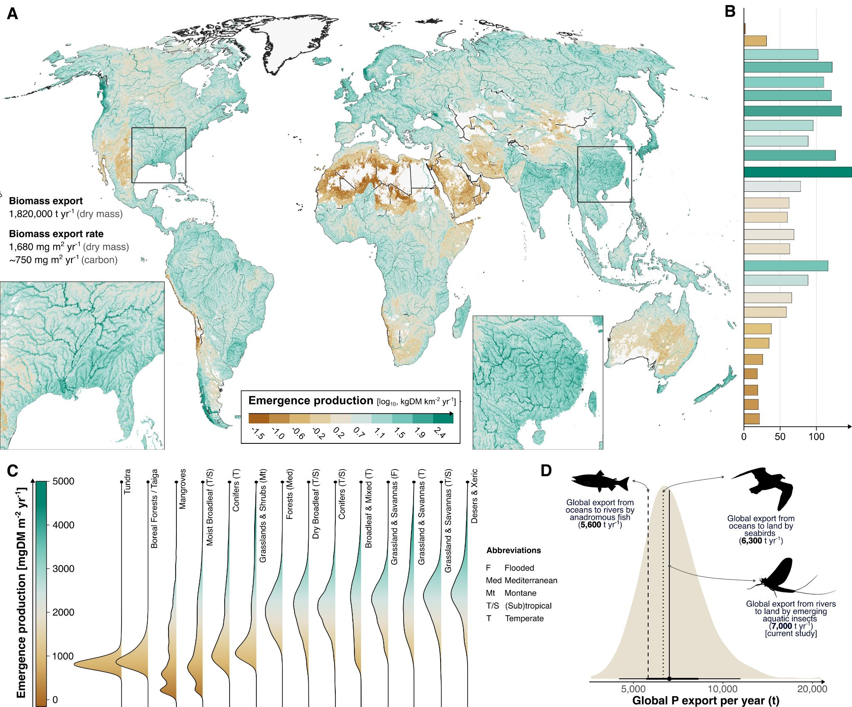
Fig. 1. Global insect emergence biomass and exports. (A) Global map of insect emergence biomass in kg dry mass km⁻² yr⁻¹ (basin area) derived per hydrobasin (n = 919,156) and extrapolated using hierarchical Bayesian modeling (305 reports, from 111 studies). Zoom-panels depict the Mississippi Portal and Southeast China. Values are displayed on a log₁₀-scale for ease of interpretation and rasterized in 0.05° resolution. (B) Bargraphs depict the total annual insect emergence biomass in kilotonnes per 5° longitude bin. (C) Annual emergence production as mg dry mass m⁻² surface area of water yr⁻¹ for the Earth’s terrestrial biomes. Densities show the distribution of posterior median emergence production across hydrobasins in each biome. (D) Posterior distribution of phosphorus (P) export by emerging aquatic insects in freshwater rivers compared to anadromous fish and seabirds. The green density represents the posterior distribution of insect-mediated P export. The dot and horizontal error bars at the bottom show the median with 66% and 95% credible interval (CrI). The vertical solid line also shows the median P export by emerging aquatic insects. The dashed and dotted lines show export of P from oceans to rivers by anadromous salmon or from oceans to land by seabirds via guano deposition, estimated from (20).

Global insect-mediated contaminant export

Global export of metals is estimated at 389 t yr⁻¹ (95% CrI: 120–856; Fig. 2A; table S2). Essential metals constitute the bulk of insect-mediated transport (368 t yr⁻¹, 95% CrI: 110–850; fig. S1), dominated by Zn (309 t yr⁻¹), Cu (54 t yr⁻¹), and Se (5 t yr⁻¹). In contrast, non-essential metal export is lower at ~11 t yr⁻¹ (95% CrI: 5–49; Pb = 7.9, Cd = 2, Hg = 0.7 t yr⁻¹; Fig. 2A). This disparity reflects the ubiquity of essential metals in insect tissue compared to the variable accumulation of non-essential elements. Consequently, essential metal export occurs across all river systems and mirrors spatial patterns of emergence biomass more closely than the localized export of non-essential metals (fig. S2).

Mercury (Hg) is of particular concern due to its neurotoxicity and biomagnification potential.
While the global abiotic transport of Hg via river discharge (~1,000 t yr⁻¹) (26) is three orders of magnitude larger than the estimated insect-mediated export (~0.72 t yr⁻¹), the latter has direct ecological implications. For example, along the North Pacific coast, we estimate insect-mediated Hg export at 21 kg yr⁻¹ (95% CrI: 5–100), nearly triple the 7 kg yr⁻¹ transported by Pacific salmon (16). Despite their lower mass relative to physical export, both insects and salmon deliver organic Hg directly into riparian food webs, facilitating biomagnification in terrestrial consumers (16, 27). Our finding that Hg export closely mirrors spatial patterns of emergence is consistent with local studies identifying emergence-controlling factors, such as nutrient availability and fish predation, as primary predictors of Hg flux (28, 29). Thus, the drivers of aquatic insect productivity ultimately influence the global magnitude of this ecologically relevant mercury vector.

Annual global export of pesticides (Fig. 2B; table S2) was lower than metals at approximately 100 kg yr⁻¹, and differed by pesticide class, with median export rates of 3.5, 115 and 12 mg km⁻² basin area for fungicides, herbicides and insecticides, respectively. Elevated exports were found in intensified agricultural regions, such as central Europe, eastern China, northern India and parts of North and South America, consistent with agriculture acting as the primary source of pesticides into non-target ecosystems (30, 31). Taken together, our results shed light on the relative contribution of beneficial versus potentially adverse export rates between ecosystem boundaries (fig. S3), a highly heterogeneous trade-off across the world’s river basins.

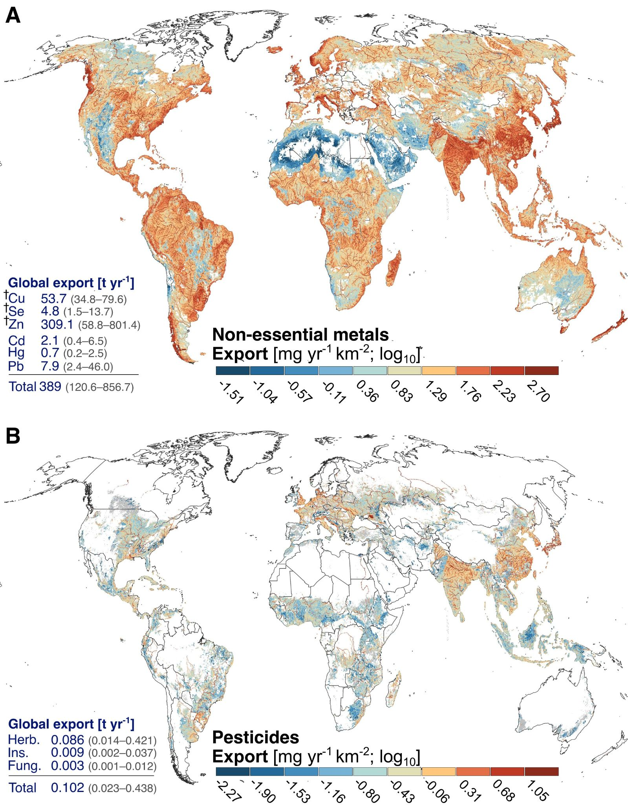

Fig. 2. Global annual aquatic contaminant export in mg km⁻² (basin area) mediated by aquatic insect emergence. Values are displayed on a log₁₀-scale for ease of interpretation and rasterized in 0.05° resolution. Contaminant export was estimated by combining meta-analytically derived emergence productivity (Bayesian GAMM; n = 305 reports from 111 studies) and contaminant transfer (i.e. aqueous uptake) models (GLMM; n = 534 reports from 20 studies) with random-forest inferred (n ~ 8.9 million, AUC 0.965–0.991) aqueous contaminant occurrence estimates (n ~ 8.0 million stream features, n = 919,156 hydrobasins) based on 24 selected spatial predictors and the observation period 2015–2019. For validation and accuracy metrics see Supplementary Methods. Two contaminant groups are included: (A) non-essential metals (cadmium, lead, mercury) and (B) 25 pesticides. Agricultural areas (≥25%, 0.05°, grey) are provided in (B) using Corine land-cover estimates for 2018. Global export rates per substance with their 95% CrI are annotated in the bottom-left corner per panel. Essential metal export rates are marked with daggers and are shown in fig. S5.

Drivers of nutrients and contaminant exports
Our models indicated that biomass of adult aquatic insect emergence was effectively predicted based on mean annual stream temperature and annual precipitation (fig. S4), in line with earlier continental-scale synthesis (24). Scaled by water surface area within basins, biomass export was particularly high in small coastal basins, such as in British Columbia, Norway and Chile, and throughout the Arctic (Fig. 1A to C). This reflects the relatively high density of flowing water in these basins (17, 32), even though Arctic basins are less productive per unit area of water than other regions (fig. S5). Emergence production (per unit of water surface area) of desert and temperate streams were relatively high, with emergence equal to or higher than tropical streams (10, 33, 34). This non-intuitive pattern is likely due to higher fish predation rates for larger insect larvae, and the relatively higher standing biomass of non-emerging invertebrates (i.e., crustaceans, mollusks) in tropical rivers (34, 35)

In models predicting metal export across river basins, emergence biomass explained 90 to 98% of variation depending on the metal analyzed. In the same models, aqueous water concentration explained 0.3 to 8% (table S3). The relatively small influence of aqueous water concentrations on metal export is somewhat counterintuitive, but it is consistent with existing knowledge of the mechanisms of metal export in emerging insects. Metals are excreted during metamorphosis in a concentration-dependent manner, a process that dampens variability in adult tissue burdens relative to the variation within the water column (36, 37). Consequently, adult insects emerging from basins with vastly different water-phase metal levels can exhibit remarkably similar tissue concentrations (38). In addition, at high aqueous concentrations most metals cause mortality-induced reductions in emergence, which then retains metals within the stream. This can lead, somewhat counterintuitively, to higher metal export from lower metal streams (37, 39). Together, these mechanisms predict strong contributions of emergence biomass to metal export from flowing waters (27, 28).

The magnitude of pesticide export by adult insects is governed by environmental persistence, bioaccumulation, and taxon-specific toxicity. Although herbicides dominate global usage, accounting for 51% of applied amounts compared to 22% each for insecticides and fungicides (40), their high export is primarily enabled by their low toxicity to aquatic insects. Unlike insecticides, herbicides typically allow high body burdens in insects without inducing larval mortality, thus maintaining the emergence-mediated export. Conversely, the higher toxicity and biomagnification potential of many modern fungicides and insecticides can limit total export mass by suppressing insect survival, shifting the ecological implications of insect emergence for consumers from from dietary exposure to loss of prey (41).

For modern low application rate neonicotinoid insecticides (42, 43), such as imidacloprid and thiacloprid, even surface water concentrations in the low ng L⁻¹ range result in 1 to 10 ng g⁻¹ dry mass within emerging insects (14, 44). Scaling these values by our global emergent biomass yields an estimated neonicotinoid export of 2–20 kg yr⁻¹, corroborating our modeled global insecticide export of ~3 kg yr⁻¹. While these exports appear small, their biological impact is amplified through food webs; neonicotinoid biomagnification from aquatic insects to terrestrial predators, such as spiders, can increase contaminant concentrations by three orders of magnitude (14). Furthermore, some insecticides, (e.g., pyrethroids) are already toxic at concentrations orders of magnitude lower than many metals (12), which likely adds to their ecological importance at the aquatic-terrestrial interface despite much lower exports compared to metals.

Caveats and conclusions
Our synthesis likely underestimates the actual extent of global contaminants export via emerging insects for several reasons: First, based on data availability our contamination models include six out of the twelve potentially relevant metals and only 25 out of the approximately 1000 relevant pesticides (45) used globally; in addition measured surface water concentrations often underestimate true exposure peaks, particularly for insecticides (46). Second, contaminant monitoring networks underrepresent small, first-order streams, which are widely diffused in catchments and could experience high levels of pesticide loads (47). Third, because our underlying data largely originate from well-regulated regions, they may not represent more extensive applications typical of less regulated economies (e.g., monitoring data were sparse in critical areas such as China). Fourth, our analyses exclude lakes, reservoirs and wetlands. These standing water systems are extensive and highly productive, yet their contributions are more spatially concentrated and less diffusely integrated into the terrestrial matrix compared to streams and rivers (48). As a source of error or bias, we also note some source studies did not specifically distinguish non-emerging insects from production estimates. Additionally, although the 305 records used for synthesis are geographically widespread and cover environmental predictors roughly comparable to global ranges, this number of estimates is relatively small compared to other data sources used in the study (e.g., >13M water quality stations).

Because ~90% of exported biomass is deposited within 1 km of shorelines, insect-mediated exports create concentrated hotspots of simultaneous nutrient enrichment and contaminant exposure. This tradeoff is likely relevant across a vast portion of the terrestrial landscape, as approximately half of the Earth’s non-desert land surface is located within this 1-km zone. Our findings extend traditional views of contaminant management, which focuses often on the protection of only one component, e.g., aquatic life. We show that bioavailable contaminants are not permanently sequestered in aquatic compartments, but can be returned to land by emerging insects at a scale that necessitates a re-evaluation of global biogeochemical cycles and conservation strategies to better account for ecosystem linkages. Since some of these contaminants are highly toxic, even low exported amounts may trigger ecological effects in the recipient terrestrial ecosystem and the species therein, particularly in globally imperiled riparian zones. Given the current global declines in insect populations and the increasing prevalence of chemical pollutants, this work provides a timely and necessary framework for understanding nutrient and contaminant exports and novel biodiversity threats across the Earth’s ecosystems

References and Notes

1. G. A. Polis, W. B. Anderson, R. D. Holt, Toward an Integration of Landscape and Food Web Ecology: The Dynamics of Spatially Subsidized Food Webs. Annu. Rev. Ecol. Syst. 28, 289–316 (1997).
2. A. L. Subalusky, D. M. Post, Context dependency of animal resource subsidies. Biol. Rev. 94, 517–538 (2019).
3. C. V. Baxter, K. D. Fausch, W. Carl Saunders, Tangled webs: reciprocal flows of invertebrate prey link streams and riparian zones. Freshw. Biol. 50, 201–220 (2005).
4. M. I. Gladyshev, E. E. Gladysheva, N. N. Sushchik, Preliminary estimation of the export of omega-3 polyunsaturated fatty acids from aquatic to terrestrial ecosystems in biomes via emergent insects. Ecol. Complex. 38, 140–145 (2019).
5. C. W. Twining, A. Blanco, C. Dutton, M. J. Kainz, E. Harvey, C. Kowarik, J. M. Kraus, D. Martin-Creuzburg, T. P. Parmar, N. R. Razavi, N. Richoux, G. Saboret, C. Sarran, T. S. Schmidt, J. R. Shipley, A. L. Subalusky, Integrating the Bright and Dark Sides of Aquatic Resource Subsidies—A Synthesis. Ecol. Lett. 28, e70109 (2025).
6. J. L. Sabo, M. E. Power, River–Watershed Exchange: Effects of Riverine Subsidies on Riparian Lizards and Their Terrestrial Prey. Ecology 83, 1860–1869 (2002).
7. M. Loreau, N. Mouquet, R. D. Holt, Meta-ecosystems: a theoretical framework for a spatial ecosystem ecology. Ecol. Lett. 6, 673–679 (2003).
8. J. D. Muehlbauer, S. F. Collins, M. W. Doyle, K. Tockner, How wide is a stream? Spatial extent of the potential “stream signature” in terrestrial food webs using meta-analysis. Ecology 95, 44–55 (2014).
9. C. Gratton, M. J. Vander Zanden, Flux of aquatic insect productivity to land: comparison of lentic and lotic ecosystems. Ecology 90, 2689–2699 (2009).
10. J. K. Jackson, S. G. Fisher, Secondary Production, Emergence, and Export of Aquatic Insects of a Sonoran Desert Stream. Ecology 67, 629–638 (1986).
11. R. P. Schwarzenbach, T. Egli, T. B. Hofstetter, U. von Gunten, B. Wehrli, Global Water Pollution and Human Health. Annu. Rev. Environ. Resour. 35, 109–136 (2010).
12. S. Bub, L. L. Petschick, S. Stehle, J. Wolfram, R. Schulz, Limitations of chemical monitoring hinder aquatic risk evaluations on the macroscale. Science 388, 1301–1305 (2025).
13. C. Strong, S. Kuzma, S. Vionnet, P. Reig, “Achieving Abundance: Understanding the Cost of a Sustainable Water Future” (World Resources Institute, 2020); https://www.wri.org/research/achieving-abundance-understanding-cost-sustainable-water-future.
14. A. P. Roodt, M. Huszarik, M. H. Entling, R. Schulz, Aquatic-terrestrial transfer of neonicotinoid insecticides in riparian food webs. J. Hazard. Mater. 455, 131635 (2023).
15. D. M. Walters, K. M. Fritz, R. R. Otter, The Dark Side of Subsidies: Adult Stream Insects Export Organic Contaminants to Riparian Predators. Ecol. Appl. 18, 1835–1841 (2008).
16. J. E. Brandt, J. S. Wesner, G. T. Ruggerone, T. D. Jardine, C. A. Eagles-Smith, G. E. Ruso, C. A. Stricker, K. A. Voss, D. M. Walters, Continental-scale nutrient and contaminant delivery by Pacific salmon. Nature 634, 875–882 (2024).
17. G. H. Allen, T. M. Pavelsky, Global extent of rivers and streams. Science 361, 585–588 (2018).
18. R. W. Sterner, J. J. Elser, Ecological Stoichiometry: The Biology of Elements from Molecules to the Biosphere (Princeton University Press, 2002; https://www.jstor.org/stable/j.ctt1jktrp3).
19. Y. M. Bar-On, R. Phillips, R. Milo, The biomass distribution on Earth. Proc. Natl. Acad. Sci. 115, 6506–6511 (2018).
20. C. E. Doughty, J. Roman, S. Faurby, A. Wolf, A. Haque, E. S. Bakker, Y. Malhi, J. B. Dunning, J.-C. Svenning, Global nutrient transport in a world of giants. Proc. Natl. Acad. Sci. 113, 868–873 (2016).
21. D. A. Satterfield, T. S. Sillett, J. W. Chapman, S. Altizer, P. P. Marra, Seasonal insect migrations: massive, influential, and overlooked. Front. Ecol. Environ. 18, 335–344 (2020).
22. C. Kowarik, D. Martin-Creuzburg, K. L. Mathers, C. Weber, C. T. Robinson, Stream degradation affects aquatic resource subsidies to riparian ground-dwelling spiders. Sci. Total Environ. 855, 158658 (2023).
23. D. Martin-Creuzburg, C. Kowarik, D. Straile, Cross-ecosystem fluxes: Export of polyunsaturated fatty acids from aquatic to terrestrial ecosystems via emerging insects. Sci. Total Environ. 577, 174–182 (2017).
24. C. J. Patrick, D. J. McGarvey, J. H. Larson, W. F. Cross, D. C. Allen, A. C. Benke, T. Brey, A. D. Huryn, J. Jones, C. A. Murphy, C. Ruffing, P. Saffarinia, M. R. Whiles, J. B. Wallace, G. Woodward, Precipitation and temperature drive continental-scale patterns in stream invertebrate production. Sci. Adv. 5, eaav2348 (2019).
25. B. Lehner, K. Verdin, A. Jarvis, New Global Hydrography Derived From Spaceborne Elevation Data. Eos Trans. Am. Geophys. Union 89, 93–94 (2008).
26. M. Liu, Q. Zhang, T. Maavara, S. Liu, X. Wang, P. A. Raymond, Rivers as the largest source of mercury to coastal oceans worldwide. Nat. Geosci. 14, 672–677 (2021).
27. J. M. Kraus, F. E. Rowland, M. L. Hladik, K. Dowdy, M. M. Chumchal, Predictors of mercury and pesticide fluxes by emerging adult aquatic insects from prairie pothole wetlands. Environ. Toxicol. Chem., vgaf280 (2025).
28. B. N. Tweedy, R. W. Drenner, M. M. Chumchal, J. H. Kennedy, Effects of Fish on Emergent Insect-Mediated Flux of Methyl Mercury across a Gradient of Contamination. Environ. Sci. Technol. 47, 1614–1619 (2013).
29. T. A. Jones, M. M. Chumchal, R. W. Drenner, G. N. Timmins, W. H. Nowlin, Bottom‐up nutrient and top‐down fish impacts on insect‐mediated mercury flux from aquatic ecosystems. Environ. Toxicol. Chem. 32, 612–618 (2013).
30. S. Stehle, A. Bline, S. Bub, L. L. Petschick, J. Wolfram, R. Schulz, Aquatic pesticide exposure in the U.S. as a result of non-agricultural uses. Environ. Int. 133, 105234 (2019).
31. J. Wolfram, S. Stehle, S. Bub, L. L. Petschick, R. Schulz, Water quality and ecological risks in European surface waters – Monitoring improves while water quality decreases. Environ. Int. 152, 106479 (2021).
32. S. Liu, C. Kuhn, G. Amatulli, K. Aho, D. E. Butman, G. H. Allen, P. Lin, M. Pan, D. Yamazaki, C. Brinkerhoff, C. Gleason, X. Xia, P. A. Raymond, The importance of hydrology in routing terrestrial carbon to the atmosphere via global streams and rivers. Proc. Natl. Acad. Sci. 119, e2106322119 (2022).
33. A. J. Boulton, L. Boyero, A. P. Covich, M. Dobson, S. Lake, R. Pearson, “9 - Are Tropical Streams Ecologically Different from Temperate Streams?” in Tropical Stream Ecology, D. Dudgeon, Ed. (Academic Press, London, 2008; https://www.sciencedirect.com/science/article/pii/B978012088449050011X)Aquatic Ecology, pp. 257–284.
34. A. Ramírez, C. M. Pringle, Structure and Production of a Benthic Insect Assemblage in a Neotropical Stream. J. North Am. Benthol. Soc. 17, 443–463 (1998).
35. D. Bass, A Comparison of Freshwater Macroinvertebrate Communities on Small Caribbean Islands. BioScience 53, 1094–1100 (2003).
36. J. M. Kraus, R. B. Wanty, T. S. Schmidt, D. M. Walters, R. E. Wolf, Variation in metal concentrations across a large contamination gradient is reflected in stream but not linked riparian food webs. Sci. Total Environ. 769, 144714 (2021).
37. J. S. Wesner, D. M. Walters, T. S. Schmidt, J. M. Kraus, C. A. Stricker, W. H. Clements, R. E. Wolf, Metamorphosis Affects Metal Concentrations and Isotopic Signatures in a Mayfly (Baetis tricaudatus): Implications for the Aquatic-Terrestrial Transfer of Metals. Environ. Sci. Technol. 51, 2438–2446 (2017).
38. J. M. Kraus, D. M. Walters, J. S. Wesner, C. A. Stricker, T. S. Schmidt, R. E. Zuellig, Metamorphosis Alters Contaminants and Chemical Tracers in Insects: Implications for Food Webs. Environ. Sci. Technol. 48, 10957–10965 (2014).
39. J. M. Kraus, T. S. Schmidt, D. M. Walters, R. B. Wanty, R. E. Zuellig, R. E. Wolf, Cross-ecosystem impacts of stream pollution reduce resource and contaminant flux to riparian food webs. Ecol. Appl. 24, 235–243 (2014).
40. FAO, “Pesticides use and trade” (2025); https://openknowledge.fao.org/items/3251bdcf-888c-40ab-8223-b135cebfe91e.
41. J. M. Kraus, Contaminants in linked aquatic–terrestrial ecosystems: Predicting effects of aquatic pollution on adult aquatic insects and terrestrial insectivores. Freshw. Sci. 38, 919–927 (2019).
42. C. Lamberth, S. Jeanmart, T. Luksch, A. Plant, Current Challenges and Trends in the Discovery of Agrochemicals. Science 341, 742–746 (2013).
43. R. Schulz, S. Bub, L. L. Petschick, S. Stehle, J. Wolfram, Applied pesticide toxicity shifts toward plants and invertebrates, even in GM crops. Science 372, 81–84 (2021).
44. J. M. Kraus, K. M. Kuivila, M. L. Hladik, N. Shook, D. M. Mushet, K. Dowdy, R. Harrington, Cross-Ecosystem Fluxes of Pesticides from Prairie Wetlands Mediated by Aquatic Insect Emergence: Implications for Terrestrial Insectivores. Environ. Toxicol. Chem. 40, 2282–2296 (2021).
45. K. A. Lewis, J. Tzilivakis, D. J. Warner, A. Green, An international database for pesticide risk assessments and management. Hum. Ecol. Risk Assess. Int. J. 22, 1050–1064 (2016).
46. S. Stehle, R. Schulz, Agricultural insecticides threaten surface waters at the global scale. Proc. Natl. Acad. Sci. 112, 5750–5755 (2015).
47. G. Weber, N. Christmann, A.-C. Thiery, D. Martens, J. Kubiniok, Pesticides in agricultural headwater streams in southwestern Germany and effects on macroinvertebrate populations. Sci. Total Environ. 619–620, 638–648 (2018).
48. M. Bartrons, M. Papeş, M. W. Diebel, C. Gratton, M. J. Vander Zanden, Regional-Level inputs of emergent aquatic insects from water to land. Ecosystems 16, 1353–1363 (2013).
49. J. Downing, J. Cole, C. Duarte, J. Middelburg, J. Melack, Y. Prairie, P. Kortelainen, R. Striegl, W. McDowell, L. Tranvik, Global abundance and size distribution of streams and rivers. Inland Waters, doi: <a href="https://dx.doi.org/10.5268/IW-2.4.502">https://dx.doi.org/10.5268/IW-2.4.502</a> (2012).
50. T. F. Waters, “Secondary Production in Inland Waters 1” in Advances in Ecological Research, A. Macfadyen, Ed. (Academic Press, 1977; https://www.sciencedirect.com/science/article/pii/S0065250408602354)vol. 10, pp. 91–164.
51. A. C. Benke, A. D. Huryn, L. A. Smock, J. B. Wallace, Length-Mass Relationships for Freshwater Macroinvertebrates in North America with Particular Reference to the Southeastern United States. J. North Am. Benthol. Soc. 18, 308–343 (1999).
52. J. Raitif, M. Plantegenest, O. Agator, C. Piscart, J.-M. Roussel, Seasonal and spatial variations of stream insect emergence in an intensive agricultural landscape. Sci. Total Environ. 644, 594–601 (2018).
53. J. S. Wesner, J. P. F. Pomeranz, Choosing priors in Bayesian ecological models by simulating from the prior predictive distribution. Ecosphere 12, e03739 (2021).
54. A. Vehtari, A. Gelman, J. Gabry, Practical Bayesian model evaluation using leave-one-out cross-validation and WAIC. Stat. Comput. 27, 1413–1432 (2017).
55. P.-C. Bürkner, brms: An R Package for Bayesian Multilevel Models Using Stan. J. Stat. Softw. 80, 1–28 (2017).
56. J. j. Elser, R. w. Sterner, E. Gorokhova, W. f. Fagan, T. a. Markow, J. b. Cotner, J. f. Harrison, S. e. Hobbie, G. m. Odell, L. w. Weider, Biological stoichiometry from genes to ecosystems. Ecol. Lett. 3, 540–550 (2000).
57. S. Moyo, Preliminary Estimations of Insect Mediated Transfers of Mercury and Physiologically Important Fatty Acids from Water to Land. Biomolecules 10, 129 (2020).
58. European Commission, Directive 2000/60/EC of the European Parliament and of the Council of 23 October 2000 establishing a framework for Community action in the field of water policy (2000).
59. E. K. Read, L. Carr, L. D. Cicco, H. A. Dugan, P. C. Hanson, J. A. Hart, J. Kreft, J. S. Read, L. A. Winslow, Water quality data for national-scale aquatic research: The Water Quality Portal. Water Resour. Res. 53, 1735–1745 (2017).
60. J. Wolfram, S. Bub, L. L. Petschick, A. Schemmer, S. Stehle, R. Schulz, Pesticide occurrence in protected surface waters in nature conservation areas of Germany. Sci. Total Environ. 858, 160074 (2023).
61. D. Borup, B. J. Christensen, N. S. Mühlbach, M. S. Nielsen, Targeting predictors in random forest regression. Int. J. Forecast. 39, 841–868 (2023).
62. T. Salles, L. Rocha, M. Gonçalves, A bias-variance analysis of state-of-the-art random forest text classifiers. Adv. Data Anal. Classif. 15, 379–405 (2021).
63. C. Arrighi, F. Castelli, Prediction of ecological status of surface water bodies with supervised machine learning classifiers. Sci. Total Environ. 857, 159655 (2023).
64. R. K. Mache, S. Schröder, M. Langguth, A. Patnala, M. G. Schultz, TOAR-classifier v2: A data-driven classification tool for global air quality stations. EGUsphere, 1–17 (2025).
65. J. Chen, L. Zhao, B. Wang, X. He, L. Duan, G. Yu, Uncovering global risk to human and ecosystem health from pesticides in agricultural surface water using a machine learning approach. Environ. Int. 194, 109154 (2024).
66. J. van den Hoogen, S. Geisen, D. Routh, H. Ferris, W. Traunspurger, D. A. Wardle, R. G. M. de Goede, B. J. Adams, W. Ahmad, W. S. Andriuzzi, R. D. Bardgett, M. Bonkowski, R. Campos-Herrera, J. E. Cares, T. Caruso, L. de Brito Caixeta, X. Chen, S. R. Costa, R. Creamer, J. Mauro da Cunha Castro, M. Dam, D. Djigal, M. Escuer, B. S. Griffiths, C. Gutiérrez, K. Hohberg, D. Kalinkina, P. Kardol, A. Kergunteuil, G. Korthals, V. Krashevska, A. A. Kudrin, Q. Li, W. Liang, M. Magilton, M. Marais, J. A. R. Martín, E. Matveeva, E. H. Mayad, C. Mulder, P. Mullin, R. Neilson, T. A. D. Nguyen, U. N. Nielsen, H. Okada, J. E. P. Rius, K. Pan, V. Peneva, L. Pellissier, J. Carlos Pereira da Silva, C. Pitteloud, T. O. Powers, K. Powers, C. W. Quist, S. Rasmann, S. S. Moreno, S. Scheu, H. Setälä, A. Sushchuk, A. V. Tiunov, J. Trap, W. van der Putten, M. Vestergård, C. Villenave, L. Waeyenberge, D. H. Wall, R. Wilschut, D. G. Wright, J. Yang, T. W. Crowther, Soil nematode abundance and functional group composition at a global scale. Nature 572, 194–198 (2019).
67. A. Beaufort, N. Lamouroux, H. Pella, T. Datry, E. Sauquet, Extrapolating regional probability of drying of headwater streams using discrete observations and gauging networks. Hydrol. Earth Syst. Sci. 22, 3033–3051 (2018).
68. K. M. Fritz, T.-L. Nadeau, J. E. Kelso, W. S. Beck, R. D. Mazor, R. A. Harrington, B. J. Topping, Classifying Streamflow Duration: The Scientific Basis and an Operational Framework for Method Development. Water 12, 1–2545 (2020).
69. D. T. Mahoney, J. R. Christensen, H. E. Golden, C. R. Lane, G. R. Evenson, E. White, K. M. Fritz, E. D’Amico, C. D. Barton, T. N. Williamson, K. L. Sena, C. T. Agouridis, Dynamics of streamflow permanence in a headwater network: Insights from catchment-scale model simulations. J. Hydrol. 620, 129422 (2023).
70. P. Döll, F. Kaspar, B. Lehner, A global hydrological model for deriving water availability indicators: model tuning and validation. J. Hydrol. 270, 105–134 (2003).
71. H. Meyer, E. Pebesma, Predicting into unknown space? Estimating the area of applicability of spatial prediction models. Methods Ecol. Evol. 12, 1620–1633 (2021).
72. J. Gabry, D. Simpson, A. Vehtari, M. Betancourt, A. Gelman, Visualization in Bayesian Workflow. J. R. Stat. Soc. Ser. A Stat. Soc. 182, 389–402 (2019).

Acknowledgements:
We are grateful to J.H. Andersen and C.J. Murray for their help throughout the work of SWG002. We also thank K. Fritz, L. Naslund, and K. Schofield for providing comments on previous versions of the manuscript.

Funding:
This work was supported by the Aquatic Synthesis Research Center (www.AquaSYNC.dk), through the Synthesis Working Group SWG002 and by the Deutsche Forschungsgemeinschaft (DFG, German Research Foundation)— 326210499/GRK2360. Further support was received from Biodiversa+, the European Biodiversity Partnership, in the context of the RIPARIANET project under the 2021-2022 BiodivProtect joint call.
JMK was funded by the U.S. Geological Survey Environmental Health Program under the Ecosystems Mission Area. The funders had no role in the study design, data collection and analysis, decision to publish, or preparation of the manuscript.

Author contributions:
SL, JMK, and RS: conceptualized the work. SL, JMK, JW2, DK, JDM, and RS extracted data. JW1, JW2, DK, JDM, JMAM, and AG analysed the data. SL led the writing, and all authors contributed to writing and editing. LS and RS acquired funding.

Competing interests:
The authors declare no competing interests.

Data, code, and materials availability:
All contaminant data and geospatial data are publicly available and can be accessed via the references provided in the Materials and Methods section. Data for all analyses are available at https://github.com/Aqua-Sync/secondary-production (to be permanently archived at Zenodo upon acceptance).
Code and data are available at https://github.com/Aqua-Sync/secondary-production (to be permanently archived at Zenodo upon acceptance).

