Supplementary Material for

Global export of biomass and contaminants from water to land by aquatic insects

Stefano Larsen; Jakob Wolfram; Jeff Wesner; Darin Kopp; Johanna M. Kraus; Jeffrey D. Muehlbauer; Jose Manuel Alvarez-Martinez; Afroditi Grigoropoulou; Ralf Schulz

Corresponding author: stefano.larsen@fmach.it

The PDF file includes:
Materials and Methods
Figs. S1 to S15
Tables S1 to S10

Materials and Methods

Downscaling estimated rivers and stream surface area

We obtained estimates for global rivers and stream surface area (RSSA) from Allen and Pavelsky (17). These estimates were produced by combining satellite observations of large rivers (>90m) with a statistical approach to account for the surface area of smaller streams. RSSA estimates are provided as grouped major basins (17, 25), which often encompass multiple hydrobasins catchment polygons (HydroBASINS level-12; resolution used in the present work). RSSA files remain spatially concordant with hydrobasin polygons, allowing for a one-to-many relationship, although this approach does not adequately capture underlying hydrological patterns, such as variations in stream order or regions with dense fluvial networks. To enhance the spatial allocation of RSSA to each hydrobasin, we downscaled RSSA estimates using the distribution of HydroRivers as a weighting factor. For each hydrobasin level-12, we identified the Strahler orders for all HydroRivers flowlines and associated them with stream width estimates obtained from Downing et al. (49). The ‘Downing-based” surface areas were derived leveraging the established relationship between Strahler order (ω) and stream width (w) as:
$$w\text{ = }0.452 ⋅ e^{0.842ω}$$
where w represents the estimated stream width corresponding to Strahler order ω.
Individual, “Downing-based” stream surface areas A were then calculated as:
$$A\text{ = }w ⋅ L$$
where L is the stream length (derived per HydroRiver feature).
Stream surface areas were subsequently aggregated per hydrobasin, rescaled between 0-1 and used as weighting factors to proportionally distribute RSSA among the underlying hydrobasins. RSSA were downscaled using the Downing-based surface areas, rather than only estimating global surface areas via Strahler orders, to prevent overestimations of global river surface areas and to incorporate robust remote-sensed information from (17). Briefly, although the relationship between Strahler orders and average stream widths is robust, the underlying variability is nonetheless considerable. Therefore, global stream surface areas, which directly define global emergence export, may be overestimated by calculations simply based on Strahler order. Additionally, lower order streams constitute a considerable fraction of the global steam surface areas (49) but are likely underrepresented in HydroRivers due to the resolution of globally available digital elevation maps, further supporting the use of the validated RSSA data as the primary determinant for our export estimates.
The available RSSA dataset had minor data gaps, predominantly along shorelines, resulting in a globally derived RSSA of ~755,000 km², lower than the ~773,000 km² reported by Allen and Pavelski (17). To address these gaps, a correction algorithm was developed in which missing hydrobasins were assigned RSSA values based on the mean percentage of stream area (mn_RSSApc) from surrounding catchments with available data. The RSSA for missing catchments was then estimated by multiplying mn_RSSApc by the respective catchment area. This correction resulted in a global RSSA of 772,884 km², closely aligning with the ~773,000 km² reported by (17).

Insect secondary production and emergence data collection
We collated a global database on secondary production to inform our model of emergence from streams and rivers (https://github.com/Aqua-Sync/secondary-production). We began by extracting annual estimates of in-stream, benthic invertebrate secondary production from a recent synthesis (24). Due to differences in objectives (e.g., annual vs. seasonal production, production across habitat types), not all data from that synthesis were usable for our study. Further, we added new datasets published since 2020 that were not available for inclusion in that former synthesis; these new datasets and others fitting our objectives were identified in part from Google Scholar and Web of Science searches with the same keywords used by (24). We also opportunistically added studies and data from papers and datasets cited within Patrick et al., the new studies, and other tables or values contained therein, as well as from studies identified separately when adding complementary variables from the emergence syntheses discussed below. Data were collated, per site, on total aquatic invertebrate annual secondary production and insect secondary production when available. Data were converted to mg dry mass m⁻² y⁻¹ using published conversion factors from ash-free dry mass (50), wet mass, or carbon (51). Papers that reported production for only a subset of aquatic insect taxa were excluded to avoid underestimating total community emergence production.
Aquatic insect production provided the most direct data source for modelling emergence export, as non-insect components of benthic secondary production (e.g., mussels, worms) lack a terrestrial life stage. However, in many cases total invertebrate secondary production data were available but aquatic insect secondary production was not; those total data were used as a proxy for aquatic insect secondary production using a conversion factor (see Annual insect emergence production). Our approach likely resulted in some non-emergent aquatic insect taxa (e.g., backswimmers, diving beetles), which were impossible to exclude from many papers that provided only a single aquatic insect secondary production estimate, being included as aquatic insect secondary production. Our goal was to provide a robust dataset for parameterizing the annual emergence export model. We excluded datasets that only provided instantaneous, daily secondary production, or annual secondary production estimates that were altered from a reference baseline (e.g. studies that experimentally increased nutrient availability). Our efforts resulted in a data set of 305 annual secondary production estimates, from 111 studies spanning on every continent except Antarctica, expanding on the data available from (24) by ~50% (fig. S6).
Out of the 305 resulting emergence estimates, 293 were derived by converting benthic secondary production to adult aquatic insect annual emergence whereas 18 directly estimated adult aquatic insect annual emergence. Our conversions from benthic production produced reasonable estimates of adult emergence. As shown in fig. S7, emergence values that were directly measured are nested within the estimates from benthic secondary production. This suggests that the conversions produced reasonable estimates of annual insect emergence, as observed elsewhere (9).

Biomass export of aquatic insects
The goal for biomass modelling was to generate predictions of annual insect emergence dry mass (DM) from rivers in each of 919,156 hydrobasins. Note that all processing workflows were initially conducted for all level-12 hydrobasins (n = 1,034,083) but subsequently reduced to non-desert, permanent lotic systems (n = 919,156, for details see Global modelling of aqueous contaminant concentration). Annual global emergence was then estimated by summing emergence across hydrobasins. To do this, we first converted literature-derived measures of annual benthic macroinvertebrate secondary production ($P_{b}$) to annual insect emergence production ($E_{i}$) in units of $mgDM{ m}^{\text{-}2} y^{\text{-}1}$.
We then estimated non-linear relationships of $E_{i}$ with environmental predictors and used the parameters from those models to predict $E_{i,basin}$ at each hydrobasin. Finally, we multiplied the predicted $E_{i,basin}$ by the surface area of river water to yield the total emergence production per basin. Finally, summing across all basins $\sum_{basin\text{=}1}^{919,156}{E_{i,basin}}$ yielded the total annual emergence biomass globally in units of kilograms or tonnes per year. Below we describe each of these steps in sequence. We have followed the notation of Gratton and Vander Zanden (9). A table of parameter definitions is presented in table S4.

Annual insect emergence production
To convert benthic secondary production to insect emergence, we first calculated the raw fraction of community production composed of insects $\left(f_{i}\right)$ from the 111 studies that reported both community-level and insect-only production. To estimate uncertainty in those proportions, we fit an intercept only model with $f_{i}$ as the response variable as follows:
$$f_{i}∼Beta\left(μ,ϕ\right)$$
$$logit\left(μ_{f_{i}}\right)∼Normal\left(0.66,0.07\right)$$
$$ϕ∼Gamma\left(0.01,0.01\right)$$
The likelihood was Beta and the prior for the intercept was the $N\left(0.66,0.07\right)$, corresponding to a prior mean fraction of ~66%, consistent with prior estimates by Gratton and Vander Zanden (9). This produced a posterior distribution of the average fraction of secondary production that is insects $μ_{f_{i}}$. We took 1000 k draws from that distribution and multiplied each draw by a corresponding benthic secondary production estimate $P_{b}$. The result yields a distribution of aquatic insect-only benthic secondary production $P_{i}^{k}$, such that $P_{i}^{k}\text{=}P_{b}⋅μ^{k}$. Averaging over the $k$ draws yielded a mean value of aquatic insect benthic production $P_{i}$ for each corresponding measure of total secondary production.
To convert $P_{i}$ to emergence production $E_{i}$, we first estimated the posterior distribution of emergence-to-production ratios E:P from streams using data from Gratton and Vander Zanden (9) and Raitif et al. (52), which included multiple studies and taxa. We used a Beta likelihood and an intercept only model with varying intercepts for study and taxon:
$$E:P∼Beta\left(μ,ϕ\right)$$
$$logit\left(μ_{E:P}\right)\text{=}α\text{+}α_{study}\text{+}α_{taxon}$$
$$α∼Normal\left(0.19,0.05\right)$$
$$α_{study}∼Normal\left(0,σ_{study}\right)$$
$$α_{taxon}∼Normal\left(0,σ_{taxon}\right)$$
$$σ_{study},σ_{taxon}∼Exponential\left(2\right)$$
$$ϕ∼Gamma\left(0.01,0.01\right)$$
After obtaining this estimate, we Monte Carlo multiplied 1000 $k$ draws from the posterior distribution of E:P ratios by 1000 $k$ draws from the posterior distribution of insect production estimates $E_{i}^{k}\text{=}μ_{E:P}^{k}⋅P_{i}$. Averaging over the draws yielded 293 modeled estimates of median $E_{i}$. We combined these with 18 empirical estimates resulting in 305 total estimates of annual insect emergence production $E_{i}$ ($mg⋅DM⋅m^{\text{-}2}⋅y^{\text{-}1}$). For simplicity, we consider that all emerging insects contribute biomass export to terrestrial systems, although a small fraction may be deposited back into the aquatic habitat (10). In this context, we estimate that approximately 49.0% of the Earth’s non-desert land surface (~120 million km², see Global modelling of aqueous contaminant concentration) is covered by emerging insect fluxes by using the HydroRivers networks and assuming a 1 km transport distance from streams and rivers (8)

Relationships of emergence and environmental variables
To determine which environmental variables best predicted emergence $E_{i}$, we used generalized additive models (GAM) with median emergence estimates from the above procedures (n = 305) as the response variable and a set of environmental variables as predictors (table S5). The likelihood was Gamma with a log-link. Prior values were determined with prior predictive simulation (53). We fit 15 models (table S6) with predictors that included combinations of mean annual water temperature, mean annual precipitation, and 8 other geospatial predictors. All models had varying intercepts of study and hydrobasin, both of which were included to allow posterior prediction to new locations. Values for the fixed predictors were determined using the Lat/Long location of each emergence sample and the corresponding environmental variables available through HydroAtlas (hydrobasin level-12). The general model structure was:
$$\frac{E_{i}}{max\left(E_{i}\right)}∼Gamma\left(μ,ϕ\right)$$
$$log\left(μ\right)\text{=}α\text{+}f\left(X\right)\text{+}α_{study}\text{+}α_{basin}$$
$$α∼Normal\left(\text{-}5,2\right)$$
$$f\left(X\right)\text{=}\sum_{k\text{=}1}^{K}{β_{k}b_{k}\left(X\right)}$$
$$β_{k}∼Normal\left(0,σ_{f}\right)$$
$$b_{k}∼Normal\left(0,2\right)$$
$$σ_{f}∼StudentT\left(3,0,2.5\right)$$
$$α_{study}∼Normal\left(0,σ_{study}\right)$$
$$α_{basin}∼Normal\left(0,σ_{basin}\right)$$
$$σ_{study},σ_{basin}∼Exponential\left(4\right)$$
$$ϕ∼Exponential\left(0.01\right),$$
where the response variable $E_{i}$ is annual insect emergence production. To improve model fit and simplify the prior selection, $E_{i}$ was standardized to the 0-1 scale by dividing each value by the maximum $E_{i}$ prior to fitting. The likelihood is Gamma with an unknown mean $μ$ and shape $ϕ$. The mean $μ$ is described by an intercept $α$ and varying intercepts for study $α_{study}$ and hydrobasin $α_{basin}$, along with the thin-plate spline smoothing function $f\left(X\right)$ for $X$ predictors. The smoothing function is described by $k$ basis functions $b_{k}$ and their corresponding weights $β_{k}$. The total $k$ varies by model as determined using the algorithms in mgcv (Wood 2025). The remaining lines denote prior distributions for each parameter
($α,β_{k},b_{k}α_{study},α_{basin},ϕ$) and hyperparameter ($σ_{f},σ_{study},σ_{basin}$).

Model comparison and global predictions of emergence
We compared the 15 models using leave-one-out-cross-validation (54) with the loo() function in brms (55). Four of the top five models had mean annual water temperature and/or mean annual precipitation in univariate, additive, or interactive forms. The remaining model was an intercept only model with no fixed predictors. For this reason, we used the model with main effects and interactions of mean annual water temperature and mean annual precipitation to predict $E_{i}$ in each of the 919,156 hydrobasins in units of $kg⋅DM⋅m^{\text{-}2}⋅y^{\text{-}1}$. Multiplying this by the surface area of river water in each hydrobasins yielded the total export per basin ($E_{i,basin}$; $kg⋅DM⋅{basin}^{\text{-}1}⋅y^{\text{-}1}$). We did this across 1000 $k$ draws of the posterior distribution. Summing over basins for each draw yielded a posterior distribution of global insect emergence $E_{i,global}$ in units of $tonnes⋅DM⋅y^{\text{-}1}$.

Range of training data versus global data
Across the samples with emergence estimates mean annual stream temperature ranged from 1 to 25°C (table S7). That covered ~96% of the global range of temperatures across all 919,156 hydrobasins. Mean annual precipitation in the emergence estimates covered a smaller percentage (~40%) of the global range. However, the median and 95% confidence intervals for precipitation (and temperature) had strong overlap with similar bounds (177 to 2,792 mm m⁻² y⁻¹ for the raw data vs 15 to 2,791 mm m⁻² y⁻¹ across the hydrobasins; table S7). We also compared the distributions of contaminants across basins relative to the basins in which emergence was collected (fig. S8) to determine if the emergence samples were taken more often in basins with low aqueous contaminant concentrations. Results showed strong overlap between the aqueous concentrations of contaminants in basins with emergence compared to the global distributions of contaminants (fig. S8). Hence, we assume that our emergence estimates (directly measured or derived from secondary production) came from basins that reflected typical environmental conditions as of 2025.
A comparison shows that our global median estimate of emergence biomass of ~1,600 mg dry mass m⁻² yr⁻¹ (equivalent to ~750 mg C m⁻² yr⁻¹) aligns with regional assessments, including estimates of ~1,000 mg C m⁻² yr⁻¹ in previous syntheses (9) and the broad range reported for Wisconsin lotic systems (48). Furthermore, emerging insects transport ~1,400 tonnes of carbon annually from Wisconsin's rivers, approximately 1/650th of our global estimate. This proportion closely matches Wisconsin’s contribution to global river surface area (1/570th), validating our scaling approach and supporting our conclusion that river density and surface area are the primary determinants of total emergent biomass.

Nutrient export by adult aquatic insects
In addition to dry mass, we estimated exports of carbon (C), nitrogen (N), phosphorus (P), and polyunsaturated fatty acids (PUFAs) by converting dry mass based on conversion ratios. For C, we first converted dry mass (DM) to ash-free dry mass (AFDM): $AFDM\text{=}0.9×DM$ (51). C was then estimated as $C\text{=}0.5×AFDM$ (50). N and P were estimated using stoichiometric ratios of 6.3 C:N and 124 C:P (56).
No standard conversions exist for PUFA. Therefore, we conducted literature searches in ISI Web of Science using search terms including “PUFA”, Poly-unsaturated fatty acid”, “aquatic insect*”, and “emergence” to identify articles on the PUFA content of adult aquatic insects. We focused on the years 2019 to 2024, with information before 2019 taken from recent review papers (4, 57). We identified those articles that reported quantitative PUFA concentrations per unit of biomass of emerging insects. Additional relevant papers were found examining references within the papers directly. We estimated exports of long-chain poly-unsaturated fatty acids (LC-PUFA) by first extracting 32 records of LC-PUFA concentrations from the literature. Of these 32 records, we limited our analysis to 25 that reported summed concentrations of docosahexaenoic acid (DHA) and eicosatetraenoic acid (EPA) in adult aquatic insects. One record was reported as DHA + EPA in “adult aquatic insects”, but all others were reported as DHA + EPA in individual insect Orders, including Diptera (e.g., Chironomidae, Culicidae), Ephemeroptera, Odonata, Trichoptera, and Plecoptera. We used these data to estimate the average concentration of EPA + DHA in adult aquatic insects using the following model:
$$F_{s}∼Gamma\left(μ,ϕ\right)$$
$$log\left(μ_{F_{s}}\right)\text{=}α\text{+}α_{study}\text{+}α_{taxon}$$
$$α∼Normal\left(\text{-}3,1\right)$$
$$α_{study}∼Normal\left(0,σ_{study}\right)$$
$$α_{taxon}∼Normal\left(0,σ_{taxon}\right)$$
$$σ_{study},σ_{taxon}∼Exponential\left(2\right)$$
$$ϕ∼Gamma\left(0.01,0.01\right),$$
where $F_{s}$ is the standardized (z-score) adult tissue concentration of DHA + EPA (standardized by dividing by the maximum concentration), with varying intercepts for study $α_{study}$ and taxon $α_{taxon}$. Because tissue concentrations are positive and continuous, we used a gamma likelihood with a log-link. Given the standardized data and log-link, we used a N(-3, 1) prior for the intercept and N(0, 1) prior for the slope, with an exponential(2) prior for the hyperparameter $σ_{study}$ and Gamma(0.01, 0.01) for $ϕ$.
After un-standardizing, this yielded a posterior distribution of PUFA concentrations in units of $ng⋅{mgDM}^{\text{-}1}$. To convert this to annual export, we multiplied each estimate of dry mass export by $k\text{=}100$ draws of PUFA, then took the median across the 100 draws, yielding estimates of PUFA export in units of $mg$ or $kg⋅y^{\text{-}1}$ .

Global modelling of aqueous contaminant concentration
Monitoring Data - To estimate global export of contaminants by adult aquatic insects, we first assembled a global dataset on the occurrence and concentration of waterborne contaminants (fig. S9). Monitoring data detailed the occurrence of 37 contaminants (12 metals, 7 fungicides, 8 herbicides, 10 insecticides) in aquatic ecosystems, compiled for European countries and the United States. Both essential and non-essential metals were considered contaminants in our analyses, although at low concentrations, essential metals could be considered as a subsidy. European monitoring data were generated as part of the Water Framework Directive (58), active since approximately 2000, and processed according to the methodology described in (31). This dataset comprised 35,781,777 measurements in total, which was reduced to 7,417,367 measurements of the 37 contaminants. For the United States, data were accessed via the Water Quality Portal (59) and processed following the approach outlined in (12), resulting in 5,338,555 contaminant measurements. The European and US datasets were harmonized (e.g. using standardized CAS-RN attribution, detection classification) and merged resulting in the combined dataset hereafter referred to as “monitoring data”. Further filtering excluded records predating 2010 to minimize legacy contamination impacts on predictions and limited data to lotic systems. The final harmonized dataset encompassed 8,933,938 monitoring records in total, taken from 48,205 locations between 2010 to 2023.
Spatial attributes - Globally available spatial attributes relevant to the occurrence of contaminants in surface waters – spanning hydrological, litho-geological, land-use/land-cover, and meteorological characteristics – were reprojected to EPSG:4326 (WGS84) in their native resolution and assigned to monitoring sites using 5 km buffer zones (table S8). This approach demonstrated good predictive power while minimizing computational demands compared to hydrological network-based methods (data not shown). Land-cover estimates were aggregated into six distinct classes: cropland, closed forests, open forests, shrubs and grasses, urban areas, and water surfaces (31, 60). Additionally, each site was assigned its predominant lithological class to limit predictor complexity. Efforts to reduce predictor complexity and inter-correlation were prioritized, as these can hinder the accuracy and generalization of random forest models (61, 62).
Additional spatial attributes from HydroSHEDS datasets were attributed to monitoring sites at the catchment or sub-catchment scale. An initial screening of 55 potentially relevant HydroATLAS attributes (e.g., discharge, runoff, elevation, air temperature, soil erosion, and population density) identified those with high explanatory power while eliminating those with high inter-correlation or low predictive relevance. Ultimately, nine HydroSHEDS attributes (at hydrobasin level-12) were retained for model building: upstream catchment area, annual average discharge, Strahler stream order, annual air temperature, annual precipitation, terrain slope, soil erosion, land-surface runoff, and population density. To account for the influence of mining activities, two global mining footprint layers were harmonized into a single predictor representing the average mining footprint (table S8). In total, 24 spatial predictors were included in the final model training.
Model training and tuning - For the global modelling of aqueous concentration, contaminants were grouped into four categories (herbicides, fungicides, insecticides, and metals). For each group, two random-forest models were developed: an occurrence model to predict the likelihood of contaminant presence and a concentration model to estimate concentrations where presence was predicted. Random-forest models were chosen based on their successful application in both water and air pollution modelling (63–65). Model training and tuning followed three key steps: predictor reduction, hyperparameter tuning, and tree reduction, utilizing k-fold cross-validation throughout (k = 3). To manage computational demands, stratified subsets (n ≤ 500,000; stratification by detection frequency and chemical identity) were used for model tuning, with data split into training (70%) and hold-out testing (30%) datasets. Feature elimination, hyperparameter tuning and tree reduction were applied successively as opposed to brute-forced randomized grid searches applied for substantially smaller datasets at the global scale (65, 66). Alongside spatial predictors, models incorporated chemical identity (CAS-RN), year, and month of observation to account for substance-specific, annual, and seasonal variability.
Predictor reduction - Recursive feature elimination (RFE) was used to iteratively remove the least important predictors, as assessed by metrics such as mean explained variance or GINI permutation importance. Resulting models were compared to the initial full model (i.e., the model including all predictors), with optimal predictors selected based on out-of-bag error (OOB; occurrence models) or mean absolute error (MAE; concentration models). While error rates on k-fold testing data were also evaluated, they were not used for model selection to avoid data leakage. The finalized predictor sets were carried forward to subsequent tuning steps.
Hyperparameter tuning - To reduce computational demands, the number of trees was minimized. Models were trained with varying tree counts (50–400), and the simplest model achieving predictive performance within 1% of the most accurate iteration was selected. This approach ensured negligible accuracy loss while improving model efficiency. Four subsequent hyperparameters were considered for optimization: number of variables per split, minimal node size, maximum tree depth, and sampling fraction using OOB errors and MAE as evaluation metrics depending on the model type. Contaminant data are highly heterogeneous in space, time and chemical reliability (12, 31). As such, overly optimized models (e.g. via minimum node size, maximum tree depths) can be biased toward the underlying data structure, thereby failing to generalize contamination patterns. Hence, hyperparameters were tuned to improve prediction accuracies while simultaneously maximizing generalization performance (e.g. via max tree reduction) accepting minimal accuracy trade-offs (i.e., 1% relative accuracy loss per hyperparameter compared to the best model).
Final model building and validation - Using optimized predictors and tuned hyperparameters, final occurrence (n = 4) and concentration (n = 4) models were trained on the full training dataset (70% of the total data). Model performance was evaluated using both internal metrics – such as permuted OOB errors and MSE from training – and external metrics from the hold-out dataset (30%). Testing accuracies were either comparable to or slightly better than training metrics, indicating no evidence of overfitting and suggesting robust generalization. A comprehensive summary of model accuracy metrics is presented in table S9 and table S10. Receiver-operator curves (AUC 0.965–0.991) for the contaminant occurrence models also indicated high classification accuracy and are shown in fig. S10.
Global model application - The contaminant occurrence and concentration models were applied to the global stream network, represented by the HydroRIVERS and HydroBASINS datasets. Flowlines outside continental boundaries, such as near-coastal estuarine systems, and those within lentic systems identified via HydroLAKES, were excluded from the predictions, resulting in 8,030,568 stream features. For modelling purposes, a theoretical monitoring site was assigned to each stream feature, providing an even representation of global lotic systems. Geospatial predictors for these theoretical sites were derived following the same procedures used for the training data (see above).
Monthly contaminant predictions were conducted for the period 2015–2019 to account for temporal variability, resulting in ~17 billion occurrence and subsequent concentration predictions. Detection frequencies and average concentrations were calculated per time-step (e.g. June 2015) and hydrobasin (level-12, the highest spatial resolution, n = 919,156) and subsequently averaged over time, yielding average contaminant concentrations (2015–2019) and their likelihood of occurrence (predicted detection frequency). These hydrobasin-level averages of contaminant concentrations and detection frequencies formed the basis for the analyses of contaminant transfers (see Methods section Contaminant transfer to adult aquatic insects). Our approach using average contaminant concentrations, thus represents a conservative approach of estimating general contaminant patterns, which do not reflect localized contamination peaks potentially found in individual streams. Furthermore, while our training data represents a wide range of bioclimatic regions, model applications can still result in implausible results, as observed for arid or desert regions and highly remote areas in the tropics.
The occurrence of pesticides in remote areas was particularly associated with higher uncertainties (fig. S11; see below for further uncertainty discussions). Thus, pesticide predictions were restricted to areas with at least residual agricultural influence (agricultural land-use > 5%) either locally (i.e. per hydrobasin) or regionally (based on the entire upstream area) to prevent overestimating pesticide exports. The latter criteria were applied as previous work has shown that natural or protected areas without noteworthy local agricultural land-use can still be exposed through fluvial inflows from upstream agricultural areas (60).
The training data mainly describe contaminant occurrences in permanent lotic systems, with the assumption that water bodies are present. Hence, contaminant predictions were restricted to hydrobasins with an estimated average discharge of >0.1 m³ s⁻¹. While ephemeral, semi-permanent or transient streams can already occur in ranges of ~0.005–0.02 m³ s⁻¹ (67–69), these criteria were not conservative enough to identify desert environments via HydroATLAS attributes based on associated discharge estimates (70). Thus, a stricter cutoff criterion of 0.1 m³ s⁻¹ was used to prevent overestimating primarily metal concentrations. Furthermore, hydrobasins permanently covered by ice or snow (derived via HydroATLAS and Corine land-cover) and those experiencing <2 months of non-freezing temperatures were removed as well. Filtering criteria were also applied to all productivity export estimates (e.g. N-export, mgDM-export), resulting in 919,156 viable hydrobasins overall. Resulting contaminant predictions are given in fig. S12, shown as long-term exposures. Long-term exposures represent average predicted water concentrations adjusted by their likelihood of occurrence (detection frequency); as such, transient but high contaminant concentrations are proportionally downweighted to account for their transience.
Global model validation - Model predictions may be less accurate in regions with distinct environmental or regulatory contexts (e.g., Africa or South America), where homogeneous monitoring data are sparse or completely unavailable. The issue of limited generalization performance when leaving parameter rooms of the training data has been raised (71). The GEMStat database, curated by the German Federal Institute for Hydrology, was utilized as an independent validation dataset to address this limitation. GEMStat compiles global surface water monitoring data from various national programs and was excluded from all training workflows. This exclusion reflects the limited availability and heterogeneity of monitoring data outside Europe and the US, particularly in developing regions, and ensures GEMStat serves as an independent dataset for global validation. The dataset, harmonized and error-checked, was reduced to the 37 contaminants modeled in this study, yielding ~3.2 million measurements. Of these, ~1.5 million measurements, spanning all continents, were from outside the training regions. Among the 37 contaminants, 32 were present in the GEMStat data, with most measurements (87.7%, ~2.8 million) related to metals. Outside the training area, pesticide occurrence data were available for 14 substances (mainly from Canada, China, Japan and Uruguay), with just two (chlordane, metolachlor) having more than 100 measurements. Consequently, validation metrics predominantly reflect the generalization accuracy of the metal contaminant models. Nevertheless, pesticide models demonstrated performance on par with the metal models (see table S9 and table S10), suggesting that their generalization accuracy may also be robust across global contexts.
Predicted average concentrations per hydrobasin were compared against GEMStat data both on actual (i.e. daily measurements) and average concentrations. The latter did not show noteworthy differences and hence will not be discussed further. All comparisons with GEMStat data were made for 2015 onwards to provide a temporally similar basis. Overall, concentration predictions were highly accurate within the training area, as 91.7% of predicted concentrations were within one order of magnitude of the actual observed concentrations (see fig. S13). Concentration predictions outside the training area were less but still comparatively accurate as 77.3% of predicted concentrations were within one order of magnitude of the actual concentrations. Residuals were virtually zero-centered on average, with no systemic under- or overestimations, although with slight tendencies toward an underestimation of contaminant concentrations. Taken together, validation with the independent GEMStat data suggested plausible results of average concentrations globally. Finally, we quantified predictor uncertainties spatially to highlight areas with assumed lower reliability (fig. S13). Briefly, all spatial predictors were normalized (z-score transformation) with respect to the training data and subsequently aggregated (mean absolute difference) per hydrobasin. Uncertainty is thereby expressed as the mean absolute standard deviation per area. Also, predictor distributions for both the training and global prediction data are provided in fig. S14 to depict the representativeness of individual predictors used for global contaminant modelling.

Contaminant transfer to adult aquatic insects

The goal of contaminant transfer modelling was to convert dry mass estimates from emergence biomass modelling into tissue concentrations of metals, herbicides, fungicides, and pesticides. To do this, we first extracted paired water concentrations and adult tissue concentrations of contaminants from 17 studies in the literature, resulting in 524 observations of 9 contaminants (fig. S15). We then modeled this relationship using generalized linear mixed models (separate model for each contaminant), yielding predictions of adult tissue concentrations $C_{a}$ in units of $ng⋅{mgDM}^{\text{-}1}$ as a continuous function of water concentrations $C_{w}$. In this analysis we do not consider the fraction of contaminants that could be offloaded by adult insects via oviposition.

To scale this globally, we generated posterior predictions of $C_{a}$ in each of the 919,156 hydrobasin using the mean water concentration ($C_{w})$ in each HydroBasin derived from contaminant modelling (see Global modelling of aqueous contaminant concentration). This generated basin level predictions of adult tissue concentrations of contaminants $C_{a,basin}$. Multiplying these by estimates of adult aquatic insect emergence $E_{i,basin}$ yielded predictions of contaminant export in each hydrobasin $C_{f,basin}$, which we report in units of $mg$ or $kg⋅y^{\text{-}1}$ .

To estimate the relationship between water concentrations $C_{w}$ and adult concentrations $C_{a}$ of metals, herbicides, fungicides, and insecticides, we fit separate generalized linear mixed models for each compound with the following structure:

$$\frac{C_{a}}{max\left(C_{a}\right)}∼Gamma\left(μ,ϕ\right)$$

$$log\left(μ\right)\text{=}α\text{+}βC_{w}\text{+}α_{study}$$

$$α∼Normal\left(\text{-}3,1\right)$$

$$β∼Normal\left(0,1\right)$$

$$α_{study}∼Normal\left(0,σ_{study}\right)$$

$$σ_{study}∼HalfStudentT\left(3,0,2.6\right)$$

$$ϕ∼Gamma\left(0.01,0.01\right),$$

where $C_{a}$ is the adult tissue concentration of a contaminant (standardized by dividing by the maximum concentration), $C_{w}$ is the water concentration of the contaminant (standardized as a z-score), with varying intercepts for study. Because tissue concentrations are positive and continuous, we used a gamma likelihood with a log-link. Given the standardized data and log-link, we used a N(-3, 1) prior for the intercept and N(0, 1) prior for the slope, with a default priors of HalfStudentT(3, 0, 2.6) for the hyperparameter $σ_{study}$ and Gamma(0.01, 0.01) for $ϕ$.

Model fitting and model checking

Analysis of regression models (simple to generalized linear mixed models) was conducted in R version 4.5.2 (R Core Team 2025) with the brms package (55). Posterior samples were generated in rstan using the No-U-Turn Sampling algorithm. Models were fit using 4 chains of 2000 iterations each with the first 1000 iterations from each chain discarded as warmup. Posterior inference, plotting, and data wrangling relied largely on the packages tidyverse, tidybayes, and data.table. Priors were determined using prior predictive simulation (53). Model fit was assessed using posterior predictive checks (72).

Modelling contaminant exports
Using the posterior distributions of parameters from the water to adult concentration models (see Contaminant transfer to adult aquatic insects), we estimated adult concentrations for each hydrobasin based on the concentrations of a given compound predicted from the random forest model ($C_{w}$; see Global modelling of aqueous contaminant concentration), such that:

Concbasin=α+βCCww

where $Conc_{basin}$ is the predicted tissue concentration (e.g., µg mgDM⁻¹) of a compound as a function of the intercept $α$ and slope $β$ multiplied by the water concentration predicted from the random contaminant model ($C_{w}$).
To estimate the export of each compound per hydrobasin, we multiplied $E_{i,basin}$*$Conc_{basin}$, resulting in 919,156 estimates of the export of each compound. Summing across hydrobasins (for each posterior iteration of $Conc_{basin}$) generated a distribution of estimates of the global export of each compound from rivers and streams per year.
As shown above, contaminant export from each basin is a function of the total insect emergence from that basin and the concentration of contaminants in an insect, which itself is a function of the aqueous contaminant concentrations. Therefore, to estimate the relative contribution of emergence biomass versus aqueous concentration to contaminant export by insects, we first fit a linear model of the form Export ~ intercept + $β$₁$E_{i,basin}$ + ${β2C}_{w}$ using the lm() function in R. The data came from 50,000 randomly sampled hydrobasins. We then used the calc.relaimpo() function from the relaimpo package to estimate the proportion of total variance explained by each predictor variable.

Supplementary Figures

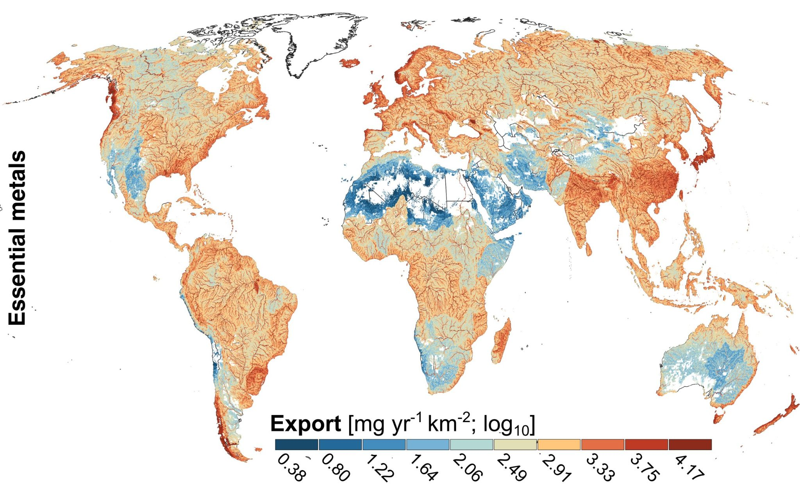
Fig. S1. Global insect-mediated export of essential metals. Map shows export of the sum of the three essential metals (copper, zinc and selenium) depicted as rates in mg per year per square kilometer. Export rates are log₁₀-transformed.

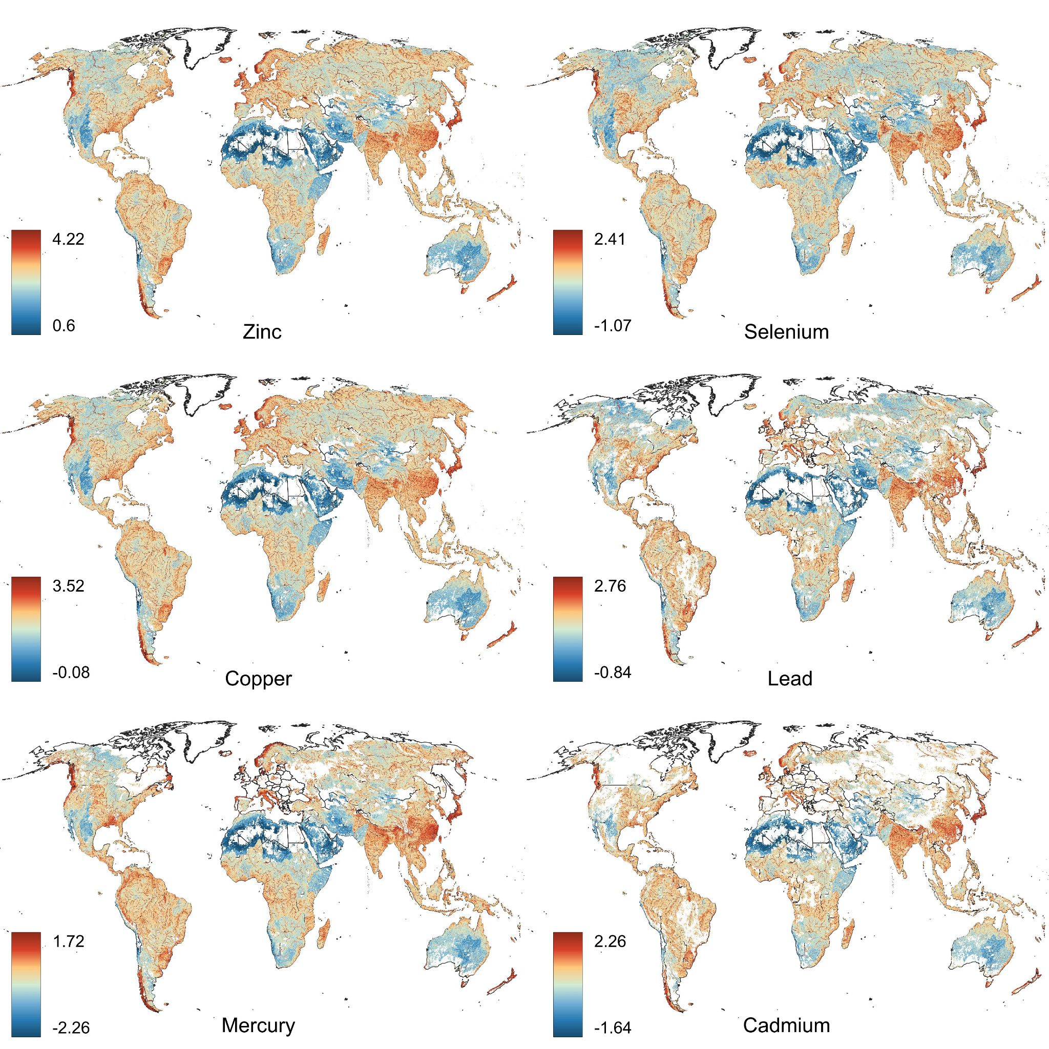
Fig. S2. Global annual export rates in mg km⁻² for three essential metals (zinc, selenium, copper) and three non-essential metals (lead, mercury, cadmium). Export rates are log₁₀-transformed for ease of interpretation; note that color scales vary across panes and thus cannot be compared.

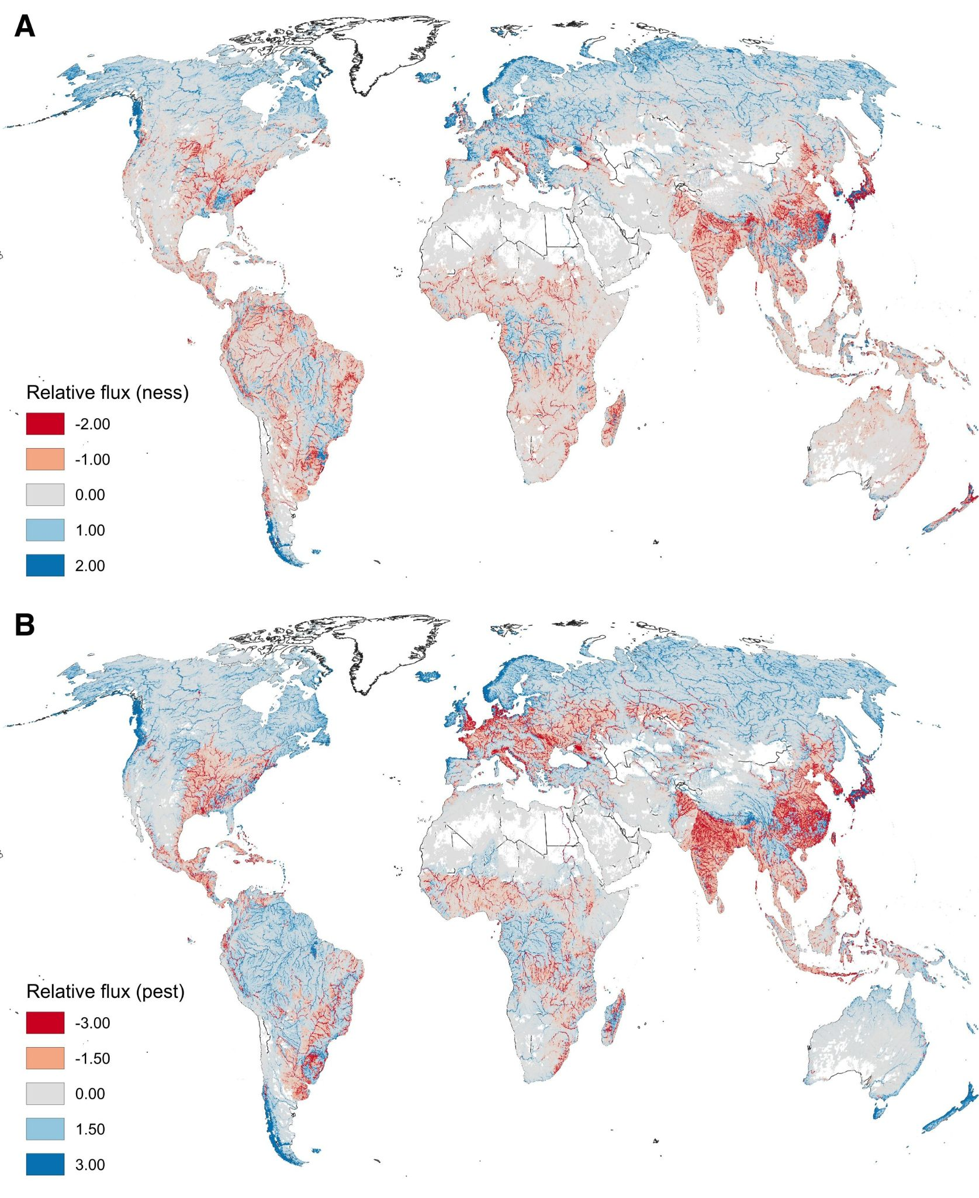
Fig. S3. Global maps of relative export fluxes comparing beneficial (i.e., polyunsaturated fatty acids; PUFA) and potentially adverse (i.e., contaminants) export rates. Relative export maps highlight the disbalance between beneficial and potentially adverse export rates with respect to the global average export of both PUFAs and contaminants. Disbalances should not be interpreted as higher environmental risks to consumer groups, but as indicators of larger potential trade-offs for higher consumers. Mapping indicates that while nutrient subsidies scale with emergent biomass and river surface area, contaminant exports are intensified by catchment land use. This results in basins where emergent insects deliver disproportionately high contaminant loads relative to their nutritional value. (A) Global map of relative export for non-essential metals (ness; sum of Cd, Hg, and Pb). (B) Global map of relative export for pesticides (pest, sum of herbicides, insecticides and fungicides). All relative export values are multiplied by 10⁶ to improve readability.
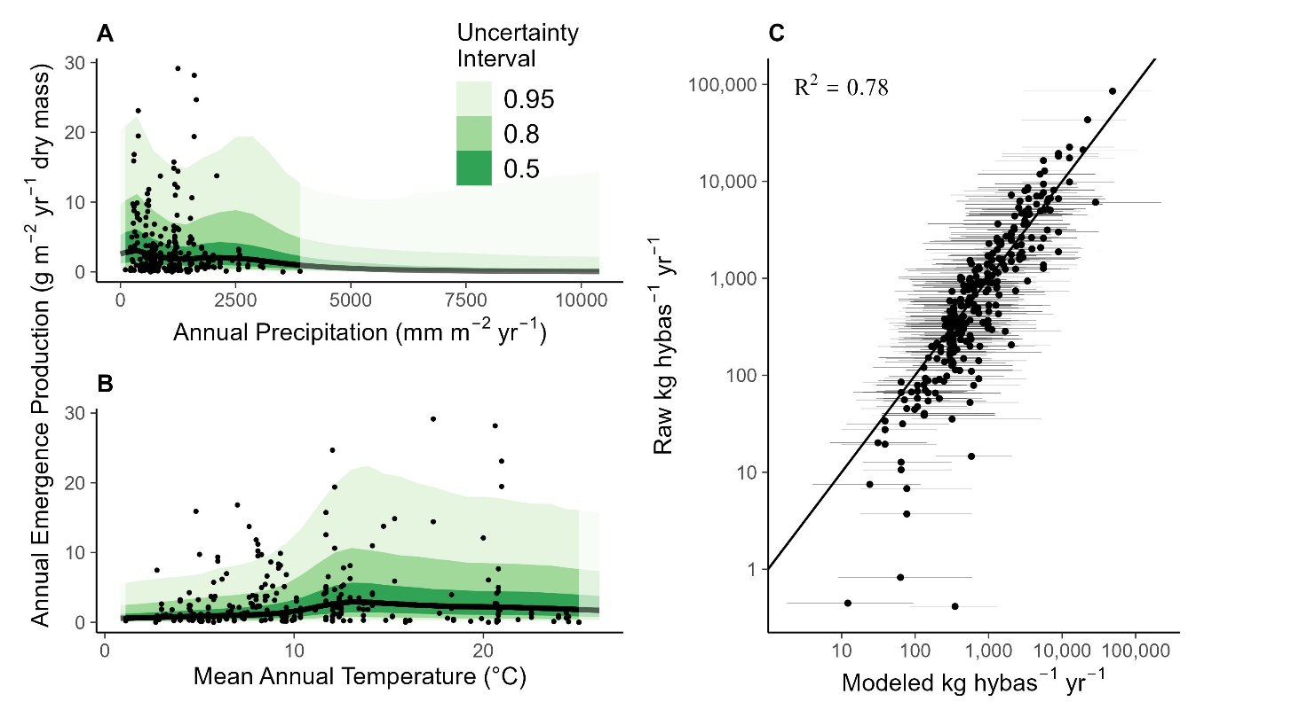
Fig. S4. Predictions of insect emergence based on environmental parameters. (A) and (B) Posterior predictions of annual insect emergence production fit to 305 samples (dots). The black line is the posterior median, with shading showing 50, 80, and 95% credible (uncertainty) intervals (CrI). The transparency shifts denote predictions within the training data (dark) versus outside the training data (light). Most precipitation values in the training data are <2500 mm m⁻² y⁻¹ (A), whereas the temperature data cover nearly the entire global range (B). (C) Modeled annual insect emergence per hydrobasin versus observed (n = 305) annual emergence per hydrobasin. The solid line shows the 1:1 relationship. Dots and error bars show the posterior median and 95% CrI (for the modeled data) or the observed values for the empirical data.
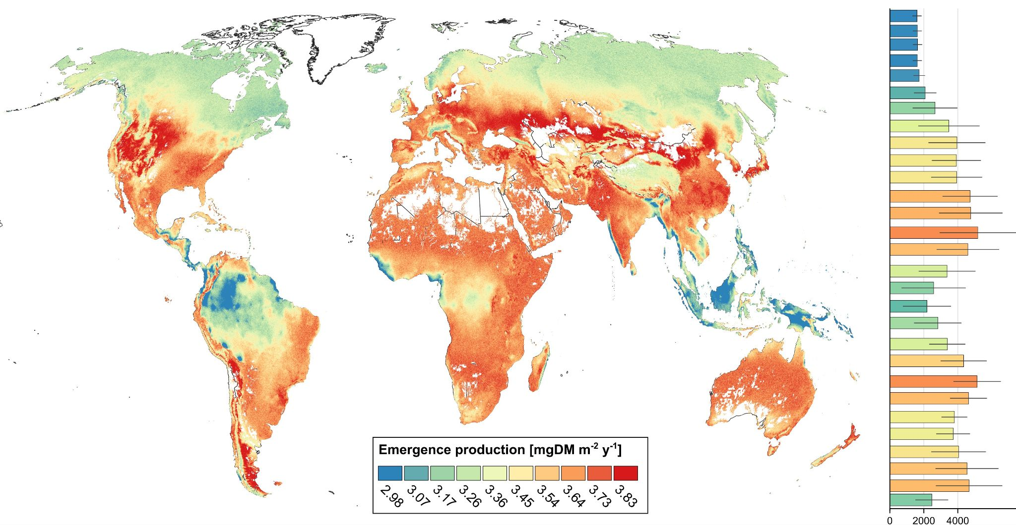
Fig. S5. Estimated aquatic insect emergence production (mgDM m⁻² y⁻¹) in each of the 919,156 sub-basins. Estimates were obtained using predictions of the Bayesian hierarchical GAM models. Median production ranged from <1,100 mgDM m⁻² y⁻¹ in the Arctic (Greenland, Siberia, and North American arctic) to >1,500 mgDM m⁻² y⁻¹ in primarily temperate regions of Europe, North America, and Asia. Bar graphs depict the average (±SD) insect emergence production (mgDM m⁻² y⁻¹) per 5° degree latitude bin.

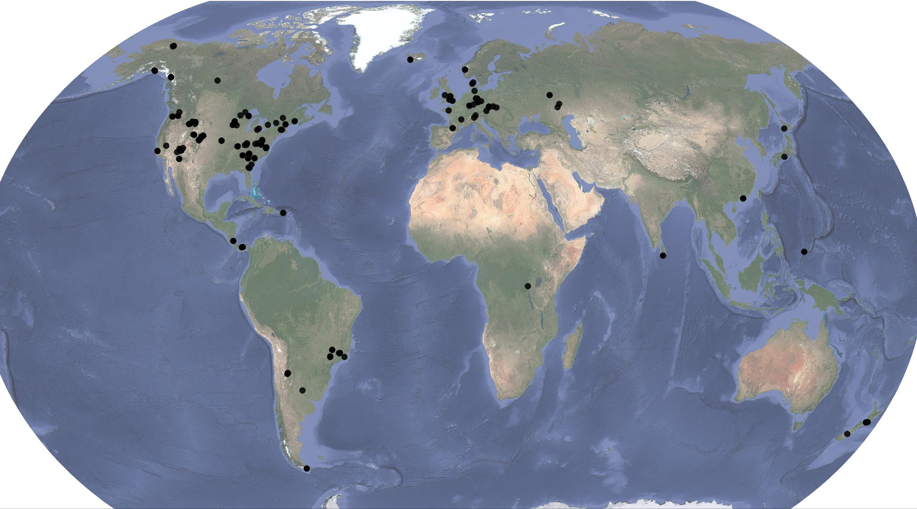
Fig. S6. Global map depicting the locations of the 305 reports used for secondary production estimates.

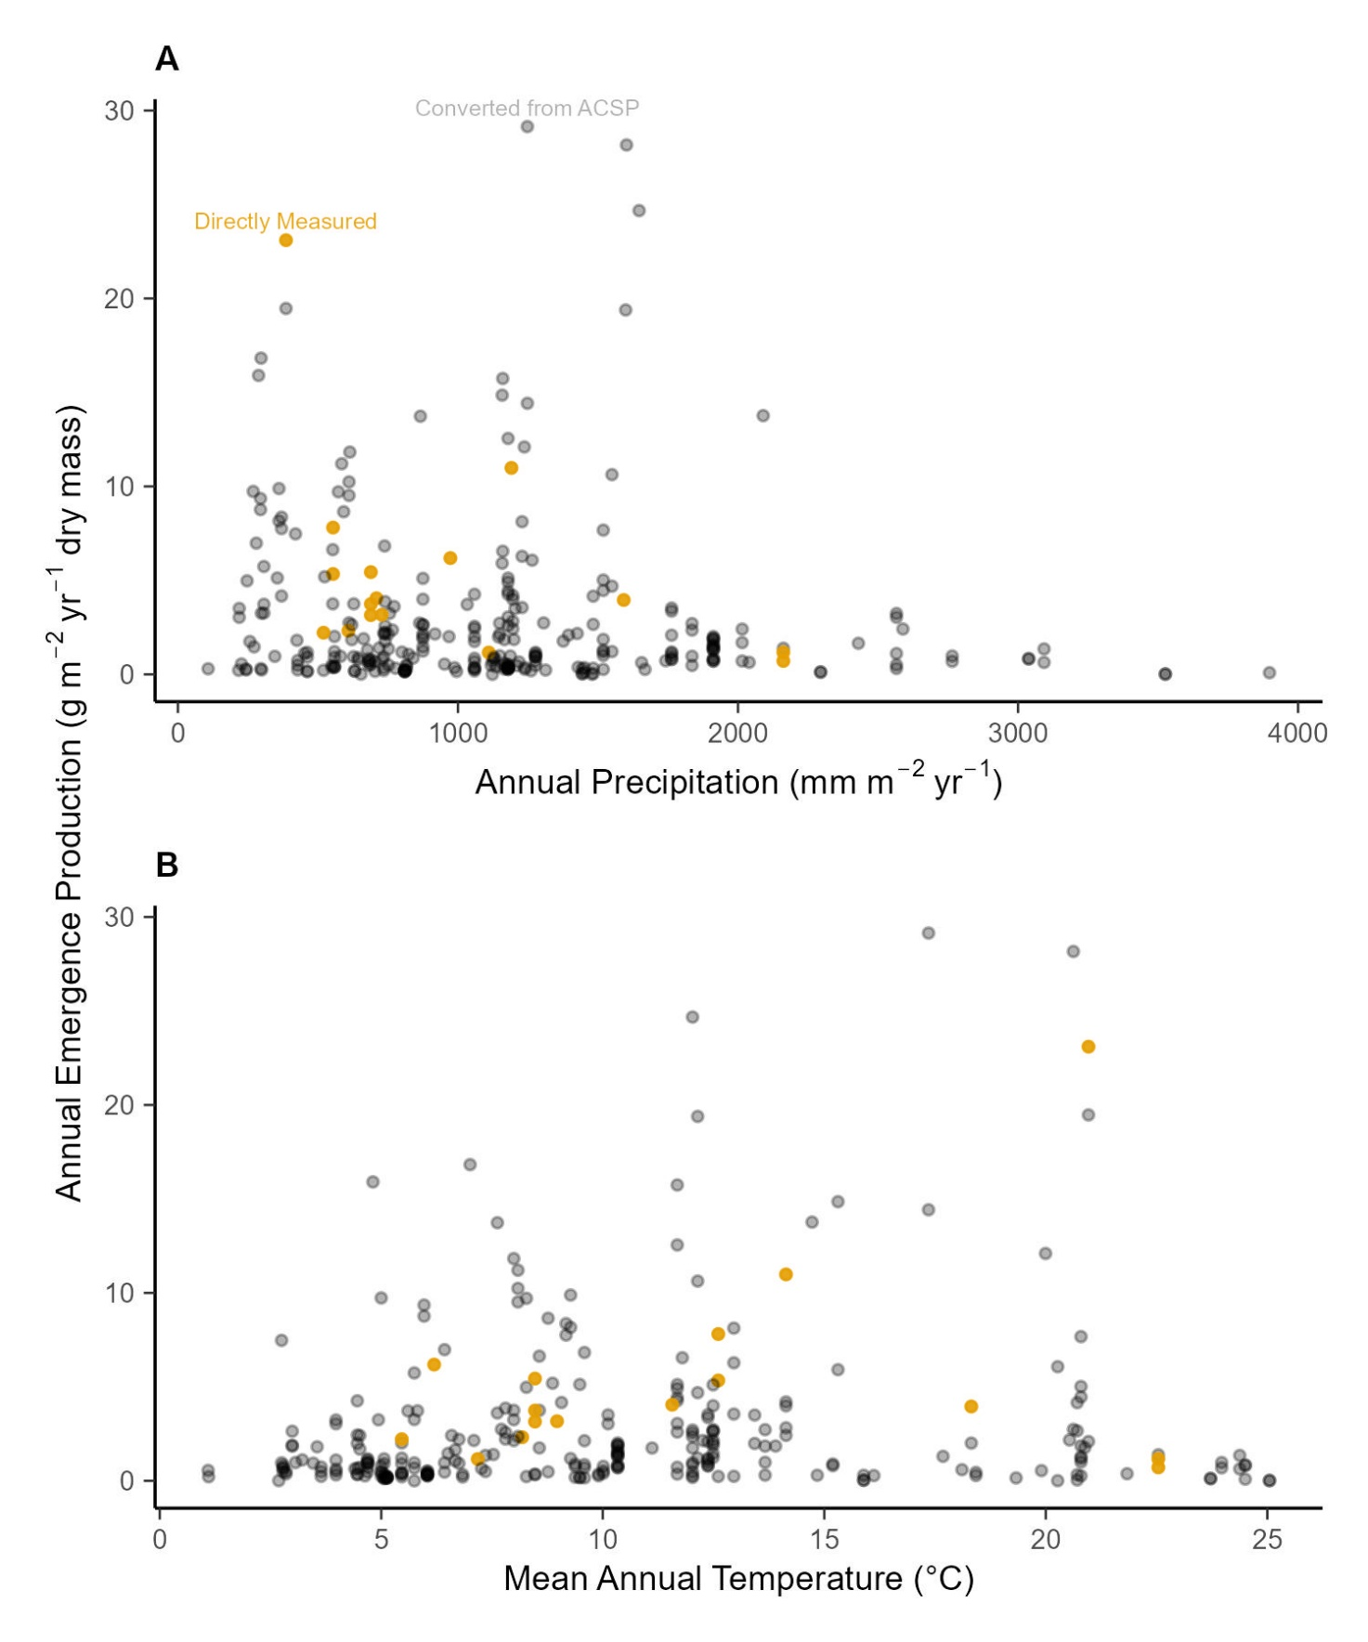Fig. S7. Comparisons of our modeled estimates of insect emergence (black dots) to directly measured annual insect emergence (orange dots). Patterns are shown in relation to associated values of annual precipitation (A), and annual stream temperature (B). Most extracted production data reported ACSP, which is annual benthic production of all macroinvertebrates. As described in the methods, we converted these measures to just adult insect emergence using empirical relationships between the fraction of benthic production that is only insects and the fraction of insect production that emerge successfully to adults. The similarity in distributions between converted and measured values (i.e. overlap of the dots) indicates that our conversion procedure produced biologically reasonable estimates of insect emergence.

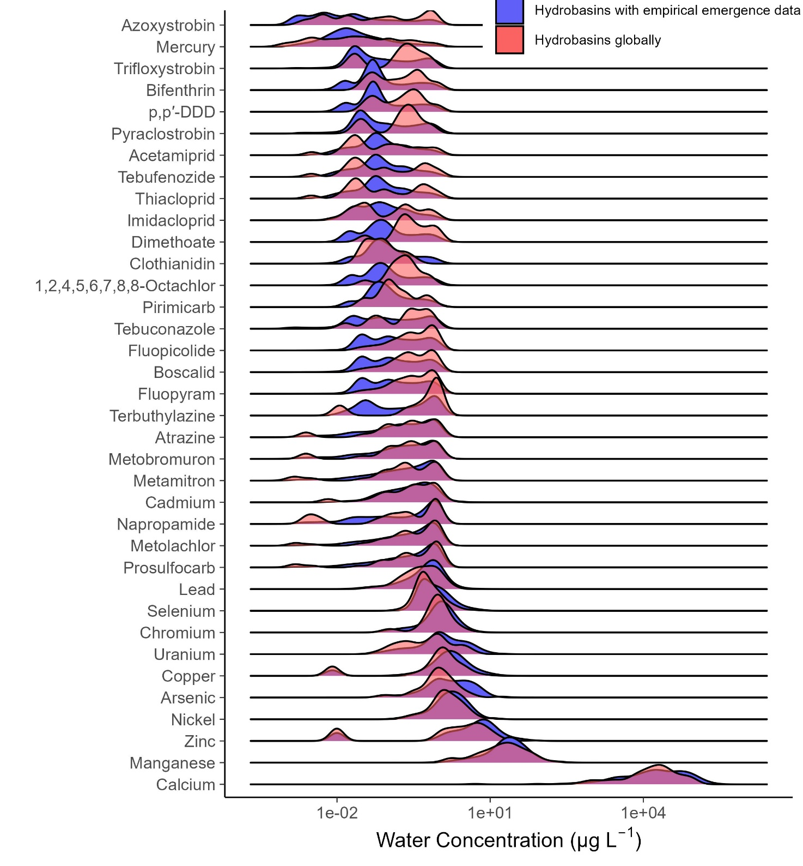
Fig. S8. Comparison of contaminant water concentrations globally (red) with concentrations only in the hydrobasins that had direct estimates of secondary production or emergence (blue). The strong overlap suggests that the hydrobasins used to sample emergence were typical in terms of water quality to global distributions.

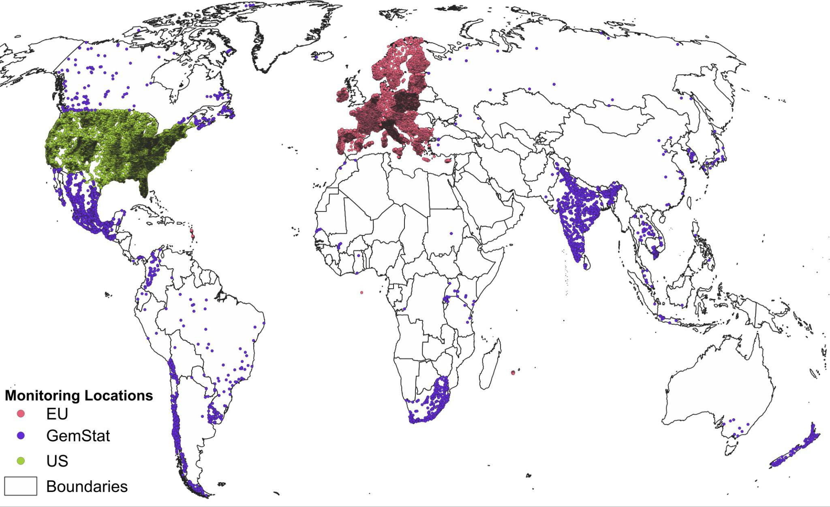

Fig. S9. Location of contaminant concentration data. Data used for model training (red = Europe, Water Information System Europe [WISE]; green = US, Water Quality Portal [WQP]) and validation (blue = global, Global Freshwater Quality Database [GEMStat]). Training data for the 37 contaminants were taken from the EU WISE (n ≈ 7.4 million) and US WQP (n ≈ 5.3 million), whereas the global validation data were provided by the GEMStat database (n ≈ 3.2 million) curated by the German Federal Institute for Hydrology.

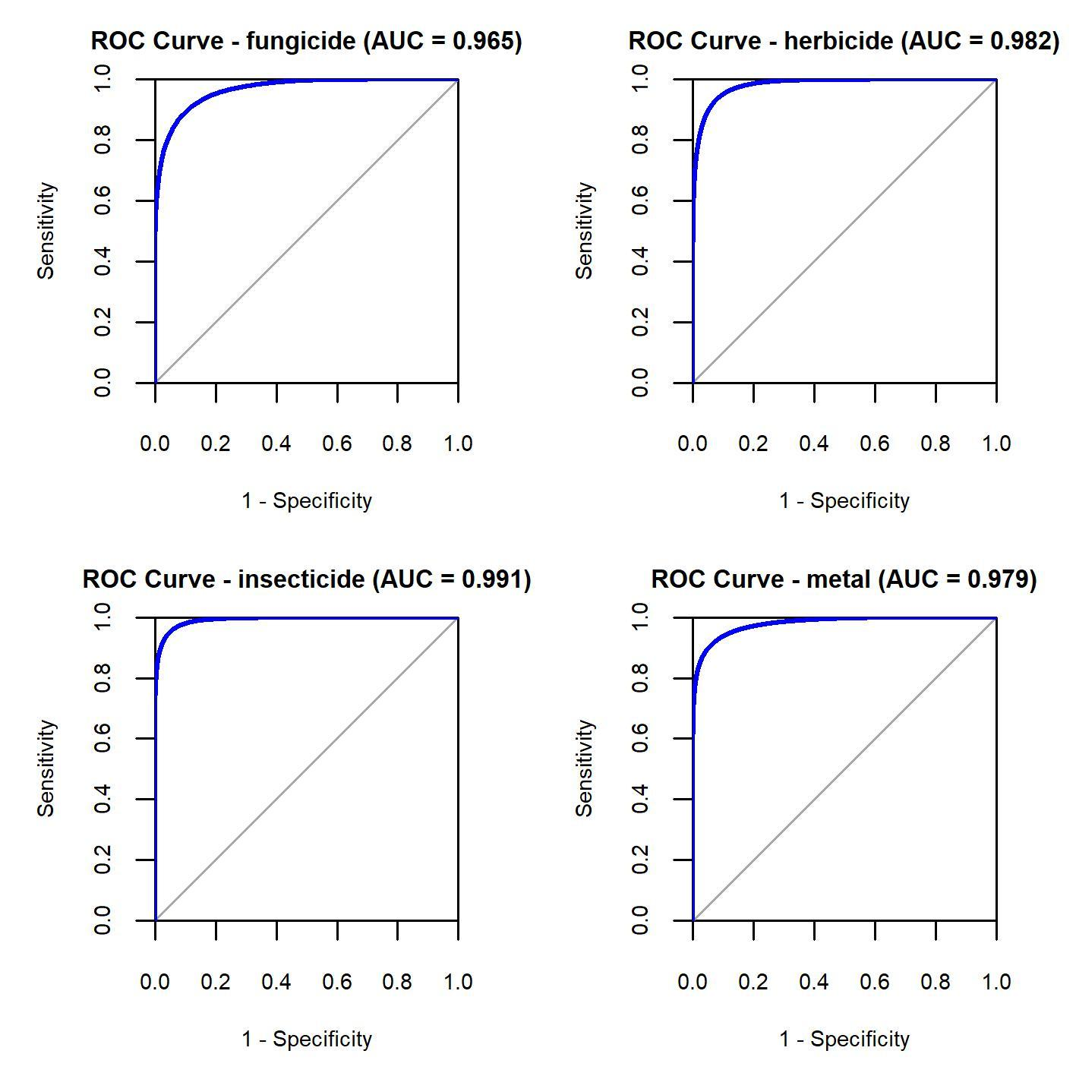
Fig. S10. Receiver-operator curves for the four contaminant classification models. Areas under the curve (AUC) annotated at the top.

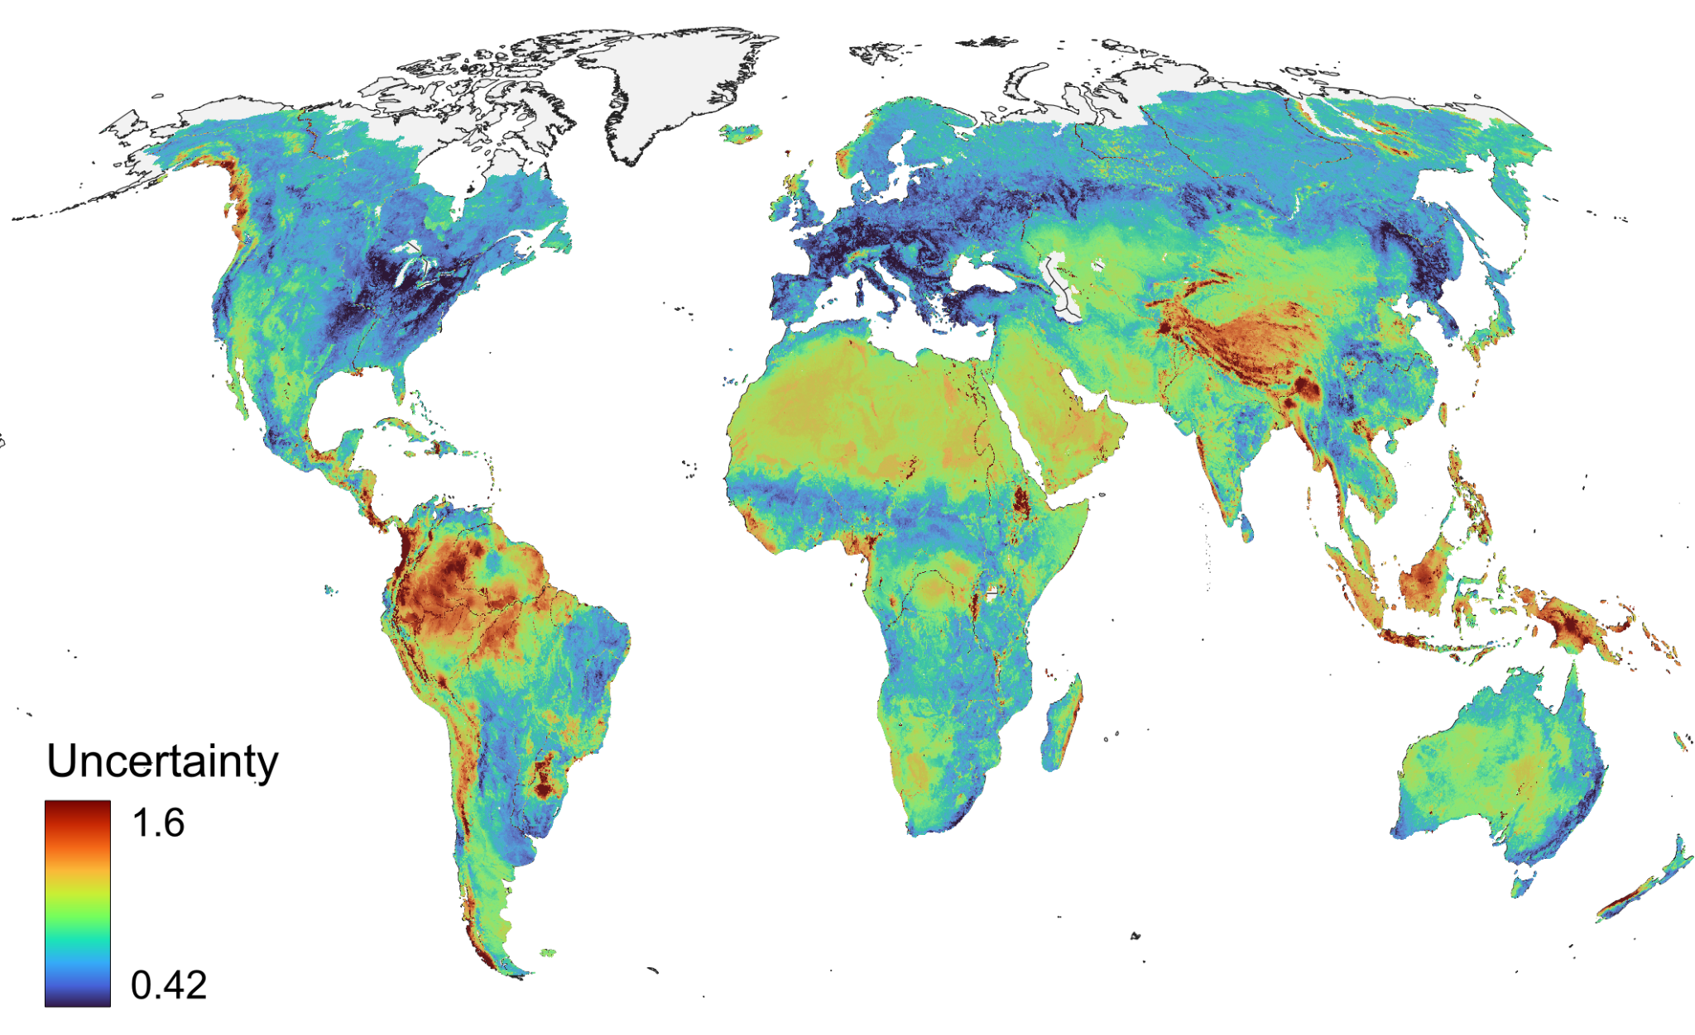
Fig. S11. Uncertainty associated with global contaminant predictions derived for the 24 main numerical predictors. Uncertainty is depicted via the mean absolute deviance across all predictors (expressed as z-score normalized parameters). Z-score normalization was conducted with respect to the training data (Europe and the US) to highlight divergences of parameter matrices outside the training area. For instance, in the western Amazonia basin (dark red), spatial predictors are on average 1.6 standard deviations away from the average predictor value used during training, whereas in Central Europe (dark blue) spatial predictors are, on average, only 0.42 standard deviations away from the parameter room used during training.

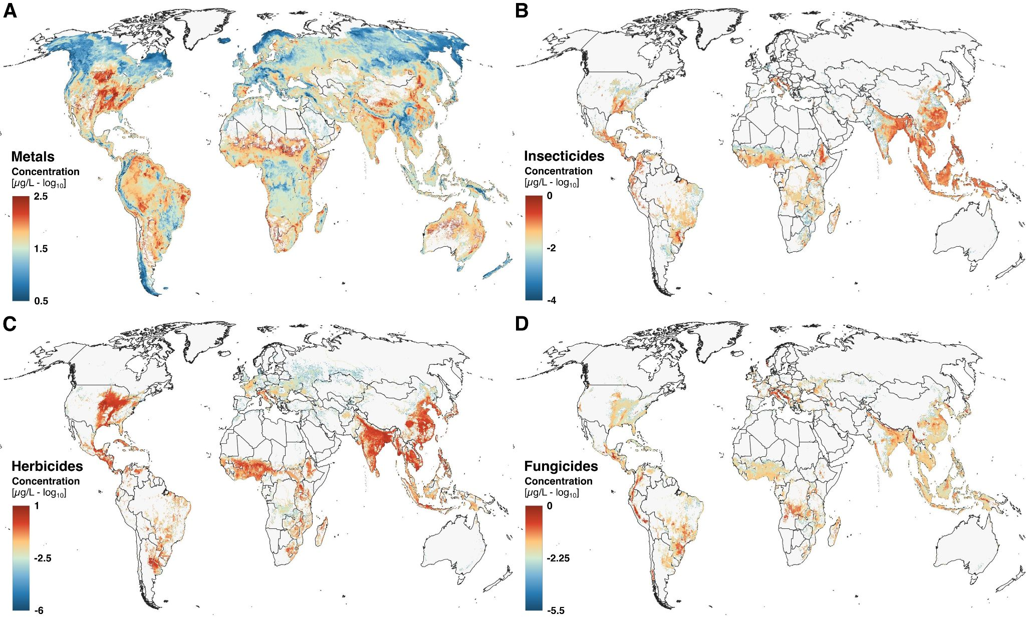
Fig. S12 - Modelled water contaminant concentration. Global average water contaminant concentrations for (A) metals, (B) insecticides, (C) herbicides and (D) fungicides displayed as log10-transformed concentrations in µg L⁻¹.

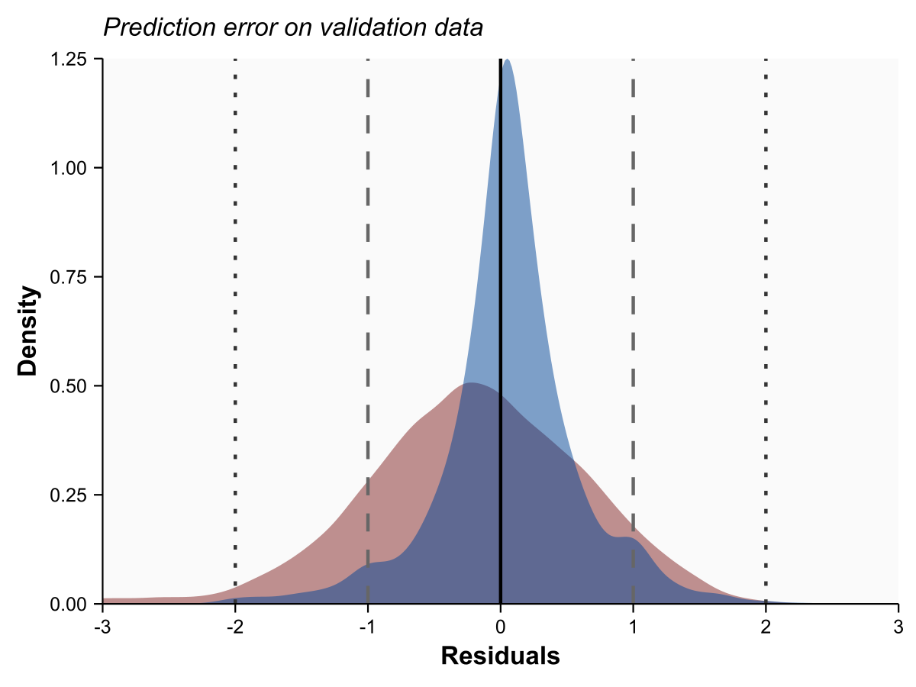
Fig. S13. Error of concentration prediction models using GEMStat data as an independent validation source. Errors are expressed as residuals (log₁₀) of predicted vs. actual measurements within the training area (i.e., Europe and US, blue) and outside the training area (i.e., rest of the world, red). Negative residual values represent underestimations of predicted concentrations.

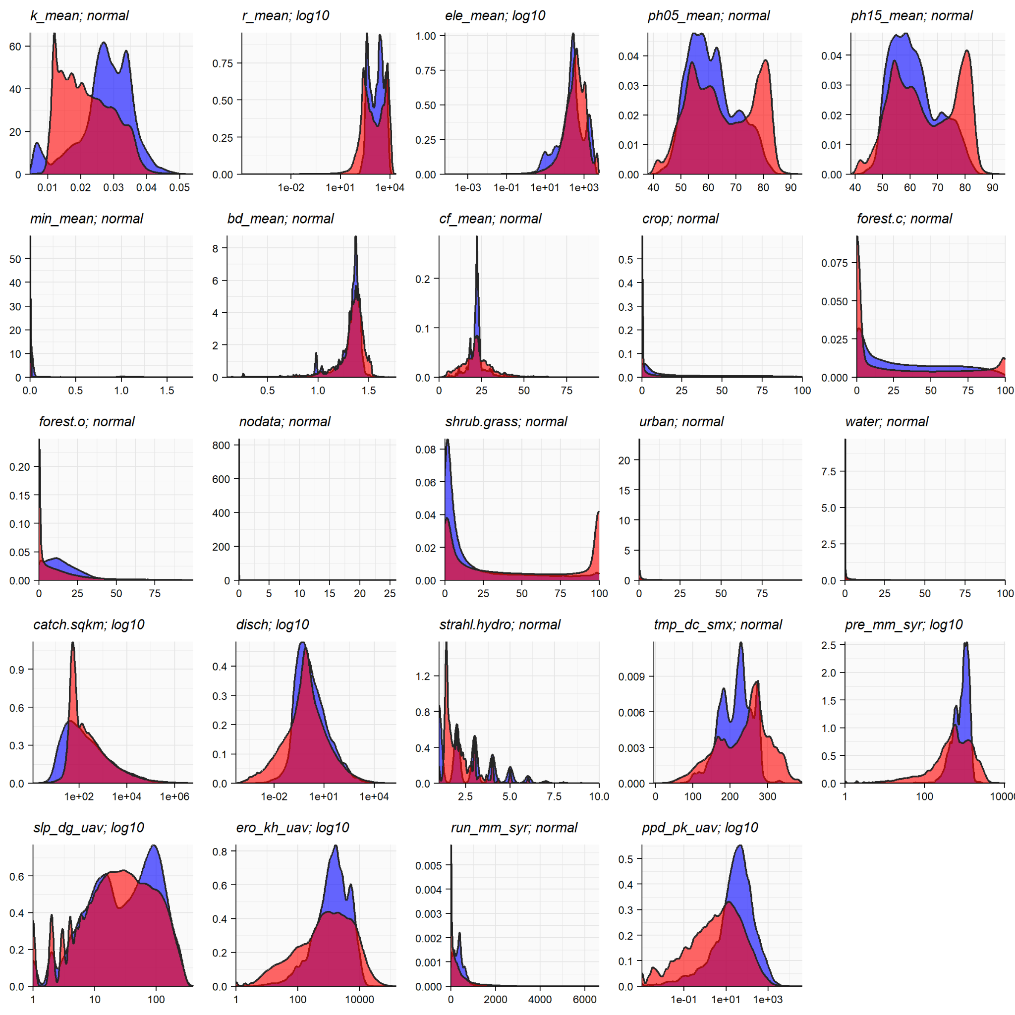
Fig. S14. Predictor distributions for both the training and global prediction. Density overview of numerical predictors for global contamination modelling with blue density curves representing predictor distributions of locations used for training and red distributions depicting all global sites for which contaminant models were applied. Definitions of predictors are provided in table S5.

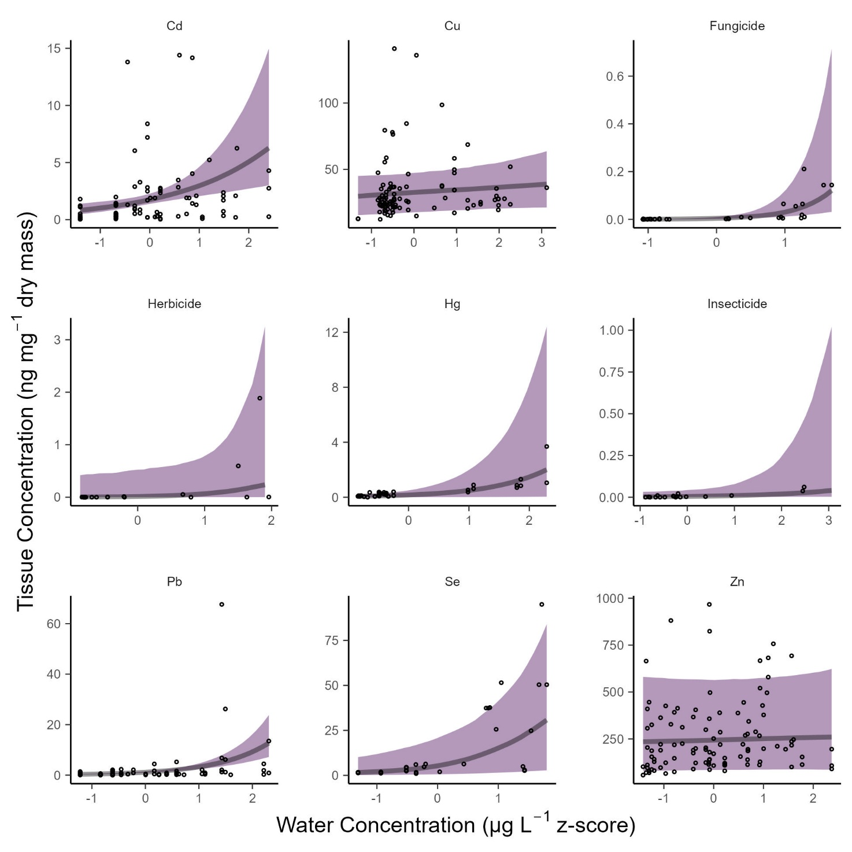

Fig. S15. Modeled relationships between tissue concentrations of contaminants in adult aquatic insects and corresponding aqueous concentrations. Lines and shading show the posterior median and 95% CrI. Dots show the raw data.

Supplementary Tables

Table. S1 - Modeled estimates of dry mass and nutrient export from water to land by adult aquatic insects in export per square meter and global export per year. Values represent the posterior median and upper and lower 95% CrI. Values are rounded to the nearest 10 for export per area and nearest 1000 for global export. PUFA = polyunsaturated fatty acids.

Nutrient | Units | Median | Q2.5 | Q97.5
Export per surface water area
Dry Mass | mg·m⁻²·yr⁻¹ | 1,680 | 130 | 17,770
Carbon | mg·m⁻²·yr⁻¹ | 750 | 60 | 8,000
Nitrogen | mg·m⁻²·yr⁻¹ | 120 | 10 | 1,270
PUFA | mg·m⁻²·yr⁻¹ | 20 | 0 | 210
Phosphorus | mg·m⁻²·yr⁻¹ | 10 | 0 | 60
Global export
Dry Mass | t·yr⁻¹ | 1,820,000 | 1,232,000 | 3,160,000
Carbon | t·yr⁻¹ | 819,000 | 555,000 | 1,422,000
Nitrogen | t·yr⁻¹ | 130,000 | 88,000 | 226,000
PUFA | t·yr⁻¹ | 17,000 | 4,000 | 69,000
Phosphorus | t·yr⁻¹ | 7,000 | 4,000 | 11,000

Table S2 - Global contaminant export. Modeled estimates of annual global metal (including essential metals) and pesticide export from water to land by adult aquatic insects from rivers. Values represent the posterior median and upper and lower 95% CrI. Each row is calculated separately across posterior iterations of a right-skewed posterior; hence sums of the median for each element may not match the totals

Contaminants | Units | Median | Q2.5 | Q97.5
Zn | t·yr⁻¹ | 309.1 | 58.8 | 801.4
Cu | t·yr⁻¹ | 53.7 | 34.8 | 79.6
Pb | t·yr⁻¹ | 7.9 | 2.4 | 46.0
Se | t·yr⁻¹ | 4.8 | 1.5 | 13.7
Cd | t·yr⁻¹ | 2.1 | 0.4 | 6.5
Hg | t·yr⁻¹ | 0.7 | 0.2 | 2.5
Total metal | t·yr⁻¹ | 389.0 | 120.6 | 856.7
Herbicide | t·yr⁻¹ | 0.086 | 0.014 | 0.421
Insecticide | t·yr⁻¹ | 0.009 | 0.002 | 0.037
Fungicide | t·yr⁻¹ | 0.003 | 0.001 | 0.012
Total pesticide | t·yr⁻¹ | 0.102 | 0.023 | 0.438

Table S3. Relative importance of annual emergence biomass and aqueous concentrations in explaining variation in insect-mediated contaminant export from river and streams. Values show the contribution of a model's total R² that is explained by each predictor.
 | Relative Importance
Contaminant | Biomass Export | Aqueous Concentration
Pb | 0.9 | 0.078
Se | 0.96 | 0.016
Cu | 0.98 | 0.0078
Hg | 0.91 | 0.023
Zn | 0.98 | 0.0031
Cd | 0.97 | 0.0043
Herbicides | 0.2 | 0.18
Insecticides | 0.32 | 0.056
Fungicides | 0.26 | 0.058

Table S4. Parameter definitions used in modelling the export of biomass, nutrients, and contaminants in adult aquatic insects from rivers and streams. For equations, “Statistical model” indicates that the parameter is derived from the fit of a regression model that is explained in the text.
Parameter | Definition | Units | Equation
$$μ_{f_{i}}$$ | Mean fraction of total community production that is comprised only of insects |  | Statistical model
$$P_{b}$$ | Annual benthic 2° production - all taxa | $$mgDM⋅m^{\text{-}2}⋅y^{\text{-}1}$$
$$P_{i}$$ | Annual benthic 2° production - insects only | $$mgDM⋅m^{\text{-}2}⋅y^{\text{-}1}$$ | $$P_{i}\text{=}P_{b}μ_{f_{i}}$$
$$E_{i}$$ | Annual emergence production | $$mgDM⋅m^{\text{-}2}⋅y^{\text{-}1}$$ | $$E_{i}\text{=}μ_{E:P}^{}P_{i}$$
$$E_{i,basin}$$ | Annual emergence production per hydrobasin | $$kgDM⋅y^{\text{-}1}$$
$$μ_{E:P}$$ | Mean ratio of emergence to insect production |  | Statistical model
$$E_{i,global}$$ | Annual global emergence production | $$tDM⋅y^{\text{-}1}$$ | $$\sum{E_{i,basin}}$$
$$C_{w}$$ | Contaminant concentration in water
$$C_{a}$$ | Contaminant concentration in adult aquatic insects | $$ng⋅mgDM^{\text{-}1}$$
$$C_{a,basin}$$ | Contaminant concentration in adult aquatic insects in each hydrobasin | $$ng⋅mgDM^{\text{-}1}$$ | Statistical model
$$C_{f,basin}$$ | Contaminant export from each hydrobasin | $$mg ∨ kg⋅y^{\text{-}1}$$ | $$C_{a,basin}⋅E_{i,basin}$$
$$C_{a,global}$$ | Contaminant export globally |  | $$\sum{C_{f,basin}}$$
$$μ_{F_{}}$$ | Mean concentration of PUFAs (EPA + DHA) in adult aquatic insects | $$ng⋅mgDM^{\text{-}1}$$ | Statistical model
$${Conc}_{basin}$$ | Tissue concentration of a contaminant or nutrient in adult aquatic insects, predicted across basin |  | $$Conc_{basin}\text{=}α\text{+}βC_{w}$$

Table S5. List of predictors used to model annual insect emergence production. All predictors were standardized to z-scores before modeling. See table S6 for the list of models.
Variable | Description | Resolution | Source | Notes
precip | Mean annual precipitation | HYBAS 12 | https://www.hydrosheds.org/hydroatlas | Converted to precipitation in mm before analyzing
streamtemp | Mean annual stream temperature | HYBAS 12 | https://www.hydrosheds.org/hydroatlas | Converted from mean annual air temperature (tmp_dc_syr in HydroSheds)
hft_ix_s93 | 1993 Human Footprint Index (at sub-basin pour point | HYBAS 12 | https://www.hydrosheds.org/hydroatlas
hft_ix_u93 | 1993 Human Footprint Index (total watershed upstream of sub-basin pour point | HYBAS 12 | https://www.hydrosheds.org/hydroatlas
hft_ix_s09 | 2009 Human Footprint Index (at sub-basin pour point | HYBAS 12 | https://www.hydrosheds.org/hydroatlas
hft_ix_u09 | 2009 Human Footprint Index (total watershed upstream of sub-basin pour point | HYBAS 12 | https://www.hydrosheds.org/hydroatlas
ele_mt_sav | Elevation | HYBAS 12 | https://www.hydrosheds.org/hydroatlas
dis_m3_pyr | Discharge | HYBAS 12 | https://www.hydrosheds.org/hydroatlas | log10 transformed before standardizing and modelling
for_pc_sse | Percent Forest Cover | HYBAS 12 | https://www.hydrosheds.org/hydroatlas
crp_pc_sse | Percent Cropland | HYBAS 12 | https://www.hydrosheds.org/hydroatlas

Table S6. Model selection for predicting mean annual insect emergence (y) as a function of abiotic predictors. Predictors are indicated in parentheses of f(), where f() represents the spline function in a Generalized Additive Model (GAM) fit in brms. Definitions of predictors are shown in table S6. Intercepts include the global intercept (α) and varying intercepts (i.e., random effects) for author and year of publication (au) and for the hydrobasin ID (hy). Model selection results are shown as the expected log posterior density and its standard error (elpd ± se), where less negative numbers indicate better fit. To generate global predictions of flux, we used Model 3, which contains an interaction of the two most common predictors (precipitation and temperature) in the top suite of models.
Model # | Model | elpd ± se
1 | y ∼ α+f1(precip)+au+hy | 0 ± 0
2 | y ∼ α+f1(streamtemp)+au+hy | -1.8 ± 2.4
3* | y ∼ α+f1(streamtemp,precip))+au+hy | -2.3 ± 3.3
4 | y ∼ α + au+hy | -2.4 ± 2.7
5 | y ∼ α+f1(streamtemp)+ +f2(precip)+au+hy | -2.9 ± 2.9
6 | y ∼ α+f1(hft_ix_s93)+au+hy | -3.5 ± 2.3
7 | y ∼ α+f1(hft_ix_u93)+au+hy | -3.6 ± 3.9
8 | y ∼ α+f1(hft_ix_s09)+au+hy | -5.2 ± 3.7
9 | y ∼ α+f1(hft_ix_u09)+au+hy | -5.3 ± 3.5
10 | y ∼ α+f1(elemsav)+au+hy | -5.6 ± 4
11 | y ∼ α+f1(log10(dism3pyr))+au+hy | -6.7 ± 4.1
12 | y ∼ α+f1(for_pc_sse)+au+hy | -7 ± 4.2
13 | y ∼ α+f1(crp_pc_sse)+au+hy | -7.7 ± 4.1
14 | y ∼ α+f1(streamtemp)+f2(crp_pc_sse)+au+hy | -8.6 ± 4.2
15 | y ∼ α+f1(streamtemp)+ f2(crp_pc_sse)+for_pc_sse )+au+hy | -9.7 ± 5.5

Table S7. Comparison of data used to fit regression models of emergence (Data in GAM Models) and the global range of data across all hydrobasins (Global Data). Summaries show the median, 95% confidence interval (CI), the range (minimum to maximum), and the
total number of replicates (N).

Predictor | Units | Data | Median (95% CI) | Range | N
Precipitation | mm m⁻² y⁻¹ | Data in GAM Models | 1096 (176.9 to 2792.5) | 52 to 4084 | 305
Precipitation | mm m⁻² y⁻¹ | Global Data | 541 (15 to 2791) | 0 to 10392 | 919,156
Stream Temperature | Mean annual °C | Data in GAM Models | 9.2 (2.9 to 24.1) | 1 to 25 | 305
Stream Temperature | Mean annual °C | Global Data | 18.4 (1 to 25.3) | 0.8 to 26.1 | 919,156

Table S8. Overview of spatial predictors attributed to monitoring data for machine-learning models with their data-prefix, resolution and direct source. Land-use land cover predictors (prefix h) encompass six spatial predictors (e.g. percent agriculture, percent urban areas)
Type | Prefix | Resolution | Source
Elevation (DEM) | ele | 1 km | https://www.earthenv.org/topography
Bulk density topsoil | bd | 0.03° | https://doi.org/10.1594/PANGAEA.868929
Clay fraction topsoil | cf | 0.03° | https://doi.org/10.1594/PANGAEA.868929
Lithological map | lit | 0.01° | https://doi.pangaea.de/10.1594/PANGAEA.788537
Land-use land cover | h | 0.001° | https://zenodo.org/records/3939038
K factor (soil erodibility) | k | 0.01° | https://esdac.jrc.ec.europa.eu/content/global-soil-erodibility
R factor (rainfall erosivity) | r | 0.008333° | https://esdac.jrc.ec.europa.eu/content/global-rainfall-erosivity#tabs-0-description=1
Soil pH (5-15 cm) | pH05 | 0.008333° | https://files.isric.org/soilgrids/latest/data/
Soil pH (15-30 cm) | pH15 | 0.008333° | https://files.isric.org/soilgrids/latest/data/
Global Mining footprint | min | 0.008333° | https://download.pangaea.de/dataset/942325/allfiles.zip  https://zenodo.org/records/7894216
Upstream catchment | catch | HYBAS 12 | https://www.hydrosheds.org/hydroatlas
Discharge | disch | HYBAS 12 | https://www.hydrosheds.org/hydroatlas
Strahler order | strahl | HYBAS 12 | https://www.hydrosheds.org/hydroatlas
Air temperature | tmp | HYBAS 12 | https://www.hydrosheds.org/hydroatlas
Precipitation | pre | HYBAS 12 | https://www.hydrosheds.org/hydroatlas
Slope | slp | HYBAS 12 | https://www.hydrosheds.org/hydroatlas
Soil erosion | ero | HYBAS 12 | https://www.hydrosheds.org/hydroatlas
Run-off | run | HYBAS 12 | https://www.hydrosheds.org/hydroatlas
Population density | ppd | HYBAS 12 | https://www.hydrosheds.org/hydroatlas

Table S9. Accuracy metrics for occurrence prediction models. Values reported are error rate of the null model (majority class), error rate of the full training model (out-of-bag), error rate of the testing data (misclassification), precision, recall, F1-score, relative improvement (RI, in percent), and the total number of data (n) used for model building and testing.
Model | Error_{null} | Error_{train} | Error_{test} | Precision | Recall | F1-score | RI % | n
fungicides | 19.7 | 7.7 | 7.74 | 0.93 | 0.98 | 0.95 | 60.9 | 247,217
herbicides | 24.5 | 7.2 | 7.2 | 0.94 | 0.97 | 0.95 | 70.6 | 940,724
insecticides | 8.6 | 2.4 | 2.4 | 0.98 | 1.00 | 0.99 | 72.1 | 900,707
metals | 65.2 | 8.5 | 8.46 | 0.87 | 0.88 | 0.88 | 87.0 | 5,243,841

Table S10. Accuracy metrics for concentration prediction models. Values reported are mean squared error (MSE, null and full model), relative improvement (RI, in percent), mean absolute error (MAE, null model), R-squared (training and testing) and the total number of data (n) used for model building and testing.
Model | MSE_{null} | MSE_{full} | RI % | MAE_{null} | R² train | R² test | n
fungicides | 0.448 | 0.080 | 82.1 | 0.478 | 0.823 | 0.821 | 48,722
herbicides | 0.762 | 0.107 | 86.0 | 0.690 | 0.860 | 0.860 | 230,347
insecticides | 0.774 | 0.066 | 91.4 | 0.625 | 0.911 | 0.914 | 77,143
metals | 2.807 | 0.100 | 96.4 | 1.206 | 0.964 | 0.964 | 3,416,562

