Caveats of modeling PUFA
Our approach to modeling PUFA (epa + dha) fluxes involves several caveats. First, we multiply a single posterior distribution of PUFA tissue concentration by insect emergence in each HYBAS. However, PUFA concentrations can vary among taxa (Kalacheva et al. 2013, Shipley et al. 2022). For example, Shipley et al. (2022) found higher PUFA concentrations in mayflies (Ephemeroptera) than other taxa. As a result, our assumption that PUFA tissue concentrations come from a single distribution is unlikely to hold in areas with, say, high mayfly biomass. However, it is worth noting that our models included insect order as a varying intercept and our predictions for PUFA concentrations carry forward the uncertainty from the σ parameter of that intercept. In other words, our predictions assume that taxonomic composition is unknown and that leads to wider prediction intervals than if we knew taxonomic composition of the emergence flux. Moreover, our meta-analysis of PUFA concentrations show similar values across taxa. Posterior medians range from 7.5 mg/gDM in Plecoptera to 11.3 mg/gDM in Ephemeroptera, but the credible intervals of all taxonomic groups are wide and include the medians of all other groups (Table SX).
Second, PUFA tissue concentrations can vary as a function of temperature, with a general expectation that concentrations decline at higher temperatures (Hixson and Arts 2016). However, this relationship is not universal (Gladyshev et al. 2011, Kalachev et al. 2013) and the functional form is not necessarily linear (Hixson and Arts 2016). In our own data, the PUFA collections occur at sites with a limited range of mean annual stream temperatures (2 to 10°C). This is much smaller than the range of stream temperatures we predict across (1 to 26°C) and preliminary models show not change or a slight increase in PUFA concentrations with temperature. However, the max of 10°C in the data make any trends potentially spurious. Thus, we were unable to include a temperature effect, if any, on PUFA concentrations are unaware of any literature derived equations that can be universally applied. Additionally, across our large spatial scale, the influence of temperature is conflated with changes in both fatty acid metabolism and taxonomic makeup of communities, neither of which are known globally.
Instead, to estimate how sensitive our results might be to temperature effects on PUFA, we simulated a linear decline in PUFA concentrations across the stream temperature gradient. We assumed that the concentration of PUFA’s would decline by 50% across the gradient (i.e., the warmest site would have 50% of the PUFA concentration as the coldest site). This effect size is mostly arbitrary, but it is similar to changes in PUFA concentrations across a similar temperature gradient reported for zooplankton in Hixson and Arts (2016).
The result is in Figure SX. It shows that the large simulated effect of temperature largely disappears after accounting for uncertainty in taxon, location, and publication (Figure SXB) and after multiplying the tissue concentrations by insect emergence biomass (Figure SXC). In other words, even a large temperature effect on PUFA concentrations that has no error (Figure SXA) would not have a large effect on spatial patterns of PUFA flux, because it is subsumed by the effects of temperature on insect emergence biomass. The global average PUFA flux (mg/m2/y) without a temperature correction is 18,000 (5 to 41,000). With a temperature correction, it is 13,000 (4,000 to 30,000), indicating similar estimates of PUFA flux.
Results
Table SX. Summary of the posterior distribution (lower, median, and upper quantiles) of tissue concentrations of EPA + DHA across aquatic insect taxa. Results show strong overlap of concentrations across taxa. Units are mg gDM⁻¹.
Order | Q2.5 | Q50 | Q97.5
Diptera | 8.8 | 10.9 | 13.8
Ephemeroptera | 8.8 | 11.3 | 15.5
Multiple | 6.4 | 14.5 | 29.0
Odonata | 6.6 | 9.3 | 14.2
Plecoptera | 4.1 | 7.6 | 12.4
Trichoptera | 8.0 | 10.7 | 14.1

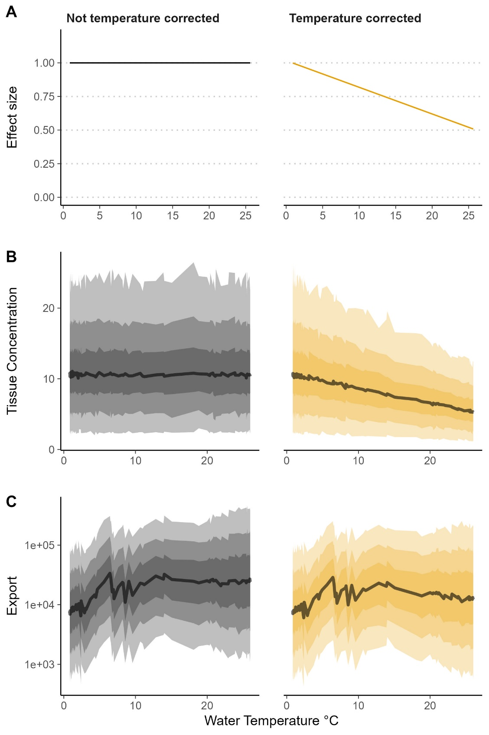
Figure SX: Results of simulating a temperature effect on PUFA tissue concentrations. A) Effect size as a proportion of mean EPA + DHA. These values are multiplied by the posterior distribution of EPA + DHA in B) showing units of mgPUFA/gDM. Predictions with no temperature correction are simply multiplied by 1. Predictions with a temperature correction are multiplied by a range of correction factors from 1 at the lowest temperature to 0.5 at the highest temperature. Those resulting tissue concentrations are then multiplied by the posterior distribution of insect emergence, resulting in C) export of EPA + DHA in kg/m2/y.

